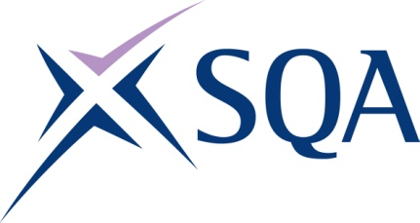
GP0E 22 | SVQ in Community Development at SCQF level 5

To attain the qualification candidates must complete 5 units in total. This comprises:

- 4 mandatory units
- 1 optional units

Please note the table below shows the SSC identification codes listed alongside the corresponding SQA unit codes. It is important that the SQA unit codes are used in all your recording documentation and when your results are communicated to SQA.

Mandatory units: Candidates must complete all 4 units from this group
SQA code | SSC code | Title | SCQF level | SCQF credits
J087 04 | JETSCD04 | Develop Yourself as a Community Development Practitioner | 5 | 5
J088 04 | JETSCD05 | Maintain Community Development Practice Within Own Organisation | 6 | 5
J089 04 | JETSCD06 | Support Inclusive and Collective Working | 5 | 5
J081 04 | JETSCD23 | Monitor and Evaluate Community Development Activities | 5 | 5

Optional units: Candidates must complete 1 units from this group
SQA code | SSC code | Title | SCQF level | SCQF credits
J08B 04 | JETSCD10 | Organise Community Events and Activities | 5 | 5
J08C 04 | JETSCD12 | Support Communities who Want to Bring About Positive Social Change | 5 | 5
J08D 04 | JETSCD16 | Support Collaborative and Partnership Work | 5 | 6

