HN Administration and IT Network Event, February 2018

Digital Technologies for Administrators (HH82 34) – Meeting web service

The purpose of this document is to provide an example of the use of a meeting web service (Meet-o-matic) to assist with delivery of the unit and illustrate the types of evidence that could be generated for assessment. The web service used is only one of many that are available online free of charge (Doddle, vyte.in etc.).
This is an illustrative guide, not a comprehensive teaching guide or assessment support pack. There are numerous possibilities for valid assessment of the unit and this document is intended to stimulate ideas among teachers and assessors that would best suit their own learners and resources available to them. The unit lends itself well to assessment by paper or e-portfolio.

Outcome 3 Use web services and collaborative software to inform, plan and organise work

Meeting web service applications
There are a range of online meeting applications that can be used to organise meetings free of charge (e.g. Meet-o-matic, Doddle, vyte.in etc.). There are others that can be downloaded and embedded within email software (e.g. Boomerang for Gmail and Outlook).

These applications have advantages over e-diaries/calendars embedded within email software, for example:

- Participants don’t need to be using the same email/e-diary software so they can be used with all external contacts as well as internal

- They allow availability to be provided by selecting from a range of options on a calendar rather than having to be typed out manually and recorded by the organiser manually.

- Removes the need for the organiser to check e-diaries/calendars for availability in advance.

- Helps prevent participants suggesting unsuitable dates as the selection of dates is set by the organiser.

- Automatically identifies best date, based on all participants’ availability without having to calculate manually. Options exist to identify key/VIP participants in the event that not everyone can agree on a date. This will allow the software to suggest a date where these participant(s) are available. This cuts out the need to go back and forward negotiating the best date in most cases.

The following example was created via Meet-o-matic www.meetomatic.com to illustrate some of these features. As mentioned there are numerous alternative applications that could be used for arranging meetings.

- The homepage presents the user with a range of possible dates. The default is two months but a greater range of dates can be selected. In this example “my DTFA meeting” is created by selecting a range of dates simply by clicking in the relevant boxes.
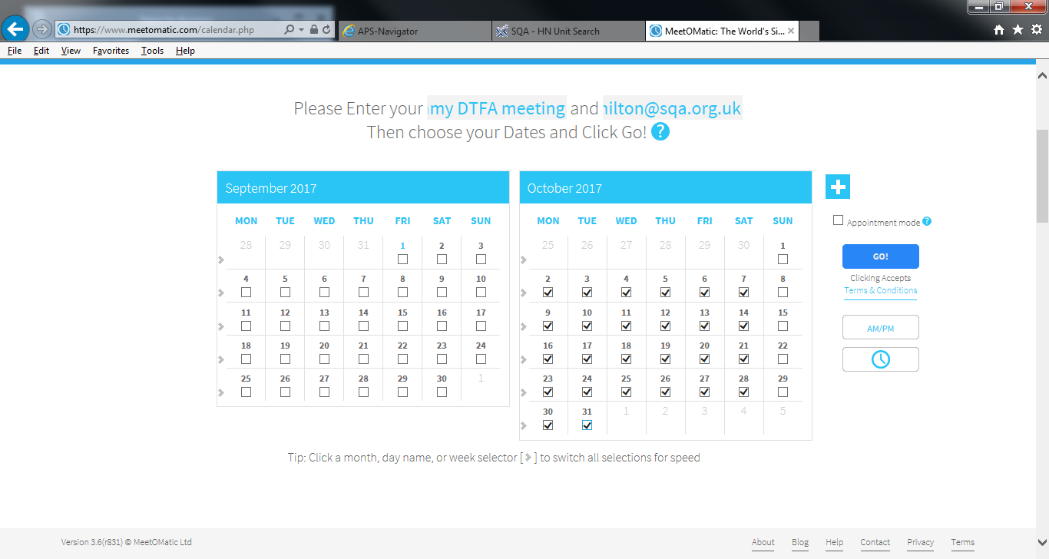
- The meeting organiser receives the following URLs. The first is used to send to meeting invitees to invite them to the meeting and the second is only for the organiser to check on progress.
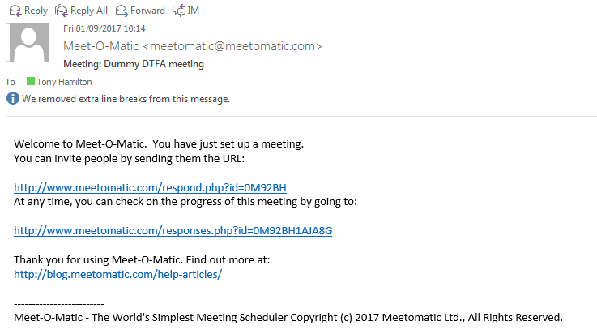

- The organiser receives an automatically generated email containing standard text as per below. The organiser has the choice of customising this text - perhaps by removing the list of dates and/or providing additional information – or using unchanged. As long as the URL is included the software will perform in the same way.
When satisfied with the text, the organiser emails it (including the URL) to all invitees.
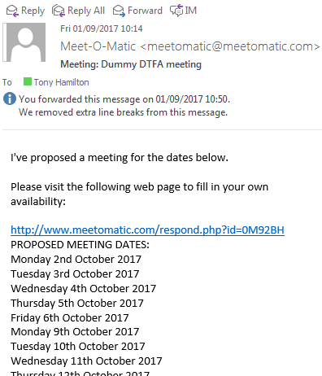
- When an invitee receives the invite email and follows the URL it takes them invitee to the page below.

They are asked to provide their name and email address and to populate the dates provided in the calendar view. Once this is done, all they need to do is click ‘Save response’.
This is much more convenient than having to create an email and manually type the dates they are available.

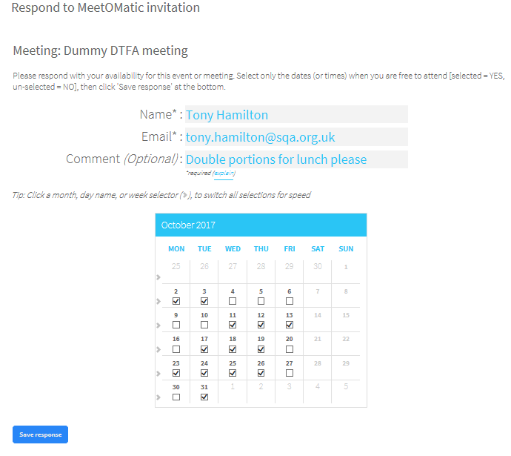

- The invitee then receives an automatic confirmation of the dates they have indicated they are available, with the facility to change this if a mistake is identified or an unexpected change occurs.

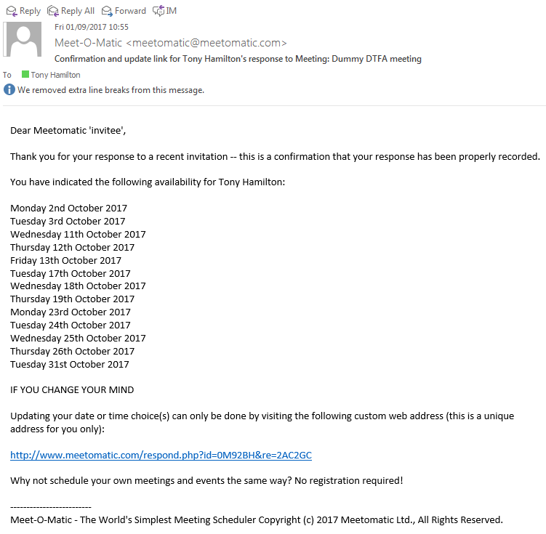

- Each time an invitee responds, the meeting organiser receives an update email as per below. This includes the dates that invitee has selected, any additional comments and a recommended date for the meeting based on responses received so far.

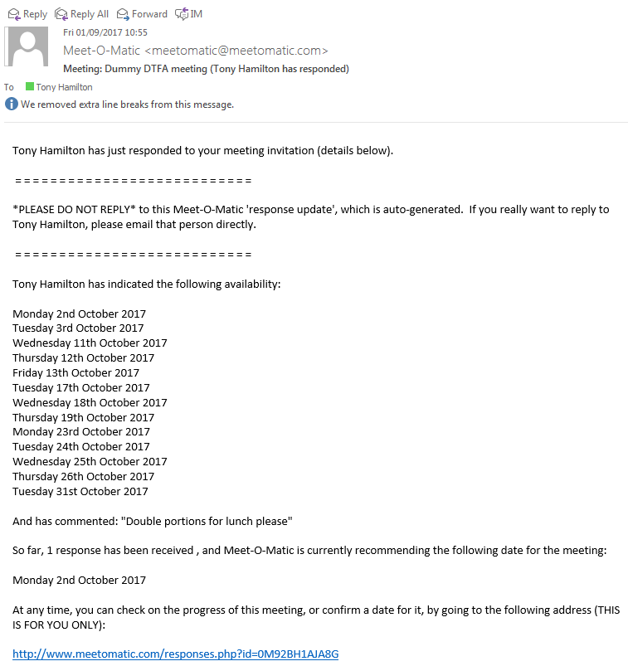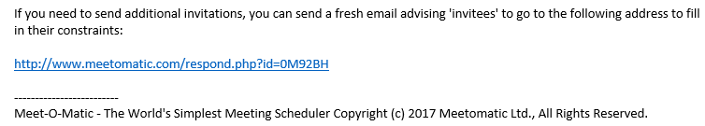

- Another example of an automatic notification to the meeting owner of someone having responded to the invite.

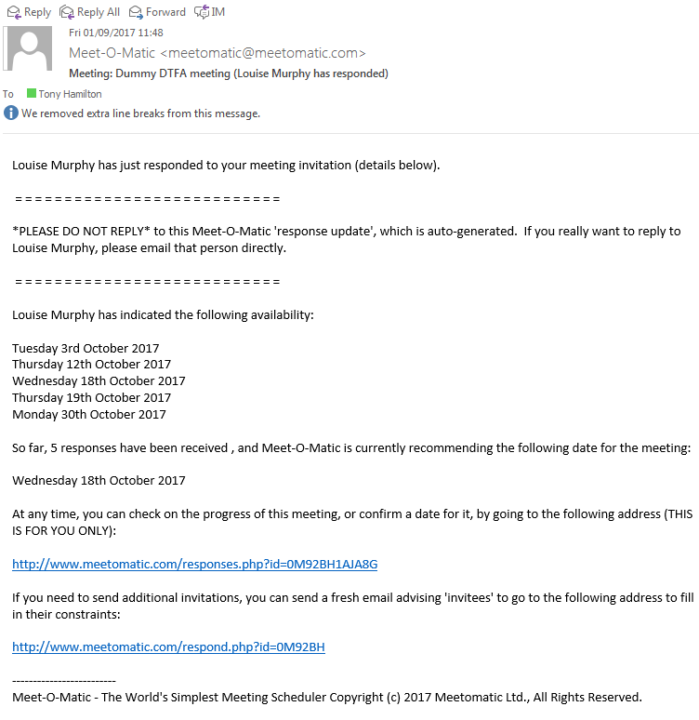

- The meeting owner can monitor progress of responses at any time using the “responses” URL. As can be seen below, the application automatically recommends three dates that are most convenient for invitees. This saves the meeting owner a lot of time in collating all the individual responses and cross referencing them against each other.

As can be seen below, the application has the facility to identify “VIPs” (see left-hand column). This can be used in cases (as with this one), where no date is suitable for all invitees. This prompts the application to prioritise dates when “VIPs” are available. Once the organiser has selected and agreed a date, he/she can then move on to organising the venue and other tasks associated with the meeting.
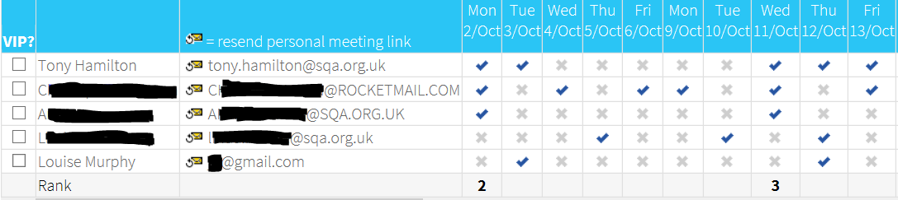
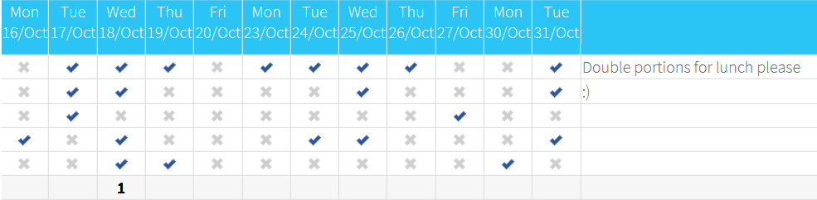
Further Guidance
https://zapier.com/blog/best-meeting-scheduler-apps/

