

Learning Support Materials

English for Speakers of Other Languages:
Everyday Life 1 part 1 (National 3)
Student Notes





Publishing information

First edition
Published date: August 2007
Publication code: CB 3816

First Published 2007

Published by the Scottish Qualifications Authority
The Optima Building, 58 Robertson Street, Glasgow G2 8DQ
Ironmills Road, Dalkeith, Midlothian EH22 1LE

www.sqa.org.uk

The information in this publication may be reproduced in support of SQA qualifications. If it is reproduced, SQA should be clearly acknowledged as the source. If it is to be used for any other purpose, then written permission must be obtained from the Assessment Materials and Publishing Team at SQA. It must not be reproduced for trade or commercial purposes.

© Scottish Qualifications Authority 2007

Please note these materials have been repurposed for the new National Qualifications - August 2015
Contents

Lesson Page

Personal identity

Personal information 4
Family 9
Work and studies — current 13
Work and studies — past and future 18
Saying how you are 22
Likes and dislikes 27
Review: lessons 1–6 32

Social and physical environment

Daily routine 36
Accommodation 40
Local area 45
Social events 49
Socialising 54
Personal opinions 59
Review: lessons 8–13 64

Free time and leisure

Free time 68
Going out 73
Television 77
Media 82
Holidays and festivals 87
Review: lessons 15–19 92

Lesson  01 | Personal information
Lesson  01 | Basic personal information
 |  | Task: Giving and asking for basic personal information
Skill: speaking, listening, reading, writing


Activity 1

Match the greetings to the responses.

1 Morning Ana ……………………………………

2 How’s life? ……………………………………

3 Nice day, isn’t it? ……………………………………

4 Have you met my cousin, Rita? ……………………………………

5 Sorry, what was your name again? ……………………………………

6 What are you up to today? ……………………………………

7 Happy Birthday! ……………………………………

8 Have a nice day ……………………………………

Thanks
We are celebrating my birthday

No, nice to meet you
Yes, lovely

My name’s Rita
Fine thanks. And you?

Hi Danila
And you

Photo: (c) istockphoto.com/marmion
Activity 2


Imagine that you meet Rita for the first time. What questions could you ask her?

Make questions based on the prompts below.

1 Surname ________________________________________?

……………………………………………………..

2 Age ________________________________________?

……………………………………………………..

3 Country of origin ________________________________________?

……………………………………………………..

4 Language ________________________________________?

……………………………………………………..

5 Marital status ________________________________________?

……………………………………………………..

6 Children ________________________________________?

……………………………………………………..

7 Home ________________________________________?

……………………………………………………..

8 Time in Scotland ________________________________________?

……………………………………………………..

Now, ask your partner the questions and write the answers in the spaces below the questions.

Photo: (c) istockphoto.com/Sharon Dominick
Activity 3
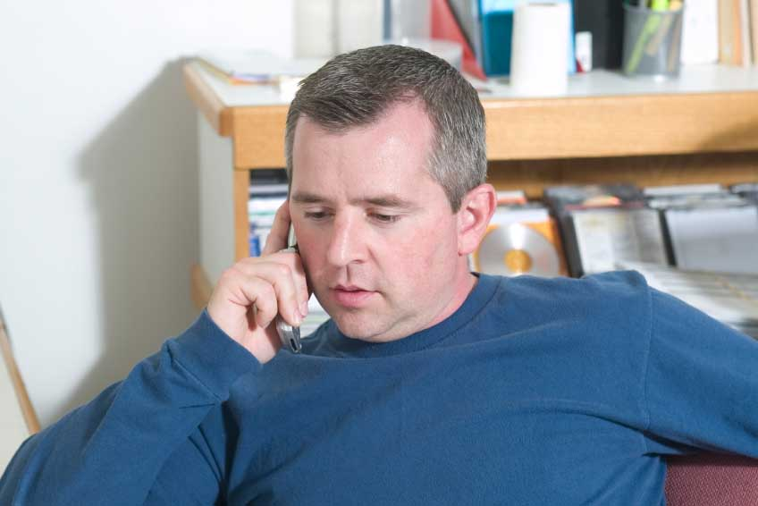
 Track 2

Andy needs to give some personal details over the phone.

The telephonist needs to fill in a form with Andy’s details on it.

Listen to the conversation. What is the form for?

Now, listen again and fill out the form with Andy’s details.

Name:
Surname:
Date of birth:
Nationality:
First language:
Marital status:
Children:
Occupation:
Address:
Telephone number:
Personal details
Photo: (c) istockphoto.com/Randolph Pamphrey
Activity 4

Skim read the following description. What kind of information does it give us?


Hi, my name is Marilyn Chambers. I was born in Uganda but I came to Scotland when I was three years old and I have lived here in Edinburgh for 23 years. I am Scottish and my first language is English but I also speak my parent’s Ugandan dialect and I regularly visit Uganda to see family and to learn more about the culture there.

At the moment, I am living in a flat in the centre of Edinburgh, in Bryson Road. I work in a local primary school as a classroom assistant, but I’m going to study to become a primary school teacher next year. I would also like to move house; I got married last year and our flat is a little bit small for the two of us. We would like to buy a house with a garden, especially as we want to have lots of children in the future!

Now, read the text again and answer the following questions.

1 How old is Marilyn? ________________________________________

2 What nationality is Marilyn? _________________________________

3 How many languages does she speak? ________________________

4 Does she live in a flat or a house? ____________________________

5 How long has she been married? _____________________________

6 How many children has she got? _____________________________

Photo: (c) istockphoto.com/Justin Horrocks
Activity 5

Write a short description of yourself.

………………………………………………………………………………………

………………………………………………………………………………………

………………………………………………………………………………………

………………………………………………………………………………………

………………………………………………………………………………………

………………………………………………………………………………………

………………………………………………………………………………………

………………………………………………………………………………………

………………………………………………………………………………………

………………………………………………………………………………………

………………………………………………………………………………………

………………………………………………………………………………………

………………………………………………………………………………………

………………………………………………………………………………………

………………………………………………………………………………………

Check your description, correct any errors and write it out neatly.

Homework task
Practise your pronunciation by reading your description out loud to yourself. Ask your teacher about any words or phrases you have a problem with.

Lesson  02 | Family
Lesson  02 | Family members
 |  | Task: Describing your family
Skill: speaking, listening, reading, writing

Activity 1
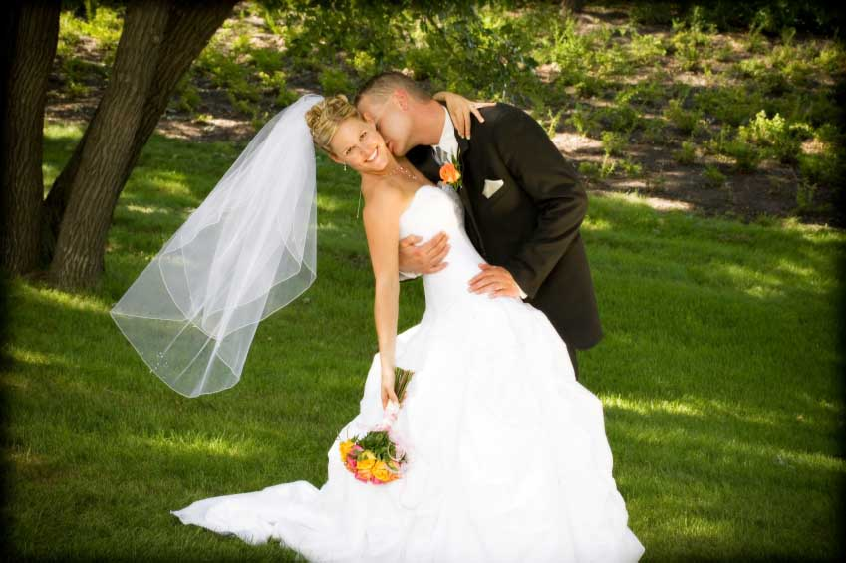
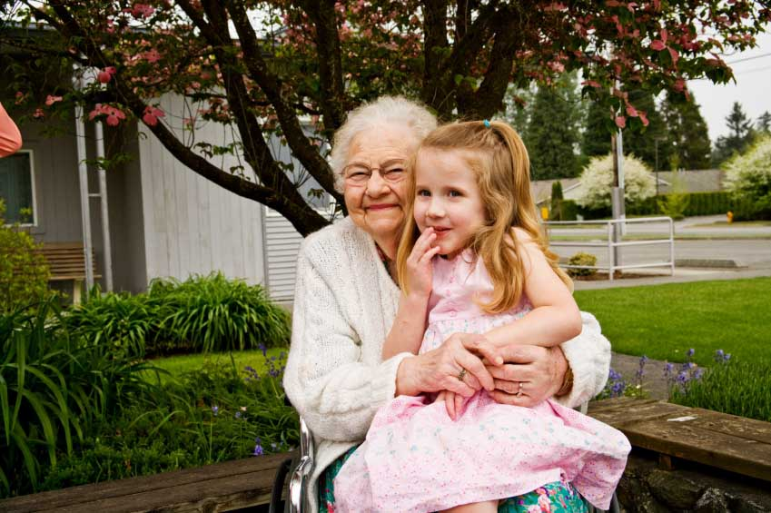

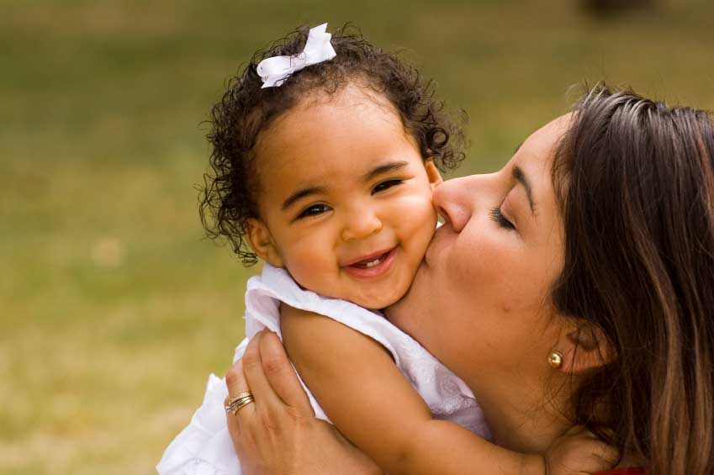

1 2 3 4

How many family members can you think of? Work with a partner to make a list.

Activity 2

The family questions below are in the wrong order. Put them in the correct order.

1 married – you – are?

…………………………………………………………………………………

2 long – married – have – been – how – you?

…………………………………………………………………………………

3 any – children – got – have –you?

…………………………………………………………………………………

4 live – parents – with – you – do – your?

………………………………………………………………………………….

5 brothers – have – sisters – and – you – how – got – many?

…………………………………………………………………………………

6 your – alive – are – still – grandparents?

…………………………………………………………………………………..

7 of – family – live – where – most – do – your?

………………………………………………………………………………..…
All Photos (c) istockphoto.com
1 – Leigh Schindler 2 digitalskillet 3 Thomas Gordon 4 Anne Marie Kurtz
Activity 3

Look at the picture below. How do you think the people are related?

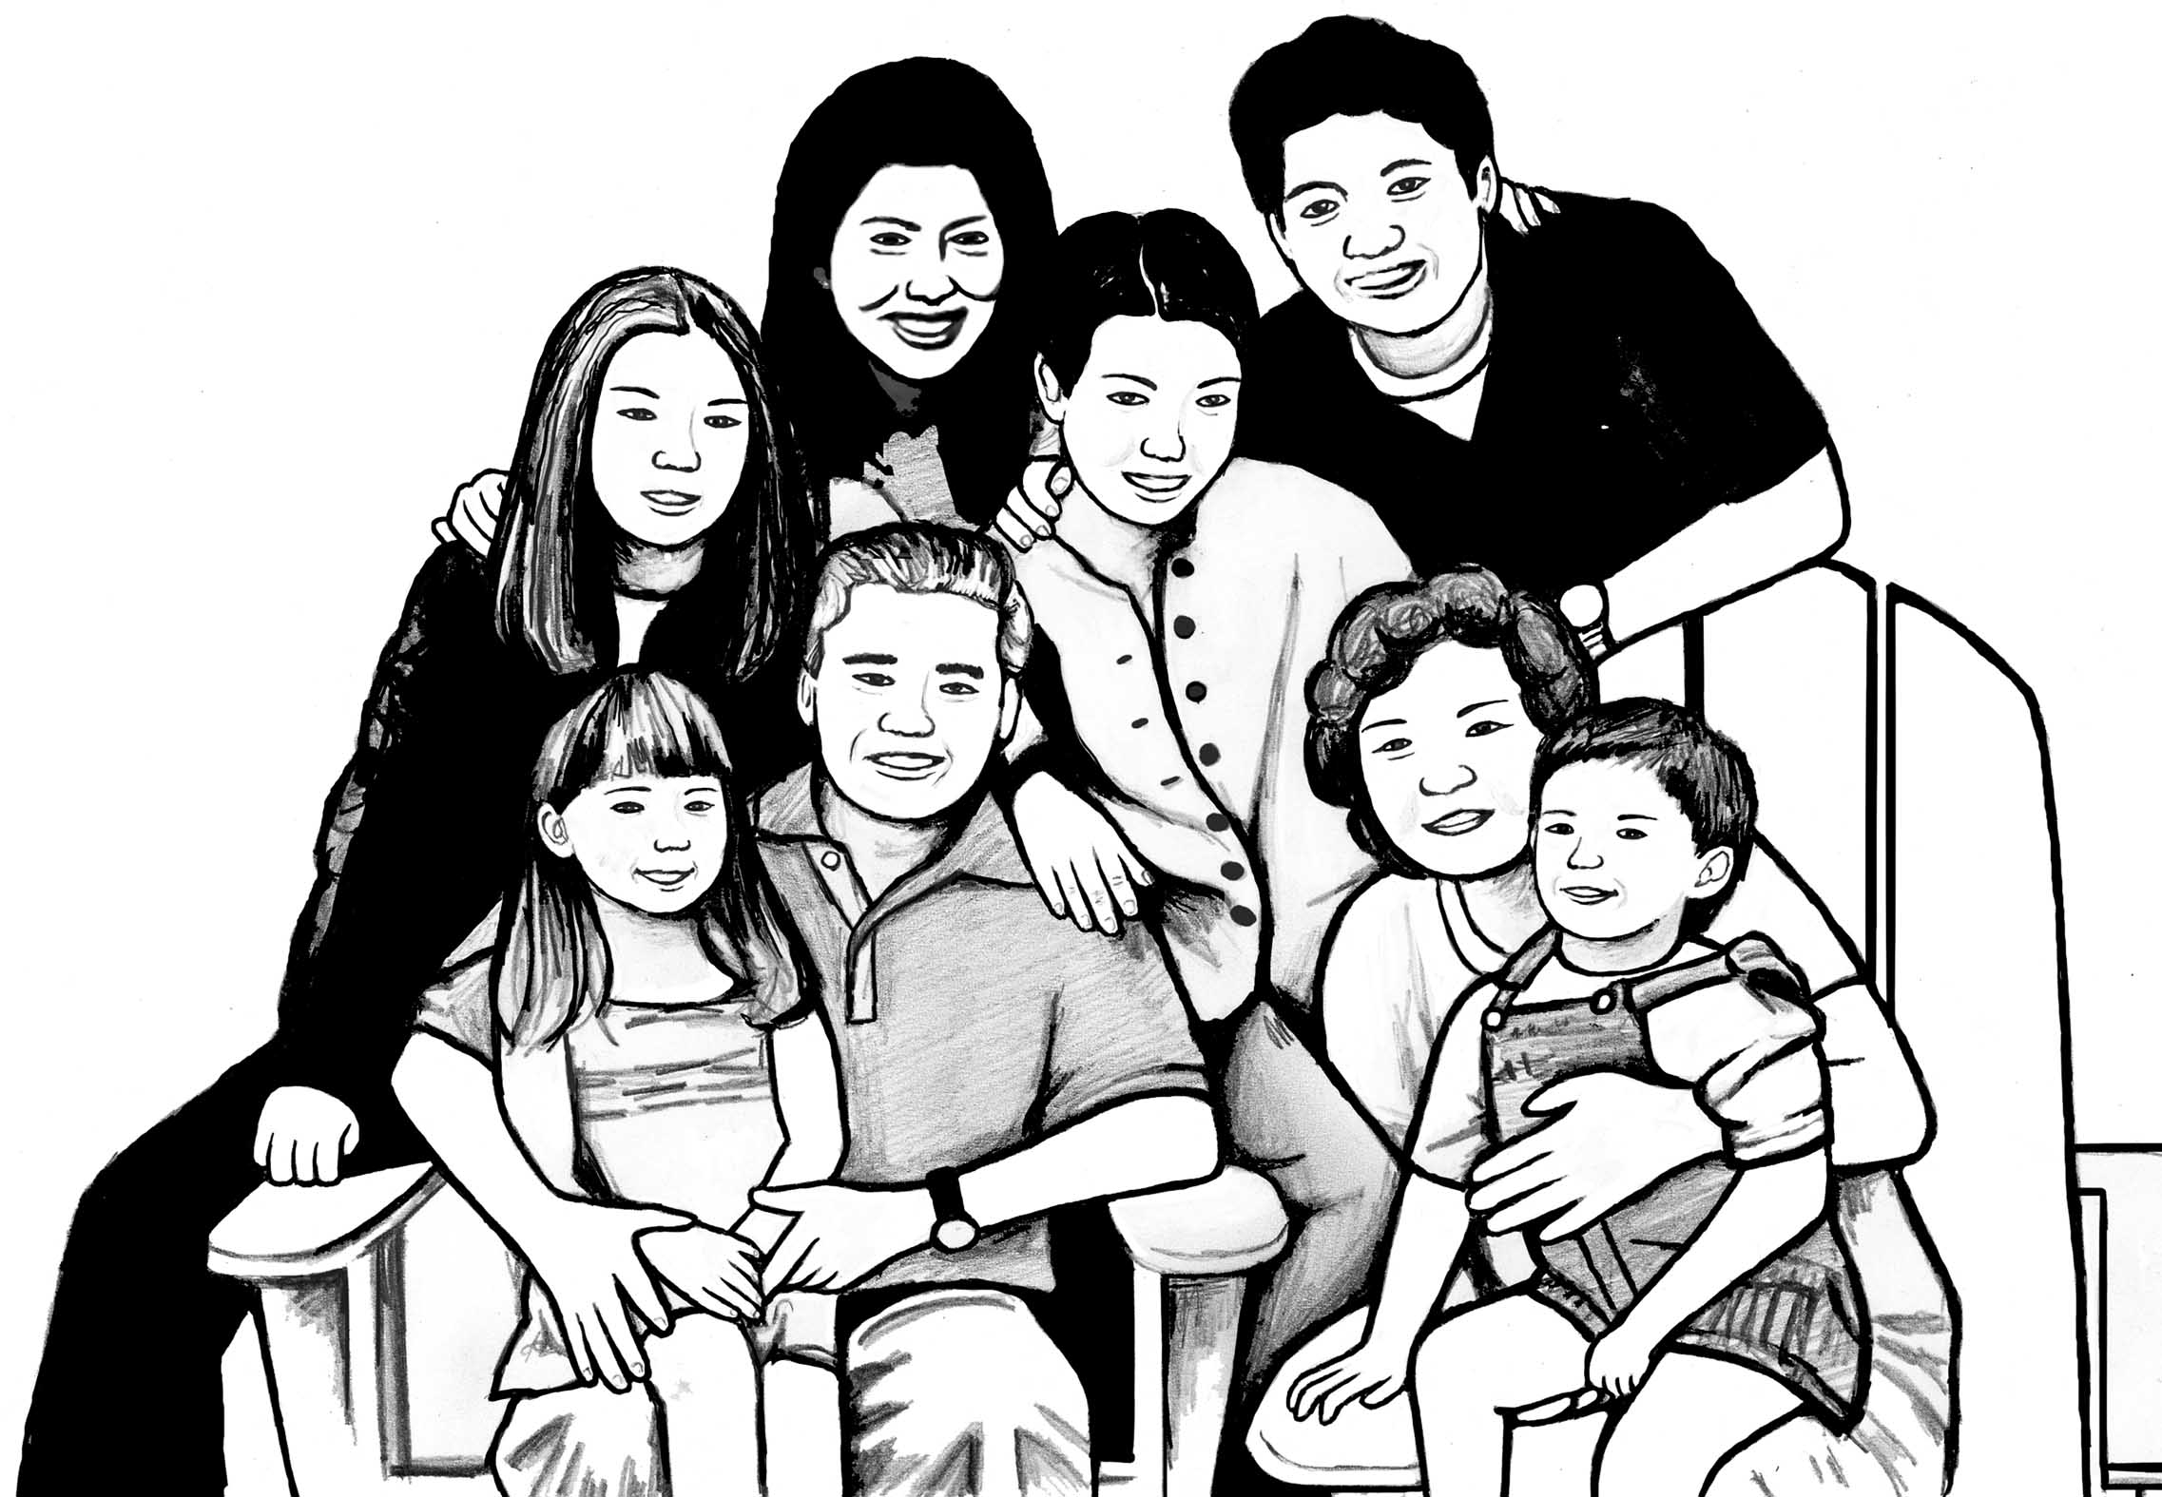

Read the family description below. Who is giving the description?

I love this drawing as the whole family is in it. My mother and father are sitting down with my niece and nephew. My elder brother Jin is at the back and his wife Amy is standing at the back too. I’m standing in the middle, and my little sister Sun is next to me.

We all live in Dundee, except my sister; she’s 19 and is studying at university in St Andrews. Although I’m a year older than her I still live with my parents, in the same house that I grew up in. My brother, who is seven years older than me, lives with Amy and the kids on the other side of Dundee. My niece and nephew are great fun: Katy is four and Jay is three. Sometimes they are naughty but the majority of the time they’re as good as gold.

I suppose my family is quite small as my grandparents are no longer living and I have no other relatives here in Scotland. I have an aunt and two cousins in Korea and an uncle in the United States, but I don’t see any of them very often. We are a close family though, and we all keep in contact by letter.

Now, read Soo-Jung’s description again and answer the questions below.

1 Where do most of the family live? ________________________________

2 Who is Jin married to? _________________________________________

3 Who lives in St Andrews? _____________________________________

4 How old is Jin? ______________________________________________

5 How many grandchildren are there in the family? _____________________

6 How many cousins has Soo-Jung got in Scotland? ___________________

Activity 4

Read the sentences about Soo-Jung’s family below and put in the correct name.

- My father’s name is Gi
- My mother’s name is Min
- My sister’s name is ……………………
- My brother’s name is ………………….
- My sister-in-law’s name is …………….
- My niece’s name is ……………………
- My nephew’s name is …………………

Now, make similar sentences about your family.

…………………………………………………………………..

…………………………………………………………………..

…………………………………………………………………..

…………………………………………………………………..

…………………………………………………………………...

…………………………………………………………………..

…………………………………………………………………..

Activity 5

 Track 3

Listen to Karen. Which member of her family is she describing?

Now, listen again and answer the questions. Circle T (True) or F (False)

1 Emma is Karen’s twin T F

2 Emma’s hair and eyes are the same colour T F

3 Emma is overweight T F

4 Emma is taller than Karen T F

5 Emma is funny T F

6 Emma is hardworking T F

Activity 6

Write a short description of your family.

Think about:

- husband/wife/children
- other family members
- names
- ages
- where the family members live
- personality and physical appearance

Homework task
Find one or two photographs of your family. Bring them in to the next class. Be prepared to talk about them.

Lesson  03 | Work and studies
Lesson  03 | Current work and study situation
 |  | Task: Describing your current job and studies
Skill: speaking, listening, reading, writing

Activity 1

Look at the jobs below. Where do people do these jobs?
a chef
a cleaner
a businessman/
a businesswoman

a househusband/ a housewife

a waiter/
a waitress
unemployed

a shop assistant
a kitchen porter
a driver

a care worker
a manager
a security guard

an office worker
a hairdresser
a builder

Find out if your partner does any of the jobs above.

Ask other students in the class. Write the names of the students and the jobs.

Name Job


__________________ _________________________

__________________ _________________________

__________________ _________________________

__________________ _________________________

__________________ _________________________

Photo: (c) istockphoto.com/Aldo Murillo
Activity 2

Skim read the description below. Where does Ana work?


My name is Ana Mackenzie. I live in Dunfermline and I’m a shop assistant at Greggs, which is a bakery on the High Street. I work Monday to Saturday with one day off during the week, usually Thursday. Thankfully, I never have to work on Sundays. I start at 8.30 am and I usually finish at about 5.30 pm, depending on how busy we are. I have an hour for lunch and I normally take my break between 12 pm and 2 pm, although occasionally I have to take it later.

I do the same thing every day. Every morning we get a delivery of fresh bread, so when I arrive I help put the bread and cakes out on the shelves. During the day I have to serve the customers, so my job involves dealing with money and people, as well as food. At the end of the day, I always have to clean the shelves and cold cabinets, which is the worst thing about the job. I don’t have to wear a uniform at work but wearing an apron is very important.

Now, answer the following questions. Circle T (True) or F (False)

1 Ana works six days a week T F

2 She never takes a lunch-break after 2 pm T F

3 Her duties change every day T F

4 She works with money T F

5 Her job involves cleaning T F

6 She has to wear an apron T F

Photo: (c) istockphoto.com/Leah-Anne Thompson
Activity 3

Choose a word from the box to complete the questions about work.
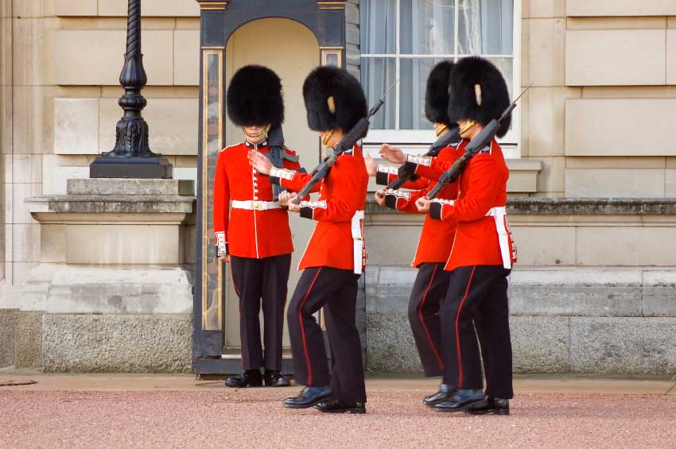

- Where do you ____________?

- What are your ____________?

- How long is your ___________? 1

- What do you have to ____________?

- Do you deal with ______________?

- Do you have to wear a ____________? 2

do hours work uniform money lunch-break

Now, ask your partner the questions about their job.

Activity 4

 Track 4

Listen to Jasmin. Is she talking about her job?

Listen again and complete the sentences below with the missing information.

1 I’m studying at _____________________

2 I’m studying ___________________ and ___________________

3 I’m doing those subjects because I want to work in a ________________

4 I’m enjoying the _____________________

5 I’m having problems with the _____________________

6 I’m finding it hard to do my _____________________

Photos: (c) istockphoto.com
1 - texasmary
2 – Jonathon Maddock
Activity 5


Look at the study questions below:

- Where are you studying at the moment?

- What subjects are you studying?

- Why are you studying?

- Are you enjoying your course?

- Are you having any problems?

- Are you finding it hard to do the homework?

Practise asking and answering these questions with a partner.

Photo: (c) istockphoto.com/Chris Schmidt
Activity 6

Read Salma’s description of her current job and studies. What’s her job and what is she studying?

She has made 10 punctuation errors. Find and correct them.

my name is salma and I am a cleaner. I work part-time for Lothian buses in edinburgh. I work three days a week, normally on Tuesday, Wednesday and Thursday. I work the night shift so I start at 10 pm and finish at 6 am. I have a thirty-minute break in the middle of my shift

In my job I have to remove rubbish from the buses and I have to clean the seats and floors. I dont have to wear a Uniform.

At the moment, I am working and studying. I am studying english at a local college. I am in the middle of a ten-week course and I am really enjoying it. i’m studying English because I need it for my job but I’m finding it difficult to concentrate in class as I’am very tired in the mornings.

Homework task
Write out Salma’s description again without the errors.

Lesson  04 | Work and studies
Lesson  04 | Past and future work and studies
 |  | Task: Describing past experiences and future plans
Skill: speaking, listening, reading, writing

Activity 1

Find out about your partner’s work experience.

Have you ever worked:

- in a bank?
- in an office?
- in a school?
- in a call-centre?
- in a hotel?
- in a hospital?
- for a transport company?
- on a building site?
- with children?
- outside?
- on a farm?

Activity 2

 Track 5



Listen to Jamie talking to his friend Adam. Has Jamie had many jobs?

Listen again and answer the questions on the next page:

Photo: (c) istockphoto.com/Ian Mcdonnell

1 Where is Jamie working at the moment? __________________

2 How many restaurants has he worked in? __________________

3 Has he ever worked in a pub? __________________

4 How old was he when he started work at the factory? ________________

5 How long did he work at the factory? __________________

6 Has he ever worked with children? __________________

Activity 3

Look at this dialogue.

A: Have you ever worked in a shop?
B: Yes, I have.
A: Really? Where did you work?

Find out about a job your partner has done.


- Have you ever worked…?

- Where did you work?

- When did you start there?

- How long did you work there?

- Did you enjoy it?

- Why did you leave?

Photo: (c) istockphoto.com/Sharon Dominick

Activity 4

What is Betty doing in the picture?
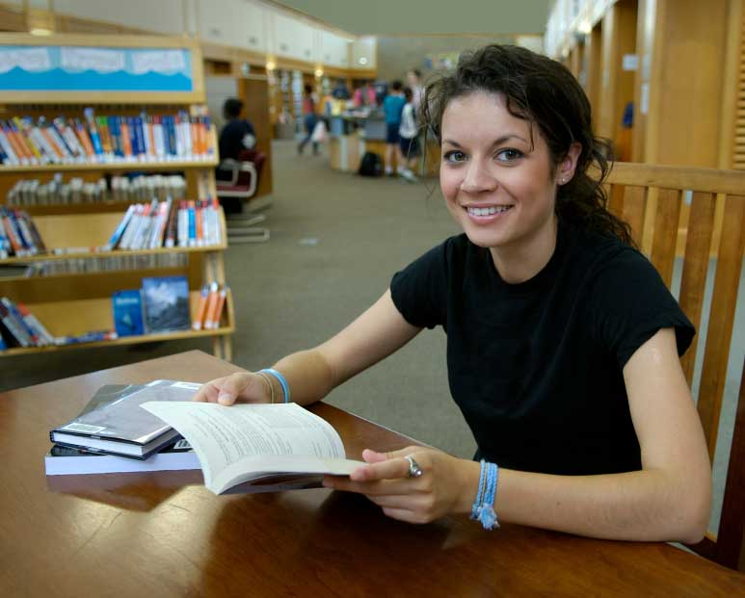

Skim read Betty’s description of her education. Is she studying now?

My education

I started school when I was five years old. I went to a school in my village and there were only nine pupils in the class. I was at primary school until I was 11 and then I went to high school. The high school was in a different town and I had to take the bus to get there. When I was 17 I took and passed my final exams and left school. I didn’t go on to university after that because I started to work in the family business, but I have always wanted to continue my education.

This September I am hoping to start a course at a local college. I want to study nursing as I would like to work in a hospital. It would be fantastic to do a job where you help people every day. I plan to study part-time so that I can continue working. I really want to start studying again so I hope I get a place on the course!

Now read the description again and answer the questions below. Circle T (True) or F (False).

1 She started high school when she was nine. T F

2 She went to university. T F

3 She worked in a hospital after finishing school. T F

4 She wants to work with ill people. T F

5 She would like to study full-time. T F

6 She doesn’t have a place on the course. T F

Photo: (c) istockphoto.com/David H Lewis
Activity 5

Look at the questions below. Are they about the past or the future?


- What would you like to study?

- Where do you want to work?

- Do you plan to continue studying English?

Ask your partner the questions.

Activity 6

Write a short text about your past education and what you would like to study in the future.

Think about your past education:

- primary school
- secondary school
- college or university
- qualifications
- favourite subjects

and your future education:

- what you want to study
- when you want to study
- part-time or full-time
- why you want to study

Homework task
Find information about a course you would like to do. Bring it into the class. Be prepared to talk about it.

Photo: (c) istockphoto.com/David H Lewis

Lesson  05 | Saying how you are
Lesson  05 | Mood and illness
 |  | Task: Describing mood and illness
Skill: speaking, listening, reading, writing

Activity 1

How are you today?

Look at the different responses to this question. Put them in the order from most happy to least happy. The first and last have been done for you.

- So-so. And you? _____
- Great thanks. And you? _1___
- Not bad thanks. And you? _____
- Terrible. And you? _7___
- Not too good. And you? _____
- Fine thanks. And you? _____
- Very well thanks. And you? _____

Find out how the students in your group are feeling today.

Activity 2

Read the dialogue below:

- How are you today?
- Not too good actually.
- Why? What’s the matter?
- I’ve got a terrible headache.

Photo: (c) istockphoto.com/ Guillermo Perales Gonzalez
What’s the matter with each person in the pictures below?

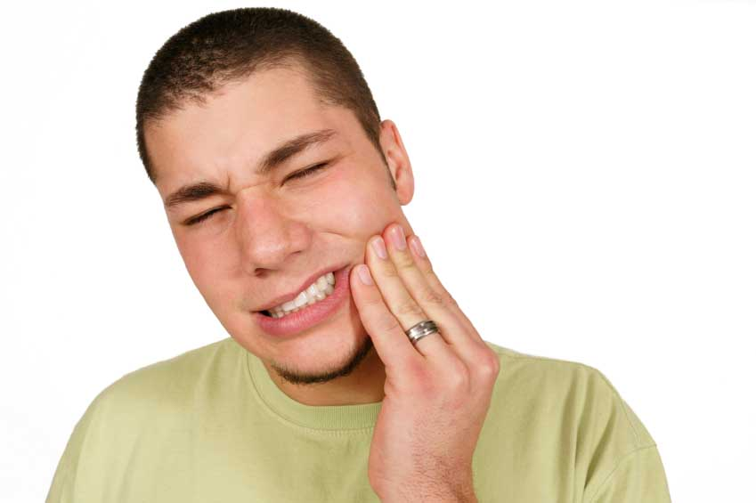


All photos (c) istockphoto.com
1, 4 – Jason Lugo
2 Steve Luker
3 Diego Cervo

1 2 3 4

Fill in the following sentences with a or — (nothing).

1 I’ve got _____ cough.
2 I’ve got _____ toothache.
3 I’ve got _____ flu.
4 I’ve got _____ temperature.
5 I’ve got _____ stomach-ache.
6 I’ve got _____ backache.
7 I’ve got _____ sore throat.
8 I’ve got _____ rash.
9 I’ve got _____ migraine.
10 I’ve got _____ nose-bleed.
11 I’ve got _____ earache.

Now, practise the dialogue at the beginning of activity 2 using the different health problems above.

Activity 3

Match the actions (1–8) with the resulting physical states (a–h).

Example: I caught a cold. My nose is blocked.

1 I ate too much. a) My toe hurts.

2 I fell over. b) I’ve lost my voice.

3 I spent too long in the sun. c) I can’t stop sneezing.

4 I sang a lot at the concert. d) I’ve got sunburn.

5 I did a lot of exercise. e) I feel sick.

6 I didn’t sleep at all. f) I’m stiff.

7 Someone stepped on my foot. g) I’m exhausted.

8 I got cat hair on my clothes. h) I’ve sprained my ankle.

Practise the dialogue in activity 2 again. Use the physical states above.



Activity 4

 Track 6

1 2
Listen to Donald and Gina talking on the phone. What’s the matter with Gina?

Listen again and write in Donald’s responses.

1 I’m not feeling very well. _______________________

2 I’ve got flu. _______________________

3 I’ve been in bed for three days _______________________

4 The whole family has got it. _______________________

5 I can’t go to the party. _______________________

Practise the dialogue with a partner.

All photos (c) istockphoto.com
1 Jon Helgason
2 Rene Jansa

Activity 5

Read the e-mail to Gina from her teacher. Why is he writing to her?

From: Iain Mills <iainmills@greenhill.ac.uk
To: Gina Ozluk <gina@hotmail.com
Subject: English class

Hi Gina

Donald told me you were ________ and that’s why you haven’t been in class for the last few days. How are you ____________ now? A lot better I hope.

Everybody in the class seems to be __________ at the moment. Please don’t worry about not being able to come to college — I think that you should stay at home until you feel 100 ____________ again. My ____________ is to stay in bed and to drink lots of water and orange juice. I also find that having hot baths with some eucalyptus oil in the water helps clear my head when I have a ____________ — you should try it.

Please let me know if you want me to send you any work to do at home.
Get __________ soon.
Iain

Read the e-mail again and fill in the gaps with words below:

wellcoldsickper cent

betterilladvicefeeling

Activity 6

Your friend has a bad back. Write a short e-mail to:

- ask how he/she is
- offer advice
- ask if he/she needs anything.

Homework task
Finish the e-mail from activity 6.

Lesson  06 | Likes and dislikes
Lesson  06 | Food and activities
 |  | Task: Describing preferences
Skill: speaking, listening, reading, writing

Activity 1


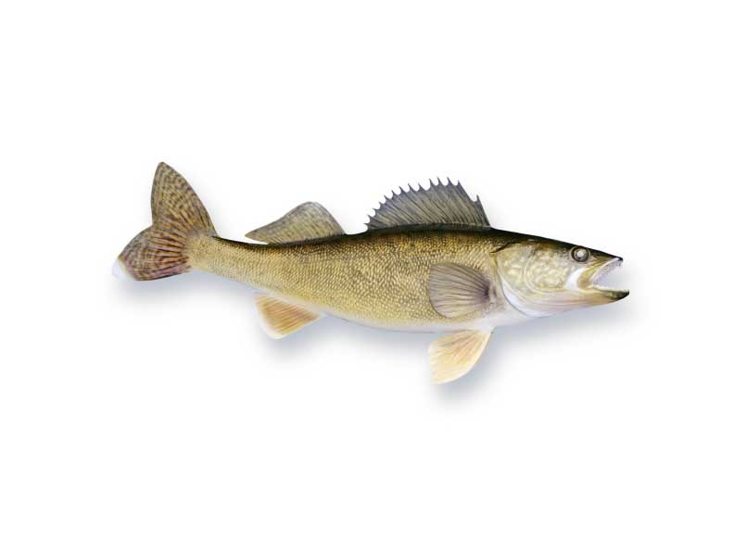

Look at the types of food and drink below. Tell your partner how you feel about them.


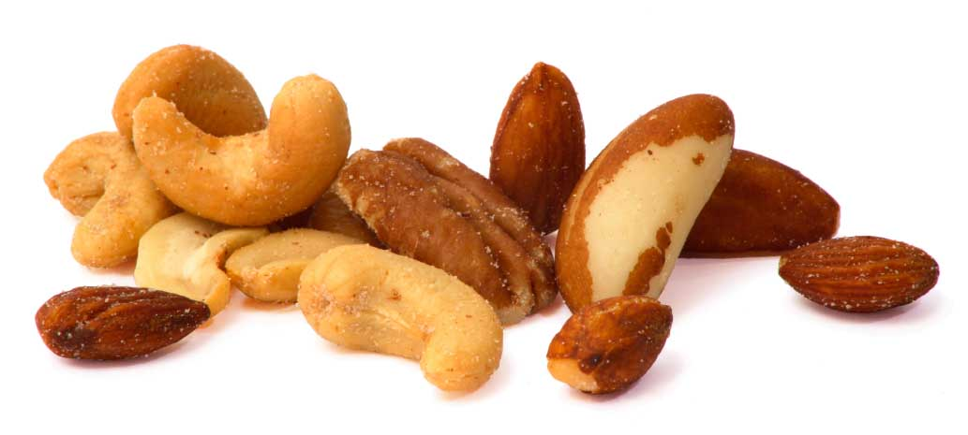

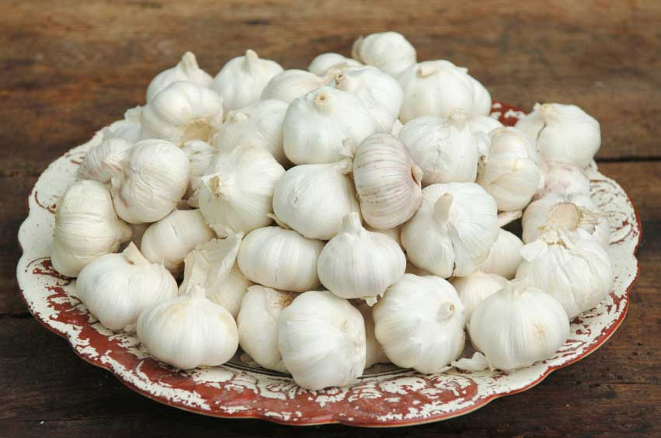

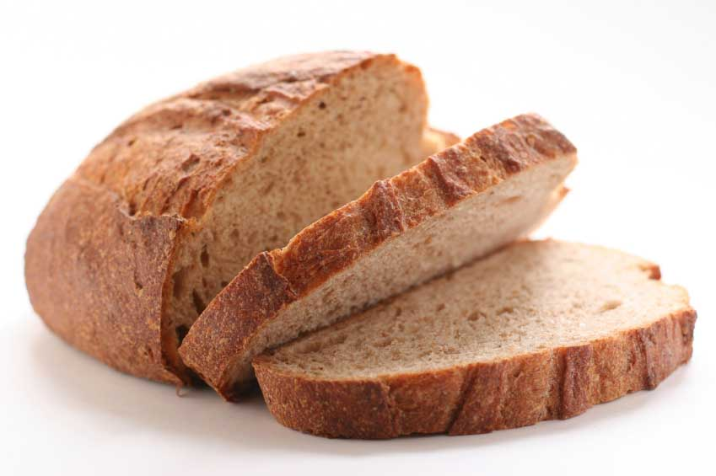

1 2 3 4 5
6 7 8 9 10

Use:

- I adore …

- I love …

- I like …

- I don’t mind …

- I don’t like …

- I hate …

- I can’t stand …

All photos: (c) istockphoto.com
1 – Firina 2 – Chris Elwell 3 Denis Pepin 4 George Peters 5 Andrew Dernie 6 Michael Blackburn 7 Kjell Brynildsen 8 Jim Jurica 9 Benjamin Brandt 10 Thomas Perkins
Activity 2

 Track 7

Listen to Jenna and Harvinder’s conversation. Where are they?

Now, listen again and fill out the table below.

Food/drink Jenna likes | Food/drink Harvinder likes
Food/drink Jenna doesn’t like | Food/drink Harvinder doesn’t like

Activity 3

Your friend offers you something to eat:

- Would you like a biscuit?

- Do you want an apple?

- Do you fancy some rice?

When do we need to use a, an and some?

Finish the offers and requests below using the food and drinks in the box.

pasta pear ice-cream sandwich
cheese egg bread sugar
orange milk chocolate salt

- Would you like ………………………………………………..?

- Do you want ….………………………………………………?

- Do you fancy …………………………………………………?

- Can I have …………………………………………………….?

- Could I have …………………………………………………..?

- May I have …………………………………………………….?

Look at the dialogues below.

- Would you like a cup of tea?
- No, thanks, I’m not thirsty.

- Do you want a biscuit?
- Yes, please, I’m starving.

- Could I have a sandwich?
- No, sorry, there’s no bread.

What other reasons could you give for saying ‘yes’ or ‘no’?

With a partner, practise making offers and requests using the food in the box — respond ‘yes’ or ‘no’ giving reasons for your answer.

Activity 4
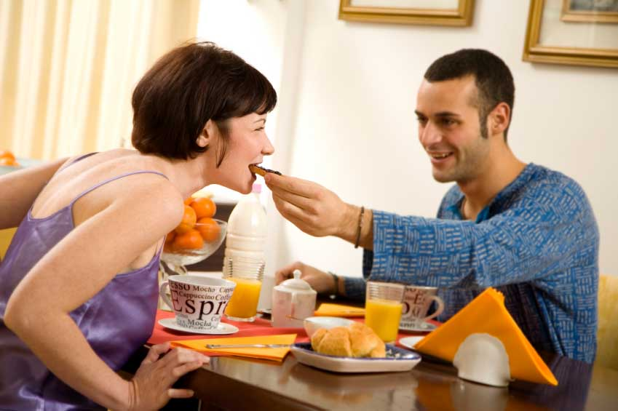
Read the text below. Does Crawford prefer eating out or eating at home?

My favourite thing in the whole world is spending time in the kitchen! I love preparing meals for friends and family and I enjoy baking too. I like making cakes and biscuits at the weekend because I find it very relaxing. I often make two different cakes on a Sunday afternoon. I don’t like clearing up afterwards though and I can’t stand washing up; it’s so boring!

Although I prefer eating at home I like going out for meals too. My favourite restaurant is a fantastic curry house, which is just at the end of my road. The food is really tasty, the service is great and the atmosphere is very relaxed; they don’t mind people spending hours at the table chatting over dessert and coffee. When we go, we often stay until they close.

In general, I’m not a fussy eater and I like most savoury and sweet foods. Pudding is definitely the best bit of the meal though. When we have dinner parties I really like making rich puddings with chocolate and cream. Everybody loves eating them, especially my chocolate mousse!

Now, read the text again and answer the following questions.

1 Why does he like baking? _________________________________

2 What does he hate doing? _________________________________

3 Is his favourite restaurant close to his house? __________________

4 Is it a problem if people spend a long time at the restaurant? __________

5 Are there a lot of foods he doesn’t like? _______________________

6 Does he prefer sweet or savoury foods? ______________________

Photo: (c) istockphoto.com/diego cerves


Activity 5

What activities do you like doing?

- I love ………………………………………………

- I like ………………………………………………. 1

- I enjoy ……………………………………………..

- I don’t mind ……………………………………….

- I don’t like …………………………………………. 2


- I hate ……………………………………………….

- I can’t stand ……………………………………….

3

Compare your likes and dislikes with a partner.

Activity 6

Think about your English class.

What do you like about it and what don’t you like about it?



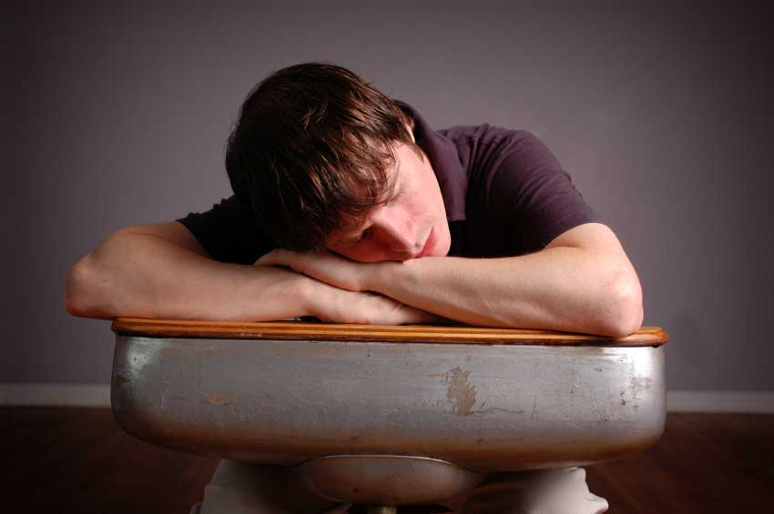
4 5 6 7

Write a short description of your class likes and dislikes.

Homework task
Finish the writing from activity 6.

All photos (c) istockphoto.com
1 – Jeffrey Smith 2 Jasmin Awad 3 Andres Peiro 4 Chris Schmidt 5 Lisa Klumpp 6 Franklin Lugenbeel 7 Rosemarie Gearheart

Lesson  07 | Review
Lesson  07 | Personal identity
 |  | Task: Revision: lessons 1–6
Skill: speaking, listening, reading, writing

Activity 1

Look at the prompts in the box. With a partner, create a question for each one.

surname age date-of-birth country of origin

nationality languages marital status children

time in Scotland job home telephone number

Now, ask your teacher the questions.

Activity 2

 Track 8

Look at the pictures of the Lamunu family. Which family members can you see?

Carl
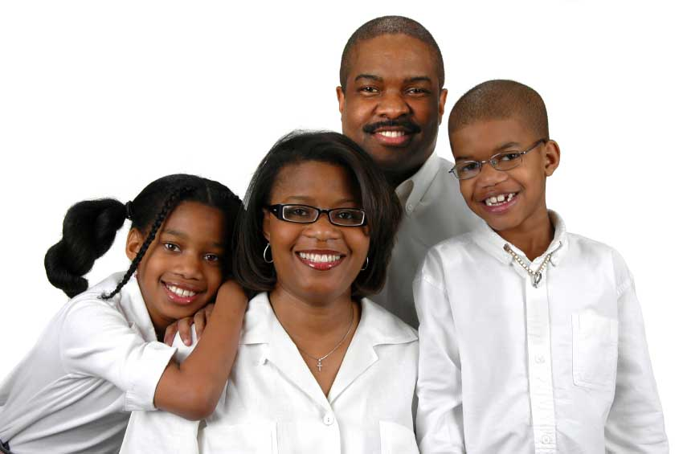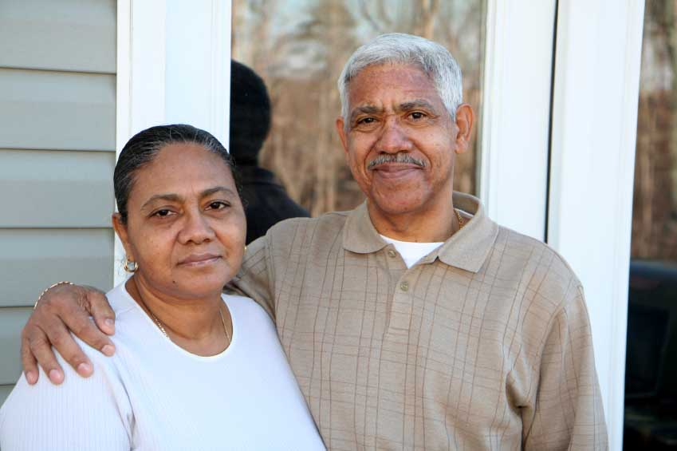

Patricia
Leoni
Otis
Ella
Jack

Carl

All photos: (c) istockphoto.com
(left) – Gino Santa Maria
(right) - lihlexmom
Ella
Jack

Listen first time. Where do the family live?

Listen again and fill in the chart below.

 | Age | Occupation | Likes | Dislikes
Jack
Ella
Carl
Otis
Patricia
Leoni

Activity 3

Look at the chart again. Are the sentences below true or false? Circle T (True) or F (False).

1 Patricia is older than Carl T F
1
2 Leoni is a good student T F

3 Carl works in an office T F


4 Otis is Patricia’s father in law. T F

5 Ella doesn’t work T F

6 Jack is Leoni’s younger brother T F
2

All photos: (c) istockphoto.com
1 – Olivier le Moal 2 YinYang
Activity 4

Read Carl’s description of his work and studies. How many jobs has Carl had?


I love working as a postman. It is a great job for me because I enjoy working outside and I like being active. Every day feels different and I really enjoy talking to the different people I meet in the street. I don’t really like delivering letters when it is raining a lot, but otherwise I think it is the best job I’ve ever had.

I’ve had a couple of other jobs. When I was at college I worked as a shop assistant and then, when I finished studying, I worked as an administrative assistant for a firm of accountants. I hated working in an office though, so that’s why I decided to become a postman, even though my college course was in business administration. Changing profession was the best thing I have ever done.

At the moment, I’m not studying anything but I’d really like to learn another language. I love travelling so I’m thinking about joining a Spanish evening course. I thought about studying Chinese but in the end I changed my mind; I think it’s too hard for me!

Now, read the description again and answer the following questions.

1 Does Carl like working in the street? __________________________

2 What doesn’t he like about his job? ___________________________

3 When did he work as a shop assistant? ________________________

4 What job did he do in an office? _____________________________

5 What did he study at college? ________________________________

6 What does he want to study in the future? ______________________

Photo: (c) istockphoto.com/Joshua Blake
Activity 5



Think about what you like and dislike about your job.

1 2

Tell your partner using the expressions below.

- I love …
- I like/enjoy …
- I don’t mind …
- I don’t like/dislike …
- I hate …
- I can’t stand …

Activity 6

Your teacher has organised a pen-pal letter writing exchange.

Write a short letter to introduce yourself to your new pen-friend.


Include information about:

- basic personal details
- family
- work
- studies
- likes and dislikes
3

Homework task
Finish the letter from activity 6.

All photos: (c) istockphoto.com
1 – Roger Lecuyer 2 - Tomasz Trojanowski 3 – Dean Sanderson
Lesson  08 | Daily routine
Lesson  08 | Activities and times
 |  | Task: Describing what you do every day
Skill: speaking, listening, reading, writing

Activity 1



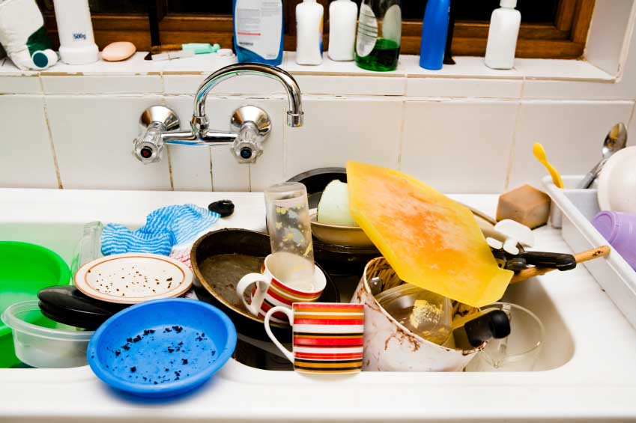
Think of three things that you normally have to do:

- in the morning
- in the afternoon
- in the evening.
1 2 3
Find out what your partner normally has to do at those times.

Activity 2

 Track 9

Look at the list of things that Barbara does on a typical day. Barbara does 16 things, but they are not in the right order. Put them in the correct order, starting with number 1. Some have already been done for you.
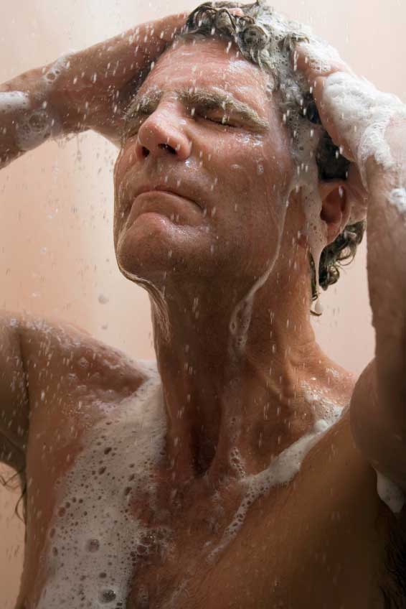
- have a shower ____
- go to bed _16_ ………………
- have lunch ____ ………………
- watch tv ____
- have breakfast ____ ……………… 4
- go to work ____ ………………
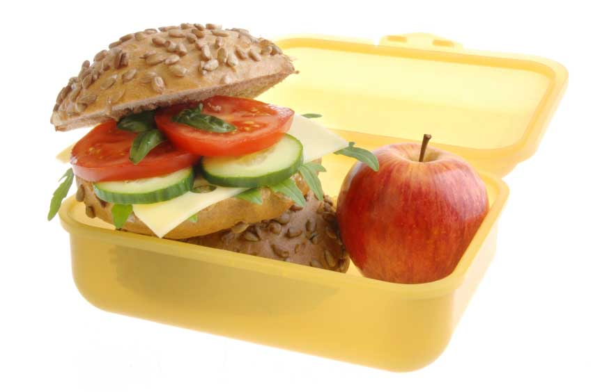
- get home ____ ………………
- read the newspaper _5__
- have dinner ____
- get dressed ____
- start work ____ ……………… 5

- start work again ____ ………………
- finish work ____ ………………
- relax _12_
- make dinner ____ ………………
- get up _1__ ………………
6
Listen to Barbara describe her day. Check your order is correct. Now, listen again for the times. Write them on the dotted lines.

All photos: (c) istockphoto.com
1 – Rene Mansi; 2 – Joselito Briones; 3 – Don Bayley; 4 – Christine Glade; 5 – Maartje van Caspel; 6 – Diane Diederich
Activity 3

Think about what you do on a typical weekday.

Your partner is going to interview you about your day using the following questions.

- What’s the first thing you do after getting up?

- What do you do after that?

- What do you do next?

- Then what do you do?

- What do you do after …ing?

- What do you do later on?

- What’s the last thing you do before going to bed?

Respond appropriately to complete the statements below.

- After getting up I …

- After that I …

- Next I …

- Then I …

- After …ing I …

- Later on I …

- Before going to bed I …

Tell your group about your partner’s day.

Remember to use the linking words and the third person.
Activity 4

Read about Tariq’s daily routine. What is his favourite time of the week?


On weekdays, I always get up at 7 am because I have to work, but at the weekend it’s different. I usually have a lie-in and get up at around 9 am, but if I’m really tired then I sometimes get up at
10 am or even 11 am. Going to bed is the same — at the weekend I tend to go to bed much later than during the week. On Friday and Saturday nights I often go out, so I sometimes go to bed at 2 or 3 in the morning. I can’t do that on other nights because I need to get up so early to go to work — on those nights I normally head up to bed at around 11 pm.
In the mornings I don’t have much time to relax because I have to be at work at 8 am. I always have a quick shower but I don’t often have breakfast and I never have time to read the paper before I leave the house. I often have to run for the bus, but I rarely miss it. At the weekends it’s nice to wake up slowly and to take my time doing things instead of rushing. On Saturdays and Sundays I normally have a long, leisurely breakfast whilst reading the paper — I hardly ever leave the house before midday. Weekends are great; if only they were longer!

Now, read the text again and answer the following questions.

1 What does Tariq never do?

…………………………………………………………………………………

2 What does Tariq rarely do?

…………………………………………………………………………………

3 What does Tariq sometimes do?

…………………………………………………………………………………

4 What does Tariq often do?

…………………………………………………………………………………

5 What does Tariq usually do?

…………………………………………………………………………………

6 What does Tariq always do?

…………………………………………………………………………………

Photo: (c) istockphoto.com/ tracy whiteside
Activity 5

Find out how often your partner does the activities below.

Your partner should give reasons for his/her answers. Here’s an example:

- How often do you get up before 7 am?
- I always get up before 7 am because I have an 18-month old baby.

- … get up before 7 am?
- … go to bed in the early hours of the morning

- … have breakfast in bed
- … go out in the evening
- … have a leisurely breakfast
- … watch TV in the evenings
- … read the paper
- … have a lie-in
- … make the dinner
- … have a cooked lunch 1

Activity 6

Write a description of what you do on a typical weekend.

Try to include the following linking words:
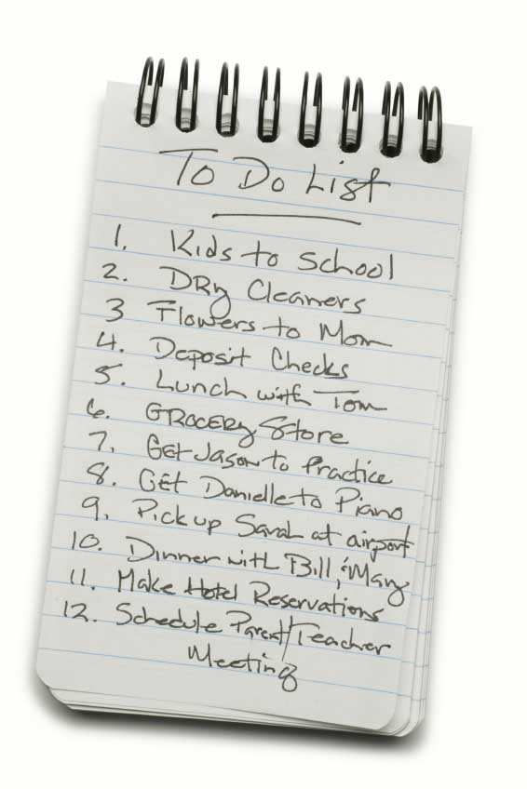
- first of all
- then
- next
- after that
- after …ing
- before …ing
- later
- finally 2

Homework task

Finish the writing activity from activity 6.

All photos (c) istockphoto.com
1 – Brian Wilke 2 – Christine Balderas

Lesson  09 | Accommodation
Lesson  09 | Your house or flat
 |  | Task: Describing where you live
Skill: speaking, listening, reading, writing

Activity 1

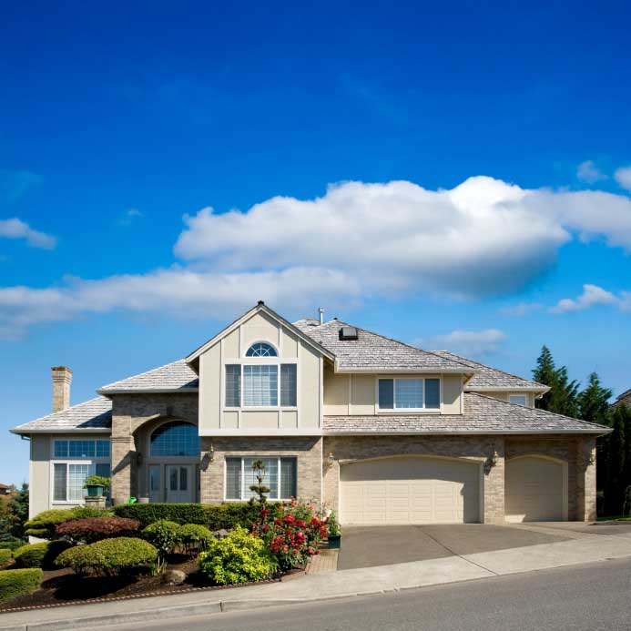
Find out where everyone in your class lives.

Your teacher will give you a map of your town. Ask each student where he/she lives and mark it on the map with a dot.

What question do you need to ask?

(c) istockphoto.com/kativ
Activity 2

Look at your map and make sentences using the stems below.

- No students live in …
- One student lives in …
- A couple of students live in …
- A few students live in …
- Several students live in …
- More than half of the students live in …
- A lot of students live in …
- Most of the students live in …
- Nearly all the students live in …
- All the students live in …

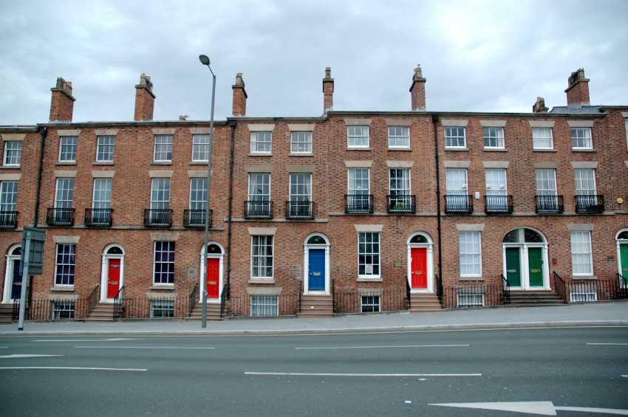

(c) istockphoto.com/Marco Prandina
Activity 3

 Track 10

Listen to Roland and Laura talk about where they live. Who is happier?

Listen again and answer the questions below.

1 Where does Roland live? ___________________________________

2 Does Roland live in a house or a flat? _________________________

3 Has Roland got a garden? __________________________________

4 How long has Roland lived there? ____________________________

5 When did Laura move to her house? __________________________

6 How many bedrooms has Laura got? __________________________

Activity 4

Look at these sentences and fill in the gaps.

How long have you lived there?

- I’ve lived there ______ six years

- I’ve lived there ______ 2001

When did you move there?

- I moved there ______ 2001

- I moved there six years ______

Make similar sentences about your house or flat.

I’ve lived in my house ________________________________

I moved into my house ________________________________
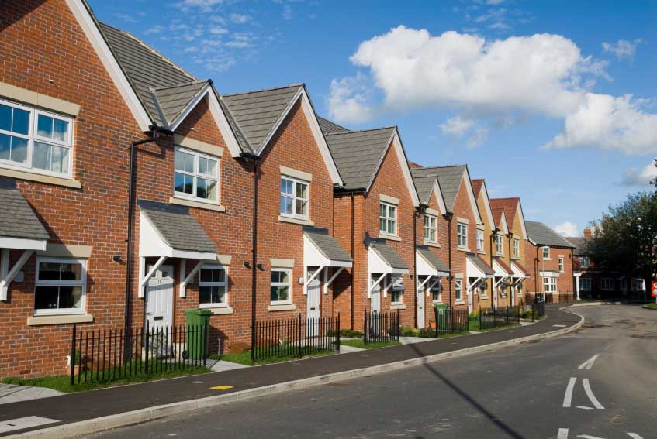
Activity 5

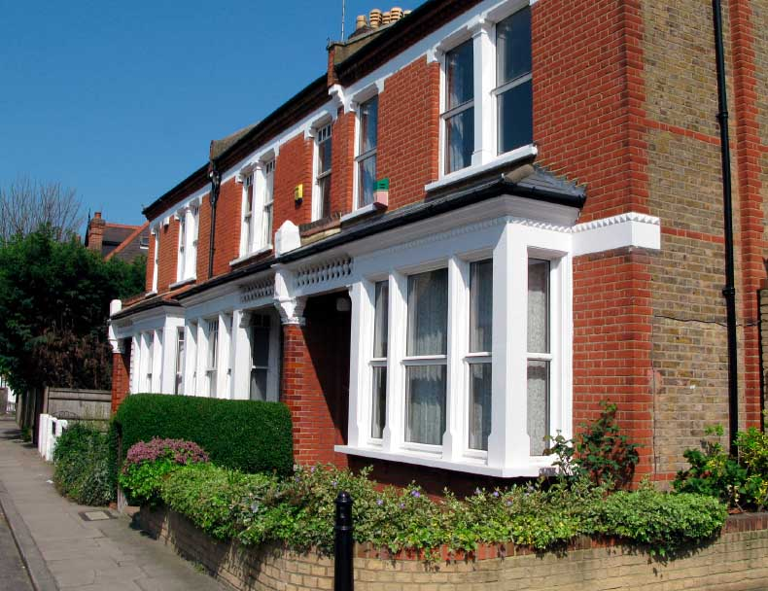
3
2
1

Find out about your partner’s home. Ask about the following:

- house or flat?
- garden?
- time there?
- moved?
- bedrooms?

Now, think of six more questions that you could ask about someone’s house.

1 …………………………………………………………………………………

2 …………………………………………………………………………………

3 …………………………………………………………………………………

4 …………………………………………………………………………………

5 …………………………………………………………………………………

6 …………………………………………………………………………………

Ask a different partner about their home, and include these six new questions.

All photos (c) istockphoto.com
1 – Owen Price
2 – Jarek Szymanski
3 – Margaret Cooper
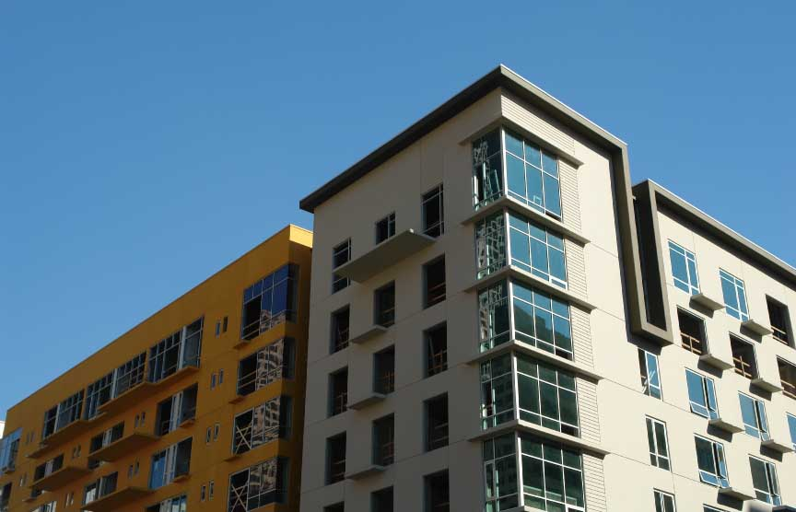
Activity 6

Read about Jason’s flat.
Is it a big flat or a small flat?

I live in a flat in the suburbs of Aberdeen. It is a second floor flat and I have access to a shared garden. My flat has one bedroom, a kitchen, a living room, a bathroom and a hallway. It is pretty small but I live alone so it isn’t too much of a problem.

The bedroom is probably the biggest room in the house. There is a king-size bed and a large double wardrobe, plus a chest of drawers, a bedside table and an armchair. It’s a nice room because it’s south facing.

My living room is a bit small but it’s also south facing and it has very large windows, which is great. I don’t have a dining room so I have a small table and two chairs in the living room, which is where I eat. There is also a sofa, a bookshelf and a television.

The smallest room is the kitchen. It’s tiny! There’s only enough room for one person at a time and there’s no room for a dishwasher or a microwave.

The bathroom is a little bit bigger than the kitchen and has everything I need. It doesn’t have a bath but I prefer showers anyway, so that’s not a problem.

In general, I like my flat but I’d like a bigger kitchen.

Now, read the description again and answer the following questions. Circle T (True) or F (False)

1 He doesn’t have his own garden. T F

2 He lives with his partner. T F

3 His bedroom gets a lot of light. T F

4 The living room is the biggest room in the house. T F

5 He has a table and chairs in the dining room. T F

6 The bathroom is smaller than the kitchen. T F

Photo: (c) istockphoto.com/tom young

Activity 7
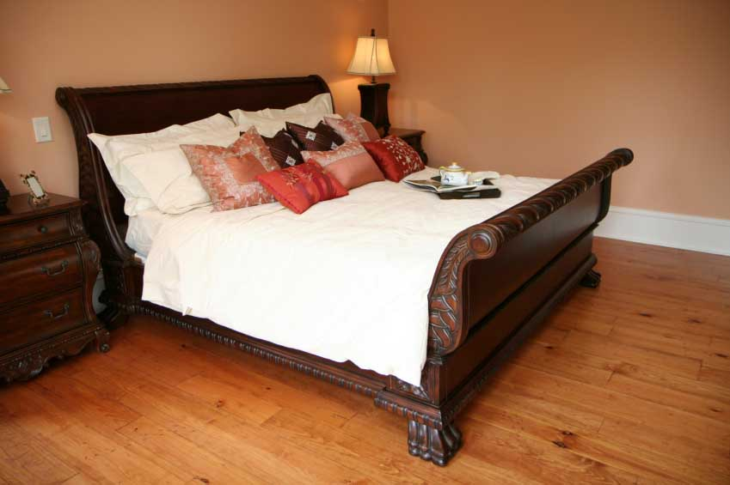
Write a description of your house or flat. Include:

- type of home
- location
- size
- number of rooms
- sizes of rooms
- furniture
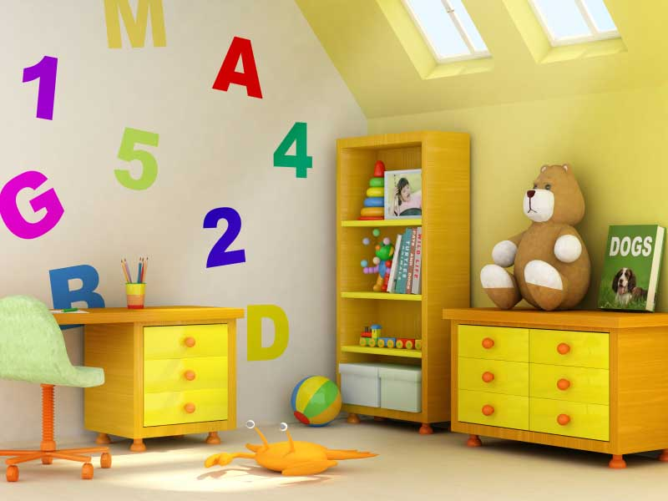
- your opinion of it.

___________________________________

___________________________________

___________________________________
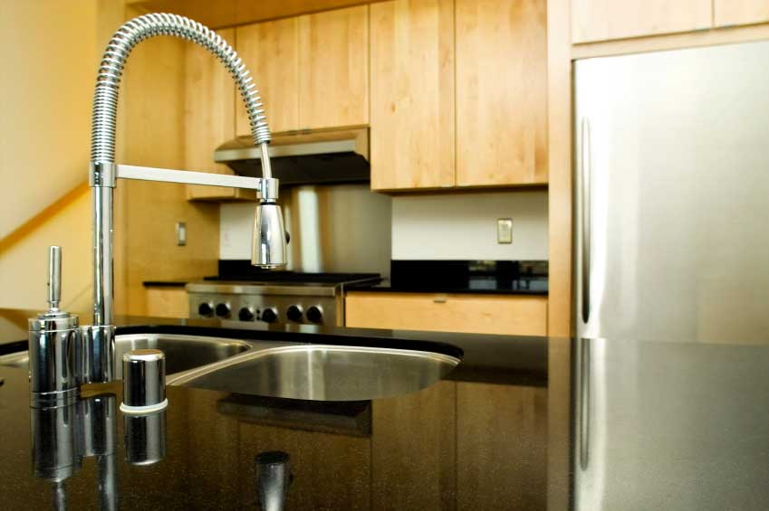
___________________________________

___________________________________

___________________________________

___________________________________

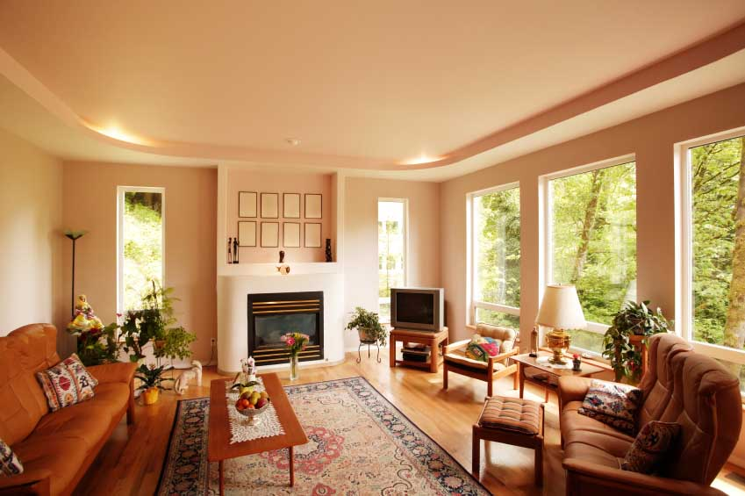
___________________________________

___________________________________

___________________________________

___________________________________

___________________________________

___________________________________

___________________________________
All photos (c) istockphoto.com
1 – lijlexmom
2 – Galina Barskaya
3 – Justin Horrocks
4 – Justin Horrocks

Homework task

Finish your description from Activity 6.

