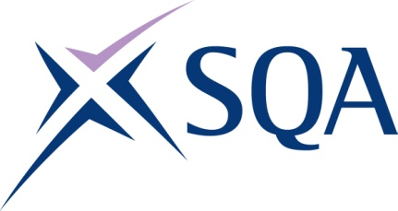

GA1K 23 SVQ 3 Leakage Control at SCQF Level 6 - Structure
To attain the qualification candidates must complete 6 Units in total. This comprises:
- 5 Mandatory Units
- 1 Optional Unit

Please note the table below shows the SSC identification codes listed alongside the corresponding SQA Unit codes. It is important that the SQA Unit codes are used in all your recording documentation and when your results are communicated to SQA.

Mandatory Units: Candidates must complete 5 Units
SQA code | SSC code | Title | SCQF level | SCQF credits
FA8G 04 | LD&C1 | Ensure Your Own Actions Reduce Risks to Health and Safety | 5 | 8
FA8L 04 | LD&C11 | Evaluate Data to Identify Potential Leakage | 6 | 7
FA8A 04 | LD&C4 | Determine Leakage Detection Methods and Techniques in Response to Water Loss | 6 | 9
FA9R 04 | LD&C5 | Programme, Deploy and Collect Data from Data-logging Equipment | 6 | 9
FC07 04 | LD&C6 | Utilise and Confirm Performance of Measuring Equipment on the Distribution Network | 6 | 9

Optional Units: Candidates must complete 1 Unit
SQA code | SSC code | Title | SCQF level | SCQF credits
FA9V 04 | LD&C12 (MSC B5) | Provide Leadership for your Team | 6 | 9
FA8K 04 | LD&C10 | Establish the Integrity of a Discrete Area on the Distribution Network | 6 | 6
FA82 04 | LD&C7 | Carry Out Step-testing Operations and Re-commission the Distribution Network | 6 | 9
FC01 04 | LD&C8 | Resolve Leakage-related Issues with Customers | 5 | 5

