Lowden parking arrangements - visitor information
There are parking restrictions around SQA’s Dalkeith/Lowden office.
Visitors to SQA must not block access to other units in Shawfair Business Park. Nor should they park in other car parks within Shawfair Business Park.
We do have parking but during peak periods the car park is often full by early morning. As such, we suggest that visitors make use of the alternative transport available.
Bike
We have cycle racks and shower/changing facilities too.
Bus
Lothian Regional Transport buses: 48, X48 and 49
First Bus: 86, 86A and X86
Departures from bus stop on Princes Street opposite Waverley Bridge or from North Bridge. Journey time is approximately 30 minutes. Alight at Shawfair Park and Ride which is adjacent to Lowden.
Train station pickups
A pick-up service operates between Waverley Station and Lowden.
Call Lowden Reception on 0345 213 6885 to book or cancel a reservation. All bookings must be made by 3pm the day before.
Where: Outside Jurys Inn on Jeffrey Street
When: 8:45 am and 9:30 am (Mon to Fri)
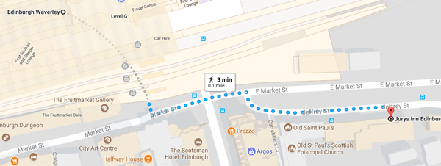
Return transport: 3.00 pm, 4.00 pm and 5.00 pm can be requested by using the taxi request form at reception.
Evening taxis can be provided but please give at least one hour notice and as much notice as possible if you need to cancel.

