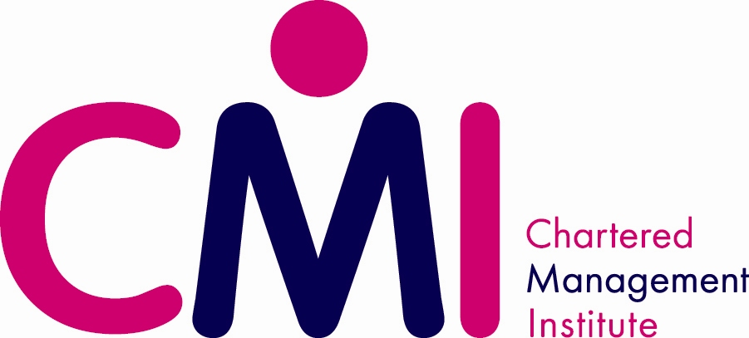
SQA Learners – Accessing CMI Membership

This document explains how SQA learners can access their complimentary (for 12 months) CMI Membership

- Log on to www.managers.org.uk/sqa

- Click on the link at the base of the screen circled below
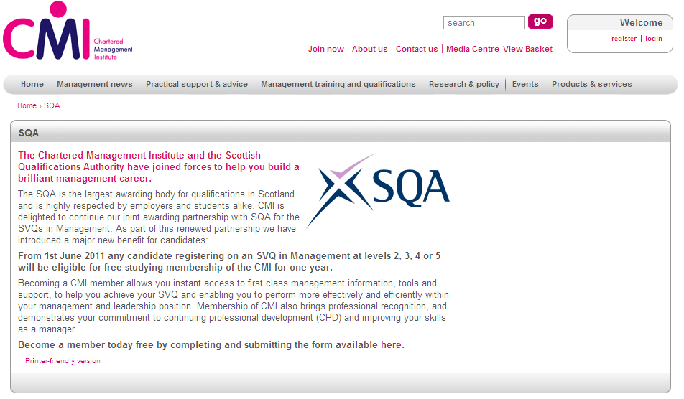

- Complete the form that appears with all requested details:

- Click Submit

CMI will send a welcome email to the learner within 3 working days.

