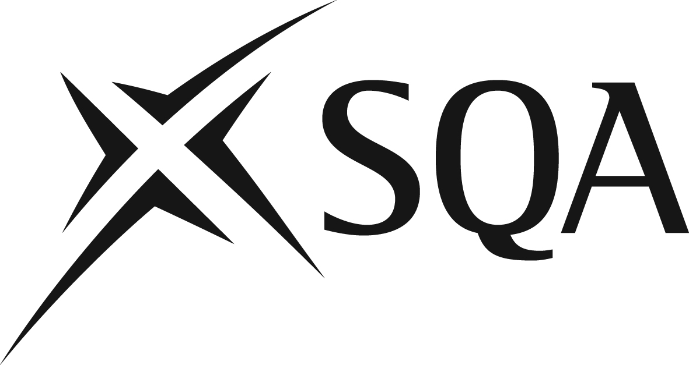

National Qualifications 2024
Advanced Higher Modern Studies

Alternative titles for dissertations
Part of the external assessment for Advanced Higher Modern Studies requires candidates to submit a project–dissertation. Candidates can research a complex, contemporary political or social issue of their choice. This may be related to areas within the mandatory content of the course but candidates are free to research any complex, contemporary political or social issue that relates to Advanced Higher Modern Studies. A list of approved titles is available on the subject page of SQA’s website. Where candidates devise an alternative title, centres may submit titles for feedback. This service is advisory in nature.

Such proposals must be submitted to SQA via the Dissertation mailbox (dissertation@sqa.org.uk) by 1 December 2023.

Centre name: |  |  | Centre number:
Scottish
Candidate Number:
Candidate name:

Proposed title/overall question/hypothesis

Aims that will be used to answer proposed title/overall question/hypothesis

Aims

Teacher or lecturer responsible: |  | Date:
SQA Co-ordinator: |  | Date:

For official use

Examiner’s comments

