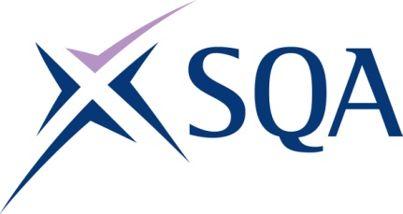
Group Award Title: SVQ in Emergency Services: Contact and Control Operations
(SCQF level 7)
Group Award Code: GV4G 23
SCQF overall credit: Minimum: 69 Maximum: 90
To attain the qualification, candidates must complete a total of six units. This consists of:

- four mandatory units and
- two optional units

Please note the table below shows the SSC identification codes listed alongside the corresponding SQA unit codes. It is important that SQA unit codes are used in all your recording documentation, and when your results are communicated to SQA.

Mandatory units: Candidates must complete all four units:
SQA code | SSC code | Title | SCQF  level | SCQF  credits | SQA  credits
J6SN 04 | SFJHA203 | Manage Personal Development and Reflect on Current Practice | 7 | 8 | 1
J6SV 04 | SFJAB101 | Communicate Effectively with Callers to Emergency Services | 7 | 15 | 1
J6SW 04 | SFJCD201 | Respond to Emergency Service Calls | 7 | 15 | 1
J6T1 04 | SFJZH13 | Operate Telephony and Computerised Systems for Emergency Services | 6 | 18 | 1

Optional group: Candidates must select and complete two optional units:
SQA code | SSC code | Title | SCQF  level | SCQF  credits | SQA  credits
HA4W 04 | SFJZC5 | Provide Information and Advice Using the Telephone | 7 | 9 | 1
J6SX 04 | SFJCD202 | Assess, Prioritise and Manage Emergency Service Calls | 7 | 15 | 1
J6SY 04 | SFJCD203 | Deploy Resources to Respond to Emergency Situations and Incidents | 7 | 19 | 1
HA55 04 | LSIAG12 | Liaise with other Services | 7 | 12 | 1
J81L 04 | SFJCCDF1.1 | Maintain the Security of Data Through Your Own Actions | 6 | 7 | 1
J81N 04 | SFJ ZA9 | Work Within Your Business Environment | 6 | 8 | 1
HC82 04 | PROHSS1 | Make Sure Your Own Actions Reduce Risks to Health and Safety | 5 | 8 | 1
HD6R 04 | SFJCCBF3.1 | Develop and Sustain Effective Working with Staff from Other Agencies | 6 | 6 | 1

Template version: December 2022.

