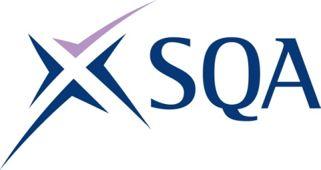
Group Award Title: Diploma in Engineering: Engineering Technical Support at SCQF level 7
Group Award Code: GV30 47
SCQF overall credit: Minimum: 151 Maximum: 191
To attain the qualification, candidates must complete 6 units. This consists of:

- 3 Mandatory units
- 3 Optional units

Please note the table below shows the SSC identification codes listed alongside the corresponding SQA unit codes. It is important that SQA unit codes are used in all your recording documentation, and when your results are communicated to SQA.

Mandatory section (three units): Candidates must complete all three units:
SQA code | SSC code | Title | SCQF  level | SCQF  credits | SQA  credits
J7JP 47 | SDS0323 | Performing Core Engineering Activities | 7 | 37 | 1
J7JR 46 | US0194 | Developing Meta-Skills and Personal Practice | 6 | 5 | 1
J7JS 47 | SDS0329 | Understanding the Importance of Environmental Good Practice and Sustainability | 7 | 12 | 1

Optional group:

Candidates must complete a further two units from Group A plus one further unit from Group A or Group B (Total: six units)

Group A:
SQA code | SSC code | Title | SCQF  level | SCQF  credits | SQA  credits
J7KV 47 | SDS0312 | Contributing to Design-Led Solutions | 7 | 48 | 1
J7JY 47 | SDS0317 | Inspecting and Testing Engineering Assets | 7 | 45 | 1
J7KW 47 | SDS0325 | Producing Engineering Drawings and Models Using Design Software | 7 | 44 | 1
J7KL 47 | SDS0311 | Conducting Quality Control | 7 | 41 | 1

Group B:
SQA code | SSC code | Title | SCQF  level | SCQF  credits | SQA  credits
J7K5 48 | SDS007 | Applying Methods and Principles in Project Management | 8 | 12 | 1
J7K0 47 | SDS0318 | Installing Engineering Assets | 7 | 38 | 1
J7K1 47 | SDS0310 | Commissioning Engineering Assets | 7 | 38 | 1
J7K2 47 | SDS0314 | Decommissioning Engineering Assets | 7 | 36 | 1
J7JX 47 | SDS0327 | Replacing Engineering Assets | 7 | 42 | 1
J7KG 47 | SDS0328 | Starting Up Engineering Processes | 7 | 37 | 1
J7KH 47 | SDS0313 | Controlling Engineering Processes | 7 | 43 | 1
J7KJ 47 | SDS0309 | Closing Down Engineering Processes | 7 | 33 | 1
J7KD 48 | SDS188 | Providing Effective Leadership | 8 | 16 | 1

