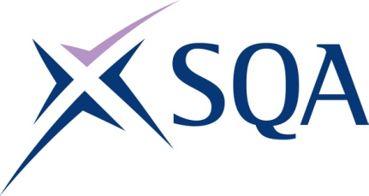

Group Award Title: Diploma in Digital Technology: Cyber Security at SCQF level 8

Group Award Code: GT8Y 48

SCQF overall credit: Minimum: 78 Maximum: 80
To attain the qualification, candidates must complete 8 Units. This consists of:

- all seven mandatory units.
- at least one optional unit.

Please note the table below shows the SSC identification codes listed alongside the corresponding SQA unit codes. It is important that SQA unit codes are used in all your recording documentation, and when your results are communicated to SQA.

Mandatory units: All seven units required
SQA code | SSC code | Title | SCQF  level | SCQF  credits | SQA  credits
J6VC 48 | SDS 187 | Supporting Digital Business Transformation | 8 | 9 | 1.5
J6TS 48 | SDS 007 | Applying Methods and Principles in Project Management | 8 | 12 | 2
J6V0 48 | SDS 012 | Developing Meta-Skills and Personal Professionalism | 8 | 16 | 2.5
J6TT 47 | SDS 029 | Contributing to Cyber Security Risk Assessment and Risk Management | 7 | 7 | 1
J6TV 48 | SDS 014 | Contributing to Intrusion Detection Activities | 8 | 9 | 1.5
J6V9 48 | SDS 027 | Providing Incident Management and Response | 8 | 9 | 1.5
J6VD 47 | SDS 028 | Supporting Security Audit and Compliance Checking | 7 | 8 | 1.25

Optional units:
Optional Group: At least one required
SQA code | SSC code | Title | SCQF  level | SCQF  credits | SQA  credits
J6TX 48 | SDS 017 | Delivering Threat Intelligence | 8 | 9 | 1.5
J6TW 48 | SDS 015 | Contributing to Scoping and Implementing Security Testing | 8 | 8 | 1.25
J6V5 48 | SDS 023 | Maintaining Security Operations | 8 | 10 | 1.75
J6V7 49 | SDS 025 | Performing Digital Forensic Analysis | 9 | 10 | 1.75

