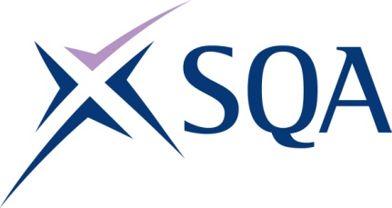

Group Award Title: Diploma in Digital Technology: Data Analytics at SCQF level 8

Group Award Code: GT90 48

SCQF overall credit: Minimum: 85 Maximum: 93
To attain the qualification, candidates must complete:

- all 9 mandatory units.

Candidates can also complete the additional non-compulsory unit should they wish to.

Please note the table below shows the SSC identification codes listed alongside the corresponding SQA unit codes. It is important that SQA unit codes are used in all your recording documentation, and when your results are communicated to SQA.

Mandatory units: Total of nine mandatory units required
SQA code | SSC code | Title | SCQF  level | SCQF  credits | SQA  credits
J6VC 48 | SDS 187 | Supporting Digital Business Transformation | 8 | 9 | 1.5
J6TS 48 | SDS 007 | Applying Methods and Principles in Project Management | 8 | 12 | 2
J6V0 48 | SDS 012 | Developing Meta-Skills and Personal Professionalism | 8 | 16 | 2.5
J6V6 47 | SDS 024 | Managing Data Assets | 7 | 8 | 1.25
J6V8 48 | SDS 026 | Planning Data Analysis | 8 | 7 | 1
J6V4 47 | SDS 022 | Locating and Accessing Data Sources | 7 | 6 | 1
J6VE 48 | SDS 032 | Transforming Data for Analysis | 8 | 8 | 1.25
J6TR 48 | SDS 013 | Analysing Data | 8 | 11 | 1.75
J6VF 47 | SDS 016 | Visualising and Communicating Data | 7 | 8 | 1.25

Additional unit:
Additional unit (non-compulsory):
SQA code | SSC code | Title | SCQF  level | SCQF  credits | SQA  credits
J6V2 48 | SDS 020 | Implementing Machine Learning Models | 8 | 8 | 1.25

