Higher Modern Languages

Assignment—writing

Assessment task

This document provides information for teachers and lecturers about the coursework component of this course in terms of the skills, knowledge and understanding that are assessed. It must be read in conjunction with the course specification.

Valid from session 2019–20 and until further notice.

The information in this publication may be reproduced in support of SQA qualifications only on a non-commercial basis. If it is reproduced, SQA must be clearly acknowledged as the source. If it is to be reproduced for any other purpose, written permission must be obtained from permissions@sqa.org.uk.

This edition: October 2019 (version 1.1)

© Scottish Qualifications Authority 2019

Contents

Introduction 1

Instructions for teachers and lecturers 2

Marking instructions 12

Instructions for candidates 13

Introduction
This document contains instructions for teachers, lecturers and candidates for the Higher Modern Languages assignment—writing. It must be read in conjunction with the course specification.

This assignment—writing has 20 marks out of a total of 120 marks available for the course assessment.

This is one of five course assessment components. The other components are question papers covering reading, writing, and listening, and a performance—talking.

The instructions for candidates can be printed and shared with candidates.

Candidates produce a piece of writing of 200–250 words in the modern language
(260–330 Chinese characters) using detailed and complex language. The piece of writing is based on one of the following contexts: society, learning, employability, culture. Candidates may refer to other contexts in their writing if they wish.

Instructions for teachers and lecturers
This section provides teachers and lecturers with:

- an outline of the assignment—writing feedback process
- examples of how to apply a writing improvement code to candidates’ drafts during the process of the assignment—writing
- examples of stimuli for the assignment—writing
- a template for the production of centre-devised writing stimuli

This must be read in conjunction with the ‘Course assessment structure’ section for the assignment—writing in the course specification.

Assignment—writing feedback process
Feedback on writing is part of normal class activities and has a crucial role to play in the production of the assignment—writing.

The writing improvement code, exemplified here, illustrates an example of how to feed back to candidates. Teachers and lecturers may adapt it to suit the individual needs of the candidates.

The purpose of a writing improvement code is to facilitate feedback to candidates on a draft piece of writing in the modern language, in order to highlight points for remediation. The aim is to encourage candidates to work out what they can improve in their writing and to develop their understanding of how the modern language works.

Teachers and lecturers should encourage candidates to look for the correct language using their reference materials and/or in discussion with their teacher or lecturer.

Teachers and lecturers do not have to apply an improvement code to writing drafts if candidates are used to other feedback methods for improving writing.

The following example list of codes is not exhaustive.

Example of a writing improvement code

Code | Meaning
^ | omission/something missing
aa | adjectival agreement/problem with agreement of the adjective(s)
acc | accent missing
ap | adjectival position/problem with position of adjective(s)
dict | dictionary/wrong word
ew | extra word/words not required
g | gender
gr | grammar problem/incorrect grammar
mv | missing verb
mw | missing word
np | new paragraph
ns | new sentence
prep | preposition to check
punct | punctuation
rep | repetition
s? (text underlined) | not making sense
sg/pl | singular/plural
sp | spelling
struct | structure — incorrect or does not exist
t | tense
ve | verb ending
vt | wrong verb tense
wo | word order
ww | wrong word

Examples of applying a writing improvement code to candidates’
assignment—writing

Example 1
Spanish — Society

Stimulus: The only way to stay healthy is by doing sport every day. Do you agree?

You could discuss what sports you do and what the benefits are. You could also mention other ways of staying fit and why this might be difficult. You could also include any other relevant information.

Write 200–250 words in Spanish to express your views and opinions. Give reasons for your opinions and draw any appropriate conclusions.

Candidate draft returned with improvement code applied by the teacher
or lecturer:
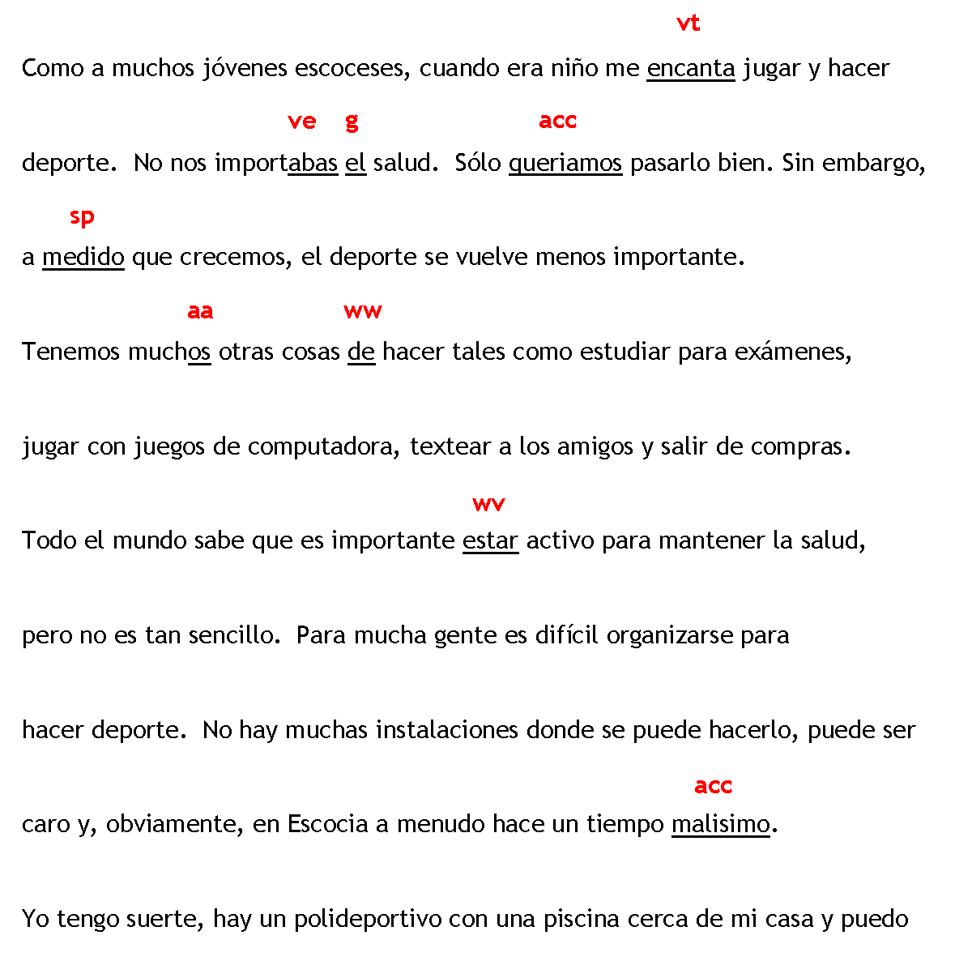

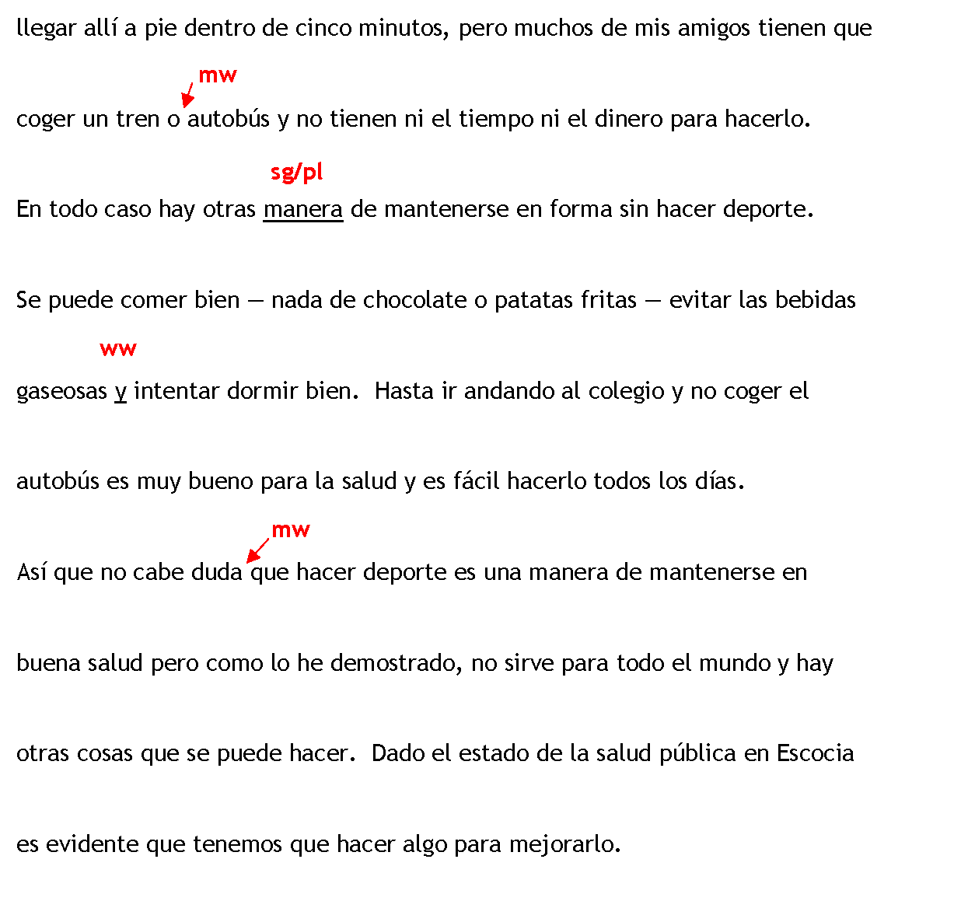

Example 2
French — Employability

Stimulus: There is nothing more stressful than a job interview. Discuss.

You could discuss what experiences you have of interviews, if any. You could also mention which aspects it is important to prepare for and why. You could include any other relevant information.

Write 200–250 words in French to express your views. Give reasons for your opinions and draw any appropriate conclusions.

Candidate draft returned with improvement code applied by the teacher
or lecturer:
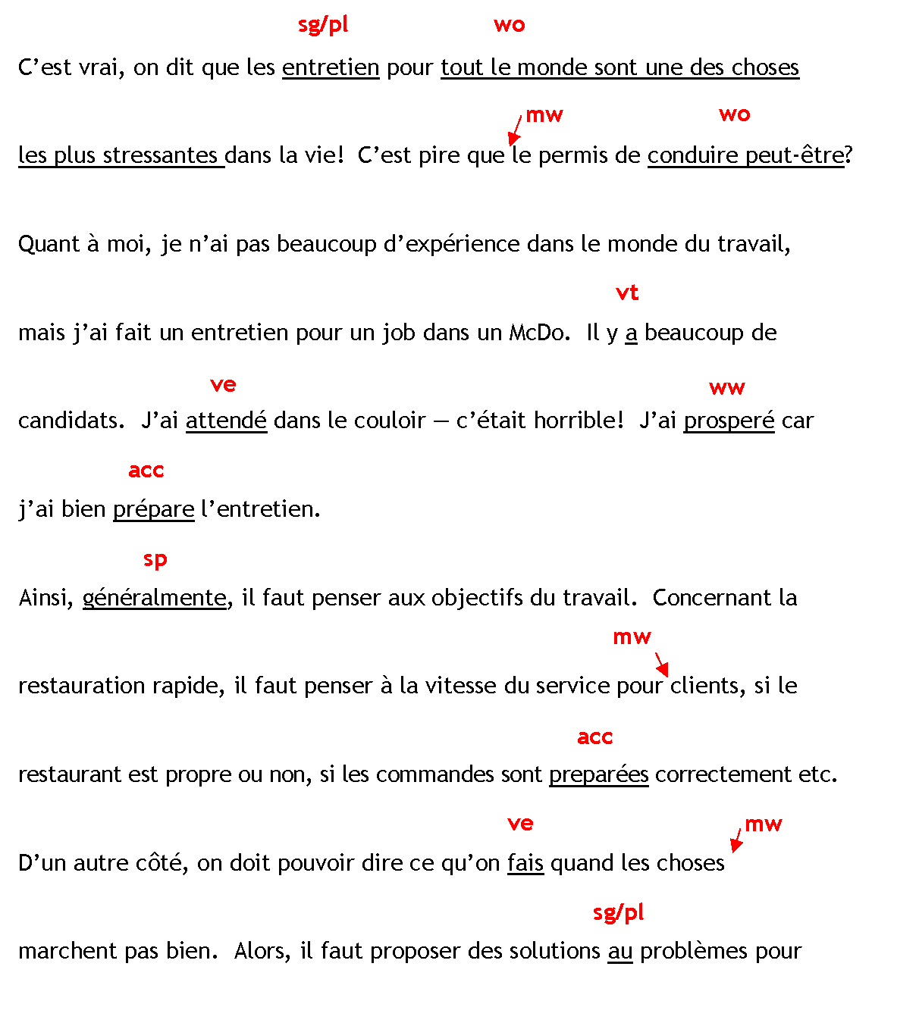
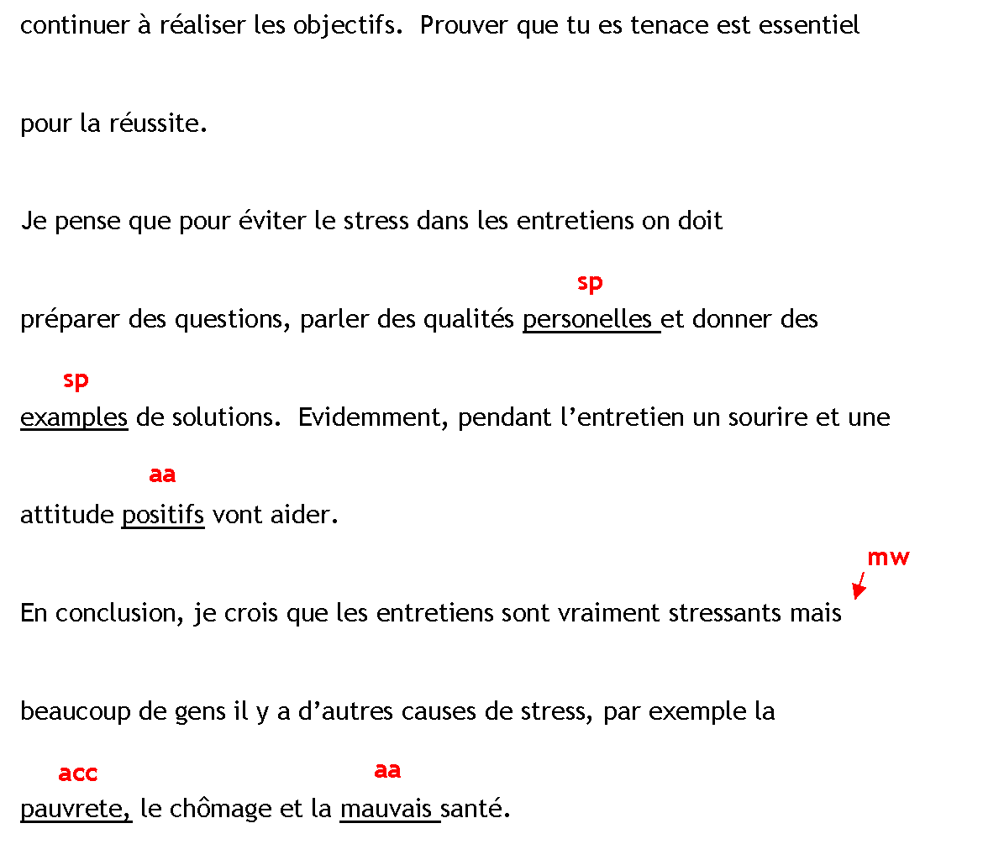

Examples of stimuli for the assignment—writing
Below are 12 examples of assignment—writing stimuli, three on each of the contexts of society, learning, employability, culture.

Candidates are to write 200–250 words (260–330 Chinese characters) in the modern language.

Society

Young people depend too much on their parents for money. Do you agree?

You could discuss the attitudes of young people towards money. For example you could consider the advantages and disadvantages of part-time jobs versus pocket money. You could also discuss how young people choose to spend their money.

Good friends are more important than family. Do you agree?

You could discuss the importance of friends and what they mean to you. You could also set out the advantages and disadvantages of different relationships. You could mention whether friends are reliable, and when being with friends is better than with family and
vice versa.

The dangers of smoking are not obvious enough. Do you agree?

You could discuss different opinions on smoking and other drugs, including alcohol. For example do young people have enough information on the harmful effects? You might also want to discuss why young people smoke or take drugs.

Learning

School days are the best days of your life! Do you agree?

You could discuss different ideas and opinions on whether young people are generally happy in school. You could include what aspects young people like or dislike and what might be done to improve their learning experience, if anything.

Everyone should have a chance to go to university. What do you think?

You could discuss different viewpoints on why this should or should not be the case. You could mention if you think school and/or university prepares you well for life and why or why not. You could discuss advantages and disadvantages of working or further study after you leave school.

There is more to school than passing exams. Do you agree?

You could discuss if you and your friends think passing exams is the most important thing about going to school. What else does school do for you? For example, you might want to discuss the benefits of taking part in extra-curricular activities and the relationships you form in school.

Employability

Work experience is more important than good exam results. Discuss.

You could discuss the advantages and disadvantages of having a part-time job. How easy is it to combine working part-time and studying for your exams and/or doing your school work? Are employers more interested in qualifications or experience? You could discuss if earning money is more important than getting good exam results.

The advantages of taking a gap year outweigh the disadvantages. Do you agree?

You could discuss which types of activities are most popular during the gap year and why. You could mention the benefits and if there are any disadvantages. You could also discuss who can help finance the gap year and why a gap year will help with future career plans.

Preparation is the greatest key to success in job interviews. Discuss.

You could discuss which qualities you think employers are looking for. You could mention which aspects are important to prepare before an interview and why. How can you make a good impression during the interview? What are the dos and don’ts?

Culture

The best way to learn a language is to visit the country. Discuss.

Your school has a twinning with a school in >insert country< and you are about to go on the exchange trip. What do you think the main benefits are and why? Can you learn as much language on the internet? You could discuss what the disadvantages of such a trip might be.

Reading a book is better than watching a film. Do you agree?

Write about a book that you have read and a film that you have watched in class. Which did you prefer and why? What differences were there between them? You could discuss how each plot developed and describe the main characters. You could also mention if it is better to see things on screen or imagine them from a book.

Holidays are for doing nothing. Do you agree?

What are your holiday plans this year? What kind of holiday is your ideal holiday, for example active, beach, or sightseeing? Discuss your ideal holiday and say what the advantages and/or disadvantages are. You could also compare different types of holidays and mention why it is better and/or worse to go with your family.

Assignment—writing template for teachers and lecturers

Centres may create their own assignment—writing tasks using this template.

In the assignment—writing answer booklet, candidates must include the chosen context, the stimulus and their signature.

Society — >insert stimulus<

Insert questions/statements in English:

Write 200–250 words (260–330 Chinese characters) in >insert modern language< to express your ideas and opinions. Give reasons for your opinions and draw any appropriate conclusions.

Learning — >insert stimulus<

Insert questions/statements in English:

Write 200–250 words (260–330 Chinese characters) in >insert modern language< to express your ideas and opinions. Give reasons for your opinions and draw any appropriate conclusions.

Employability — >insert stimulus<

Insert questions/statements in English:

Write 200–250 words (260–330 Chinese characters) in >insert modern language< to express your ideas and opinions. Give reasons for your opinions and draw any appropriate conclusions.

Culture — >insert stimulus<

Insert questions/statements in English:

Write 200–250 words (260–330 Chinese characters) in >insert modern language< to express your ideas and opinions. Give reasons for your opinions and draw any appropriate conclusions.

Marking instructions
The marking instructions for the Higher Modern Languages assignment—writing are in the course specification.

Instructions for candidates
This assessment applies to the assignment—writing for Higher Modern Languages.

This assignment—writing has 20 marks out of a total of 120 marks available for the course assessment.

It assesses the following skills, knowledge and understanding:

- using detailed and complex written language, in the modern language, as part of a coursework writing task on a chosen topic
- using language accurately to convey meaning
- expressing ideas and opinions and using content relevant to the task
- demonstrating language resource and a range of vocabulary, structures and, where appropriate, tenses

Your teacher or lecturer will let you know if there are any specific conditions for doing this assessment.

In this assessment, you have to produce a piece of writing of 200–250 words in the modern language (260–330 Chinese characters), using detailed and complex language, based on one of the following contexts:

- society
- learning
- employability
- culture

Writing practice is part of normal class activities in the Higher Modern Languages course. The assignment—writing is another opportunity to do this, with this piece of writing counting towards your final grade.

The purpose of the assignment—writing is to improve your writing, and develop techniques for checking accuracy and understanding how the language works.

You produce a draft piece of writing, and aim to improve it by using the feedback and support your teacher or lecturer provides. You should aim to produce your best writing by the end of the process.

Process and degree of supervision:

- Your teacher or lecturer will tell you which reference materials you may use during the process of producing your assignment—writing.
- You produce one initial draft and one final version of your assignment—writing over a period of time.
- You produce your writing in class time under the supervision of your teacher or lecturer.
- You must not remove from the classroom any materials, including your initial draft, relating to the assignment—writing.
- You must sign the assignment—writing answer booklet to confirm the writing is your own work.
- Your school or college sends the assignment—writing to SQA for marking. There is a deadline for this, which your teacher or lecturer will give you well in advance.
- You will not be awarded any marks if you do not produce an assignment—writing in the modern language.

Main points about the assignment—writing:

- Aim to use detailed and complex language. You may want to use the language structures and vocabulary you have learned in listening and reading activities during the Higher course.
- You must write on one of the following contexts: society, learning, employability, culture.
- Your writing must be relevant to your chosen stimulus.
- You may add information from other contexts as long as it is relevant to the stimulus.
- Express your ideas and opinions, and, where applicable, express reasons for your opinions.
- Express or discuss different viewpoints and draw conclusions as appropriate.
- You will choose a stimulus in English (for example a question or statement to respond to or discuss). Your teacher or lecturer will suggest a choice of topics to write about or you may suggest a topic of your own.
- The piece of writing should be of 200–250 words in the modern language (260–330 Chinese characters).
- Your writing should be focused and structured and in paragraphs.
- Check the accuracy of your work at all stages.

Your writing will be marked in terms of three aspects:

- content
- accuracy
- language resource

You may ask your teacher or lecturer to share with you the marking instructions for the assignment—writing.
Administrative information

Published: October 2019 (version 1.1)

History of changes

Version | Description of change | Date
1.1 | Clarification to wording in the ‘Process and degree of supervision’ section. | October 2019

Note: you are advised to check SQA’s website to ensure you are using the most up-to-date version of this document.

Security and confidentiality
This document can be used by SQA approved centres for the assessment of National Courses and not for any other purpose.

© Scottish Qualifications Authority 2019

