National 5 Modern Languages

Assignment—writing

Assessment task

Valid from session 2019–20 and until further notice.

This edition: October 2019 (version 1.1)

The information in this publication may be reproduced to support SQA qualifications. This publication must not be reproduced for commercial or trade purposes. This material is for use by teachers and lecturers.

© Scottish Qualifications Authority 2019

Contents
Introduction 1
Instructions for teachers and lecturers 2
Marking instructions 12
Instructions for candidates 13

Introduction
This document contains instructions for candidates for the National 5 Modern Languages assignment—writing. It must be read in conjunction with the course specification.

This assignment—writing is worth 20 marks out of a total of 120 marks available for the course assessment.

This is one of five course assessment components. The other components are question papers covering reading, writing, and listening, and a performance—talking.

The instructions for candidates can be printed and shared with candidates.

Instructions for teachers and lecturers
This section provides teachers and lecturers with:

- an outline of the assignment—writing feedback process
- examples of how to apply a writing improvement code to candidates’ drafts during the process of assignment—writing
- examples of scenarios for the assignment—writing
- a template for the production of centre-devised writing stimuli

This should be read in conjunction with the ‘Course assessment structure’ section for the assignment—writing within the course specification.

Assignment—writing feedback process
Feedback on writing is part of normal class activities and has a crucial role to play in the production of the assignment—writing.

The writing improvement code, exemplified here, illustrates an example of how to feedback to candidates and may be adapted by teachers and lecturers to suit the individual needs of their candidates.

The purpose of a writing improvement code is to facilitate feedback to candidates on a draft piece of writing in the modern language in order to highlight points for remediation. The aim is to encourage candidates to work out what can be improved in their writing and to develop their understanding of how the modern language works.

Candidates should be encouraged to look for the correct language using their reference materials and/or in discussion with their teacher or lecturer.

Teachers and lecturers do not have to apply an improvement code to writing drafts if candidates are used to other feedback methods for improving writing.

The following example list of codes is not exhaustive.

Example of a writing improvement code

Code | Meaning
^ | omission/something missing
aa | adjectival agreement/problem with agreement of the adjective(s)
ap | adjectival position/problem with position of adjective(s)
acc | accent missing
dict | dictionary/wrong word
ew | extra word/words not required
g | gender
gr | grammar problem/incorrect grammar
np | new paragraph
ns | new sentence
mv | missing verb
mw | missing word
punct | punctuation
prep | preposition to check
rep | repetition
s? (text underlined) | not making sense
struct | structure — incorrect or does not exist
sg/pl | singular/plural
sp | spelling
t | tense
ve | verb ending
vt | wrong verb tense
wo | word order
ww | wrong word

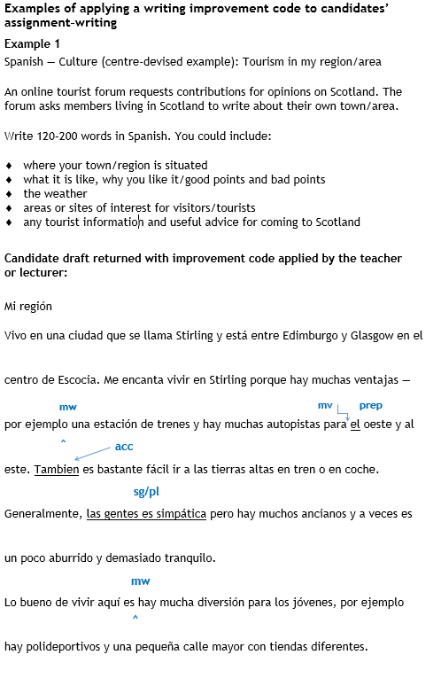

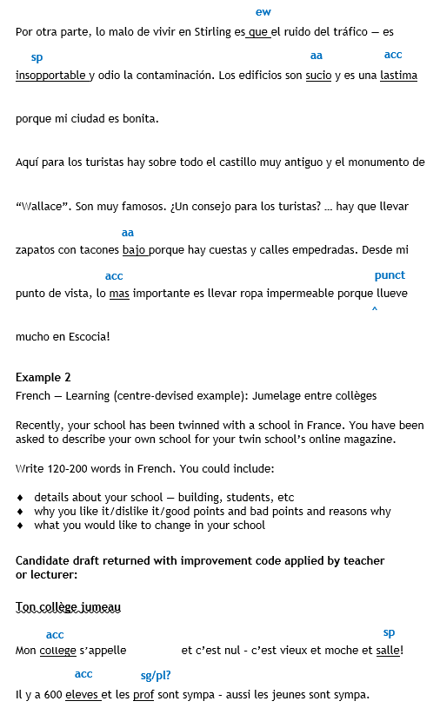

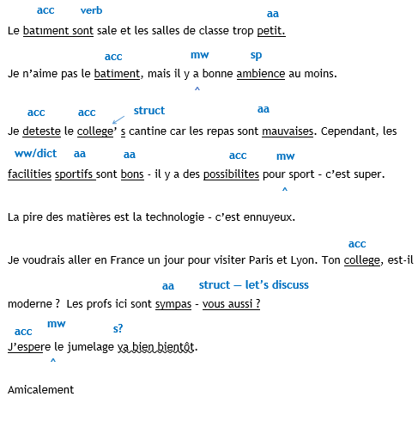

Examples of scenarios for the assignment—writing
Below are 15 examples of assignment—writing scenarios, five on each of the contexts of society, learning, and culture.

Candidates must indicate the chosen context and title and sign the assignment—writing answer booklet.

Society examples

Society — Personal profile
Write 120–200 words (150–250 Chinese characters) in >insert language<.

Your teacher has set up an e-twinning project with a school in >insert country< and you have been asked to complete a personal profile to be included on your school’s homepage.

You could include information on the following:

- >insert bullet points<

Society — My friends
Write 120–200 words (150–250 Chinese characters) in >insert language<.

Your friend in your partner school in >insert country< has asked you about your friends here in Scotland.

You could include details about:

- >insert bullet points>

Society — How I use technology
Write 120–200 words (150–250 Chinese characters) in >insert language<.

A recent email from your e-twinning classmates described how they use technology. You respond to explain how you use technology in your life in and out of school.

You could include:

- >insert bullet points>

Society — My view on mobile phones
Write 120–200 words (150–250 Chinese characters) in >insert language<.

You have been asked to write an article about mobile phones for the languages page of your school’s website.

You could include details about:

- >insert bullet points>

Society — Sports and attitudes to sport
Write 120–200 words (150–250 Chinese characters) in >insert language<.

You write an article about sport and health, in >insert language< for your online school magazine.

You could include the following:

- >insert bullet points>

Learning examples

Learning — Our school exchange
Write 120–200 words (150–250 Chinese characters) in >insert language<.

Your school is organising a visit to your partner school in >insert country<. You write to your friend in the school about the plans for the visit.

You could include some of the following information:

- >insert bullet points>

Learning — Exams, studying and free time
Write 120–200 words (150–250 Chinese characters) in >insert language<.

You have a busy year ahead and you are preparing for exams. Your twin school does not have exams at this time so you explain to your penpal what you are trying to do with your time to prepare.

You could include:

- >insert bullet points>

Learning — Our school community
Write 120–200 words (150–250 Chinese characters) in >insert language<.

Your friend in >insert country< has asked you about any links your school has with the local community.

You could include:

- >insert bullet points>

Learning — School clubs
Write 120–200 words (150–250 Chinese characters) in >insert language<.

Your friend in >insert country< has asked you about what extra-curricular activities are available in your school. You write about it.

You could include some of the following information:

- >insert bullet points>

Learning — Languages and global citizenship
Write 120–200 words (150–250 Chinese characters) in >insert language<.

You have read about how learning is organised in schools in other countries. You are to write an article on a global citizenship theme for upload as a podcast to send to your e-twinning classmates.

For example, you could include:

- >insert bullet points>

Culture examples

Culture — My holidays
Write 120–200 words (150–250 Chinese characters) in >insert language<.

You visit a >insert language< website for young people where ideas on holidays are exchanged. You write your own post in >insert language< about what kind of holiday you like.

You could use the following questions to help you write your post.

- >insert bullet points>

Culture — Television
Write 120–200 words (150–250 Chinese characters) in >insert language<.

Your friend in >insert country< has asked you about television in Scotland.

You could include information on the following:

- >insert bullet points>

Culture — Cinema and foreign films
Write 120–200 words (150–250 Chinese characters) in >insert language<.

You take part in an outing with your school to see a foreign film. You are asked to give a brief account of the film in >insert language<.

You could mention:

- >insert bullet points>

Culture — Scottish life and culture
Write 120–200 words (150–250 Chinese characters) in >insert language<.

You take part in an event about Scottish life and culture and you are to write up your findings for your exchange school in >insert language<.

You could mention:

- >insert bullet points>

Culture — A music concert
Write 120–200 words (150–250 Chinese characters) in >insert language<.

Your friend in your partner school in >insert country< has asked you about a recent concert you attended. Write in >insert language< to describe it.

You could include the following:

- >insert bullet points>

Assignment—writing template for teachers and lecturers

Centres may create their own assignment—writing tasks using this template.

Candidates must indicate the chosen context and title, and sign the assignment answer booklet.

Society — >insert title<
Write 120–200 words (150–250 Chinese characters) in >insert language<.

Insert questions/statements or bullet points in English:

Learning — >insert title<
Write 120–200 words (150–250 Chinese characters) in >insert language<.

Insert questions/statements or bullet points in English:

Culture — >insert title<
Write 120–200 words (150–250 Chinese characters) in >insert language<.

Insert questions/statements or bullet points in English:

Marking instructions
The marking instructions for the National 5 Modern Languages assignment—writing can be found in the course specification.

Instructions for candidates
This assessment applies to the assignment—writing for National 5 Modern Languages.

This assignment—writing is worth 20 marks out of a total of 120 marks available for the course assessment.

It assesses the following skills, knowledge and understanding:

- the ability to use detailed written language, in the modern language, as part of a coursework writing task on a chosen topic
- the ability to use language accurately to convey meaning
- the ability to express ideas and opinions and use content relevant to
the task
- the ability to demonstrate language resource and to employ a range of vocabulary, structures and, where appropriate, tenses

Your teacher or lecturer will let you know how the assessment will be carried out and any required conditions for doing it.

In this assessment, you have to produce a piece of writing of 120–200 words in the modern language (150–250 Chinese characters), using detailed language, based on one of the following contexts:

- society
- learning
- culture

Writing practice is part of normal class activities in the National 5 Modern Languages course. The assignment—writing is another opportunity to do this, with this piece of writing counting towards your final grade.

The purpose of the assignment—writing is to improve your writing, and develop techniques for checking accuracy and understanding how the language works.

You produce a draft piece of writing and aim to improve it by using the feedback and support provided by your teacher or lecturer. You should aim to produce your best writing by the end of the process.

Process and degree of supervision:

- Your teacher or lecturer will tell you which reference materials you may use during the process of producing your assignment—writing.
- You produce one initial draft and one final version of your assignment—writing over a period of time.
- You produce your writing in class time under the supervision of your teacher or lecturer.
- You must not remove from the classroom any materials, including your initial draft, relating to the assignment—writing.
- You must sign your work to confirm the assignment—writing is your
own work.
- Your school or college will send the assignment—writing to SQA for marking. There will be a deadline for this, which you will be given well in advance.
- You will not be awarded any marks if you do not produce an assignment—writing in the modern language.

Main points about the assignment—writing:

- You should aim to use detailed language. You may want to use the language structures and vocabulary you have learned in listening and reading activities in the National 5 course.
- You will write on one of the following contexts: society, learning, culture.
- You should express your ideas and opinions.
- You will choose a topic stimulus in English (bullet points to write about or questions/statements to respond to) and the content of your writing should be relevant to the context and title. Your teacher or lecturer will suggest a choice of topics to write about or you may suggest a context/topic of
your own.
- You do not have to cover all the bullet points, and you may add other information as long as it is relevant to the title.
- The piece of writing should be of 120–200 words in the modern language (150–250 Chinese characters).
- Your writing should be focused and structured and you should write
in paragraphs.
- You should check the accuracy of your work at all stages.

Your writing will be marked in terms of three aspects:

- content
- accuracy
- language resource

You may ask your teacher or lecturer to share with you the marking instructions for the assignment—writing.

Administrative information

Published: October 2019 (version 1.1)

History of changes

Version | Description of change | Date
1.1 | Clarification to wording in the ‘Process and degree of supervision’ section. | October 2019

Security and confidentiality
This document can be used by practitioners in SQA approved centres for the assessment of National Courses and not for any other purpose.

Copyright
This document may be reproduced in whole or in part for assessment purposes provided that no profit is derived from reproduction and that, if reproduced in part, the source is acknowledged. If it needs to be reproduced for any purpose other than assessment, it is the centre’s responsibility to obtain copyright clearance.

Re-use for alternative purposes without the necessary copyright clearance may constitute copyright infringement.

© Scottish Qualifications Authority 2019

