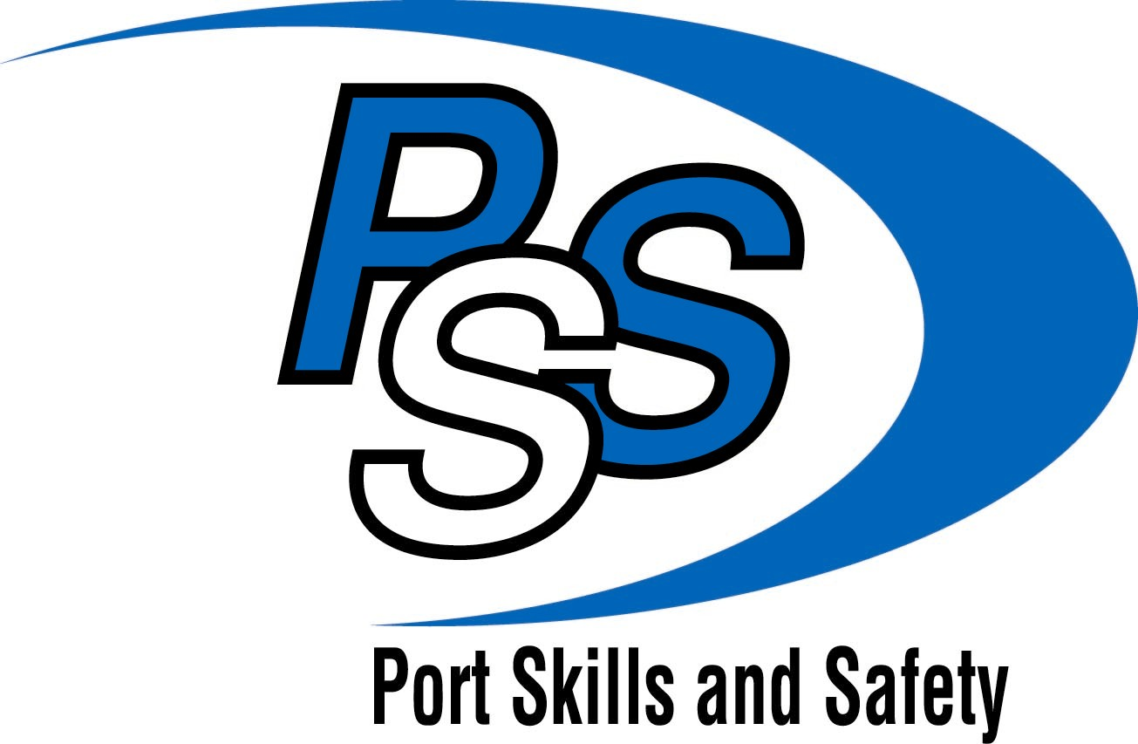

Assessment Strategy for NVQs

Port Operations
and
Supervision of Port and Maritime Operations

February 2014

Contents
Assessment Strategy for NVQs in Port Operations 1
Introduction 1
Purpose of the assessment strategy 1
External quality control of assessment 2
Adherence to the national guidelines 2
Risk management 2
Awarding Body Quality Assurance 2
Assessment in the workplace 3
Use of expert witness testimony 4
Use of simulation 4
Occupational expertise of assessors and verifiers 6
Occupational expertise of assessors 7
Occupational expertise of internal verifiers 7
Occupational expertise of external verifiers 8

Assessment Strategy for NVQs in Port Operations

Introduction

Port Skills and Safety (PSS) is the body tasked with setting standards of best practice for port operations.

Working with key stakeholders in this industry, including employers, the HSE, unions and education bodies, PSS has developed a suite of standards covering the activities undertaken by port operatives and their supervisors.

The standards are available to inform a range of applications, including the development of qualifications. The standards are also the basis for National Vocational Qualifications (NVQs) in Port Operations and Supervision of Port and Maritime Operations.

Purpose of the assessment strategy

This assessment strategy, and therefore the purpose of this document, sets out the overarching principles for the assessment of NVQs in Port Operations. These principles are in addition to the regulatory requirements that awarding bodies must meet as specified by Ofqual.

The primary audience for this document is awarding bodies wishing to offer NVQs in Port Operations and Supervision of Port and Maritime Operations. Centres delivering these NVQs should also be aware of, and meet, the relevant requirements of this strategy. The assessment strategy should also be a requirement for other Standards Setting Body and awarding bodies that import the Port Operations and Supervision of Port Operations national occupational standards into NVQs that are not designed primarily for port operatives and their supervisors.

PSS believes that awarding bodies are responsible for providing quality assurance processes for the assessment of the standards within NVQs. The awarding bodies are in the best position to provide detailed assessment guidance and requirements regarding evidence of competence. However, assessment should be effective without being overly burdensome, and suitably qualified and experienced assessors, internal verifiers and external verifiers must be allowed to apply their professional judgement, whilst ensuring that they comply with the assessment guidance and requirements regarding evidence in a consistent manner.

Prospective, or approved centres offering NVQs in Port Operations and Supervision of Port and Maritime Operations, need to be aware of the requirements of this document. They need to see, and to work within the overall documentation, procedures and systems proposed by their chosen awarding body for operation of the Ports NVQs.

This assessment strategy will be available for view and to download from the PSS website (www.portskillsandsafety.co.uk).

External quality control of assessment

Adherence to the national guidelines

The national guidelines prepared by the regulatory body set out quality assurance principles, and PSS believes that these offer sufficient guidance to awarding bodies regarding the quality assurance and control of NVQs in Port Operations.

Should PSS have concerns regarding the effectiveness of an awarding body, it has the right to raise such concerns with that body, and if necessary, with the regulatory authority.

Risk management

An integral part of the ongoing process of improving the quality of assessments is the identification and management of risks associated with NVQ assessment. In recent years, the regulatory authorities and awarding bodies have worked together in developing approaches towards identifying and responding to such risks, where the aim is to ensure effective and consistent assessment across individual approved centres. PSS will expect awarding bodies to apply relevant risk management systems in the awarding of NVQs in Port Operations, and to deploy resources accordingly to address identified risks.

Awarding Body Quality Assurance

To ensure that common approaches are employed and that consistent, high standards are achieved, all awarding bodies offering the qualifications within the Ports Sector Qualifications Framework are required to meet with PSS on at least an annual basis to discuss and address assessment issues. PSS and the Awarding Bodies will seek to improve the quality and consistency of assessment, and will provide the opportunity to identify and address any emerging areas of risk resulting from the performance of assessment centres, and to review external verification activity if necessary.

The aims will be to:

- Facilitate the flow of non-confidential information between PSS and the awarding bodies regarding the delivery of the NVQs in Port Operations,
- Collate information and statistics regarding the uptake of the qualifications for each country,
- Identify trends and developments affecting delivery of the qualifications,
- Provide ongoing review of feedback upon the content of the national occupational standards making up the NVQs in Port Operations and Supervision of Port and Maritime Operations
- Resolve any issues relating to interpretation of the standards,
- Consider risks arising from the performance of the assessment centres,
- Resolve any issues relating to the definition of occupational expertise of assessors, internal verifiers and external verifiers,

- Act as the arbiter upon interpretation of the assessment strategy.

Each awarding body will be expected to make every effort to meet with PSS. It is accepted that an awarding body, for various reasons, may need to re-schedule a meeting. However, if an awarding body fails to attend meetings PSS may advise the awarding body chief executive and the regulatory authority accordingly. In doing so, PSS would take account of any ongoing discussion with the awarding body on issues affecting assessment and quality assurance.

Assessment in the workplace

PSS considers it essential to the validity of the NVQs that performance be assessed in the workplace. All of the units of competence within the Port Operations and Supervision of Port and Maritime Operations standards are designed to reflect best practice by practitioners in real workplace settings. The standards have been tested to ensure that performance evidence can be collected in a reasonable time and cost. There are no circumstances where performance cannot be assessed by the use of one or more of the established assessment methods including, observation, the scrutiny of documentary evidence and reports, and the use of witness testimony. There are however some circumstances where response to emergencies will form part of the standard or where there may be unreasonable risk involved in demonstrating a skill or task. In those instances the use of simulation will be allowed (see below).

Assessment of NVQs in Port Operations must include observation of the candidate’s performance. However, observation by either the assessor and/or an expert witness need not be the only form of assessment. As above, there are several further established methods of assessment, and all are acceptable for use when assessing these NVQs. The use of media such as video and stills photography are wholly acceptable as part of an assessment and evidence portfolio.

Where a candidate is not in a position to provide evidence across a particular unit(s) due to their current assignment or position, they will need to agree upon suitable opportunities to generate evidence, such as through work placement or simulation. This must be planned and agreed with the assessment centre and, if necessary, with the employer at the start of the qualification.

The evidence provided, together with information gained from discussion with, and questioning by, the assessor, should enable candidates to show that they:
- Have achieved all of the stated outcomes of effective performance,
- Have demonstrated all of the behaviours which underpin effective performance,
- Possess, and are capable of applying, all of the required aspects of knowledge and understanding.

Use of expert witness testimony

Observation of the candidate’s performance will include some observation by the assessor and it is also anticipated that observation may also be undertaken by a relevant ‘subject matter’ expert(s). A subject matter expert, or ‘expert-witness’, must:
- Be occupationally competent in the activity which they witness and would be considered to be a ‘good role model’ for the candidate,
- Understand the national occupational standards covering the activity about which they are providing witness testimony.

Use of simulation

PSS believes that the most reliable evidence is generated through work activities occurring naturally in the workplace, therefore simulation should not be viewed as the main source of performance evidence of NVQs.

There are some particular units and isolated requirements within the standards for Port Operations for which candidates may not always be able to produce evidence from the workplace within an acceptable timeframe and for which simulation will therefore be an acceptable form of assessment. Indeed, within some aspects of health and safety, and in dealing with emergencies, there are sophisticated simulation procedures available which may offer an appropriate alternative for the assessment of competence.

It is recognised, therefore, that there will be situations where individual candidates may find it difficult to provide performance evidence derived from their normal working activities. In these situations simulation can be considered as an option. Particular units where simulation may be appropriate are identified below.

If simulation is required, then this must be agreed with the external verifier, who will decide whether the circumstances warrant its use. Simulation should be allowed only when other sources of performance evidence cannot be assessed effectively without undue burden upon the candidate. External verifiers should discuss these situations with the assessor and candidate, and be able to establish a rationale for the decision. The awarding body is responsible for the parameters under which simulation should operate in order to avoid the use of invalid and unacceptable practice.

Units where simulation must not be used include:

Units for port operations (level 2 NVQ)

PSSPO112.1 | Provide leadership for your team
PSSPO112.2 | Allocate and check work of your team
PSSPO113.2 | Liaise and develop professional working relationships with third parties
PSSPO114.1 | Manage own resources

Units for the supervision of port and maritime operations (level 3 NVQ)

PSSSPO107.5 | J/507/1720 | Monitor procedures to control risks to health, safety and security in ports
PSSSPO101.2 | Y/507/1708 | Encourage innovation in teams within a port environment
PSSSPO101.3 | D/507/1709 | Plan change in a port environment
PSSSPO101.4 | R/507/1710 | Implement change in a port environment
PSSSPO101.5 | Y/507/1711 | Promote equality of opportunity and diversity in a port environment
PSSSPO107.2 | R/507/1707 | Conduct an assessment of risks in a port environment
PSSSPO109.3 | F/507/1640 | Work with others to improve customer service in ports
PSSSPO109.4 | H/505/5012 | Monitor and solve customer service problems
PSSSPO110.1 | T/507/1716 | Provide learning opportunities for individuals in a port environment
PSSSPO110.2 | M/507/1715 | Enable learning through coaching in a port environment
PSSSPO111.2 | D/507/1712 | Develop working relationships with colleagues in a port environment

Units where simulation may be appropriate include:

Units for port operations (level 2 NVQ)

PSSPO109.3 | Work safely near water
PSSPO110.1 | Respond to emergency situations
PSSPO110.2 | Respond to a pollution incident
PSSPO110.3 | Administer emergency first aid in ports
PSSPO110.4 | Respond to emergency situations aboard vessels

Unit for the supervision of port and maritime operations (level 3 NVQ)

PSSSPO108.2 | A/507/1717 | Manage port users in an emergency
PSSSPO108.3 | A/5071734 | Respond to an incident within a port environment
PSSSPO108.4 | A/602/3872 | Emergency first aid in response to maritime  accidents or medical emergencies

Occupational expertise of assessors and verifiers

It is important that assessors, internal verifiers (IVs) and external verifiers (EVs) of NVQs have appropriate occupational expertise to fulfil their roles. This is required in addition to the achievement of the further requirements specified in national codes of practice and encompassed within the regulatory requirements that awarding bodies must meet as specified by Ofqual. The assessment process must be credible, and assessors and verifiers perform an essential role in achieving this.

PSS does recognise that the search for experience and ability has to be tempered with the availability of assessors and verifiers. However, awarding bodies must ensure that the assessors and verifiers recruited by assessment centres fulfil all of the relevant requirements. The requirements for the occupational expertise of assessors, IVs and EVs are set out below, and it will be the responsibility of the awarding body to monitor their effectiveness and to provide any recommendations for modifications.

Occupational expertise of assessors

Assessors for the NVQs in Port Operations must be occupationally competent and knowledgeable in respect of the units they are going to assess. The awarding body must ensure that assessors have verifiable, relevant and current industry experience and knowledge of the occupational working area at, or above, the level being assessed. This experience and knowledge must be of sufficient depth to be effective and reliable when judging candidate’s competence. Assessors’ experience and knowledge could be verified by:
  - CV and references
  - Possession of a relevant NVQ/SVQ or other equivalent qualification

  - Membership of a relevant professional body
To assess NVQs at:
  - level 3, the assessor must be operating, or have operated, at a supervisory level or above, and/or within a relevant training function with responsibility for training port supervisors
  - level 2, the assessor must be operating, or have operated, at a technical/operational level or above, and/or within a relevant training function with responsibility for training port operatives
Assessors must also:
  - be familiar with the National Occupational Standards making up the NVQs which they are seeking to assess to be able to interpret and make judgements on current working practices and technologies within the area of work
  - have sufficient time to carry out the role
  - receive an appropriate induction to the NVQs that they are assessing
  - actively engage in relevant, industry specific continuing professional development activities to keep up-to-date with developments relating to the port operations practice in which they are assessing
  - hold or be working towards an appropriate Assessor qualification as identified by the qualification regulator. Assessors holding older assessor qualifications must be able to demonstrate that they are assessing to the current standards

Occupational expertise of internal verifiers

IVs for the NVQs in Port Operations and Supervision of Port and Maritime Operations must:
- Have an understanding of the role being verified, based upon some occupational expertise and experience in port operations appropriate to the level of NVQ that they are seeking to internally verify, and to the pathway(s) being progressed,

- Hold or be working towards an appropriate Internal Verifier qualification as identified by the qualification regulator. Internal Verifiers holding older qualifications must be able to demonstrate that they are verifying to the current standards.
- Keep up to date with developments in relevant port operational practice,
- Have a thorough understanding of the national occupational standards making up the NVQs which they are seeking to internally verify, and be able to provide advice upon the interpretation of the standards.

Occupational expertise of external verifiers

EVs for the NVQs in Port Operations and Supervision of Port and Maritime Operations must:
- Have some occupational understanding of working within port operations at a level appropriate to the qualifications which they are externally verifying. Whilst there is no requirement for EVs to have occupational experience of working within port operations, it is highly desirable that they do, and they must at least have some experience of working in a related occupational environment, for example, goods handling, marine, and/or passenger handling operations,

- Hold or be working towards an appropriate External Verifier qualification as identified by the qualification regulator. External Verifiers holding older qualifications must be able to demonstrate that they are verifying to the current standards.
- Have a thorough understanding of the national occupational standards making up the NVQs which they are seeking to externally verify.

