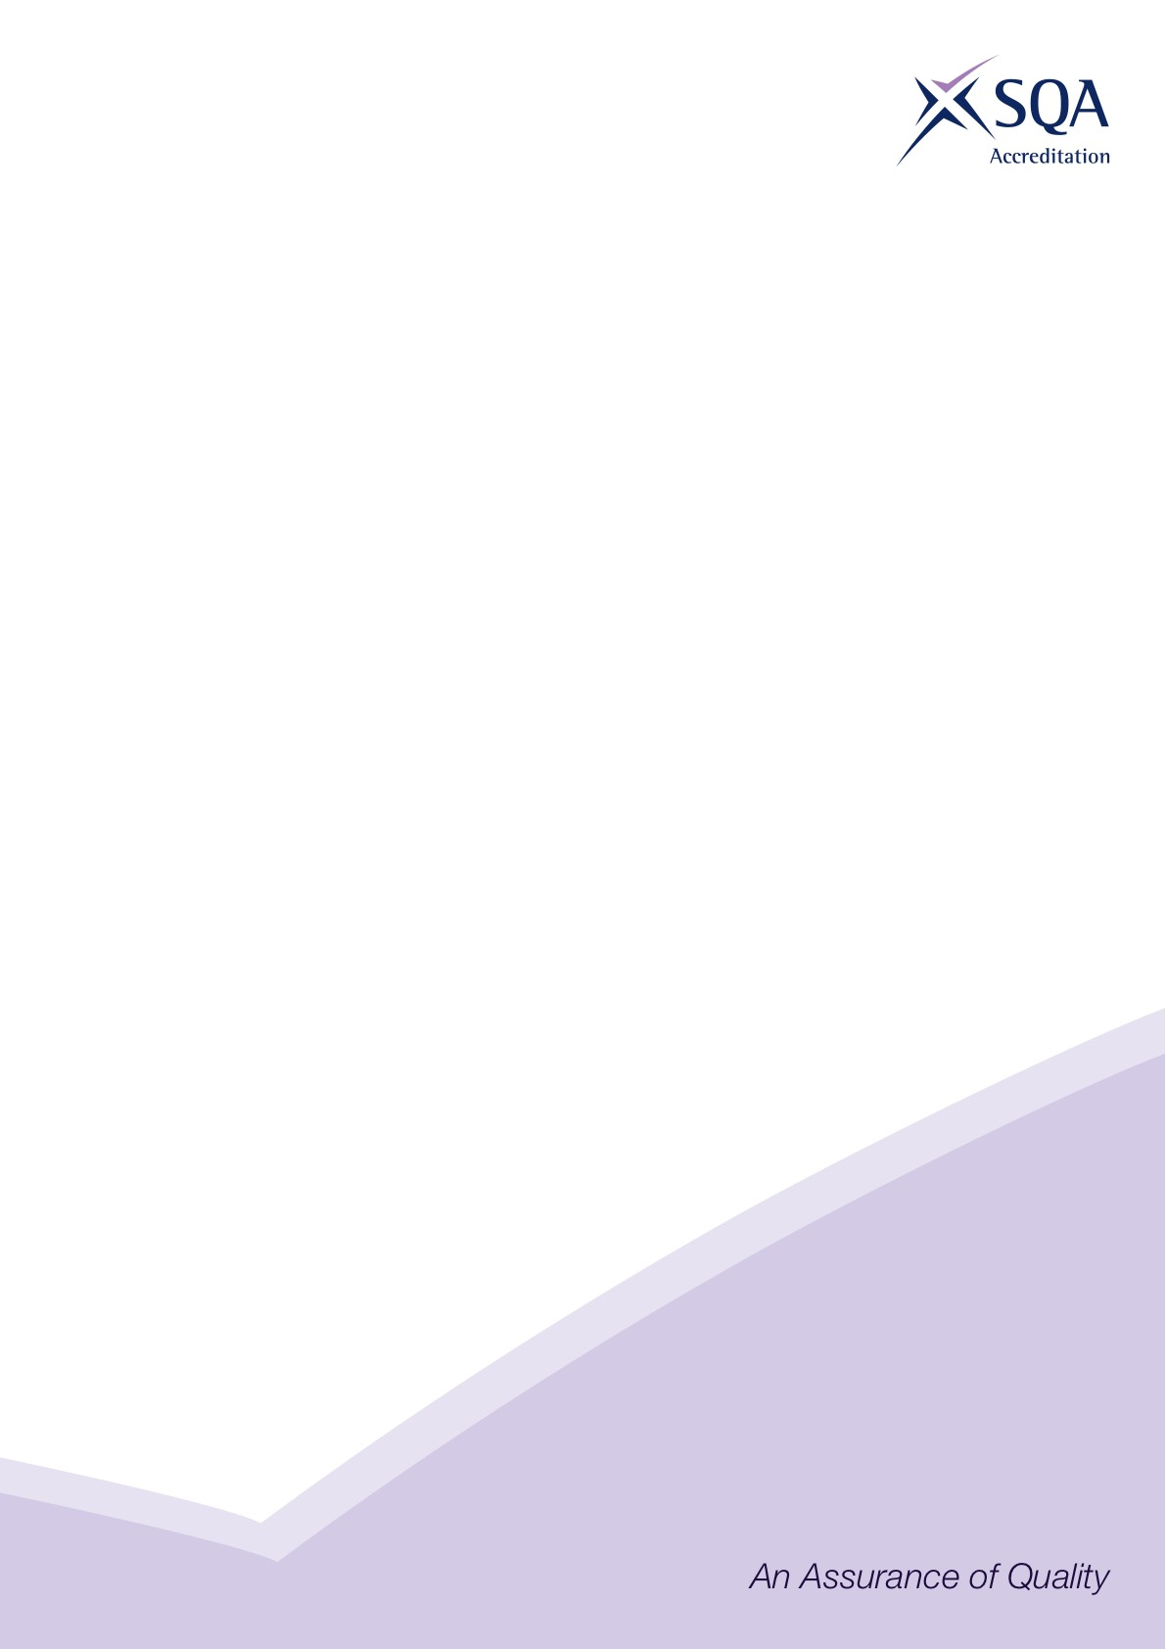

**Core Skills Signposting**

|  |  |
| --- | --- |
| **Sector** | Building Services Engineering |
| **Qualification Title(s)** | SVQ in Electrical Installation at SCQF level 7 |
| **Developed by** | BSE Skills Ltd |
| **Approved by ACG** | 03 June 2020 |
| **Version** | 1 |

## Introduction

Core Skills signposting indicates if there are opportunities within units to develop Core Skills in the workplace to a specified SCQF level. The signposting document should also acknowledge where there are no opportunities to develop Core Skills. This signposting can be used by providers and assessors to plan the development and assessment of Core Skills.

The five Core Skills are:

◻ Communication

◻ Information and Communication Technology

◻ Numeracy

◻ Problem Solving

◻ Working with Others

**Note**

The mapping signposts the opportunities to use evidence generated against the NOS to also satisfy the Core Skills (SCQF Level 5) requirement:

* 1 is an excellent opportunity
* 2 is an opportunity
* 3 is little or no opportunity

This approach has been adopted so as to provide useful information, in the form of a starting point, for Awarding Bodies and providers.

## Core Skills Signposting

|  |  |  |  |  |  |  |
| --- | --- | --- | --- | --- | --- | --- |
| Qualification or Suite Title: SVQ in Electrical Installation at SCQF level 7 | | | | | | |
| URN | Unit title | Communication | ICT | Numeracy | Problem Solving | Working with Others |
| BSEBSE01 | Apply health and safety and environmental legislation in the building services engineering sector | 1 | 1 | 3 | 3 | 2 |
| BSEBSE02 | Establish and maintain relationships in the building services engineering sector | 1 | 3 | 2 | 2 | 1 |
| BSEBSE03 | Coordinate a work site in the building services engineering sector | 1 | 2 | 2 | 1 | 1 |
| BSEET04 | Install enclosures for electrical cables, conductors and wiring systems | 2 | 3 | 1 | 1 | 2 |
| BSEET05 | Install and connect electrical cables, conductors, wiring systems and equipment | 2 | 3 | 1 | 1 | 2 |
| BSEET06 | Inspect and test electrical systems and equipment | 2 | 3 | 1 | 2 | 2 |
| BSEET07 | Commission electrical systems and equipment | 1 | 2 | 1 | 2 | 1 |
| BSEET08 | Identify and rectify faults in electrical systems and equipment | 2 | 3 | 1 | 1 | 1 |
| BSEET09 | Maintain electrical systems and equipment | 2 | 2 | 1 | 1 | 2 |
| FICA | Final Integrated Competence Assessment | 2 | 2 | 1 | 1 | 2 |