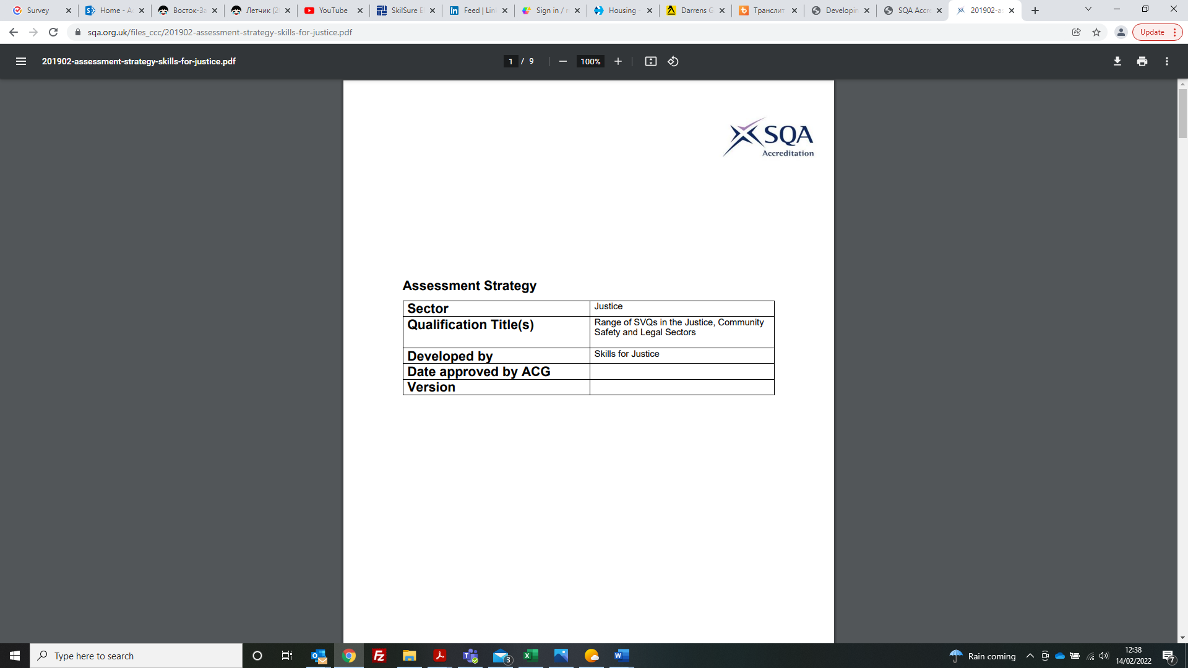

|  |  |
| --- | --- |
| **Assessment Strategy** | |
| **Qualification Title(s)** | SVQ in Learning and Development at SCQF level 8  SVQ in Learning and Development at SCQF level 9 |
| **Developed by** | Instructus |
| **Approved by ACG** | 26/06/2024 |
| **Version** | 2 |

#### **Introduction:**

The purpose of an assessment strategy is to provide awarding bodies with a consistent approach to assessment that complies with SQA Accreditation’s regulatory requirements.

The key areas this assessment strategy will cover are:

* assessment requirements
* the extent to which simulation may be used
* the assessment environment, including what constitutes a realistic working environment when assessing competence
* the roles and requirements of assessor and quality assurers
* external quality assurance requirements for awarding bodies.

Awarding bodies must use the assessment strategy as the basis for developing and defining the evidence requirements and assessment methods their providers will use. This includes specifying how the qualification will be internally and externally quality assured.

This strategy should only be used for the assessment of the SVQs in Learning and Development at SCQF Level 8 and SCQF Level 9.

**Scope of this Assessment Strategy**

This assessment strategy applies to the SVQs in Learning and Development at SCQF Level 8 and Level 9 and all units that make them up. All of the units that make up the SVQs for Learning and Development are based on the Learning and Development National Occupational Standards approved in June 2021.

**Assessment requirements**

This outlines specific requirements for how assessment must be approached or undertaken.

* Evidence for all SVQ Learning and Development units at all levels must be generated and collected through naturally occurring performance in a real work environment.
* Assessment of all Performance Criteria and Knowledge and Understanding should, wherever possible, be carried out during performance across all units to ensure integration of theory and practice.
* Evidence of Performance Criteria and Knowledge and Understanding should be clearly identified and referenced appropriately to provide a robust quality audit trail.
* All evidence must be made available to assessors, internal verifiers and external verifiers as required to ensure the validity of the assessment process.

**Simulation**

This outlines the extent to which simulation is permitted.

All performance evidence must come from real practice in Learning and Development. The use of simulation is not allowed for Learning and Development qualifications.

**The assessment environment**

This outlines any requirements for the assessment environment.

Assessment of all units at any level of SVQs in Learning and Development should normally be based on candidate’s performance in a real work environment

For each Unit, an appropriate range of methods will allow a candidate to meet the requirements of the standards. Assessment can be carried through the following direct and indirect methods:

* observation
* related questioning
* inspecting work products (created at the time of the observation)
* and must also cover indirect assessment methods including:
* examination of work products (created at the time of observation and not created at
* the time of observation)
* discussing with candidates
* testimony of others (witnesses)
* examining candidate statements
* assessing candidates in simulated environments
* Recognition of Prior Learning (RPL).

Such evidence, together with information gained from discussion with and questioning by the assessor, should enable candidates to show that they:

* have achieved all Performance Criteria in each chosen unit.
* possess and are capable of applying all the required items of Knowledge and Understanding.

**Requirements for roles in assessment and quality assurance**

This outlines the experience, qualifications, training and continuous professional development requirements for those involved in the assessment and quality assurance processes.

## Assessors

The primary responsibility of an Assessor is to assess candidates’ performance in a range of tasks and to ensure the evidence submitted by the candidate meets the requirements of the assessment criteria.

It is important that an Assessor can recognise competence as specified by the national standard. Assessors therefore need to have a thorough understanding of assessment and quality assurance practices, as well as have in-depth technical understanding related to the qualifications for which they are assessing candidates. To assess Learning and Development candidates, Assessors must:

* be occupationally competent. Assessors must provide current evidence of competence, knowledge and understanding in the areas to be assessed. This must be demonstrated by relevant experience and continuing professional development (CPD) which may include the achievement of qualification(s) at a commensurate level, relevant to the areas being assessed.
* hold or be working towards an appropriate Assessor qualification as specified by SQA Accreditation the qualification regulator. Assessors holding older qualifications must be able to demonstrate that they are assessing to the current standards through up-to-date CPD.

**Assessors working towards an appropriate qualification** must be supported by a qualified assessor throughout the period of completing the qualification. This support may be provided by a qualified assessor and/or qualified internal verifier. This must include monitoring of assessment decisions which may be achieved via the process of internal verification and/or sampling of assessment decisions by a qualified assessor.

**If they are assessing** **CLDLD09 Assess learner achievement, and/or CLDLD11 Internally monitor and maintain the quality of assessment, they must hold one of the assessor qualifications, not just be working towards it.**

Evidence of the support provided and monitoring of assessment decisions must be recorded and accessible to the awarding body.

## Internal Verifiers

The primary responsibility of Internal Verifiers is to assure the quality and consistency of assessments by Assessors. Internal Verifiers therefore need to have a thorough understanding of quality assurance and assessment practices, as well as sufficient technical understanding of the qualifications that they are internally verifying.

To internally verify Learning and Development assessment decisions, Internal Verifiers must:

* be occupationally competent. Internal Verifiers must demonstrate sufficient and current understanding of the qualifications to be internally verified and know how they are applied. This must be demonstrated by relevant experience and CPD which may include the achievement of qualification(s) at a commensurate level, relevant to the areas being assessed.
* hold, or be working towards, an appropriate Internal Verifier qualification as specified by SQA Accreditation the qualification regulator. Internal verifiers holding older qualifications must be able to demonstrate that they are assessing to the current standards through up-to-date CPD.

**Internal Verifiers working towards an appropriate qualification** must be supported by a qualified Internal Verifier throughout the period of completing the qualification. This must include monitoring of verification decisions which may be achieved by sampling of reports and evidence by a qualified Internal Verifier. Evidence of the support provided and monitoring of verification decisions must be recorded and made available to SQA Accreditation on request.

**If they are internally verifying CLDLD09 Assess learner achievement, and/or CLDLD11 Internally monitor and maintain the quality of assessment, they must hold one of the internal verifier qualifications, not just be working towards it.**

## External Verifiers (EVs)

The primary responsibility of External Verifiers is to participate in verification of qualifications in the subject areas concerned to ensure that quality standards are maintained. An EV is required to demonstrate an up to date and sound knowledge of the occupational standards, qualifications and units to make judgements about the quality of assessment and the assessment processes. To carry out external verification, EVs must:

* be occupationally knowledgeable and have gained their knowledge working within the Learning and Development occupational area or other associated professional sectors.
* have a thorough understanding of the qualifications they will be quality assuring.
* have a detailed knowledge of the Awarding Bodies’ systems, processes and relevant documentation.
* have a thorough understanding of the guidance produced by the awarding bodies describing assessment and quality assurance practice.
* maintain their occupational knowledge by actively engaging in continuous professional development activities to keep up to date with developments relating to the changes taking place in the Learning and Development occupational area or other associated professional sectors.
* hold or be working towards an appropriate External Verifier qualification as identified by SQA Accreditation the qualification regulator. External Verifiers holding older qualifications must be able to demonstrate that they are verifying to the current standards.

**If they are externally verifying CLDLD09 Assess learner achievement, and/or CLDLD11 Internally monitor and maintain the quality of assessment, they must hold one of the external verifier qualifications, not just be working towards it.**

## Personal Development Plans (PDP) and Continuing Professional Development (CPD) Records

The Assessment Strategy requires all Assessors, Internal and External Verifiers to maintain current competence in internal and external quality assurance and assessment practices to deliver these functions. This can be achieved in many ways. However, such information must be formally recorded in individual Personal Development Plans and CPD records that are accessible to the awarding body.

All assessors, internal verifiers and external verifiers must show current evidence of continuing professional development in the relevant area of practice by demonstrating they continue to meet the standard set out in CLDLD10 Reflect on, Develop and Maintain Own Skills and Practice in Learning and Development.

**External quality assurance**

This outlines the requirements for awarding bodies to monitor the quality of assessment.

The process of quality control should be ensured through robust and strong internal and external verification systems that meet the requirements of the qualification regulators’ documentation.

All assessment evidence must be checked and internally verified by qualified IQA. External quality control should be ensured through external verification by competent external verifiers. Awarding bodies must use risk management to determine the frequency and scope of external quality control of assessment.