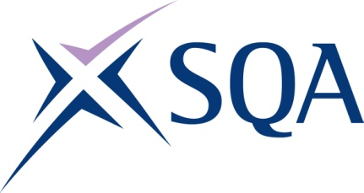

Qualification structure for SQA Level 4 Award in Maritime Studies: Tug Master less than 500 gross tonnage

SQA Qualification Code: GK0X 78

Ofqual’s Qualification Code: 601/4861/5
Total Qualification Time: 120 hours
Minimum Guided Learning Hours: 64

Credit value: 12

To gain the qualification, learners must complete the TWO Mandatory units to achieve a total of 12 credits (120 hours TQT)

Please note: It is important that the SQA Unit codes are used in all your recording documentation and when your results are communicated to SQA.

Mandatory Units: Learners must achieve all 12 credits

SQA Unit Code | Unit Title | Regulator’s Unit code | Level | Credit value | GLH | TQT
H81K 78 | Direct Tug Operations | J/616/7084 | 4 | 6 | 32 | 60
H81L 78 | Manoeuvre a Tug | Y/616/7087 | 4 | 6 | 32 | 60

