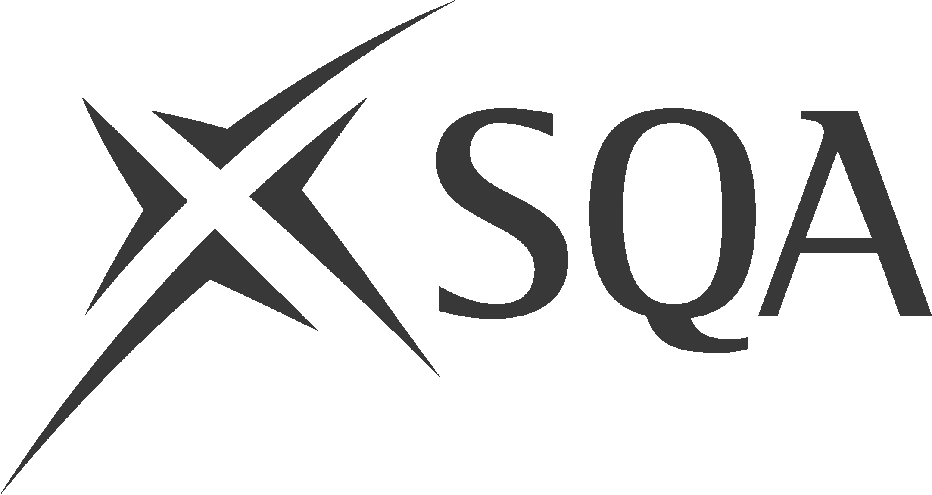

Scottish Baccalaureate: Guidance for teachers/lecturers when approving candidate Interdisciplinary Project proposals.

Audit Tool (this may be useful for teaching staff)

Does the Project Proposal: | Yes/No | Comments
Demonstrate a theme of personal and/or career interest?

Allow the candidate to develop and demonstrate the required generic and cognitive skills across the three stages*?
Allow a high degree of learner autonomy and independent learning/working?
Allow collaborative working?
Allow the accessing of less familiar learning environments (other institutions, employers, virtual environments etc?
Explore and bring out the relevance of Expressive Arts/Languages/Sciences/Social Sciences in one or more of the five broad contexts**?
Make a connection between subject knowledge and the wider world?
Indicate practical applications for subject knowledge?
Involve the use of knowledge and skills across different disciplines?
Clearly define research methodologies and allow for research from a variety of sources?

Other Relevant Questions: | Yes/No | Comments
Is the scope of the project viable (neither too wide nor too narrow)?
Is it achievable within the required timescale and does it make allowance for contingency possibilities?
Does it set realistic goals?
Is it realistic in terms of resources and support required?
If working on a group project, are individual roles and participation across the three stages clearly defined?

*Generic and Cognitive Skills **Broad Contexts

Application Citizenship
Research Skills Enterprise
Interpersonal Skills Employability
Planning Economic Development
Independent Learning Sustainable Development
Problem Solving
Presentation Skills
Self-evaluation

