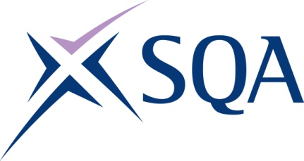
GK75 22 | SVQ 2 Barbering at SCQF Level 5

To attain the qualification candidates must complete 8 Units in total. This comprises:

- 7 mandatory Units
- 1 optional Unit

Please note the table below shows the SSC identification codes listed alongside the corresponding SQA Unit codes. It is important that the SQA Unit codes are used in all your recording documentation and when your results are communicated to SQA.

Mandatory Units: Candidates must complete 7 Units from this group
SQA code | SSC code | Title | SCQF level | SCQF credits
H9D1 04 | SKACB2 | Cut Hair using Basic Barbering Techniques | 5 | 13
H9D2 04 | SKACB3 | Cut Facial Hair to Shape using Basic Techniques | 5 | 7
H9D3 04 | SKACB4 | Dry and Finish Men's Hair | 5 | 5
H9D4 04 | SKACB5 | Create Basic Outlines and Detailing in Hair | 5 | 6
H9CE 04 | SKACHB9 | Advise and Consult with Clients | 5 | 8
H9CF 04 | SKACHB11 | Shampoo, Condition and Treat the Hair and Scalp | 5 | 5
H9CG 04 | SKACHB12 | Develop and Maintain your Effectiveness at Work | 5 | 3

Optional Units: Candidates must complete 1 Units from this group
SQA code | SSC code | Title | SCQF level | SCQF credits
H9C8 04 | SKACB1 | Assist with Shaving Services | 4 | 5
H9D5 04 | SKACB6 | Colour and Lighten Men's Hair | 6 | 12
H9CJ 04 | SKACH5 | Perm and Neutralise Hair | 6 | 9
H9CK 04 | SKACH6 | Plait and Twist Hair | 5 | 5
H9CL 04 | SKACH7 | Temporarily Attach Hair to Enhance a Style | 5 | 3
H9CM 04 | SKACHB13 | Fulfil Salon Reception Duties | 5 | 5
H9D0 04 | SKACHB18 | Contribute to the Financial Effectiveness of the Business | 6 | 7

