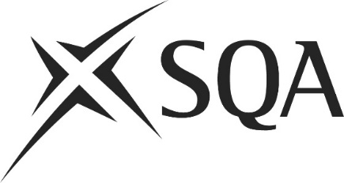

Blank candidate recording forms for Awards, Certificates and Diplomas

Published by the Scottish Qualifications Authority
The Optima Building, 58 Robertson Street, Glasgow, G2 8DQ
Lowden, 24 Wester Shawfair, Dalkeith, Midlothian, EH22 1FD

www.sqa.org.uk

© Scottish Qualifications Authority August 2023

Candidate Recording Form: Index of Evidence

Evidence  number | Description of evidence | Included in portfolio  (yes/no)  If ‘no’, state location | Sampled by the IV  (initials and date)

Candidate Recording Form: Observation Record

Unit/outcome(s)
Candidate’s name
Evidence index number
Date of observation

Skills/activities observed | Assessment criteria covered

Knowledge and understanding apparent from this observation

Other units/outcome(s) to which this evidence may contribute

Assessor’s comments and feedback to candidate

I can confirm the candidate’s performance was satisfactory.

Assessor’s signature Date

Candidate’s signature Date

Candidate Recording Form: Personal Statement

Date | Evidence index number | Details of statement | Links to other evidence  (enter numbers) | Unit, Learning Outcomes covered

Candidate’s signature Date

Candidate Recording Form: Questions and Candidate’s Answers

Unit
Outcome(s)
Evidence index number

Circumstances of assessment

List of questions and candidate’s responses
Q
A
Q
A

Assessor’s signature Date

Candidate’s signature Date

Candidate Recording Form: Unit Progress Record

Qualification and level

Candidate’s name

Mandatory units achieved
Unit number | Title | Assessor’s signature | Date

Optional units achieved
Unit number | Title | Assessor’s signature | Date

Candidate Recording Form: Assessment Plan

Unit:

Outcomes:

Activities | Assessment criteria | Method of assessment/sources of evidence | Date of assessment | Evidence already available | Links to other units (assessment criteria)

Assessor’s signature 1st review due

Candidate’s signature 2nd review due

Date of agreement Date of completion

Candidate Recording Form: Witness Testimony

Qualification title and level
Candidate’s name
Evidence index no.
Index no. of other evidence which this testimony relates to (if any)
Outcome(s)
Date of evidence
Name of witness
Designation/relationship to candidate

Details of testimony

Witness’s signature Date

Witness (please select the appropriate box):

Holds appropriate qualifications

Is familiar with the units to which the candidate is working

