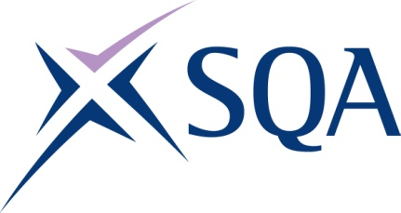
GP0F 23 | SVQ in Community Development at SCQF level 6

To attain the qualification candidates must complete 6 units in total. This comprises:

- 5 mandatory units
- 1 optional units

Please note the table below shows the SSC identification codes listed alongside the corresponding SQA unit codes. It is important that the SQA unit codes are used in all your recording documentation and when your results are communicated to SQA.

Mandatory units: Candidates must complete all 5 units from this group
SQA code | SSC code | Title | SCQF level | SCQF credits
J07W 04 | JETSCD02 | Work with the Tensions Inherent in Community Development Practice | 7 | 6
J07X 04 | JETSCD03 | Relate to Different Communities | 6 | 5
J07Y 04 | JETSCD07 | Get to Know a Community | 6 | 8
J080 04 | JETSCD14 | Promote and Support Effective Relationships Between Communities and Public Bodies and Other Agencies | 6 | 6
J081 04 | JETSCD23 | Monitor and Evaluate Community Development Activities | 5 | 5

Optional units: Candidates must complete 1 units from this group
SQA code | SSC code | Title | SCQF level | SCQF credits
J082 04 | JETSCD18 | Promote Opportunities for Community Development Learning | 7 | 7
J083 04 | JETSCD19 | Facilitate Community Learning for Social and Political Development | 6 | 7
J084 04 | JETSCD25 | Supervise and Support Community Development Practitioners | 6 | 8
J085 04 | JETSCD21 | Plan and Gain Resources and Funding for Sustainability | 5 | 6
J086 04 | JETSCD22 | Strengthen the Organisational Development of Groups | 6 | 6

