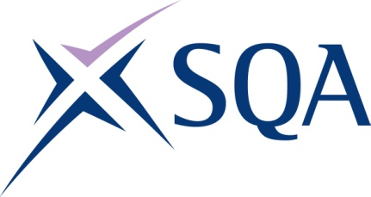
GV2K 48 | Diploma in Digital Technology: IT Support at SCQF level 8

To attain the qualification candidates must complete 7 Units in total. This comprises:

- 6 mandatory Units
- 1 optional Unit

Please note the table below shows the SSC identification codes listed alongside the corresponding SQA Unit codes. It is important that the SQA Unit codes are used in all your recording documentation and when your results are communicated to SQA.

Mandatory Units: Candidates must complete all 6 Units from this group
SQA code | SSC code | Title | SCQF level | SCQF credits
J6VC 48 | SDS187 | Supporting Digital Business Transformation | 8 | 9
J6TS 48 | SDS007 | Applying Methods and Principles in Project Management | 8 | 12
J6V0 48 | SDS012 | Developing Meta-Skills and Personal Professionalism | 8 | 16
J7F3 48 | SDS264 | Responding to Digital Technology Service Requests | 8 | 11
J7F5 48 | SDS265 | Maintaining Service Support Procedures​ | 8 | 9
J7F6 48 | SDS268 | Providing Digital Technology Asset Management | 8 | 7

Optional Units: Candidates must complete 1 Units from this group
SQA code | SSC code | Title | SCQF level | SCQF credits
J7F7 48 | SDS266 | Producing and Testing Automation Scripts | 8 | 8
J7F8 48 | SDS267 | Producing Service Management Reports and Metrics | 8 | 8

