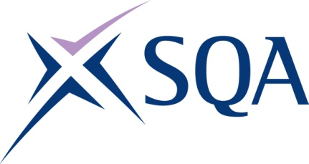

Qualification structure for SQA Level 2 NVQ Certificate in Removal of Non-hazardous Waste (Construction)

SQA Qualification Code: GT4E 66

Ofqual’s Qualification Code: 610/0389/X

Minimum Total Qualification Time: 300 hours
Minimum Guided Learning Hours: 196

Credit value: 30

To gain the qualification, learners must achieve a minimum total of 30 credits (300 TQT)

This comprises:
- 30 credits from the Mandatory Core Units

Please note: It is important that the SQA Unit codes are used in all your recording documentation and when your results are communicated to SQA.

Mandatory Core Units: Learners must achieve all 30 credits

SQA Unit Code | Unit Title | Regulator’s Unit code | Level | Credit value | GLH | TQT
J62R 66 | Installing, maintaining and removing work area protection and safety equipment in the workplace | K/650/1234 | 2 | 10 | 55 | 100
J62P 66 | Removing non-hazardous waste in the workplace | D/650/1230 | 2 | 10 | 57 | 100

FX74 81 | Conforming to general health, safety and welfare in the workplace | D/616/6569 | 2 | 2 | 7 | 20
FX6X 68 | Conforming to productive working practices in the workplace | R/616/6570 | 2 | 3 | 10 | 30
FX73 68 | Moving, handling and storing resources in the workplace | Y/616/6571 | 1 | 5 | 17 | 50

