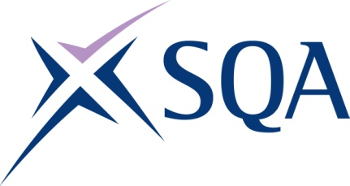

Qualification structure for SQA Level 3 NVQ Diploma in Occupational Work Supervision (Construction)

SQA Qualification Code: GT27 79

Ofqual’s Qualification Code: 603/7900/5

Total Qualification Time: 890 hours
Minimum Guided Learning Hours: 387

To gain the qualification, learners must achieve

- Mandatory Core Units
- plus two units from Group A

Please note: It is important that the SQA Unit codes are used in all your recording documentation and when your results are communicated to SQA.
-
Mandatory Core Units: Learners must achieve six units

SQA Unit Code | Unit Title | Regulator’s Unit code | Level | Credit value | GLH | TQT
J3GY 79 | Developing and Maintaining Good Occupational Working Relationships in the Workplace | J/617/8387 | 3 | 8 | 37 | 80
FX6R 79 | Confirming the Occupational Method of Work in the Workplace | K/616/6574 | 3 | 11 | 47 | 110
J3H0 79 | Implementing and Maintaining Health, Safety, Environmental and Welfare Practices in the Workplace | F/617/8388 | 3 | 14 | 60 | 140
J5RM 79 | Co-ordinating and Organising Work Operations in the Workplace | M/616/7144 | 3 | 14 | 60 | 140
J3H1 79 | Monitoring Progress of Work Against Schedules in the Workplace | T/617/8386 | 3 | 10 | 40 | 100
FX6T 79 | Confirming Work Activities and Resources for an Occupational Work Area in the Workplace | L/618/8809 | 3 | 10 | 43 | 100

Group A: learners must achieve two units

SQA Unit Code | Unit Title | Regulator’s Unit code | Level | Credit value | GLH | TQT
J3H2 79 | Allocating and Monitoring the Use of Plant, Machinery, Equipment or Vehicles in the Workplace | A/617/8387 | 3 | 20 | 100 | 200
J3H3 79 | Confirming Work Meets Contractual, Industry and Manufacturers’  Standards in the Workplace | M/617/8385 | 3 | 16 | 70 | 160
J3H4 79 | Implementing Procedures to Support Team Performance in the Workplace | K/617/8384 | 3 | 13 | 60 | 130
J3H5 79 | Co-ordinating and Confirming the Dimensional Control Requirements of the Work in the Workplace | H/617/8383 | 3 | 9 | 40 | 90

