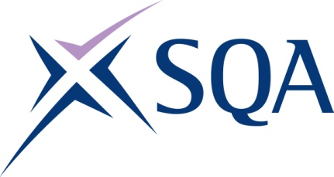
Qualification structure for Level 4 NVQ Diploma in Controlling Lifting Occupations – Supervising Lifts

SQA Qualification Code: GJ51 80

Regulated Qualification Code: 301/2956/6
Total Qualification Time: 740 hours

Minimum Guided Learning Hours (GLH) for whole qualification: 317

To achieve this qualification, learners will need to complete a minimum total of 74 credits

This comprises:
- 74 mandatory core credits

Please note: It is important that the SQA Unit codes are used in all your recording documentation and when your results are communicated to SQA.

Mandatory core units: Learners must achieve all 74 credits from this group
SQA Unit Code | Title | credit value | Level | GLH | Regulated Unit code
FX75 83 | Developing and Maintaining Good Occupational Working Relationships in the Workplace | 8 | 5 | 37 | F/616/7150
FJ5D 79 | Supervising Lifting Operations Using Lifting Equipment in the Workplace | 12 | 3 | 50 | A/616/7275
H6TF 80 | Maintaining Systems for Health, Safety, Welfare and Environmental Protection in the Workplace | 8 | 4 | 40 | L/616/7202
H6TG 80 | Coordinating and Organising the Control of Work in the Workplace | 12 | 3 | 50 | K/616/7143
H6TH 80 | Allocating and Monitoring the Use of Plant, Equipment or Machinery in the Workplace | 9 | 4 | 40 | Y/616/7106
FK0T 79 | Maintaining the Dimensional Accuracy of the Work in the Workplace | 8 | 3 | 40 | M/616/7208
FJ6D 79 | Co-ordinating Preparation Work for Site or Lifting Operations in the Workplace | 8 | 3 | 20 | T/616/7145
H6TJ 83 | Allocating Work and Checking People’s Performance in the Workplace | 9 | 5 | 20 | D/616/7107

