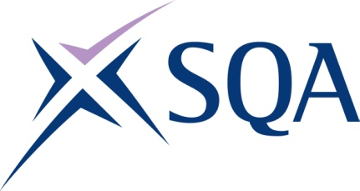
Qualification structure for SQA Level 2 Certificate in Maritime Studies: Engine Room Rating

SQA Qualification Code: GC7W 54

Ofqual’s Qualification Code: 603/4892/6
Total Qualification Time: 267 hours

Minimum Guided Learning Hours: 220

Credit value: 27
To gain the qualification, learners must complete the EIGHT Mandatory units to achieve a total of 27 credits (267 TQT)

Please note: It is important that the SQA Unit codes are used in all your recording documentation and when your results are communicated to SQA.

Mandatory Units: Learners must achieve all 27 credits

SQA Unit Code | Unit Title | Regulator’s Unit code | Level | Credit value | GLH | TQT
FA5M 54 | Maritime employment, environmental and health and safety practice | D/616/6877 | 2 | 2 | 18 | 20
FA5N 54 | Survival in the water during maritime emergencies | Y/503.2634 | 2 | 1 | 8 | 8
FA5T 54 | Vessel fire prevention and fire fighting | T/502/5920 | 2 | 2 | 20 | 20
FA5P 54 | Maritime security | K/602/3866 | 2 | 1 | 8 | 8
FA5R 54 | Emergency first aid in response to maritime accidents or medical emergencies | A/602/3872 | 2 | 1 | 7 | 7
FN1V 54 | Safe operation of merchant vessel machinery systems | R/503/2633 | 2 | 4 | 36 | 42
FN1W 54 | Electrical safety on merchant vessels | Y/503.2634 | 2 | 2 | 18 | 22
FN1X 54 | Producing components using hand fitted techniques | H/616/7271 | 2 | 14 | 105 | 140

Additional Optional Unit: Learners may complete this unit, however, the credit from this will not count towards achievement of the qualification

SQA Unit Code | Unit Title | Regulator’s Unit code | Level | Credit value | GLH | TQT
FF2D 57 | Control operation of survival craft and rescue boats | T/616/6870 | 3 | 3 | 26 | 30

