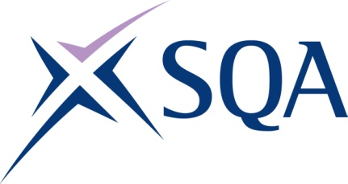

GP3K 47 Certificate in Policing at SCQF Level 7

To attain the qualification candidates must complete 9 units in total. This comprises:

- 9 mandatory units

Please note the table below shows the SSC identification codes listed alongside the corresponding SQA unit codes. It is important that the SQA unit codes are used in all your recording documentation and when your results are communicated to SQA.

Mandatory units: Candidates must complete all 9 units from this group
SQA code | SSC code | Title | SCQF level | SCQF credits
J57Y 04 | Unit 1 | Operational First Aid | 6 | 1
J1FE 04 | Unit 2 | Operational Safety Training | 7 | 4
J1FG 04 | Unit 3 | Scots Criminal Law: Police Powers and Principles of Evidence | 7 | 67
J1FH 04 | Unit 4 | Scots Criminal Law: Introduction and Investigation | 7 | 29
J1FJ 04 | Unit 5 | Health and Wellbeing for Police Officers | 6 | 2
J1FK 04 | Unit 6 | Protection and Wellbeing in our Communities | 7 | 28
J1FL 04 | Unit 7 | General Police Duties | 7 | 10
J1FM 04 | Unit 8 | Conduct Systematic Searches | 7 | 1
J1FN 04 | Unit 9 | Roads Policing | 7 | 28

