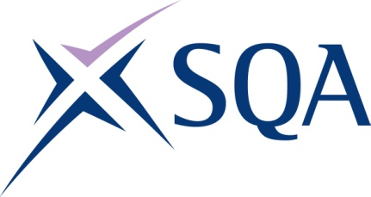

GH4Y 21 SVQ 1 Cleaning and Support Services at SCQF Level 4 – Structure
To attain the qualification candidates must complete 6 Units in total. This comprises:
- 2 Mandatory Units
- 4 Optional Units

Please note the table below shows the SSC identification codes listed alongside the corresponding SQA Unit codes. It is important that the SQA Unit codes are used in all your recording documentation and when your results are communicated to SQA.

Mandatory Units: Candidates must complete 2 Units from this group
SQA code | SSC code | Title | SCQF level | SCQF credits
F470 04 | C2 01 | Make Sure Your own Actions Reduce Risks to Health and Safety | 5 | 8
FM0H 04 | C2 02 | Maintain Personal Hygiene Standards when Cleaning | 4 | 1

Restricted Units: Candidates must complete 1 Unit from this group
SQA code | SSC code | Title | SCQF level | SCQF credits
F27L 04 | C1 03 | Do Your Job in a Customer Friendly way | 4 | 4
F05E 04 | C1 04 | Provide Customer Service Within the Rules | 5 | 6

Restricted Units: Candidates must complete 1 Unit from this group
SQA code | SSC code | Title | SCQF level | SCQF credits
FM0K 04 | C1 05 | Work with Others Following Reporting Procedures | 4 | 2
FM0L 04 | C106 | Work Individually and Follow Reporting Procedures | 4 | 2

Optional Units: Candidates must complete 2 Units from this group
SQA code | SSC code | Title | SCQF level | SCQF credits
FM0M 04 | C1 07 | Work in an Environmentally Friendly Way | 4 | 2
FM0N 04 | C1 08 | Use and Store Equipment and Cleaning Agents In Line with Organisational Procedures | 4 | 3
FM0R 04 | C1 09 | Deal with Waste, Recyclables, Lost Property and Suspicious Packages when Cleaning | 4 | 2
FM0T 04 | C1 10 | Use Electrical or Battery Powered Cleaning Equipment Effectively and Safely | 4 | 2
FM0V 04 | C1 11 | Clean a Variety of Surfaces using Correct Methods | 4 | 2
FM0W 04 | C2 08 | Clean Washrooms and Replenish Supplies | 5 | 2
FM0X 04 | C2 18 | Perform Street Cleansing Manually | 5 | 3

