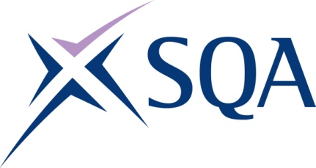

GP9C 22 | SVQ Court Operations at SCQF level 5

SCQF overall credit: Minimum 32 Maximum 41

To attain the qualification candidates must complete seven units in total. This comprises:

- five mandatory units
- two optional units

Please note the table below shows the SSC identification codes listed alongside the corresponding SQA unit codes. It is important that the SQA unit codes are used in all your recording documentation and when your results are communicated to SQA.

Mandatory units: Candidates must complete all five units from this group
SQA code | SSC code | Title | SCQF level | SCQF credits
J2NL 04 | SFJDC1 | Prepare Court and Tribunal Rooms for Proceedings | 5 | 5
J2NM 04 | SFJDC2 | Provide Support to Those Attending Courts and Tribunals | 5 | 6
J2P2 04 | SFJDC4 | Maintain Public Order and Protocols at Courts and Tribunals | 6 | 7
H559 04 | CFABAD332 | Store and Retrieve Information Using a Filing System | 5 | 3
H4R5 04 | SFJAE1 | Maintain and Develop Your Own Knowledge, Skills and Competence | 5 | 5

Optional units: Candidates must complete two units from this group
SQA code | SSC code | Title | SCQF level | SCQF credits
J2NN 04 | SFJDB6 | Address Requirements for Special Arrangements at Courts and Tribunals | 5 | 5
J2P3 04 | SFJDD2 | Support Jurors at Court | 6 | 7
J2NP 04 | SFJDH1 | Respond to Enquiries Regarding Courts and Tribunals | 5 | 8
J2NR 04 | SFJAG1 | Maintain Personal Security and Safety, and be Alert to the Security of Others | 5 | 7
HD6R 04 | SFJCCBF3.1 | Develop and Sustain Effective Working with Staff from Other Agencies | 6 | 6
H9XJ 04 | CFACSA3 | Communicate Effectively with Customers | 5 | 5
H9YE 04 | CFACSC4 | Deliver Customer Service to Challenging Customers | 5 | 6
FD96 04 | CFABAC311 | Meet and Welcome Visitors | 5 | 3
F9A4 04 | ESKEML2 | Using Email 2 | 5 | 3

