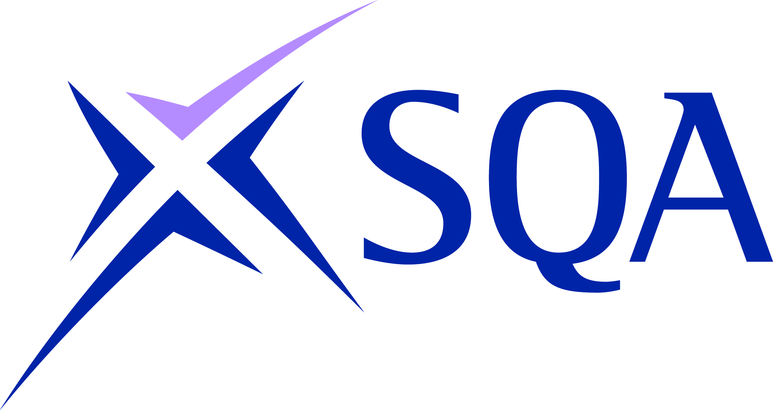

Quality Assurance for Higher National and Vocational Qualifications 2015–18

Enhanced guidance on meeting quality assurance criterion 4.8

Internal assessment appeals must be handled in line with a documented procedure which meets SQA requirements.

This edition: February 2016
Publication code: CA7202E

Published by the Scottish Qualifications Authority
The Optima Building, 58 Robertson Street, Glasgow G2 8DQ
Lowden, 24 Wester Shawfair, Dalkeith, EH22 1FD
www.sqa.org.uk

The information in this publication may be reproduced in support of SQA qualifications. If it is reproduced, SQA should be clearly acknowledged as the source. If it is to be used for any other purpose, then written permission must be obtained from SQA. It must not be reproduced for trade or commercial purposes.

© Scottish Qualifications Authority 2016

Introduction to your procedures
Your procedures must state that candidates have the right to appeal against the results of internal assessments. They should also state the grounds for appeal which will be accepted (eg if candidates feel they were not treated fairly in assessments).

State how you will disseminate this information to candidates (eg through induction, handbooks, student advice centre, administration office).

Stages of internal assessment appeals

Stage 1: Informal
For your organisation, indicate to whom candidates can appeal against an assessment decision, on an informal basis. This is most likely to be their assessor.

Include reasonable timescales for:

- submission of the appeal by the candidate (from the date of receiving the assessment result)
- dealing with the appeal and responding to the candidate

Explain what will happen with their appeal — eg will it be logged, recorded?

Stage 2: Informal
For your organisation, explain how candidates should appeal against an assessment decision, if they are dissatisfied with the response from their assessor, or feel that they cannot approach the assessor.

It is recommended that the appeal is referred to the internal verifier at this stage.

Include reasonable timescales for:

- submission of the appeal by the candidate (from the date of receiving the response from the assessor to the informal appeal or from receiving the assessment result)
- dealing with the appeal and responding to the candidate

Explain what will happen with their appeal — eg will it be logged, recorded?

Stage 3: Formal
Formal appeals should be in writing.

The formal stage of appeal should be to an independent third party, who has not been previously involved in the assessment decision.

Identify the person to address the appeal to, including e-mail and/or postal address.
Do you have an appeal form, or do you just accept letters/e-mails? If you have a form, where can this be obtained?

Is there anyone who can help with writing an appeal, if necessary?

Include a reasonable timescale for submission of the appeal by the candidate (from the date of receiving the response to the formal appeal or from receiving the assessment result).

You should state that you will acknowledge every appeal, and give a realistic timescale for this.

You should state that you will investigate every appeal and provide a formal written response, and give a realistic timescale for this. Who will deal with the appeal eg senior manager for the relevant department, an independent manager, quality manager, dedicated appeals committee?

State clearly that if candidates are undertaking non-regulated qualifications (HNs, NQs), they have no further right of appeal against internal assessment decisions. The final decision rests with your centre. SQA will not accept internal assessment appeals.

Regulated qualifications — escalation of appeals
You must inform candidates of regulated qualifications (including all SVQs) within your internal assessment appeal procedures that they have further routes of appeal against internal assessment results. You must make clear that this does not apply to candidates on non-regulated qualifications (do not include this section if your centre does not offer regulated qualifications). We recommend the following standard wording:

If you have gone through all the stages of (insert your organisation’s name) internal assessment appeals procedure and remain dissatisfied with the outcome or the way in which we handled your appeal you can:

- appeal to SQA the awarding body
- appeal to SQA Accreditation (or Ofqual if relevant) if you feel that the centre and/or SQA (awarding body) has not dealt with your appeal appropriately

SQA Accreditation (or Ofqual if relevant) cannot overturn assessment decisions or academic judgements but may investigate the effectiveness of the centre and/or SQA’s appeals process and require corrective action.

See The Appeals Process: Information for centres

Retention of records
State that, in the case of an appeal to SQA against an internal assessment result in a regulated qualification, your centre will retain records until the appeal has been resolved (including all materials and candidate evidence). Thereafter, assessment and internal verification records for appeals cases should be retained for five years.

