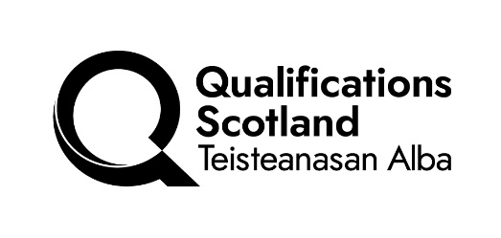

Validation Notification (DAVAL 1)

This form should be used by centres with devolved authority to validate AWDs/NCs/NPAs/HNC/Ds/PDAs and to request it/they be added to our Awards Processing System (APS).

Centre name |  |  | Centre number
Centre contact name |  |  | E-mail address:
Telephone number |  |  | Qualification type:
Qualification title: |  |  | SCQF level:
Country qualification will be delivered in:

Is there any specific delivery criteria necessary for any of the units in the Group Award for example, specific qualification, physical/specialist resources, legislative requirements and/or an examination/assessment administered on or on behalf of another agency? If there are, please provide details for the relevant units.
Unit Code | Unit Title | Specific Delivery Criteria

Revision of an existing Group Award?
Existing Code | Existing Title | Finish date to be applied
 |  | 31/07/20XX

(Insert centre name) has validated the Group Award(s) named above and associated graded units (where applicable) under its own devolved validation procedures. A copy of the signed validation report, Group Award Specification(s) and their associated graded units are included with this notification.

Signature of centre contact: Date: ______________

Print name: E-mail address:

Please e-mail this form and all attachments to: qpmteam@qualifications.gov.scot

Form: February 2026

