HN Administration and IT Network Event, February 2018

Digital Technologies for Administrators (HH82 34) – Web Analytics

The purpose of this document is to provide an example of Web Analytics in common use within a social software application (Facebook) to assist with delivery of the unit and illustrate the types of evidence that could be generated for assessment.
This is an illustrative guide, not a comprehensive teaching guide or assessment support pack. There are numerous possibilities for valid assessment of the unit and this document is intended to stimulate ideas among teachers and assessors that would best suit their own learners and resources available to them. The unit lends itself well to assessment by paper or e-portfolio.

Outcome 2 Investigate and explain the effective use of social software in the modern business environment
Outcome 3 Use web services and collaborative software to inform, plan and organise work
.

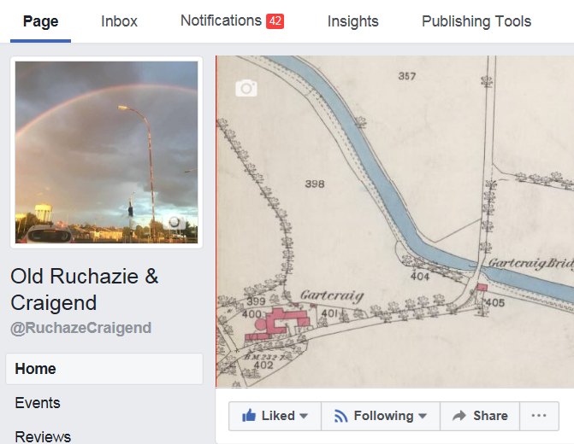

Web analytics are applications that allow traffic to websites to be measured and analysed. In its most basic form, web analytics provide information about the number of visitors to a website, what content was viewed, what visitors engaged with and some information about their characteristics (e.g. gender, age, location etc.). This can be used not only to help improve the website but as market research information.
Opposite is an example of web analytics within a Facebook Group page (as opposed to a personal Profile page) that an organisation may use to engage with people online. In Facebook, web analytics are embedded within Group pages with the title ‘Insights’. This provides the page administrator with valuable information on the number and characteristics of users engaging with the page.
This example concerns a page of historical interest not a commercially oriented page, however the principles of how it can be managed and used are the same. Facebook Group pages are free to create and use although additional functionality can be purchased.

Web analytics – Facebook Insights: Overview
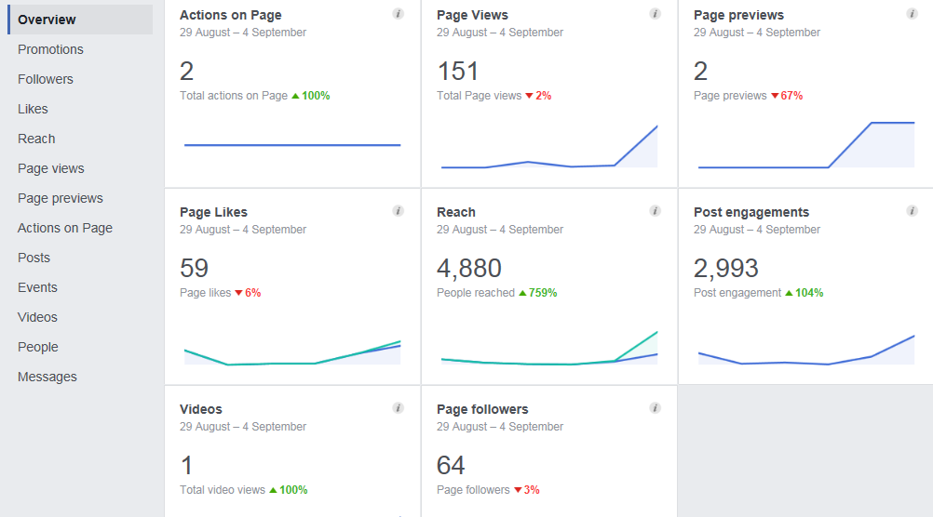

Actions on page clicks on interactive elements of the page (Contact info, email etc)
Page views Number of
Page Previews number of times people hovered over page name or photo for a preview of page content
Page likes number of times users liked the page
Reach no of people who viewed any page content, posts, comments, shares etc. not necessarily on the page itself (i.e. also includes views of shares by others).
Post engagements interactions (e.g. ‘likes’, shares, comments etc.) not necessarily on the page itself (i.e. includes interactions with shares on other pages).
Videos number of times videos have been viewed for more than 3 seconds
Page followers Number of those who are following the page at any given time. People may follow a page without liking and vice versa. Some people ‘like’ a page then unfollow due to too many messages taking up newsfeed, spam etc. but still retain an interest and will re-visit periodically.

Web analytics – Facebook Insights: Followers

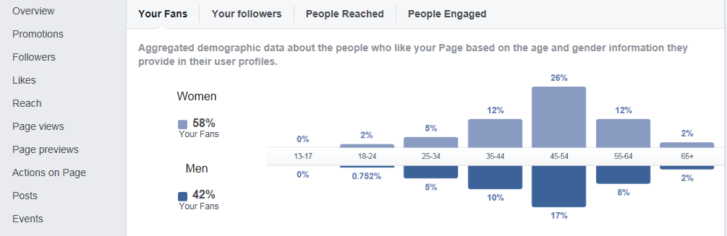

The Followers tab provides demographic information about visitors and subscribers to your page as well as the numbers and frequency of visitors, reaches and interactions.
Web analytics – Facebook Insights: Reach

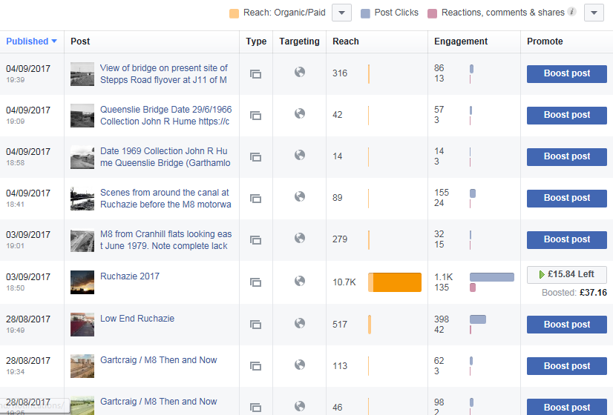
Reach indicates how many times each post has been viewed anywhere on Facebook (i.e. not necessarily on the Group page).
As illustrated opposite, the page administrator can see what the most and least popular posts are. This may be due to a number of factors – how attractive the content is to users, time of day of posting (i.e. at peak/off-peak usage times), the number of posts made at the same time (posts made in isolation may be more visible than one included in a batch), how often a post was shared elsewhere etc.
In this case, the effect of using a paid promotion can be seen. The most popular post is the one using this facility and has just over 20 times more views than the next most viewed post.
This information could be used to customise future posts to focus on things of most interest to the page users and even to select the kinds of promotions offered in future.
Web analytics – Facebook Insights: Promotions
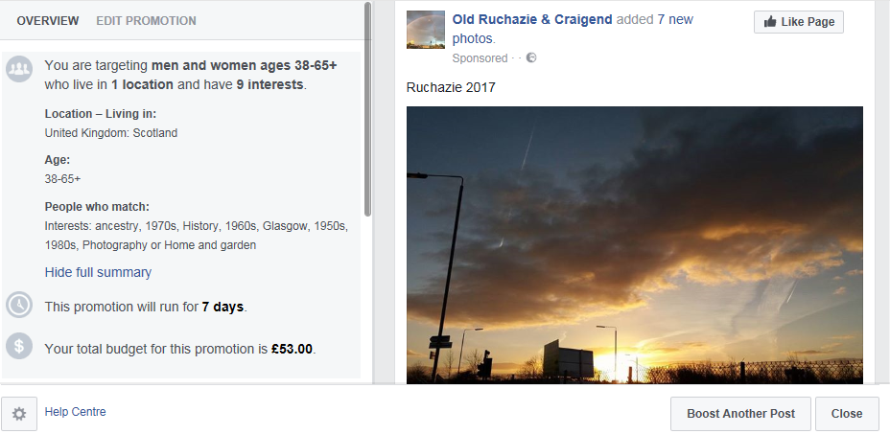
Web analytics can allow promotions to be targeted at certain groups. Facebook Insights includes the facility to target specific groups of users for a sliding scale payment. When creating a promotion, consideration should be given to the most likely groups who would be interested in the page /product /service / brand.
In this case men and women of ages over 38 years living in Scotland and with various interests e.g. 1960s, history, ancestry etc. were selected as those most likely to be interested in a page of historical interest. As well as age and interests, it was considered people within the geographic location of Scotland would be most likely to engage.
Pages and posts can be promoted in ways that don’t involve payment, for example, sharing links on other popular Facebook pages or on other social media platforms such as Twitter and Instagram to achieve a positive synergy. Different social software platforms do not exist in isolation from each other, content is constantly shared between them, e.g. YouTube clips on Facebook, LinkedIn updates shared via Twitter etc.
Web analytics – Facebook Insights: Promotions
SQA would not expect centres and learners to pay for additional functionality for any part of a unit, however it is useful for learners to be aware such options exist and for what purposes.
Learners could be encouraged to think about ways they could promote their social software page both within the software application itself and across other social media platforms.
This could be linked to some of the Evidence Requirements within Outcomes 2 and 3:

Outcome 2
- select two social software applications and explain and/or demonstrate the ways in which they could be used and their potential benefits to the organisation.

Learners could share content between two social software applications demonstrating the benefits of co-ordinated use of social software across platforms to engage with users and increase reach (e.g. sharing video content from Youtube via Facebook).

- explain and/or demonstrate correct etiquette when interacting in a professional capacity via social software and outline any legal considerations.

Learners should employ appropriate etiquette in content they post and language used and could provide a statement explaining the potential legal issues that need to be considered.
- explain and/or demonstrate the ways in which web analytics can be used to inform an organisation’s social media activity.

Learners could demonstrate how they used web analytics data to form a rationale for the actions they took to promote their page/event.

Outcome 3
A Facebook Group page could be used to organise and administer an event/meeting.
- Explain and/or demonstrate methods to verify the validity of information sourced or received via the internet.

Learners could demonstrate the methods used to verify any information they have sourced in the planning of the event/meeting.

- Explain and/or demonstrate the use of a web feed to source relevant information.
This could be linked to the above, with learners setting up an appropriate web feed (eg Reddit, Digg etc.) and explaining and/or providing a statement or information to explain the steps they took to establish this is a valid and reliable information source.
- Explain and/or demonstrate the use of a web service or software to organise a meeting or event involving three or more participants.

Facebook pages contain the functionality to invite others to an event or meeting. As well as invites the page can be used to share documents, discuss agenda/programmes and follow up actions. It should be possible for the entire event/meeting to be administered via a Facebook page or other web service or combination of web services.

Evidence

Achievement of the above could be evidenced via screenshots of these activities supplemented by statements as to the rationale for choices made and actions taken. This could be saved on a PC, data stick, Cloud-space (eg MS OneDrive), e-portfolio or printed on hard copy. Whatever method is chosen, evidence must be made available to SQA in the event of selection for External Verification.

Further Guidance:
https://www.facebook.com/business/a/page/page-insights
https://www.facebook.com/facebookmedia/get-started/page-insights
https://www.tutorialspoint.com/web_analytics/web_analytics_quick_guide.htm

