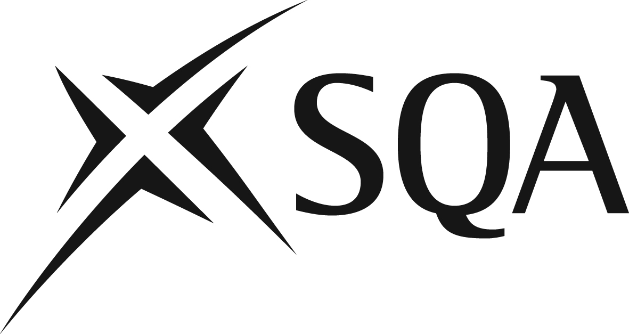

Notes Concerning Progression Data Sources
These tables represent the first formal release of annual progression information to be published on the SQA website. Progression information has previously been created within SQA in response to specific requests, some of which were later made available to a wider range of external stakeholders. Production of such progression information requires decisions to be made regarding the source of the data to be used (e.g. August or December attainment data), the data flags to be considered before any data are included, as well as the progression routes to be considered. Such decisions mean that there may be minor differences between the figures in this publication and what has previously been made available through SQA responses to specific requests and historical reports.

Attainment Statistics (December) data is used for all tables. This was referred to as ‘Post-Appeal’ data prior to the introduction of Post-results Services. Attainment Statistics (December) data includes all recorded course results after completion of Post-results Services.

These tables detail progression at the lower level of the qualification to each available graded result at the higher level of the qualification. Progression from an ungraded to graded National Qualification is only considered for National 4 to National 5, given that such qualifications were designed to be in a hierarchy and related further by the Recognising Positive Achievement arrangements. During the dual-running years where the new National Qualifications were available alongside the previous qualifications (Standard Grades, Intermediates, previous Higher and previous Advanced Higher), a number of progression pathways were possible.

In most instances, only subjects with a direct (intended by design) progression route are included. Typically, these progression routes will now involve a qualification at consecutive levels with the same qualification code. A small number of alternative subject progression routes are considered where the number of learners involved is moderate or high, and/or no direct progression is available between SCQF levels (e.g. Lifeskills Mathematics is not available at Higher level, so the progression route Lifeskills Mathematics National 5 to Mathematics Higher is presented). Cases where progression is between qualifications with different titles are explicitly detailed as ‘Qualification Name X to Qualification Name Y’. Where qualifications in the progression route share the same title, only the title is shown.

Qualifications are grouped in line with standard SQA statistical reporting titles (e.g. ‘Chinese Languages’ includes ‘Cantonese’, ‘Mandarin (Traditional)’ and ‘Mandarin (Simplified)’).

Where there are fewer than 20 candidates progressing from a given result at the lower level, no progression percentages are displayed (such candidates will be counted in the ‘Total Candidates Progressing Figure’, however). The ‘Total Students Progressing’ figure is split across all results at the lower level.

Tables are ordered alphabetically by the name of the qualification at the greater SCQF level of the progression route (e.g. National 5 ‘Biology’ to Higher ‘Human Biology’ is ordered by Higher ‘Human Biology’, as this is the greater level in that particular progression route).

