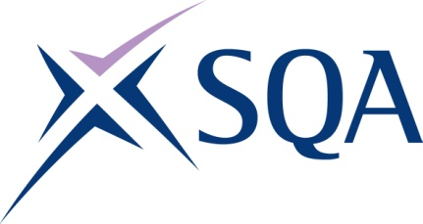
Qualification Structure for SQA Level 2
Diploma in Maritime Studies: Sea Fishing

SQA Qualification Code: GD29 60

Ofqual Qualification Code: 603/4893/8

Total Qualification Time: 386 hours
Minimum Guided Learning Hours: 348

Credit value: 39

To gain the qualification, learners must achieve a minimum total of 39 Credits by completing the THIRTEEN Mandatory Units (38 credits) plus ONE of the Optional units
(minimum of 1 Credit)

Learners may also complete the Additional Optional Unit, however, credit from this does not count towards achievement of the qualification.

Please note: It is important that the SQA Unit codes are used in all your recording documentation and when your results are communicated to SQA.

Mandatory Units: Learners must complete the THIRTEEN Mandatory units to achieve all 38 credits

SQA Unit Code | Unit Title | Regulator Unit code | Level | Credit value | GLH | TQT
FA5M 54 | Maritime Employment, Environmental and Health and Safety Practice | D/616/6877 | 2 | 2 | 18 | 20
FA69 54 | Maritime Sector Overview | R/616/6777 | 2 | 3 | 26 | 30
FA5N 54 | Survival in the Water During Maritime Emergencies | Y/602/3071 | 2 | 1 | 8 | 8
FA5P 54 | Maritime Security | K/602/3866 | 2 | 1 | 8 | 8
FA5R 54 | Emergency First Aid in Response to Maritime Accidents or Medical Emergencies | A/602/3872 | 2 | 1 | 7 | 7
FA68 54 | Communicate Using Equipment and Visual Means | J/602/4023 | 2 | 2 | 19 | 21
FA61 54 | Securing a Vessel for Passage | H/602/3901 | 2 | 3 | 26 | 20
FA63 54 | Assist with a Vessel's Navigational Watch | J/602/3907 | 2 | 3 | 30 | 34
FA60 54 | Vessel Ropework, Anchoring and Mooring Operations | K/602/3897 | 2 | 5 | 46 | 50
FA66 54 | Assemble, Operate and Maintain Fishing Gear | A/602/4021 | 2 | 5 | 46 | 50
FA67 54 | Receiving Handling and Stowing the Catch on a Fishing Vessel | F/602/4022 | 2 | 5 | 46 | 50
FA6C 54 | Maintain Your Own Work Practice | M/602/4436 | 2 | 2 | 16 | 20
FA62 54 | Vessel Construction and Stability | T/602/3904 | 2 | 5 | 44 | 50

Optional Units: Learners must also achieve a minimum of 1 credit by completing ONE of the Optional units

SQA Unit Code | Unit Title | Regulator Unit code | Level | Credit value | GLH | TQT
FA5T 54 | Vessel Fire Prevention and Fire Fighting (STCW) | T/502/5920 | 2 | 2 | 20 | 20
FA5V 54 | Maritime Fire Prevention and Fire Actions | D/602/3878 | 2 | 1 | 8 | 10

Additional Optional Units: Learners may complete this unit, however, credit from it does not count towards achievement of the qualification

SQA Unit Code | Unit Title | Regulator Unit code | Level | Credit value | GLH | TQT
FA6A 54 | Assist With Cooking on a Fishing Vessel | R/602/4025 | 2 | 2 | 18 | 20

