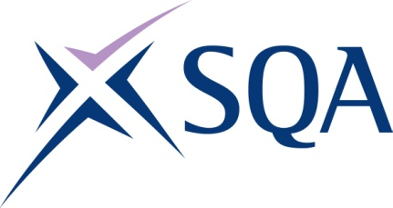

Qualification structure for SQA Level 2 Diploma in Maritime Studies: Marine Vessel Maintenance (Electro-Technical)

SQA Qualification Code: GD20 60

Ofqual’s Qualification Code: 603/4893/8

Total Qualification Time: 666 hours
Minimum Guided Learning Hours: 565

Credit value: 67

To gain the qualification, learners must complete the EIGHT Mandatory Units to achieve a total of 67 credits (666 TQT)

Please note: It is important that the SQA Unit codes are used in all your recording documentation and when your results are communicated to SQA.

Mandatory Core Units: Learners must achieve all 67 credits

SQA Unit Code | Unit Title | Regulator’s Unit code | Level | Credit value | GLH | TQT
FT2E 60 | Marine Vessel Electrical Installation | H/503/3446 | 2 | 10 | 90 | 100
FT2F 60 | Maintaining Electrical Equipment/Systems | L/616/6874 | 2 | 15 | 95 | 150
FT2G 60 | Marine Electrical Lighting and Control Systems | H/503/4144 | 3 | 5 | 44 | 50
FT2J 60 | Marine Vessel Electronic Systems Design and Test | K/503/4145 | 3 | 9 | 80 | 90
FT2K 60 | Marine Vessel Electronic Systems Assembly | T/503/4147 | 3 | 8 | 70 | 78
FT2L 60 | Marine Vessel Electronic Navigational Equipment Maintenance | K/503/4159 | 3 | 11 | 102 | 110
FT2M 60 | Marine Vessel Communications Systems | D/503/4160 | 3 | 6 | 56 | 58
FT2N 60 | Marine Vessel High Voltage Awareness | K/503/4162 | 3 | 3 | 28 | 30

