

ESOL Literacies: National 2

Daily life








Publishing information
First edition
Published date: March 2008
Publication code: BB4354

First Published 2008

Published by the Scottish Qualifications Authority
The Optima Building, 58 Robertson Street, Glasgow G2 8DQ
Ironmills Road, Dalkeith, Midlothian EH22 1LE

www.sqa.org.uk

The information in this publication may be reproduced in support of SQA qualifications. If it is reproduced, SQA should be clearly acknowledged as the source. If it is to be used for any other purpose, then written permission must be obtained from the Assessment Materials and Publishing Team at SQA. It must not be reproduced for trade or commercial purposes.

© Scottish Qualifications Authority 2008

Please note these materials have been repurposed for the new National Qualifications - August 2015
Contents and notes
Where appropriate, answer keys are included for learners to check their work. You should photocopy certain worksheets.
Page | Activity
1  *3 | Exercises for simple routines, including:  - picture and verb cards for matching, pelmanism etc  - writing practice
5 | - collocation circles; learners should be encouraged to add extra words if they know them
11 | - picture sentences, followed by flashcards for drilling; learners need to associate the image with the phrase before tackling the exercises which follow on page 21
25 | - word cards to be cut up and arranged by learners to make simple sentences. They can also be used for whole word recognition, matching (if two copies are made) and alphabet exercises. They can also be employed in the exercise which follows on page 27. This is useful writing practice for Literacies 2.
28 | Days of the week to be cut up and ordered, matched etc. Further cutting up into syllables may also be useful.
34 | Reading exercise: ‘This is Anna’, including:  - practice of third person ‘s’
38  40 | - a description of the ‘Look/Cover/Write/Check’ method, with a table on the following page which could be used with any new vocabulary  The use of phonemic symbols here and elsewhere is meant to be a guide only, and learners are not expected to know them. They correspond with standard Scottish pronunciation and occasionally differ from RP.
46 | Useful writing practice for Literacies 2
48 | Exercises on frequency adverbs using the theme of housework, including:
50 | - substitution tables to practise sentence and question formation
52 | More phonics work on vowels
54 | Frequency and times, including:
*57 | - reading exercise on identifying different genres of timetable/diary
* assessment practice

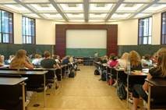1 | go to college/school
2 | go shopping
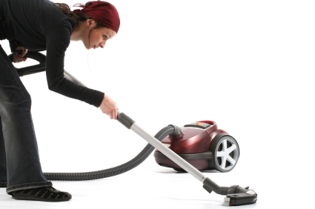3 | do the housework
4 | have dinner
5 | listen to music
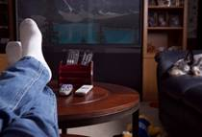6 | watch TV
Simple routines
Name: | Date:
What do you do on Mondays? Tick (✓) or cross (✗).
On Mondays, do you …
go to college/school?

go shopping?

do the housework?

have dinner?

listen to music?

watch TV?

Writing practice: Simple routines
Name: | Date:
Match the verbs with the other words.

go | dinner
go | TV
do | shopping
have | to music
listen | the housework
watch | to college/school

Now write about yourself, or copy from your teacher.

If the answer is yes (✓):  On Mondays I go to college. | If the answer is no (✗):  On Mondays I don’t go shopping.

______________________________________________

______________________________________________

______________________________________________

______________________________________________

______________________________________________

______________________________________________

Simple routines
Answer key
Match the verbs with the other words.

go | dinner
go | TV
do | shopping
have | to music
listen | the housework
watch | to college/school

Name: | Date:
Simple routines
What other words go together with these verbs? Do you know? There are some pictures to help. Write the words in the boxes. Write any extra words you know.
shopping
go

the housework
do

dinner
have

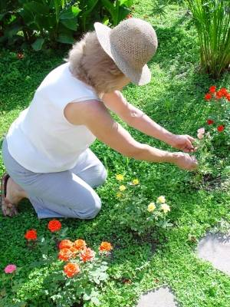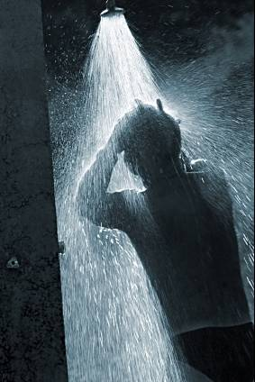
the gardening for a walk a shower


swimming homework a coffee

Answer key

 | shopping
go | swimming
 | for a walk

 | the housework
do | the gardening
 | homework

 | dinner
have | a shower
 | a coffee

Name: | Date:
Simple routines

If we talk about another person (he or she), the verb changes. We add ‘s’ or ‘es’.

I go shopping on Saturdays.

He goes shopping on Saturdays.

I don’t go shopping on Mondays.

She doesn’t go shopping on Mondays.

Match the verbs for ‘I’ with the verbs for ‘he’ and ‘she’. Check the new verbs with your teacher.

I | he/she
go | watches
do | speaks
have | eats
listen | writes
watch | does
eat | has
speak | reads
visit | goes
read | visits
write | listens

Answer key
Match the verbs for ‘I’ with the verbs for ‘he’ and ‘she’.

I | he/she
go | watches
do | speaks
have | eats
listen | writes
watch | does
eat | has
speak | reads
visit | goes
read | visits
write | listens

Name: | Date:
Word search
Find the verbs below, with ‘s’ and with no ‘s’. Words can go along or down . One has been found for you.

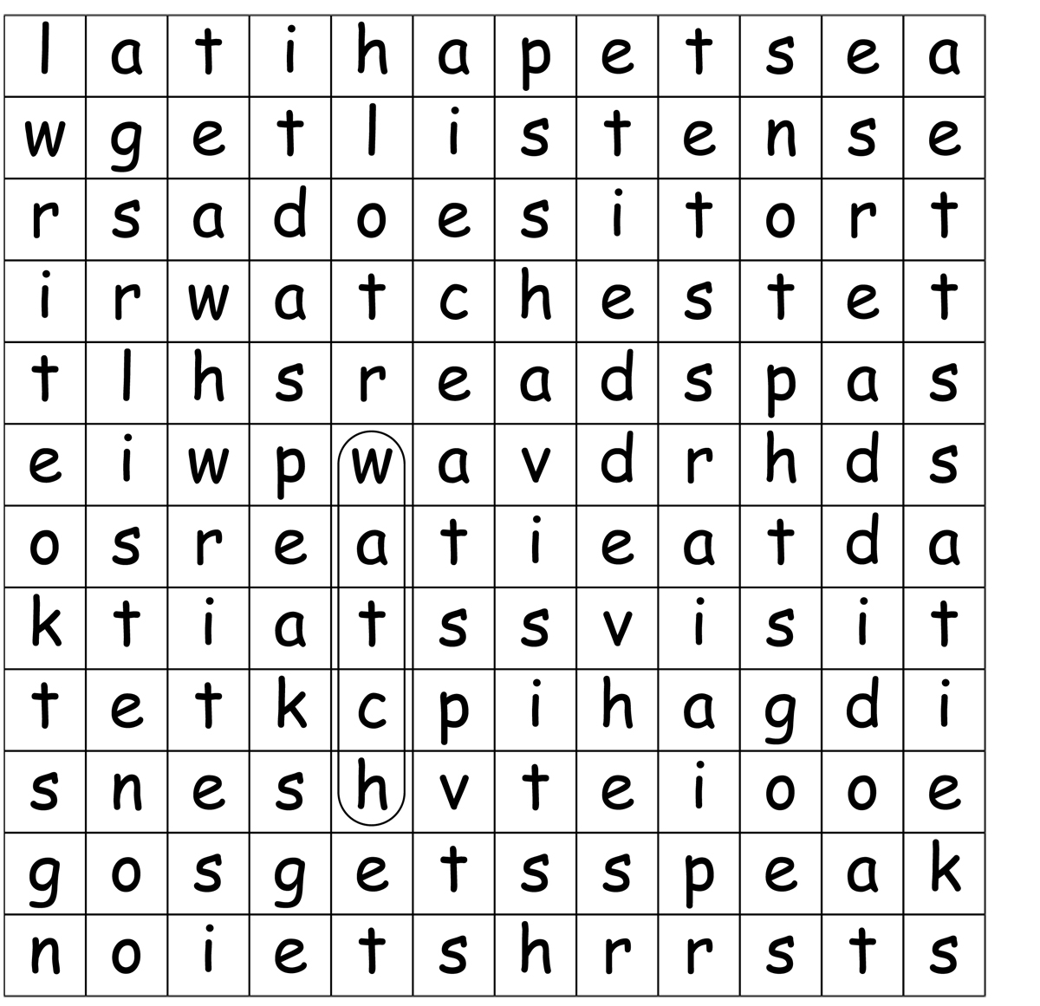

Answer key
Word search

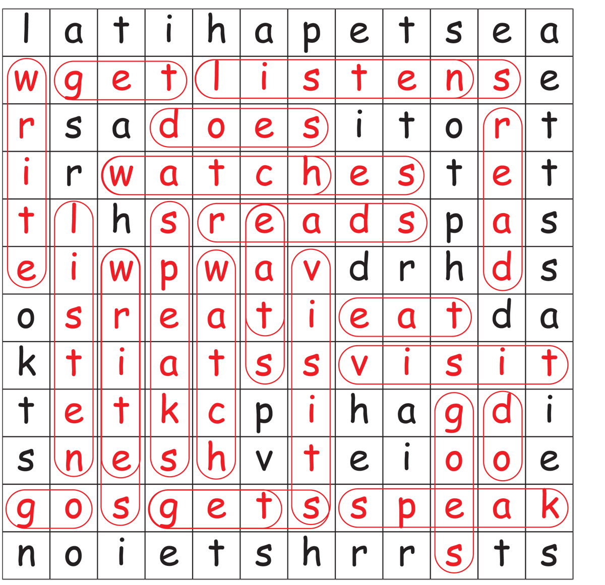

Name: | Date:
Think about every day. When do you do things?

In the …

  morning |   afternoon |   evening

Read with your teacher. Look at the pictures. Copy the sentences.
I
I | go to college | in the morning.

_______________________________________

I
I | don’t go to college | in the afternoon.

_______________________________________

Name: | Date:


He | listens to music | in the evening.

_______________________________________________

*
He | doesn’t listen to music | in the afternoon.

_____________________________________________

*
She | has a shower | in the morning.

_____________________________________________

She | doesn’t have a shower | in the evening.

_____________________________________________

I

 | 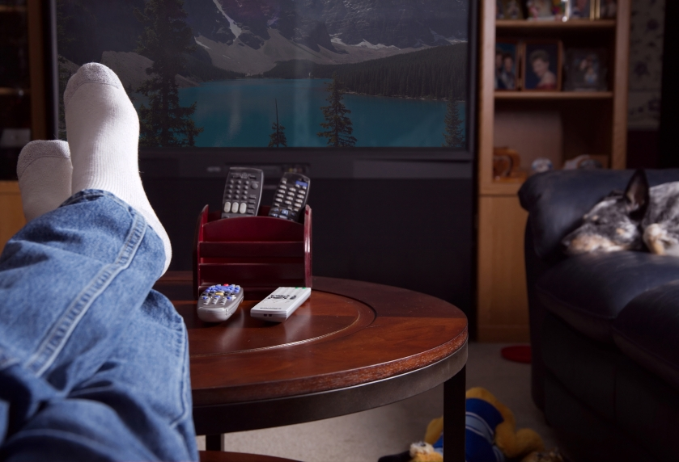

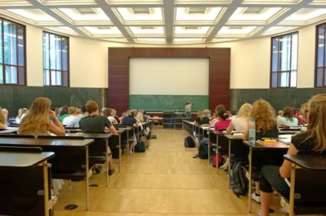 | 

 | 



Name; | Date:

Match the pictures to the sentences.

 |  | I don’t have coffee in the evening.
I |  | I do housework in the morning.
 |  | He has a shower in the evening.
I |  | He doesn’t watch TV in the afternoon.
 |  | She does homework in the evening.

Answer key

 |  | I don’t have coffee in the evening.
I |  | I do housework in the morning.
 |  | He has a shower in the evening.
I |  | He doesn’t watch TV in the afternoon.
 |  | She does homework in the evening.

Name: | Date:
Look at the pictures. Write sentences using the pictures.

1 I

_________________________________
2 I

_________________________________
3

_________________________________
4

_________________________________
5

_________________________________
6

_________________________________

Answer key
1 I go shopping in the afternoon.

2 I don’t listen to music in the morning.

3 She goes swimming in the afternoon.

4 She doesn’t go shopping in the morning.

5 He doesn’t have dinner in the morning.

6 He watches TV in the evening.

I | He | She | go | goes
do | does | have | has | listen
listens | watch | watches | visit | visits
friends | to music | shopping | to college | housework
homework | dinner | a coffee | TV | don’t
doesn’t | in | the | morning | afternoon
evening | on | Mondays | Tuesdays | Wednesdays
Thursdays | Fridays | Saturdays | Sundays

Name: | Date:

What do the other students do on Saturdays? Tick (✓) or cross (✗) the answers for two friends.

Do you …

Write two names here
go to college/ school?
go shopping?
do the housework?
have dinner?
listen to music?
watch TV?
Do you go to college on Saturdays?
Yes I do. ✓

W
No I don’t. ✗

Name: | Date:
Write some true sentences about you and your friends. You can:
- speak to the teacher and copy what she writes for you
or
- use the cards your teacher gives you to make sentences and copy them. You can write your friends’ names on the blank cards.
or
- write sentences for yourself, then check with your teacher.

____________________________________________

____________________________________________

____________________________________________

____________________________________________

____________________________________________

____________________________________________

____________________________________________

____________________________________________

____________________________________________

Days of the week

Monday
Tuesday
Wednesday
Thursday
Friday
Saturday
Sunday

Days of the week

MONDAY
TUESDAY
WEDNESDAY
THURSDAY
FRIDAY
SATURDAY
SUNDAY

Name: | Date:

Days of the week
Can you fit the days of the week into the shapes? They are in small letters, but remember the first letter is always a capital!

1

2

3

4

5

6

7

Answer key
Days of the week

1

2

3

4

5

6

7

Note: answers for numbers 2 and 7 are interchangeable
.

Name: | Date:
Days of the week word search
Can you find all the days of the week here? They are in CAPITAL letters. One has been found for you.

Answer key
Days of the week word search

Name: | Date:
This is Anna.

Anna is a teacher at Shettleston College.
She works Monday to Friday. She teaches classes at college in the mornings. She doesn’t teach on Tuesday and Thursday afternoons. She works in the office on Tuesday and Thursday afternoons.

On Thursday evenings she goes to exercise classes. On Saturdays she cleans her house and relaxes in the evening. On Sundays she visits her friends.

Answer the questions.

1 Where does Anna work? ______________________

2 When does she teach? ______________________

3 When does she work in the office? ______________

4 When does she go to exercise classes? __________

5 What does she do at the weekends? ______________

Answer key
This is Anna.

1 At Shettleston College.

2 In the mornings.

3 On Tuesday and Thursday afternoons.

4 On Thursday evenings.

5 On Saturdays she cleans her house then relaxes in the evening. On Sundays she visits her friends.

Name: | Date:
This is Anna.
Study the text again. Now put the verbs back in the text below.

Anna is a teacher at Shettleston College.
She _____ Monday to Friday. She ______ classes at college in the mornings. She doesn’t _____ on Tuesday and Thursday afternoons. She _____ in the office on Tuesday and Thursday afternoons.

On Thursday evenings she _____ to exercise classes. On Saturdays she _____ her house and _______ in the evening. On Sundays she ______ her friends.

Now write the two forms of each verb: for ‘I’ and for ‘He’ or ‘She’.

I | he/she
work | works

Answer key
This is Anna.

Anna is a teacher at Shettleston College.
She works Monday to Friday. She teaches classes at college in the mornings. She doesn’t teach on Tuesday and Thursday afternoons. She works in the office on Tuesday and Thursday afternoons.

On Thursday evenings she goes to exercise classes. On Saturdays she cleans her house and relaxes in the evening. On Sundays she visits her friends.

I | he/she
work  teach  go  clean  relax  visit | works  teaches  goes  clean  relaxes  visits

Name: | Date:
Fill in the missing vowels from Anna’s day.

1 S_turday | 2 t_ _cher | 3 _xercise | 4 cl_sses
5 _ffice | 6 S_nday | 7 m_rnings | 8 v_s_ts
9 rel_xes | 10 aftern_ _n | 11 cl_ _ns | 12 th_s

With your teacher, choose some words from ‘This is Anna’ to learn the spelling. First, copy the word and:

- look  at the word

then

- cover the word

then

- write  the word

then

- look again and check to see if you are correct.

Name: | Date:
Look, cover, write and check.

Copy,  look  and  cover | Write  and  check | Copy,  look  and  cover  again | Write  and  check  again

Name: | Date:
Answer these questions about the ‘This is Anna’ text.

1 How many different verbs can you find? Which ones end in the spelling ‘s’ and which ones end in ‘es’?

-s | -es

2 With your teacher, practise saying the verbs. What is the sound at the end? Is it /s/, /z/ or /ɪz/?

/s/ | /z/ | /ɪz/

Now think about other sounds.
3 How many times can you see ch? What ‘s the sound?

4 How many times can you see th? What’s the sound?

5 How many times can you see sh? What’s the sound?

6 How many times can you see oo? What’s the sound?

7 How many times can you see ee? What’s the sound?

Answer key
Vowel exercise
1 Saturday | 2 teacher | 3 exercise | 4 classes
5 office | 6 Sunday | 7 mornings | 8 visits
9 relaxes | 10 afternoon | 11 cleans | 12 this

‘This is Anna’
1 Spelling:
-s | -es
is  works  cleans  visits | teaches  goes  relaxes

2 Sound:
/s/ | /z/ | /ɪz/
works  visits | is  cleans  goes | teaches  relaxes

Usually, when ‘es’ comes after ch, sh or x, you say it like /ɪz/.

When ‘es’ comes after a vowel (like in goes or does), you say it like /z/.

Answer key
3 How many times can you see ch? What ‘s the sound?
Three times: ‘teacher’, ‘teaches’ and ‘teach’. The sound is /tʃ/.

4 How many times can you see th? What’s the sound?
Seven times: ‘this’, ‘the’ (three times) and ‘Thursday’. The sound is /ð/ for ‘this’ and ‘the’ and /θ/ for ‘Thursday’.

5 How many times can you see sh? What’s the sound?
Nine times: ‘she’ (eight times) and ‘Shettleston’. The sound is /ʃ/.

6 How many times can you see oo? What’s the sound?
Two times: ‘afternoons’ (two times). The sound is /uː/, but some words with ‘oo’ have a different sound, like ‘door’ and floor’ (/ɔ:/).

7 How many times can you see ee? What’s the sound?
Four times: ‘teacher’, teaches’, teach’ and ‘cleans’. The sound here is /iː/ but some other words with ‘ea’ have a different sound, like ‘bread’ and ‘head’ (/e/).

Name: | Date:
Look at the vowel sounds and spelling. Say them with your teacher.

1 | /æ/ as in apple, hat, cat
2 | /e/ as in egg, elephant, bed, bread
3 | /ɪ/ as in India, Iraq, sit
4 | /ɒ/ as in bottle, orange, cot
5 | /ʌ/ as in umbrella, but, Monday, work
6 | /uː / as in boot, foot, school
7 | /iː/ as in feet, street, teacher

Name: | Date:
Match the words together.

go | the house
do | at home
clean | my homework
visit | to class
relax | friends

Now write some sentences about yourself. Put the day or time of day at the end of the sentence.

… on Monday. | … on Tuesday afternoons. | … Monday to Friday.
… every day. | … every morning. | … every evening.

For example:

I go to class Monday to Friday.

I clean the house ____________________________

I visit my friends ____________________________

I relax ____________________________________

I ________________________________________

_________________________________________

Answer key

go | the house
do | at home
clean | my homework
visit | to class
relax | friends

Name: | Date:
Let’s do the housework! Write the words with the pictures.
sew wash the dishes sweep the floor
hoover make the bed mop the floor
dust do the ironing

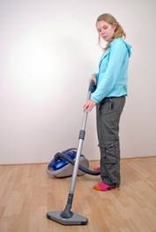



_____________ ___________ ___________


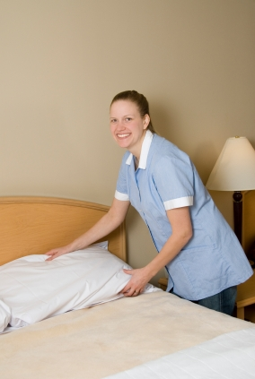
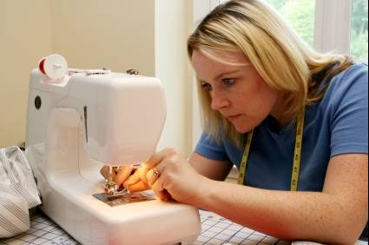

_____________ ___________ ____________


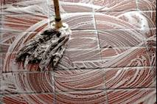

_____________ ______________

Answer key
Let’s do the housework!

hoover dust wash the dishes

make the bed sweep the floor sew

do the ironing mop the floor

Name: | Date:
Making questions

Do you |  | dust  do the ironing  sew  mop the floor  hoover  make the beds | at the weekend?
Does | she  he |  | at the weekend?

Answering
0%
10%
50%
80%
100%

No, never.
Yes,
sometimes.
Yes,
usually.
Yes,
always.
No, not usually.

Making sentences

I | never | dust  do the ironing  sew  wash the floor  hoover  make the beds | at the weekend.
I | sometimes  usually  always |  | at the weekend.

She  He | never | dusts  does the ironing  sews  washes the floor  hoovers  makes the beds | at the weekend.
She  He | sometimes  usually  always |  | at the weekend.

For ‘not usually’, we make sentences with ‘don’t’ or ‘doesn’t’. There is no ‘s’ on the verb with ‘he’ or ‘she’.

I don’t usually dust at the weekend.

She doesn’t usually dust at the weekend.

He doesn’t usually hoover at the weekend.

Name: | Date:
Speak to another student and ask them about housework! Tick the answers.
At the weekend do you …? | never  0% | not usually  10% | sometimes  50% | usually  80% | always  100%
dust?
iron?
sew?
mop?
hoover?
make the beds?

Name: | Date:
Write some true sentences about you and your partner. You can:

- speak to the teacher and copy what she writes for you

- use the table on page 48–49 to help you make up sentences. You can write your friend’s name instead of ‘he’ or ‘she’.

- write sentences for yourself, then check with your teacher.

For example:

I never make the beds at the weekend.
Mariam always hoovers at the weekend.

____________________________________________

____________________________________________

____________________________________________

____________________________________________

____________________________________________

____________________________________________

____________________________________________

____________________________________________

Name: | Date:
More vowels

1 Read these words or listen to your teacher. Then write the words under the correct sound. The main stress has been underlined where required.
meet train shop foot bus read
school jumper take dog job teach
Monday move want she rain see
mop /ɒ/ | dust /ʌ/ | feed /iː/ | hoover /uː/ | make /eɪ/

2 Can you think of more words with the same sounds?

3 Which sounds are long, and which are short?

4 What happens when you put ‘e’ at the end of a word?

mat + e = mate not + e = note fin + e = fine

Answer key
More vowels
1
mop /ɒ/ | dust /ʌ/ | feed /iː/ | hoover /uː/ | make /eɪ/
shop  dog  job  want | bus  jumper  Monday | meet  read  teach  she  see | foot  school  move | train  take  rain

3 Mop and dust are short; the others are long.

4 The vowel becomes long. It has the same sound as the alphabet name, for example:

mat = /æ/ mate = /eɪ/ A = /eɪ/

Name: | Date:
Frequency and times

Mon | Tue | Wed | Thu | Fri | Sat | Sun
● | ● | ● | ● | ● | ● | ●
Once a day

Mon | Tue | Wed | Thu | Fri | Sat | Sun
●● | ●● | ●● | ●● | ●● | ●● | ●●
Twice a day

Mon | Tue | Wed | Thu | Fri | Sat | Sun
●●● | ●●● | ●●● | ●●● | ●●● | ●●● | ●●●
Three times a day

Mon | Tue | Wed | Thu | Fri | Sat | Sun
 | ●
Once a week

Twice a week
Mon | Tue | Wed | Thu | Fri | Sat | Sun
 | ● |  |  |  | ●

Now draw the dots for these phrases:

a) Three times a week
Mon | Tue | Wed | Thu | Fri | Sat | Sun

b) Four times a day
Mon | Tue | Wed | Thu | Fri | Sat | Sun

Name: | Date:
Frequency and times

Write the answers to these questions with a partner or your teacher.
Mon | Tue | Wed | Thu | Fri | Sat | Sun
1 How many days are in a week?
___________________________

2 In one day, how many times do you brush your teeth?
___________________________
3 In one day, how many times do you have coffee or tea?
___________________________

4 In one day, how many times do you use a telephone?
___________________________
5 In one week, how many times do you come to English class?
___________________________
6 In one week, how many times do you go shopping?
___________________________

Answer key
1 Seven

2-6 Different students will have different answers!

a) Three times a week
Mon | Tue | Wed | Thu | Fri | Sat | Sun
● |  |  | ● |  |  | ●

(or any three days)

b) Four times a day
Mon | Tue | Wed | Thu | Fri | Sat | Sun
●●●● | ●●●● | ●●●● | ●●●● | ●●●● | ●●●● | ●●●●

Name: | Date:
Read the three texts (A to C) and answer the questions on page 59.

A
 | Morning | Afternoon
Monday | maths | English
Tuesday | maths | computing
Wednesday | English | science
Thursday | music | science
Friday | music | art

B
 | Monday–Friday |  | Saturday |  | Sunday
City Centre | 10:00 | 10:30 | 10:00 | 10:20 | 09:30 | 10:30
Meadowbank | 10:15 | 10:45 | 10:15 | 10:35 | 09:40 | 10:40
King’s Road | 10:20 | 10:50 | 10:20 | 10:40 | 09:43 | 10:43

C
March | 9 am | 10 am | 11 am | 12 pm | 1 pm
Monday  12th | dentist | work |  |  | lunch
Tuesday  13th | shopping | work |  |  | lunch
Wednesday 14th | take John to doctor | meet Sara for coffee |  |  | lunch
Thursday  15th |  | work |  |  | lunch
Friday  16th |  | work |  | lunch | football

Name: | Date:
1 Write the correct letter (A, B or C). Which text is:
- a diary? ____

- a school or college timetable? ____

- a bus timetable? ___

2 Look at A. How many times a week is computing?
_______________

3 Look at B. Does a bus leave the city centre at 10:00 on Sunday? _________________

4 On Saturday, what time does the 10:20 bus arrive at King’s Road? ___________________

5 Look at C. How many days a week does this person work?
_____________________

6 When do they play football?
_________________________

Answer key

1 a) C b) A c) B

2 Once a week

3 No

4 10:40

5 Four

6 On Friday at 1 pm

All photos © istockphoto.com

Cover - Quavondo Nguyen

p.1
1 – Dr Heinz Linke
2 – Lisa Gagne
3 – Walik
4 – Sandra O’Clarke
5 – Suprijono Suharjoto
6 – Curt Pickens

p.5
Gardening – Angelafoto
Walk - Jonathan Cook
Shower - Zsolt Biczo
Swimming – ShaneKato
Homework - Aldo Murillo
Coffee - Nicky Gordon

p.11
Morning - Jill Fromer
Afternoon - Luis Carlos Torres
Evening - Evgeny Kuzmenko

p.12
Asian businessman - Quavondo Nguyen
Girl in window - Juan Estey

p.34
Anna - Michael Kemter

p.38
Eye - lucwa
Hand - Petko Danov
Pen - Dejan Nikolic

p.43
1 – Diane Steffes
2 – Diane Rutt
3 – Marisa Allegra Williams
4 – mjp
5 – Jzsef Szasz-Fabian
6 – adam muir
7 – Brian Chase

p.46
Hoover - Niels Laan
Dust - Glenda Powers
Wash dishes - Christian Pound
Make bed – Vicki Reid
Sweep floor - Glenda Powers
Sew - Brad Killer
Iron - Claudia Dewald
Mop the floor - saied shahin kia

p.55
Brushing teeth – Jelani Memory
Woman on telephone – Rebecca Ellis

