

ESOL Literacies: National 2

Health

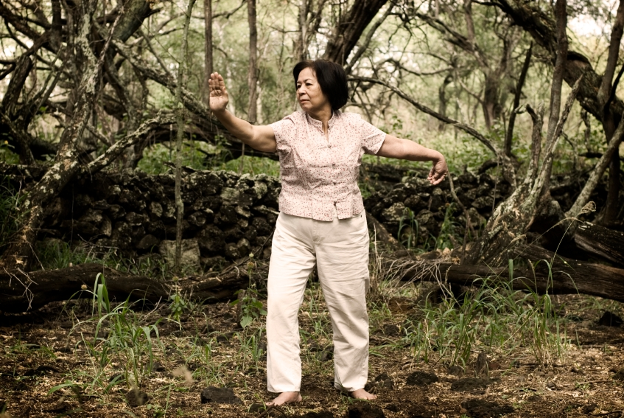






Publishing information
First edition
Published date: March 2008
Publication code: BB4354

First Published 2008

Published by the Scottish Qualifications Authority
The Optima Building, 58 Robertson Street, Glasgow G2 8DQ
Ironmills Road, Dalkeith, Midlothian EH22 1LE

www.sqa.org.uk

The information in this publication may be reproduced in support of SQA qualifications. If it is reproduced, SQA should be clearly acknowledged as the source. If it is to be used for any other purpose, then written permission must be obtained from the Assessment Materials and Publishing Team at SQA. It must not be reproduced for trade or commercial purposes.

© Scottish Qualifications Authority 2008

Please note these materials have been repurposed for the new National Qualifications - August 2015
Contents and notes
Where appropriate, answer keys are included for learners to check their work. You should photocopy certain worksheets.

Page | Activity
1 | Introduction to topic. Picture/word match.
3 | Making an appointment. Dialogue for learners to listen to and read. Cut up and reorder dialogue then complete the appointment card. Practise the dialogue.
*4 | Reading task. Surgery opening times.
6 | Body vocabulary. Match the words to the parts of the body. Spelling practice.
11 | Cue cards for explaining symptoms. Structures and pictures/words for eliciting and practising vocabulary and various matching activities, eg pelmanism, card games, spelling.
17 | Listen and identify symptoms by numbering pictures. Tapescript included.
21 | Short dialogue to read and practise using symptom cue cards. Follow–up writing exercise with cue cards to copy.
25 | Practice of ‘It hurts when I …’ is needed before students can complete this worksheet.
*27 | Listening task to complete a form and multiple choice questions. Two levels of worksheets for the questions — one with picture cues. Tapescript included.
31 | Naming medicines. If possible bring in real medicines to identify and then follow up with this worksheet.
33 | Cue cards of written instructions and pictures for eliciting and matching. Pre–teach and demonstrate, eg ‘apply’ verbs. Worksheet.

38 | Pre–teach new vocabulary such as ‘temperature’ and ‘home visit’. Listening task. Identify problem. Tapescript included.
43 | Spelling/phonics: ‘oa’ and ‘o–e’. Match words to pictures.
45 | Reading exercise with various tasks. Pre–teach new vocabulary.
*50 | Writing practice.
*52 | Identify hospital signs.
*55 | Get information from medicine labels.
* assessment practice

Name: | Date:

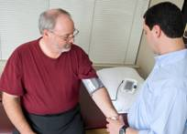 | doctor
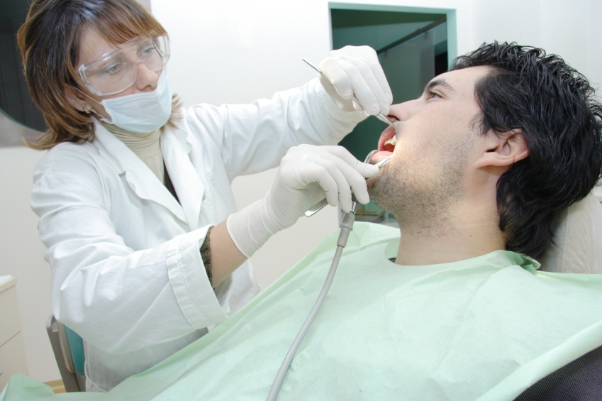 | dentist
 | nurse

What is a GP? _________________________________

What is your GP’s name? ___________________________

What is your dentist’s name? ________________________

HEALTH
CENTRE

MEDICAL
PRACTICE

DENTAL
PRACTICE

HOSPITAL

Name: | Date:
Making an appointment



Listen and read.
Receptionist: Good morning. City Medical Practice.
Patient: Hello. I’d like to make an appointment please.
Receptionist: Can I have your name?
Patient: Najma Kauser.
Receptionist: How do you spell your surname, please?
Patient: K – a – u – s – e – r
Receptionist: How about ten past three tomorrow with
Dr Brown?
Patient: Ten past three on Thursday. That’s fine.
Thank you.
Receptionist: OK. Bye.
Patient: Bye.

Fill in the patient’s appointment card.
City Medical Practice
Appointment Card
Patient’s name: ___________________________
Day | With | Time
 | Dr____________

Now practise making an appointment.

Name: | Date:
Look at the text and answer the questions.
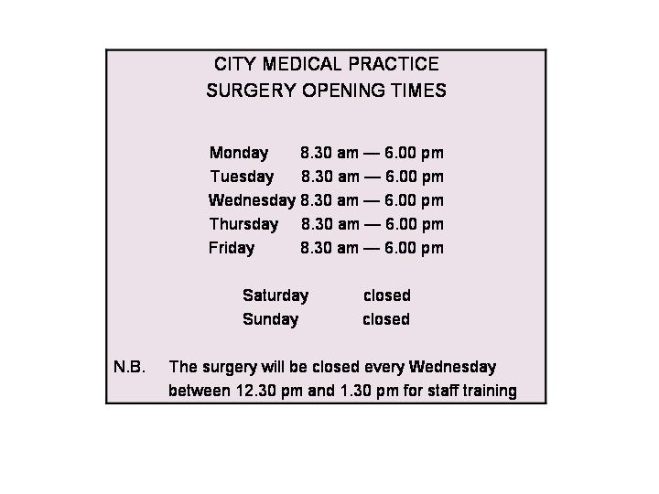
Circle T (True) or F (False).

1 You can see your doctor at these times. T F
2 The surgery is open seven days a week. T F
3 You can’t get an appointment after six o’clock. T F
4 The surgery is closed for one hour at lunchtime
on Wednesdays. T F

Answer key
Look at the text and answer the questions.
Circle T (True) or F (False).

1 You can see your doctor at these times. T F

2 The surgery is open seven days a week. T F

3 You can’t get an appointment after six o’clock. T F

4 The surgery is closed for one hour at lunchtime on Wednesdays. T F

Name: | Date:
Number the parts of the body.

1 stomach 2 foot 3 hand 4 leg
5 back 6 arm 7 ear 8 head
9 eye 10 neck 11 chest 12 mouth
13 knee 14 finger 15 nose 16 ankle

Answer key

Number the parts of the body.

1 stomach 2 foot 3 hand 4 leg
5 back 6 arm 7 ear 8 head
9 eye 10 neck 11 chest 12 mouth
13 knee 14 finger 15 nose 16 ankle

9
15
12
7
11
1
4
13
8
10
5
6
14
16
2
3

Name: | Date:
Circle the correct spelling.

1 | nek | kcen | neck | nekc
2 | leck | lig | lihg | leg
3 | ir | ear | era | eir
4 | muoth | mouth | mout | motuh
5 | ankle | angul | anke | enkle
6 | bakk | beck | back | bek
7 | knee | kne | kene | nee
8 | haed | head | hed | hade
9 | arrm | amr | arm | erm
10 | fingir | fingor | finker | finger
11 | eye | eey | aye | eyee
12 | nois | nose | noes | knose
13 | chast | chist | ches | chest
14 | hand | hadn | hund | hend
15 | somach | stumach | stomak | stomach
16 | fout | foot | fuut | fot
Now copy the correct spelling in your notebook.

Name: | Date:
Put in the missing vowels: a, e, i, o, u.

1 h __ __ d 2 l __ g

3 __ __ r 4 m __ __ th

5 h __ nd 6 __ y __

7 __ nkl __ 8 kn __ __

9 b __ ck 10 ch __ st

11 st __ m __ ch 12 f __ ng __ r

13 n __ s __ 14 f __ __ t

15 __ rm 16 n __ ck

Answer key
Circle the correct spelling.
1 | nek | kcen | neck | nekc
2 | leck | lig | lihg | leg
3 | ir | ear | era | eir
4 | muoth | mouth | mout | motuh
5 | ankle | angul | anke | enkle
6 | bakk | beck | back | bek
7 | knee | kne | kene | nee
8 | haed | head | hed | hade
9 | arrm | amr | arm | erm
10 | fingir | fingor | finker | finger
11 | eye | eey | aye | eyee
12 | nois | nose | noes | knose
13 | chast | chist | ches | chest
14 | hand | hadn | hund | hend
15 | somach | stumach | stomak | stomach
16 | fout | foot | fuut | fot
Put in the missing vowels.
1 head 2 leg
3 ear 4 mouth
5 hand 6 eye
7 ankle 8 knee
9 back 10 chest
11 stomach 12 finger
13 nose 14 foot
15 arm 16 neck

I’ve got …

I feel …

What’s the matter?

What’s
wrong?

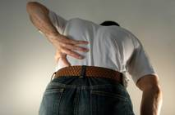 | 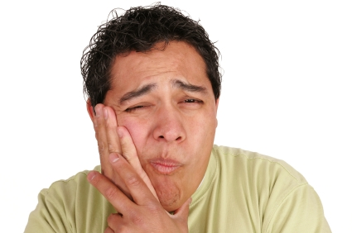
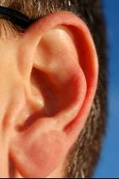 | 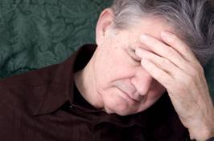
 | 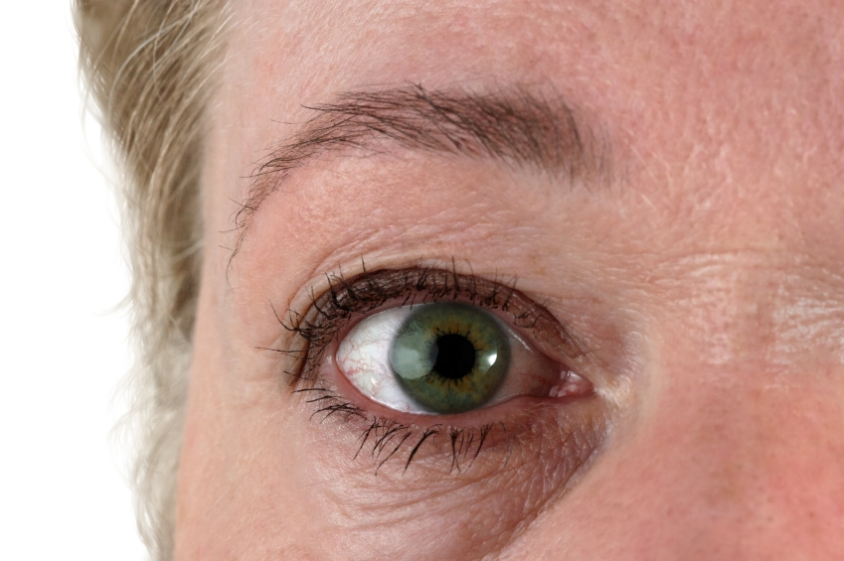
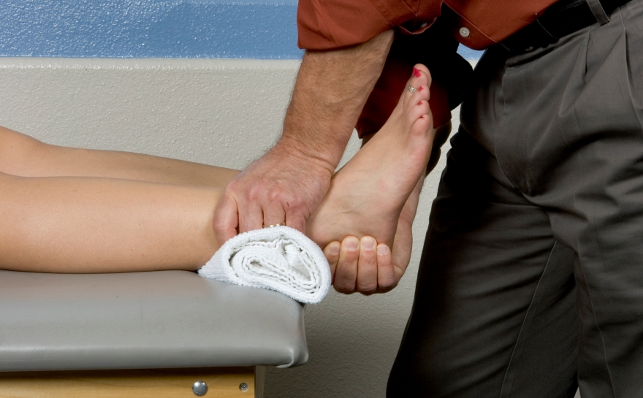 | 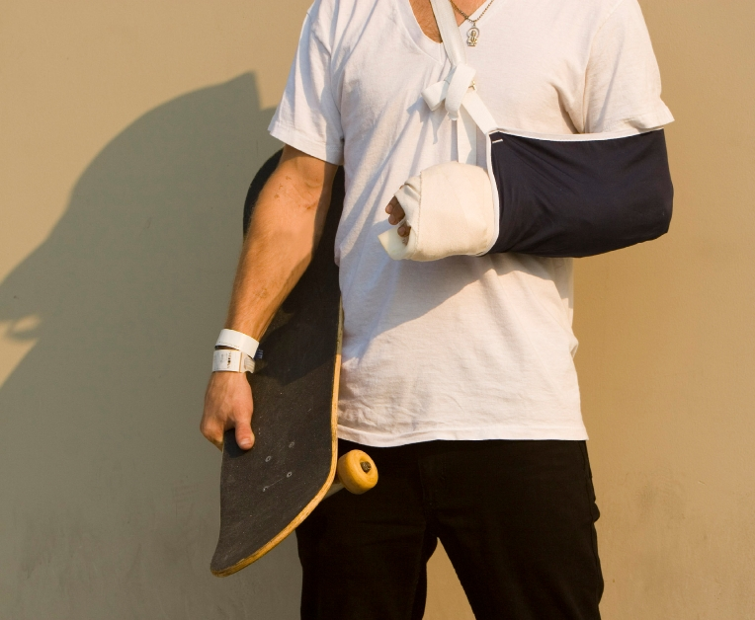

toothache | backache
a headache | earache
a sore eye | a stomach ache
a sore arm | a sore ankle

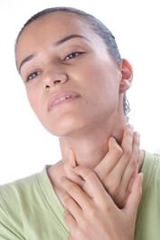 | 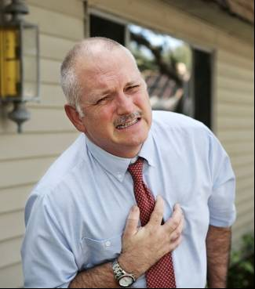
 | 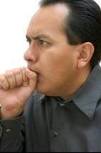
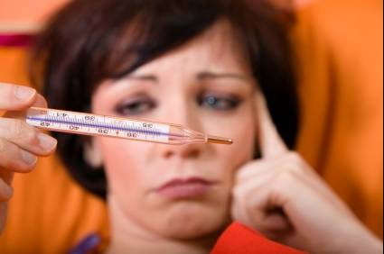 | 

a sore chest | a sore throat
sick | a cold
a cough | a temperature

Name: | Date:
Listen and write the number below the pictures.
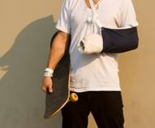

__________ | __________ | __________ | __________
__________ | __________ | __________ | __________
 | 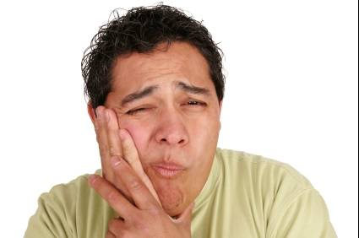
__________ | __________ | __________ | __________
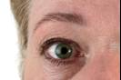 | 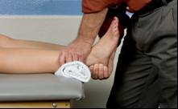
__________ | __________

Tapescript

1 What’s the matter?
I’ve got earache.

2 What’s wrong?
I’ve got a sore chest.

3 What happened to you?
I fell. I’ve got a sore ankle.

4 What’s the problem?
I’ve got a sore throat.

5 Ooh, I ate too much. I’ve got a stomach ache!

6 What’s the matter?
I feel sick.

7 You don’t look very well.
I’ve got a bad cold.

8 Are you OK?
I’ve got a headache. Have you got any tablets?

Tapescript
9 You look tired.
I didn’t sleep well last night. I’ve got a cough.

10 I’ve got a sore eye. It hurts when I blink.

11 I can’t eat or drink anything. I’ve got toothache.

12 I feel really hot. I’ve got a temperature.

13 What happened to you?
I fell and hurt my arm.

14 I can hardly move. I’ve got backache.

Answer key
Listen and write the number below the pictures.
13 | 2 | 12 | 8
5 | 1 | 6 | 14
7 | 11 | 9 | 4
10 | 3

Name: | Date:
Listen …

A Hello, how are you?

B I’m fine thanks. And you?

A Not very well. I’ve got a cold.

B Oh dear! I hope you feel better soon.

A Thank you.

Practise the dialogue with a partner. Your teacher will give you cue cards.

Name: | Date:
What’s the matter?

I’ve got a headache.

1 |  | What’s the matter?  I’ve got _____________________
2 |  | What’s the matter?  I’ve got _____________________
3 |  | What’s the matter?  I’ve got _____________________
4 |  | What’s the matter?  I’ve got _____________________
5 |  | What’s the matter?  I’ve got _____________________
6 |  | What’s the matter?  I feel _____________________

I’ve got a cold.

I’ve got earache.

I’ve got toothache.

I’ve got a cough.

I’ve got a sore throat.

I feel sick.

Answer key
What’s the matter?

I’ve got a headache.

1 |  | What’s the matter?  I’ve got a cold.
2 |  | What’s the matter?  I’ve got earache.
3 |  | What’s the matter?  I’ve got toothache.
4 |  | What’s the matter?  I’ve got a cough.
5 |  | What’s the matter?  I’ve got a sore throat.
6 |  | What’s the matter?  I feel sick.

Name: | Date:
Say what’s wrong and when it hurts
I’ve got backache.
It hurts when I bend.
eg

Use the words in the box to help you.

eat walk cough swallow

1 |  | ____________________________  ____________________________
2 |  | ____________________________  ____________________________
3 |  | ____________________________  ____________________________
4 |  | ____________________________  ____________________________

Answer key
Say what’s wrong and when it hurts
I’ve got backache.
It hurts when I bend.
eg

Use the words in the box to help you.

eat walk cough swallow

1 |  | I’ve got a sore foot. It hurts when  I walk.
2 |  | I’ve got a sore throat. It hurts when  I swallow.
3 |  | I’ve got toothache. It hurts when I  eat.
4 |  | I’ve got a sore chest. It hurts when  I cough.

Name: | Date:
Listen and complete the form.

Surname

First name

D D M M Y Y Y Y
DOB

Address

Postcode

Tel. no.:

Name: | Date:
Listen again and tick the correct answer.
1 Her doctor’s name is a Dr Black

b Dr Green

c Dr Brown

2 She has hurt her
a  b 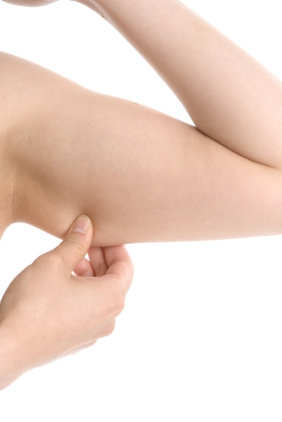 c 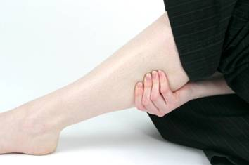

3 She hurt herself when she was
a  b 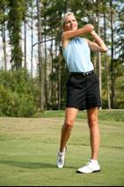 c 

4 Tick the waiting room.

x
a
b
c
d
f

e
g
h

You are here

Tapescript
R: I need some information from you to fill in this form. What’s your surname?
P: Stevens.
R: Can you spell that please?
P: S–T–E–V–E–N–S
R: What’s your first name?
P: Kathryn. That’s K–A–T–H–R–Y–N.
R: And what’s your date of birth?
P: 17th August 1984.
R: OK. What’s your address?
P: 23/5 Stewart Street, Glasgow. That’s S–T–E–W–A–R–T.
R: Thank you. What’s your postcode?
P: It’s G12 5UD. That’s G12 5UD.
R: What’s your phone number?
P: 0141 double 5 7 2469
R: Who is your GP?
P: Doctor Brown at the Langside Medical Practice.
R: Right. What’s the problem?
P: I think I have broken my arm. I was playing tennis and I fell. My arm hurts when I move it.
R: Take a seat in the waiting room and someone will call you to see a doctor.
P: Thanks very much. Where’s the waiting room?
R: Go straight ahead and take the first right.
P: Thank you.

Answer key
Listen and complete the form.

S | T | E | V | E | N | S

K | A | T | H | R | Y | N

D D M M Y Y Y Y
1 | 7 | 0 | 8 | 1 | 9 | 8 | 4

2 | 3 | / | 5 |  | S | T | E | W | A | R | T |  | S | T | R | E | E | T
G | L | A | S | G | O | W

G | 1 | 2 |  | 5 | U | D

0 | 1 | 4 | 1 | 5 | 5 | 7 | 2 | 4 | 6 | 9

1c 2b 3c 4f

Name: | Date:
Look at the medicines. What are they?
Write the words under the pictures.

tablets syrup ointment powder
drops inhaler cream capsules

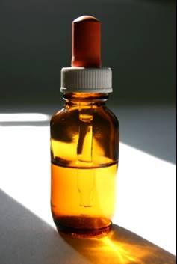1 |   2 | 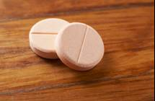  3
_____________ | ______________ | _______________
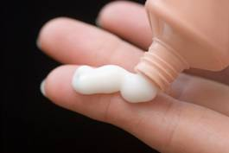  4 | 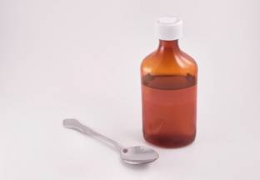  5 | 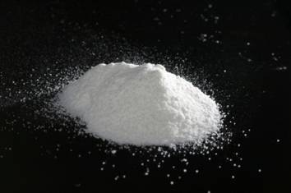  6
_____________ | _____________ | _____________
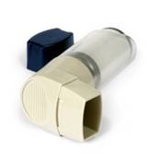  7 |   8
_____________ | _____________

Answer key
Look at the medicines. What are they?

tablets syrup ointment powder
drops inhaler cream capsules

drops | capsules | tablets
ointment | syrup | powder
inhaler | cream

Take two capsules every four hours. | Dissolve the tablets in water.
Take one 5 ml spoonful three times a day. | Apply two drops to each eye three times a day.
Apply two drops to each ear in the morning and at night. | Take two 5 ml spoonfuls four times a day.
Take one tablet after meals. | Apply twice a day.

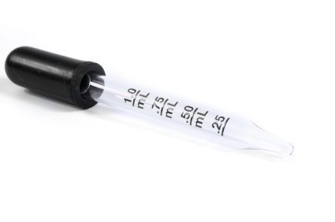
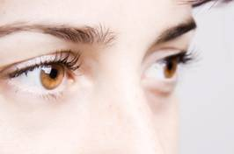


8 am 12 pm 4 pm 8 pm

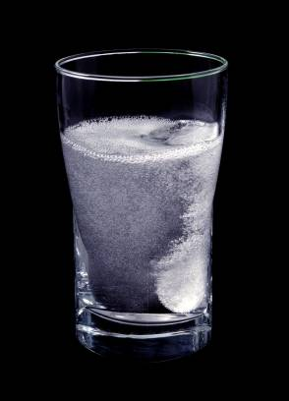

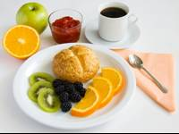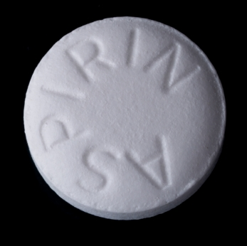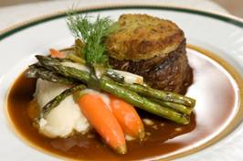

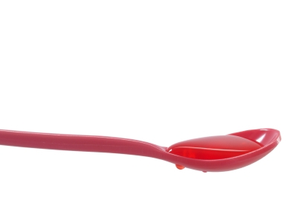

8 am 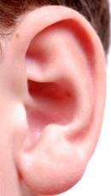 8 pm

Answer key
Match the instructions to the pictures.
Take two capsules every four hours.  1 | Dissolve the tablets in water.  2 | Take one 5 ml spoonful three times a day.  3
Apply two drops to each eye three times a day.  4 | Apply two drops to each ear in the morning and at night.  5 | Take two 5 ml spoonfuls four times a day.  6
Take one tablet after meals.  7 | Apply twice a day.  8

4 1
2
1 3
8 am 12 pm 4 pm 8 pm

3
8

Answer key
Match the instructions to the pictures.
Take two capsules every four hours.  1 | Dissolve the tablets in water.  2 | Take one 5 ml spoonful three times a day.  3
Apply two drops to each eye three times a day.  4 | Apply two drops to each ear in the morning and at night.  5 | Take two 5 ml spoonfuls four times a day.  6
Take one tablet after meals  7 | Apply twice a day  8

2 4

7 5 6 7 8

6 9

5
8 am 8 pm

Name: | Date:
Listen and circle the correct answers.
1 She hurt her
a b c

2 She wants an appointment with a
a  b c

3 She’s got a
a b c
d  e

Name: | Date:
Listen and circle the correct answers.

4
a

b 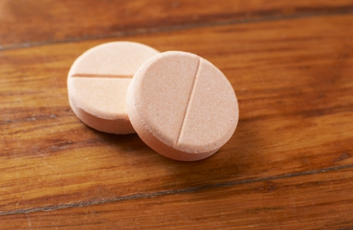

5 a  b  c 

Tapescript

1 What’s the matter? Have you hurt your leg?
No, it’s my foot. I fell on the stairs.

2 Leith Surgery. Can I help you?
I’d like to make an appointment for a check–up please.
I’ve got really bad toothache.

3 Hello. How are you?
Not very well. I’ve got a sore throat.
Oh dear! I hope you feel better soon.

4 How many tablets should I take?
Take two, three times a day after food.

5 Health Centre. Can I help you?
I’d like a home visit please. My daughter has a temperature and she has been sick all night.

Answer key
Listen and circle the correct answers.
1 She hurt her

a b c

2 She wants an appointment with a

a b c

3 She’s got a

a b c

d e

Answer key
Listen and circle the correct answers.

4 a

b

5 a b c

Name: | Date:
‘o_e’ ‘oa’
sore throat
Read these words.
nose code road soap
home note coat toast
bone phone loaf coach
hope rose goal loan

Write the words under the pictures.
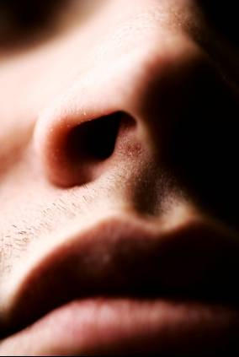  1 |   2 | 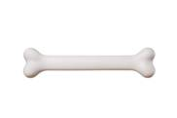  3
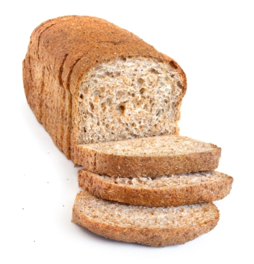4 | 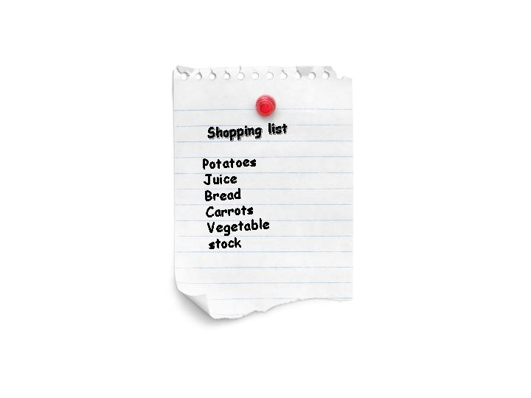5 | 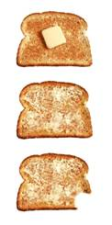 6
7 | 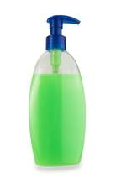8 | 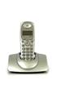9
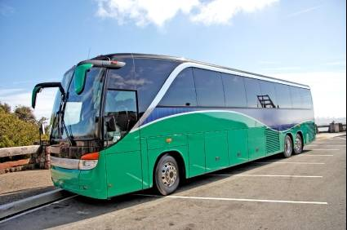
10

Answer key
‘o_e’ ‘oa’
sore throat

Write the words under the pictures.
nose | road | bone
loaf | note | toast
home | soap | phone
coach

Name: | Date:
Read and listen.
Tom is not well today. He’s got a cough and a sore throat. His throat hurts when he swallows and his chest hurts when he coughs. He phones the doctor’s surgery to make an appointment. He gets an appointment for 10:15.
The doctor gives him a prescription for some tablets. Tom takes the prescription to the chemist and gets his tablets. Then he goes home and goes to bed.

Underline all the words with o__e and oa.

Now find the words in the text to match these pictures.

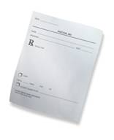  1 |   2 |   3
4 | 5 | 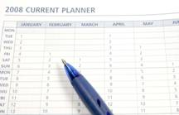  6

Answer key
Read and listen.
Tom is not well today. He’s got a cough and a sore throat. His throat hurts when he swallows and his chest hurts when he coughs. He phones the doctor’s surgery to make an appointment. He gets an appointment for 10:15.
The doctor gives him a prescription for some tablets. Tom takes the prescription to the chemist and gets his tablets. Then he goes home and goes to bed.

Underline all the words with ‘o__e’ and ‘oa’.

Now find the words in the text to match these pictures.

a prescription | chemist | tablets
a sore throat | a cough | an appointment

Name: | Date:
Match the beginning and end of the sentences.
Tom is…
…the doctor’s surgery.

He’s got…
…a cough and a sore throat.

…not well today.
His throat hurts…

His chest hurts…
…the prescription to the chemist.

He phones…
…home and goes to bed.

He gets…
…an appointment for 10:15.

The doctor gives him…
…when he coughs.

Tom takes…
…when he swallows.

Then he goes…
…a prescription for some tablets.

Now, write the correct sentences in your notebook.

Answer key
Match the beginning and end of the sentences.

Tom is not well today.
He’s got a cough and a sore throat.
His throat hurts when he swallows.
His chest hurts when he coughs.
He phones the doctor’s surgery.
He gets an appointment for 10:15.
The doctor gives him a prescription.
Tom takes the prescription to the chemist.
Then he goes home and goes to bed.

Name: | Date:
Put the words in the correct order.

1 today not Tom well is.
________________________________

2 got He’s throat a sore a and cough.
________________________________

3 throat His swallows when he hurts.
________________________________

4 when hurts he His coughs chest.
________________________________

5 surgery he the phones doctor’s Then.
________________________________

6 10:15 gets He an for appointment.
________________________________

7 doctor prescription gives The him a.
________________________________

8 prescription the Tom chemist to the takes.
________________________________

9 home he goes bed and Then goes to.
________________________________

Name: | Date:
Where are the capital letters and full stops?

tom is not well today he’s got a cough and a sore throat his throat hurts when he swallows and his chest hurts when he coughs he phones the doctor’s surgery to make an appointment
he gets an appointment for 10:15 the doctor gives him a prescription for some tablets tom takes the prescription to the chemist and gets his tablets then he goes home and goes to bed

Write again, putting in the capital letters and the full stops.

______________________________________________

______________________________________________

______________________________________________

______________________________________________

______________________________________________

______________________________________________

______________________________________________

______________________________________________

______________________________________________

Answer key
Put in the capital letters and full stops.

Tom is not well today. He’s got a cough and a sore throat. His throat hurts when he swallows and his chest hurts when he coughs. He phones the doctor’s surgery to make an appointment.
He gets an appointment for 10:15. The doctor gives him a prescription for some tablets. Tom takes the prescription to the chemist and gets his tablets. Then he goes home and goes to bed.

Name: | Date:
Look at these signs. Where would you see them?
Answer the questions on the next page.

a
EMERGENCY DEPARTMENT
b
Outpatient Department
c
Dental Surgery
d
MAIN ENTRANCE &
INFORMATION DESK

e
PHARMACY

f
All Wards
g
Ambulances only

Name: | Date:
Which sign tells:

1 the way in ___

2 where you can get medicine ___

3 you can’t park here ___

4 where to go if you have an appointment ___

5 where to go if you have an accident ___

6 where to go to visit someone ___

7 where to go to get a tooth out ___

8 where you can ask for information ___

Answer key
Which sign tells:

1 the way in d

2 where you can get medicine e

3 you can’t park here g

4 where to go if you have an appointment b

5 where to go if you have an accident a

6 where to go to visit someone f

7 where to go to get a tooth out c

8 where you can ask for information d

Name: | Date:
Look at the labels and circle the answers below.

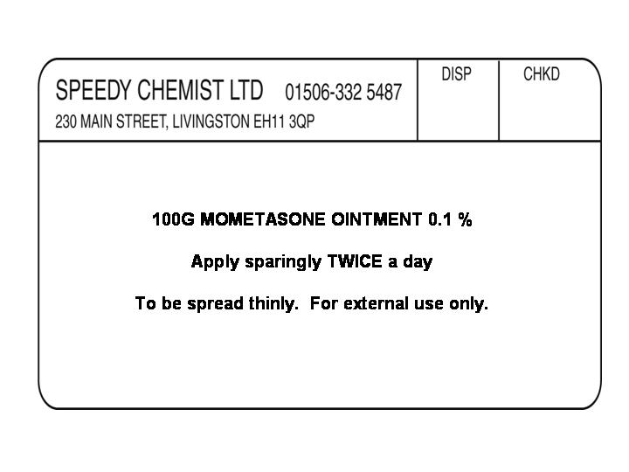
1
This label is for: a b

c d

Name: | Date:
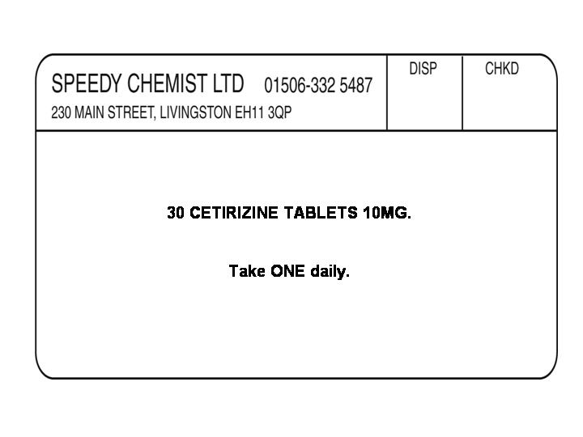
2
This label is for: a b

c d

Name: | Date:
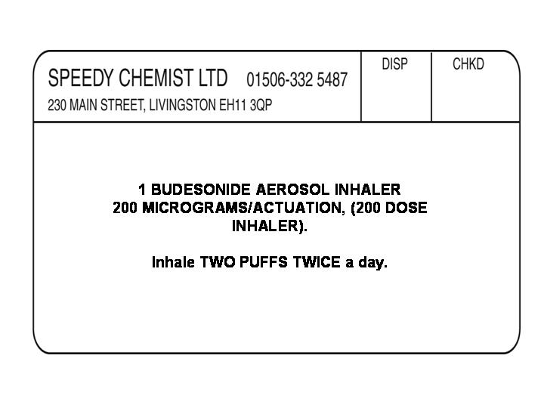

3
This label is for: a b

c d

Name: | Date:
Now answer the questions.
Label 1:

1 How often should I use the ointment?
______________

2 Which number is the weight?
______________

3 What’s the name of the chemist?
______________

Name: | Date:
Label 2:

1 How many tablets are in the packet?
______________

2 How many tablets should you take and how often?
______________

3 Which number is the weight of each tablet?
______________

Name: | Date:
Label 3:

1 How much should you take?
______________

2 How often should you use it?
______________

3 What’s the chemist’s phone number?
______________

Answer key
Now answer the questions.

Label 1: c
1 How often should I use the ointment?
Twice (two times) a day

2 Which number is the weight?
100 g

3 What’s the name of the chemist?
Speedy

Label 2: b
1 How many tablets are in the packet?
30

2 How many tablets should you take and how often?
One tablet a day

3 Which number is the weight of each tablet?
10 mg

Label 3: c
4 How much should you take?
Two puffs

5 How often should you use it?
Twice (two times) a day

6 What’s the chemist’s phone number?
01506-332 5487
All photos used in this learning and teaching pack are
© istockphoto.com

Cover – Marcela Barsse

p.1
1 lijlexmom
2 Steven Miric
3 lijlexmom

p.3
Patient – Christine Glade
Receptionist – Naomi Bassitt

p.17 (left to right, top to bottom)
Tim McCaig / Lisa F. Young / Diego Cervo / Leslie Banks
Ana Blazic / Stacey Newman / Sharon Dominick / Pali Rao
Luis Pedrosa / Jason Lugo / Andres Balcazar / Nikola Hristovski
Jo Ann Snover / David Peeters

p. 28
2a Dirk Freder
2b Yumi Miki
2c Karl Rosencrants
3a Andrejs Pidjass
3b Ana Abejon
3c TriggerPhoto

p.31
1 Pleio
2 Onur Dongel
3 Jason Reekie
4 zilli
5 Robert Byron
6 Christoph Ermel
7 ron summers
8 Eugene Bochkarev

pp. 36–37
1 Christopher O’Driscoll
2 cristin Ardelean
3 Bill Fehr
4 maria gritzai
5 M algorzata korpas
6 Jim DeLillo
7 Floortje
8 Juan Monino
9 Victor Burnside

p.39
5a Darren Baker
5b Kelvin Wakefield
5c Peter Spiro

p.43
1 and 2 Duncan Walker
3 Ljupco
4 and 5 Olivier Blondeau
6 marie-france belanger
7 M. Eric Honeycutt
8 Rolf Bodmer
9 Jaroslaw Wojcik
10 Joe Potato

p.45
1 Steve Dibblee
2 Frances Twitty
3 Marcelo Wain
4 Nikola Hristovski
5 Andres Balcazar
6 RainforestAustralia

