

ESOL Literacies: National 2

Personal identity

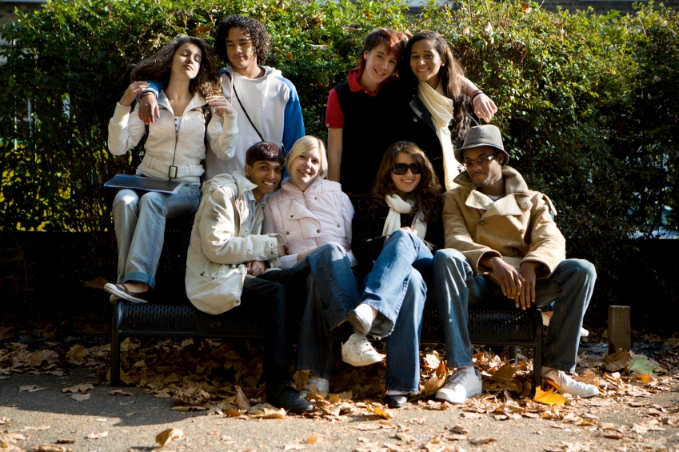






Publishing information
First edition
Published date: March 2008
Publication code: BB4354

First Published 2008

Published by the Scottish Qualifications Authority
The Optima Building, 58 Robertson Street, Glasgow G2 8DQ
Ironmills Road, Dalkeith, Midlothian EH22 1LE

www.sqa.org.uk

The information in this publication may be reproduced in support of SQA qualifications. If it is reproduced, SQA should be clearly acknowledged as the source. If it is to be used for any other purpose, then written permission must be obtained from the Assessment Materials and Publishing Team at SQA. It must not be reproduced for trade or commercial purposes.

© Scottish Qualifications Authority 2008

Please note these materials have been repurposed for the new National Qualifications - August 2015

Contents and notes
Where appropriate, answer keys are included for learners to check their work. You should photocopy certain worksheets.
Page | Activity
1 | Form-filling — teacher’s notes
2 | The name game — teacher’s notes
4 | Key words for personal identity and form-filling — cards for recognition, ordering and matching; good for social sight assessment
5  *11 | Role-play cards: name, country and nationality. These can be used to practise structures (What’s your name? My name’s … What’s his/her name? etc) in mingling or group activities. Learners can then cover the information and look at the pictures to check memory.  Please note that Kujtim is described as British as he has been naturalised. This might be an interesting talking point for learners and a useful introduction to the concepts of citizenship and naturalisation.  Follow-on activities with simple writing
17  18  19  24 | Dates and date-of-birth materials, including:  - information and substitution tables to teach cardinal and ordinal numbers  - month cards for cutting up and ordering (the cards themselves can be cut into syllables for reconstructing)  - writing, speaking and listening exercises for d.o.b.  - d.o.b. ‘bingo’, with a teacher’s master card and student cards to be cut up  Remind learners that when we say these dates we say ‘the 1st of January’ but when we write, we miss out ‘the’ and ‘of’.

29 | Form-filling, including:  - a simple form with a matching exercise  - a more complex form with deleting, circling and underlining  Teachers’ notes on additional ideas/activities with forms are provided on page 1. Any work with names and addresses is good assessment practice for Literacies 2.
33 | Countries, continents and languages. Suggested use:  - Pre-teach/elicit the continents and ask students to identify these on the map (page 33).  - Students match the countries to the continents using cards (page 34) — the cards can be adapted according to learners’ nationalities.  - Use page 35 for a mingling speaking activity. Practise the necessary questions. For students with very low literacy, names etc can be copied from cards. Use this as the basis for simple speaking/writing activities with the structures:  I am from ________ in ___________.  X is from ________ in ___________.  - There are also simple speaking and writing activities about learners’ languages. Adapt these according to needs.
39 | Writing, punctuation and capitalisation exercises to follow from above.
42 | Word-shapes exercise: cities. Students match the city names to the shapes and fill in the boxes. Can be adapted to teach the shapes of any key lexis.

*44 | Reading and writing a simple personal letter, including:  - genre identification and comprehension  - literacy work — phonics, sentencing and layout  - gap-fill  - personalisation
*assessment practice

Teacher’s notes

Form-filling activities
(NB A sample form for learners to complete is provided on page 30.)

Different types of forms should be used throughout the course to build confidence in writing personal information as well as to assist real-life and assessment tasks. Some activities which may be of use are as follows:

- cut up addresses for learners to re-order, to build awareness of sequencing (flat/house, street, area, city, postcode)
- write out learners’ personal information with spelling mistakes for correction
- as above, missing out vowels, digraphs or blends for learners to insert
- cut out different parts of address etc to be inserted or pasted onto a blank form before being copied
- dictate names, addresses and telephone numbers
- teach questions for learners to interview each other and fill out each other’s personal information
- play bingo with telephone numbers, postcodes and dates of birth

Teacher’s notes

The name game

This can be used with a new group of beginner students, particularly for those who have some knowledge of the alphabet and some ability to form it (for those with no such knowledge, it may be very daunting). It is useful as an ice-breaker as well as to diagnose particular issues with reading, spelling and letter formation.

1 Find out your students’ names before the class begins and prepare A4 cards with the names spelled out in large letters. For each student, write or print out three large cards — one with the correct spelling in English, and two others with mistakes, eg for a student named Foursat:
Fousat | Foursat | Frst

2 Tack the cards onto the whiteboard or around the room, in random order.

3 After introducing yourself to the students and requesting their names, ask them to find their names on the wall. Assist as necessary, but allow the students to make their own choices. Take note of any errors, and gently point out to those students that this spelling differs from the one they registered with. Encourage them to notice the difference for themselves.

Teacher’s notes
4 When students are happy that they have their correct name, ask if they know the names of the letters which make up their names. Demonstrate with your own name. Even for students with very limited knowledge of the English alphabet, the sequence of letters which makes up their names can be taught in this first lesson.

5 While teaching this, introduce the questions ‘What’s your name?’ and ‘What’s the spelling?’ Demonstrate with your own name and write it on the board.

6 When students can ask and respond to these questions, line them up behind you, facing the whiteboard. Ask the student behind you the two questions, and write their name on the board. Check with the student that this is correct, then pass them the board pen. They then turn around and ask the student behind them the same questions, and in turn attempt to write the name on the board.

7 The activity continues in sequence. Fall in line behind the final student so she/he can ask you the questions.

8 Throughout the activity, and during feedback, take note of particular problems that occur. These can then form the basis of future lessons on letter formation, spelling, phonics and alphabet awareness.

address | ADDRESS
name | NAME
surname | SURNAME
first name | FIRST NAME
postcode | POSTCODE
nationality | NATIONALITY
telephone number | TELEPHONE NUMBER
date of birth | DATE OF BIRTH
marital status | MARITAL STATUS
occupation | OCCUPATION
black capitals | BLOCK CAPITALS
circle | CIRCLE
underline | UNDERLINE
delete | DELETE
tick | TICK

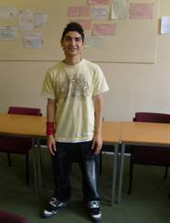  Name: Amin  Country: Iran  Nationality: Iranian | 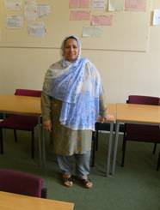  Name: Foursat  Country: Afghanistan  Nationality: Afghani
  Name: Neil  Country: Scotland  Nationality: British | 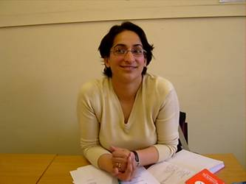  Name: Mercan  Country: Turkey  Nationality: Turkish

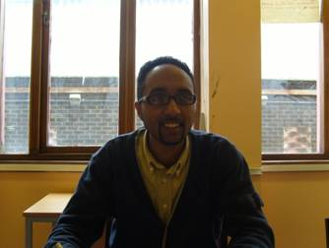  Name: Maheri  Country: Eritrea  Nationality: Eritrean | 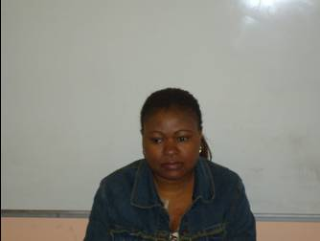  Name: Ana Tazi  Country: Congo  Nationality: Congolese
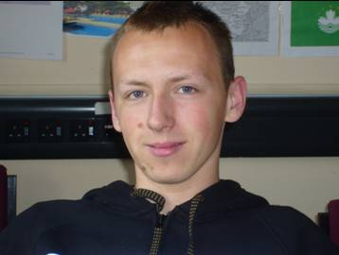  Name: Bartosz  Country: Poland  Nationality: Polish | 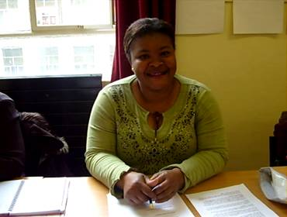  Name: Justine  Country: Ivory Coast  Nationality: Ivorian

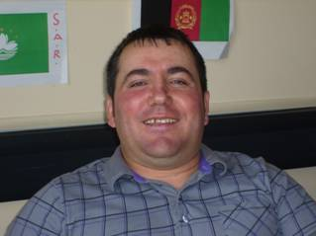  Name: Kujtim  Country: Albania  Nationality: British | 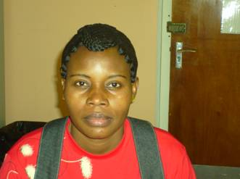  Name: Isabel  Country: Angola  Nationality: Angolan
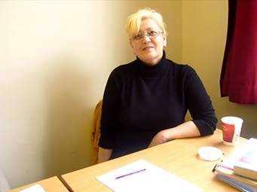  Name: Iralya  Country: Kazakhstan  Nationality: Kazakh | 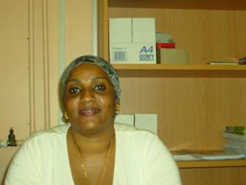  Name: Raiyana  Country: Somalia  Nationality: Somali

Name: | Date:
Now write some answers. The first one is finished.

1

What’s her name? Her name’s Justine.

Where’s she from? She’s from the Ivory Coast.

What’s her nationality? She’s Ivorian.

2

What’s his name? His name’s _____________________

Where’s he from? He’s from _____________________

What’s his nationality? He’s ______________________

Name: | Date:

3

What’s his name? ______________________________

Where’s he from? _____________________________

What’s his nationality? __________________________

4

What’s her name? _____________________________

Where’s she from? ____________________________

What’s her nationality? _________________________

Name: | Date:

Ask and answer questions about these people with a partner. Write the questions and answers in your notebooks.

5 | 6 | 7

Now use the role cards to check your answers!

Name: | Date:

Write and copy answers about yourself.

What’s your name?

My name’s _________________. My name__ _________________.

My ______ _________________. ___ _______ _________________.

Where are you from?

I’m from _________________. I’m ____ _________________.

I_ ____ _________________. ___ _____ _________________.

What’s your nationality?

I’m _________________. I__ _________________.

___ _________________.

Vowels
There are five vowels:
a, e, i, o, u
Name: | Date:

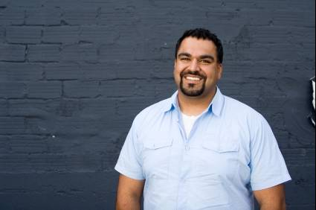

This is Sami Mahmoud.

There are five vowels in Sami’s name: Sami Mahmoud.

What is your name?

My name is ____________________________________.

There are _____ vowels in my name.

My name is Sami Mahmoud.

I live in Wishaw.

I am 35.

I am from Iraq.

I am Iraqi.

I have a son.

Name: | Date:

Sami Wishaw 35 Iraq
Iraqi Mahmoud son

My name is _________ ______________.

I live in ______________.

I am ________________.

I am from _______________.

I am ________________.

I have a _____________.

Copy in the correct letter.

a I i e o u I

My name is Sami Mahmo_d.

I live in W_shaw.

_ am 35.

I _m from Iraq.

I am _raqi.

I have a s_n.

Name: | Date:
Fill in the gaps.

My ______ ___ ______ ________.

I _____ ___ __________.

I ___ ___ ________.

I _____ ________.

I _______ __ ________.

Now copy out the sentences.

Name: | Date:
Match the words.

NAME Wishaw Iraqi Wishaw

LIVE son SON Iraq son

IRAQI WISHAW IRAQ Iraqi

Name Wishaw Iraqi Name Iraq

Name live live Iraq son

Name: | Date:

Join up the words.

me
Na

Li
ve

Ir
aq

aqi
Ir

Wi
shaw

Mah
moud

Name: | Date:
Learn the numbers for dates!

Numbers |  | Numbers for dates/order
1 | one | 1st | first
2 | two | 2nd | second
3 | three | 3rd | third
4 | four | 4th | fourth
5 | five | 5th | fifth
6 | six | 6th | sixth
7 | seven | 7th | seventh
8 | eight | 8th | eighth
9 | nine | 9th | ninth
10 | ten | 10th | tenth
11 | eleven | 11th | eleventh
12 | twelve | 12th | twelfth
13 | thirteen | 13th | thirteenth
14 | fourteen | 14th | fourteenth
15 | fifteen | 15th | fifteenth
16 | sixteen | 16th | sixteenth
17 | seventeen | 17th | seventeenth
18 | eighteen | 18th | eighteenth
19 | nineteen | 19th | nineteenth
20 | twenty | 20th | twentieth
21 | twenty-one | 21st | twenty-first
22 | twenty-two | 22nd | twenty-second
23 | twenty-three | 23rd | twenty-third
24 | twenty-four | 24th | twenty-fourth
25 | twenty-five | 25th | twenty-fifth
26 | twenty-six | 26th | twenty-sixth
27 | twenty-seven | 27th | twenty-seventh
28 | twenty-eight | 28th | twenty-eighth
29 | twenty-nine | 29th | twenty-ninth
30 | thirty | 30th | thirtieth
31 | thirty-one | 31st | thirty-first

January | 1
February | 2
March | 3
April | 4
May | 5
June | 6
July | 7
August | 8
September | 9
October | 10
November | 11
December | 12

Speaking

What’s the date today?

It’s …
Monday | the | 1st | 2nd | 3rd | 4th | 5th | of | January |  |  | February
Tuesday | the | 6th | 7th | 8th | 9th | 10th | of | March |  |  | April
Wednesday | the | 11th | 12th | 13th | 14th | 15th | of | May |  |  | June
Thursday | the | 16th | 17th | 18th | 19th | 20th | of | July |  |  | August
Friday | the | 21st | 22nd | 23rd | 24th | 25th | of | September |  |  | October
Saturday | the | 26th | 27th | 28th | 29th | 30th | of | November |  |  | December
Sunday | the | 31st |  |  |  |  | of | 2007 | 2008 | 2009 |  | 2010

Name: | Date:

What’s the date of birth? Write the numbers or words.

1/1/1973 | 1st January 1973
24/6/1985 | 24th
15/ / | 15th February 1968
12/11/1990
 | 30th October 2001
2/1/1975
 | 12th March 1982
9/9/1956
 | 31st August 1960
28/5/1995

Answer key
What’s the date of birth? Write the numbers or words.

1/1/1973 | 1st January 1973
24/6/1985 | 24th June 1985
15/2/1968 | 15th February 1968
12/11/1990 | 12th November 1990
30/10/2001 | 30th October 2001
2/1/1975 | 2nd January 1975
12/3/1982 | 12th March 1982
9/9/1956 | 9th September 1956
31/8/1960 | 31st August 1960
28/5/1995 | 28th May 1995

Name: | Date:
Complete in numbers and words.

My date of birth is ____/____/______.

My date of birth is ____ _______ ________.

My friend’s date of birth is ____/____/______.

My friend’s date of birth is ____ _______ ________.

My son’s date of birth is ____/____/______.

My son’s date of birth is ____ _______ ________.

My daughter’s date of birth is ____/____/______.

My daughter’s date of birth is ____ _______ ________.

Name: | Date:
Ask some other students. Write the answer in numbers.

The 14th of December 1973. And you?

What’s your date of birth?



Sara

Name | Date of birth
Sara | 14/12/73

Teacher’s bingo master card
Date of birth bingo

To vary the difficulty, the dates can be read out as numbers or as words. Cross out as you read them so learners’ answers can be checked.

12/6/1965 | 3/5/1990 | 20/1/1982 | 19/9/1955
1/3/2000 | 4/8/1988 | 28/7/1973 | 5/1/1977
6/4/1975 | 30/11/1991 | 4/4/1950 | 16/12/1980
14/2/1998 | 18/9/1968 | 25/1/1949 | 6/12/2001
8/1/1982 | 30/3/1987 | 12/10/1973 | 5/5/1955
21/7/2001 | 13/11/1969 | 16/6/1974 | 12/12/1986

Name: | Date:
Dates bingo cards

Card 1

1/3/2000
 | 4/4/1950 | 5/5/1955 | 21/7/2001
3/5/1990 |  | 25/1/1949
Card 2

16/6/1974 |  | 13/11/1969
16/12/1980 |  | 3/5/1990
 | 8/1/1982 |  | 1/3/2000

Card 3

 | 14/2/1998
30/11/1991 |  | 21/7/2001 | 28/7/1973
 | 12/12/1986 |  | 19/9/1955

Name: | Date:
Card 4

 | 12/10/1973 | 5/1/1977
 | 8/1/1982 |  | 4/8/1988
12/6/1965 |  | 4/4/1950

Card 5

3/5/1990 |  |  | 16/12/1980
20/1/1982 |  | 6/4/1975
 | 30/3/1987 | 18/9/1968

Card 6

13/11/1969 |  |  | 4/8/1988
 |  | 30/3/1987
25/1/1949 | 8/1/1982 |  | 20/1/1982

Name: | Date:
Card 7

4/4/1950 |  |  | 21/7/2001
 | 30/11/1991 |  | 12/10/1973
 |  | 5/1/1977 | 6/4/1975

Card 8

19/9/1955 |  | 12/6/1965
3/5/1990 | 14/2/1998
6/12/2001 |  |  | 12/12/1986

Card 9

30/3/1987 | 28/7/1973
 |  |  | 18/9/1968
 | 18/9/1968 | 8/1/1982 | 4/8/1988

Name: | Date:
Card 10

1/3/2000 | 30/11/1991
 |  | 25/1/1949 | 12/12/1986
16/12/1980 |  |  | 6/4/1975

Card 11

8/1/1982 |  |  | 5/1/1977
21/7/2001 |  | 14/2/1998
 | 4/4/1950 | 18/9/1968

Card 12

1/3/2000 |  |  | 20/1/1982
 |  | 30/3/1987
25/1/1949 | 12/6/1965 |  | 28/7/1973

Name: | Date:
Match the information. The first one is done for you.

Name | British
Address | 0141 636 0449
Telephone | Teacher
Occupation | Neil McDade
Marital status | Flat 5/1  115 London Road  Glasgow  G45 8DX
Nationality | Single

Now copy the above in BLOCK CAPITALS.

NAME: __________________________

ADDRESS: __________________________

__________________________

__________________________

__________________________

TELEPHONE: __________________________

OCCUPATION: __________________________

MARITAL STATUS: __________________________

NATIONALITY: __________________________

Name: | Date:
Now write your details in BLOCK CAPITALS.

NAME: __________________________

ADDRESS: __________________________

__________________________

__________________________

__________________________

TELEPHONE: __________________________

OCCUPATION: __________________________

MARITAL STATUS: __________________________

NATIONALITY: __________________________

Answer key
Match the information.
Name | British
Address | 0141 636 0449
Telephone | Teacher
Occupation | Neil McDade
Marital status | Flat 5/1  115 London Road  Glasgow  G45 8DX
Nationality | Single

Please copy the above in BLOCK CAPITALS.

NAME: NEIL MCDADE

ADDRESS: FLAT 2/1

115 LONDON ROAD

GLASGOW

G45 8DX

TELEPHONE: 0141 636 0449

OCCUPATION: TEACHER

MARITAL STATUS: SINGLE

NATIONALITY: BRITISH

Name: | Date:

Please fill in the form and sign it.
Title (please circle): | Mr Mrs Miss Ms Dr
Surname:
First name:
Address:
Postcode:
Age (please circle) | 0-9 10-19 20-29  30-39 40-49 50-59 60+
Please delete as appropriate: | I like learning English.  I don’t like learning English.
Signature:

Use BLOCK CAPITALS.

Name: | Date:

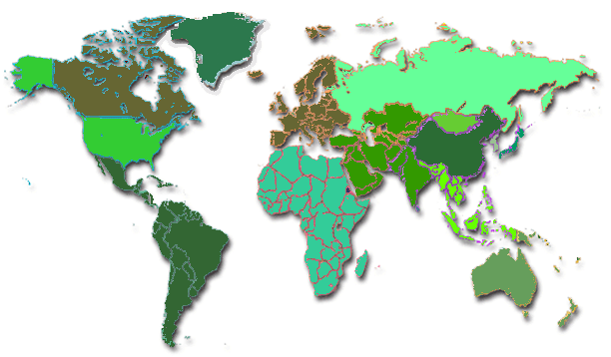

Asia Europe North America
South America Africa Australasia

Iran
Afghanistan
Poland
Sudan
Kosovo
Iraq
Scotland
Brazil
Australia
United States (USA)
China
South Africa
Europe
Asia
Australasia
Africa
North America
South America

Name: | Date:


Speak to other learners in the class and fill in the table.

Where are you from?
I’m from _________ in ___________.

Name | Country | Continent

Name: | Date:


Match the countries and the languages.

1 In Scotland  2 In Iran  3 In Poland  4 In China  5 In Kosovo  6 In Afghanistan  7 In Brazil  8 In Sudan  9 In Spain  10 In Iraq  11 In the United States | they speak | Chinese ___________  Portugese ___________  English ___________  Polish ___________  Arabic ___________  Spanish ___________  Farsi ___________  Albanian ___________  Pushtu ___________

Name: | Date:
Copy some sentences about languages.

They speak English in Scotland and the United States.

________________________________________

________________________________________

________________________________________

________________________________________

________________________________________

________________________________________

________________________________________

________________________________________

________________________________________

________________________________________

________________________________________

________________________________________

________________________________________

________________________________________

________________________________________

Answer key
Copy some sentences about languages.

They speak English in Scotland and the United States.

They speak Farsi in Iran.

They speak Polish in Poland.

They speak Chinese in China.

They speak Albanian in Kosovo.

They speak Pushtu in Afghanistan.

They speak Portuguese in Brazil.

They speak Arabic in Sudan.

Name: | Date:
Copy the following text, putting in the capital letters and full stops.

in our class we have students from many countries
there are three students from iran there is one
student from iraq there is one student from sudan
there is one student from afghanistan some students
speak farsi foursat speaks pushtu jamal and habiba
speak Arabic some students live in torry some
students live in stonehaven our teacher lives in aboyne

________________________________________

________________________________________

________________________________________

________________________________________

________________________________________

________________________________________

________________________________________

________________________________________

________________________________________

________________________________________

Name: | Date:


Write CAPITAL LETTERS in the correct place.

1 i live in glasgow in scotland.

________________________________________

2 your new teacher’s name is norma.

________________________________________

3 we come to class monday to friday.

________________________________________

4 tomorrow is tuesday 5th december 2008.

________________________________________

5 habiba can speak english, arabic, kurdish and many other languages.

________________________________________

6 amin is masoumeh and mohsen’s son.

________________________________________

7 iraq is next to iran.

________________________________________

8 i am happy when i go to edinburgh for the weekend.

________________________________________

Answer key
Copy the following text, putting in the capital letters and full stops.

In our class we have students from many countries. There are three students from Iran. There is one student from Iraq. There is one student from Sudan. There is one student from Afghanistan. Some students speak Farsi. Foursat speaks Pushtu. Jamal and Habiba speak Arabic. Some students live in Torry. Some students live in Stonehaven. Our teacher lives in Aboyne.

Write CAPITAL LETTERS in the correct place.

1 I live in Glasgow in Scotland.
2 Your new teacher’s name is Norma.
3 We come to class Monday to Friday.
4 Tomorrow is Tuesday 5th December 2008.
5 Habiba can speak English, Arabic, Kurdish and many other languages.
6 Amin is Masoumeh and Mohsen’s son.
7 Iraq is next to Iran.
8 I am happy when I go to Edinburgh for the weekend.

Name: | Date:
Fit these words for cities in the gaps below.
Manchester Aberdeen Birmingham Leeds
Inverness Dundee Edinburgh Glasgow London

Answer key
Fit these words for cities in the gaps below.
Manchester Aberdeen Birmingham Leeds
Inverness Dundee Edinburgh Glasgow London



Flat 2/2
30 London Road
Edinburgh
EH2 9PB
25/10/08
Dear Class,
Nice to meet you. My name is Jane Grey and I am 23 years old. I am from Edinburgh, Scotland. I live on London Road. I am a student.

Please write and tell me about yourselves.

Jane

Name: | Date:
A: Read the text on the previous page and talk with your teacher about these questions.

1 What kind of text is this?

- an e-mail?
- a letter?
- a form?

2 How do you know the answer?

3 Who wrote it and how do you know?

4 Where is she from?

5 How old is she?

6 What is her postcode?

7 What is her job?

Name: | Date:
B: Correct the information.

1 Her name is John Grey.

2 She is 32 years old.

3 She is Somali.

4 Her address is 30 London Street.

5 She is a teacher.

C: Answer the questions.

1 How many capital letters are there in the letter?

2 When do we need capital letters?

3 How many full stops are there in the letter?

4 How many sentences are there in the letter?

5 What does Jane want?

Answer key
A
1 A letter.
2 Because it begins with ‘Dear’ and ends with the writer’s name; because it has the address in the top right corner.
3 Jane; her name comes last.
4 Edinburgh
5 23
6 EH2 9PB
7 Student

B
1 Her name is John Grey. x Jane
2 She is 32 years old. x 23
3 She is Somali. x Scottish
4 Her address is 30 London Street. x Road
5 She is a teacher. x student

C
1 How many capital letters are there? 24
2 When do we need capital letters? For the beginning of sentences, for names, for places and addresses, including postcodes, and for ‘I’.
3 How many full stops are there? 5
4 How many sentences are there? 7
5 What does Jane want? She wants us to write back.

Name: | Date:
Fill in the gaps.
Flat 2/2
__ London Road
_________
EH2 _PB
25/__/08

Dear _____,

Nice to ____ you. My ____ is Jane Grey and I __ 23 years old. I am from Edinburgh, ________. I live on ______ Road. I am a _______.

Please _____ and tell me about yourself.

Jane

Now check Jane’s letter for the answers.

Name: | Date:
Write a reply to Jane.
______________
______________
______________
______________
______________

Dear _______,

Nice to meet you too. My name is _______________ and I am __ years old. I am from ___________________. I live ________________________. I am a ____________.

Please write back and tell me more!

________________
Write your
address
here

Name: | Date:
Copy your letter in full.
______________
______________
______________
______________
______________

Dear _______,

__________________________________________________________________________________________________________________________________________
____________________________________________________________________________________________

_______________

All photos © istockphoto.com (unless noted otherwise)

Cover — Chris Schmidt

Photographs on pages 5–10 reproduced with kind permission of the ESOL students of North Glasgow College

p.12
Daniel Rodriguez

p.23
Man — Ann Marie Kurtz
Woman (‘Sara’) — emily2k

p.35
Andrew Johnson

p.36
Viorika Prikhodko

p.40
Andrea Gingerich

p.44
Kelly Borsheim

