Answer key
Read and listen.

How many places did Ann go to? 5
Name them.
bank, butcher, greengrocer, baker, newsagent

Write Ann’s shopping list.
Shopping list

4 chops
onions
baby potatoes
leeks
green beans
stamps
bread
4 cakes
newspaper

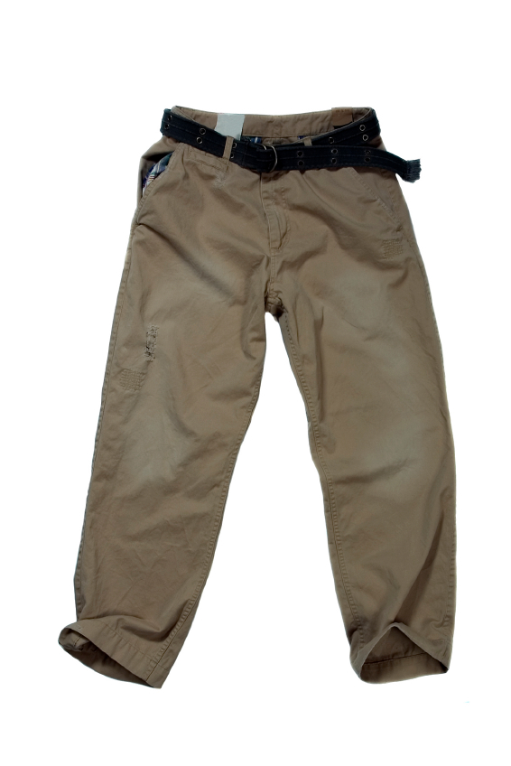 | 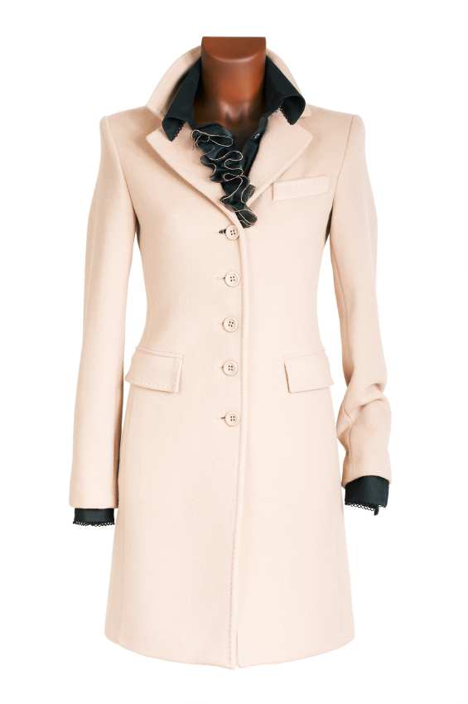
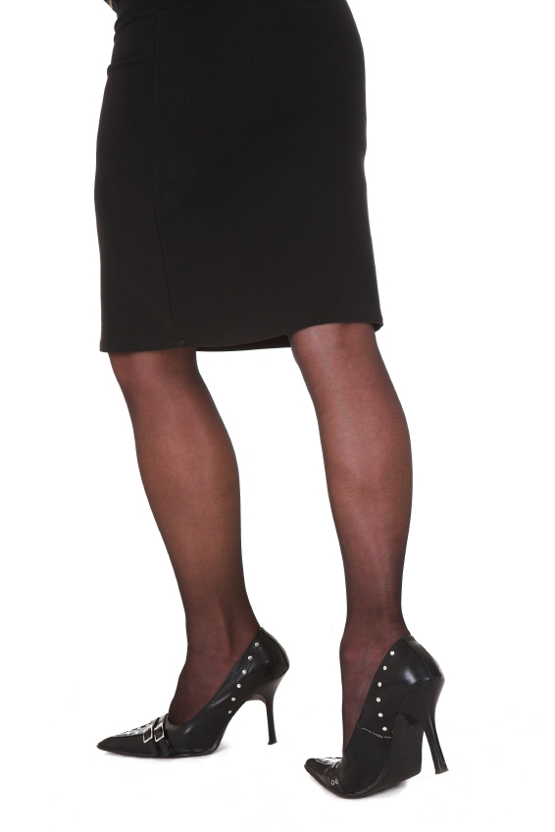 | 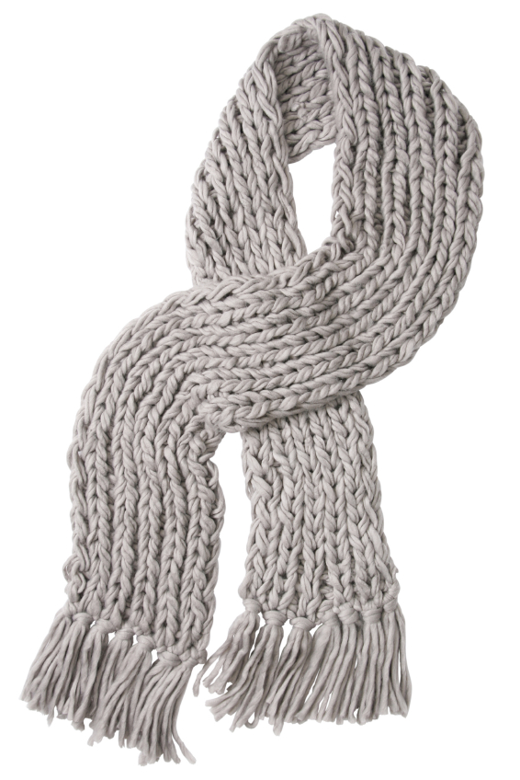
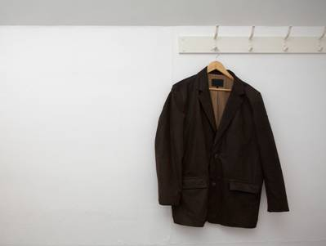 | 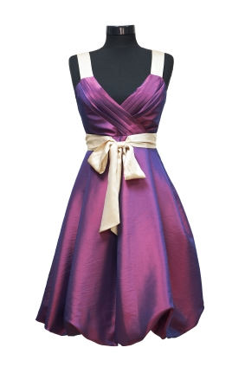  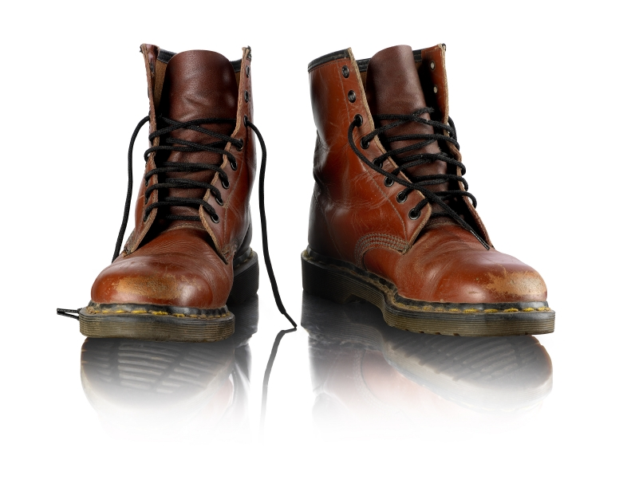
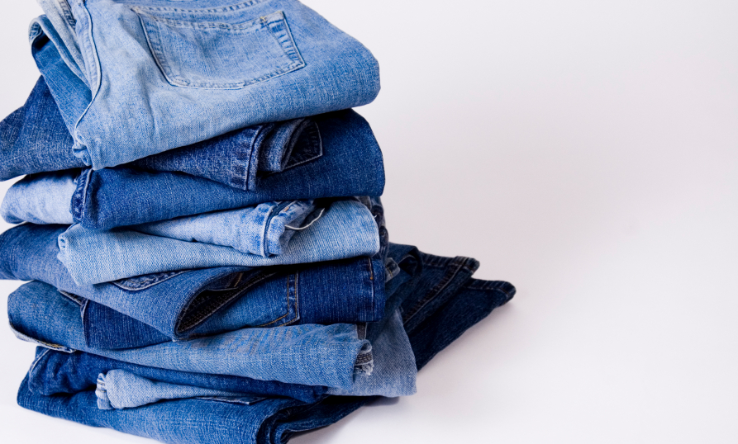

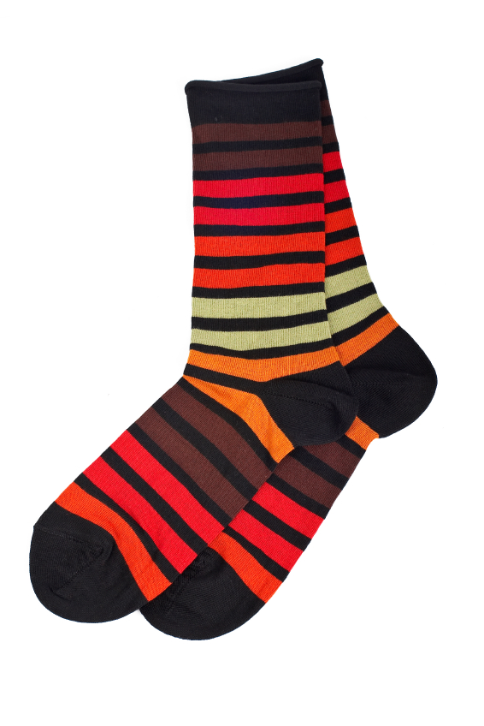 | 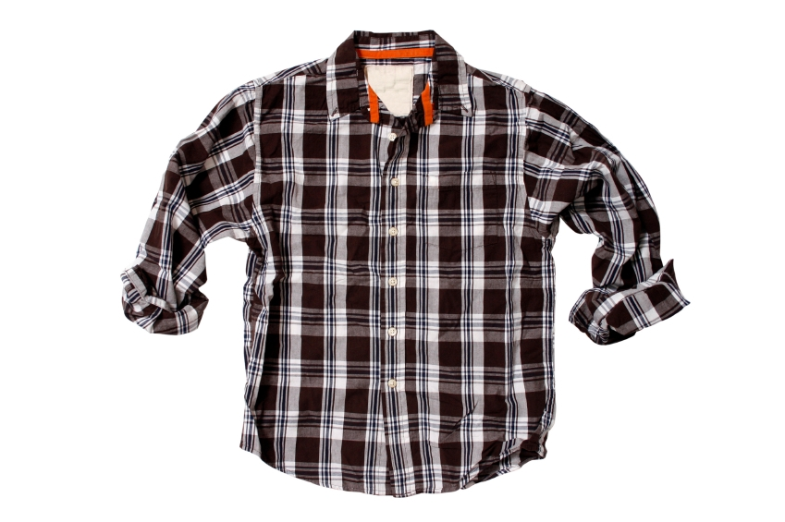
 | 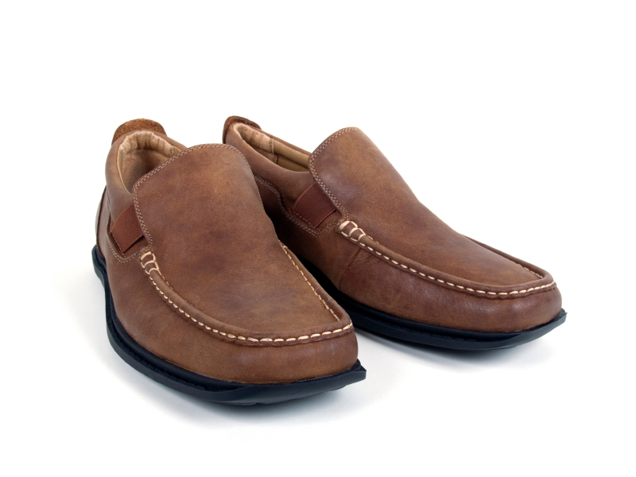
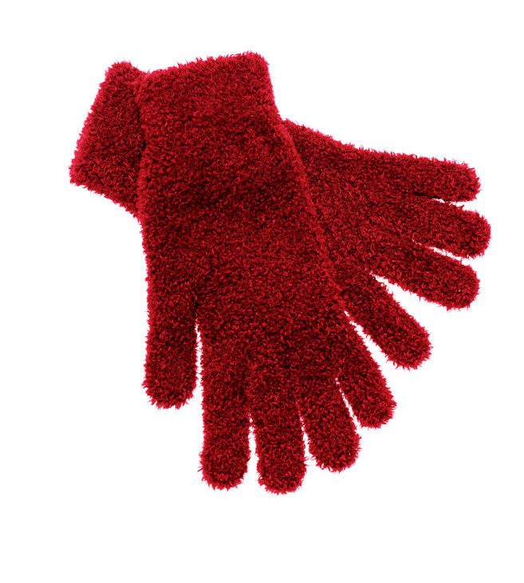 | 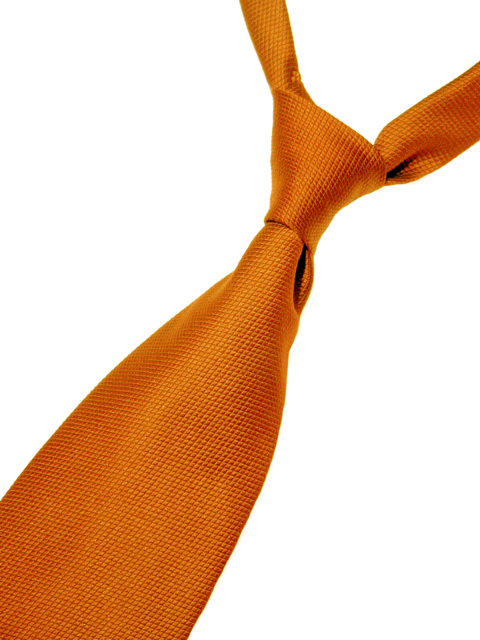
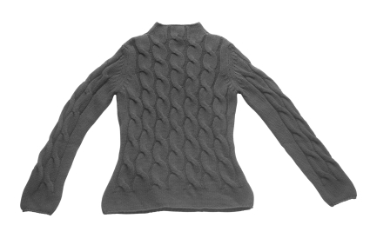 | 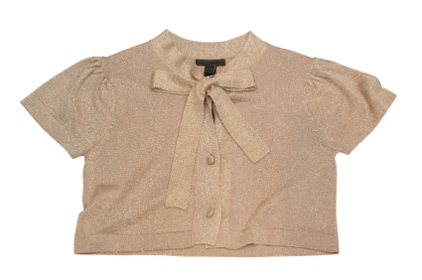

coat | trousers
scarf | skirt
boots | jacket
dress | jeans

shirt | socks
shoes | t-shirt
tie | gloves
blouse | jumper

Name: | Date:
Match the pictures to the words.
1 gloves

2 shoes

3 t–shirt

4 scarf
5 jacket

6 boots
7 trousers

8 coat
9 dress

10 jumper
11 socks

12 skirt
13 tie

14 shirt

15 jeans

16 blouse
Answer key

Match the pictures to the words.
1 gloves

2 shoes

3 t–shirt

4 scarf
5 jacket

6 boots
7 trousers

8 coat
9 dress

10 jumper
11 socks

12 skirt

13 tie

14 shirt
15 jeans

16 blouse

Name: | Date:
Write the names of the clothes.
1 | 2 | 3
_____________ | ______________ | _______________
4 | 5 | 6
_____________ | _____________ | _____________
7 |  | 8
_____________ | ______________ | _____________

Name: | Date:
Write the names of the clothes.
1 | 2 | 3
_____________ | ______________ | _______________
4 | 5 | 6
_____________ | _____________ | _____________

Answer key
Write the names of the clothes.
1 | 2 | 3
jacket | boots | blouse
4 | 5 | 6
tie | socks | shoes
7 |  | 8
scarf | dress | shirt

Answer key

1 | 2 | 3
coat | sweater | trousers
4 | 5 | 6
skirt | jeans | gloves

Name: | Date:
Listen and tick the correct prices.

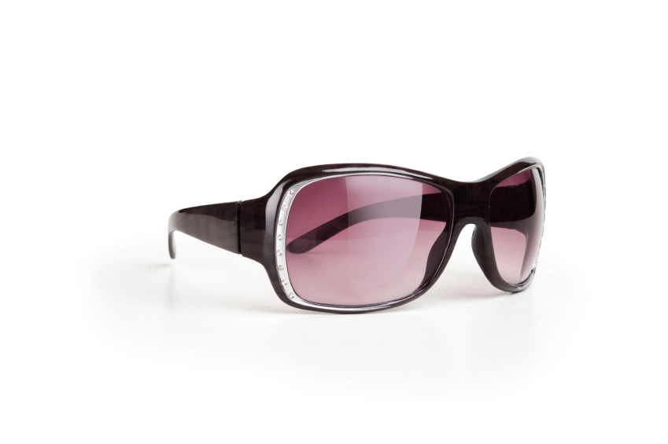 | £6.20  £12.60  £20.60 |  | £28.75  £57.85  £27.85 |  | £65.50  £56.60  £45.30
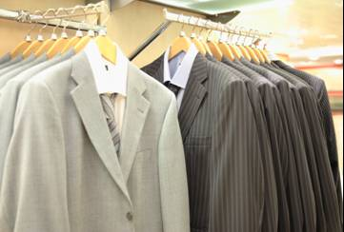 | £100.28  £128.00  £108.20 |  | £50.99  £13.99  £15.99 |  | £19.99  £9.99  £9.19
 | £23.59  £32.95  £39.25 |  | £29.95  £25.59  £59.25 | 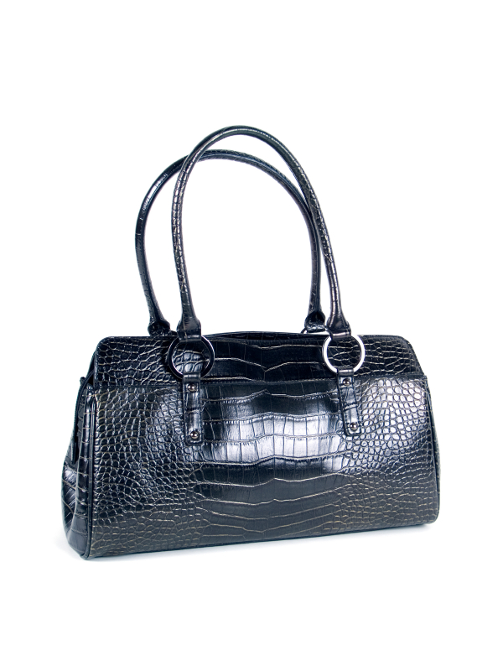 | £44.49  £54.59  £54.49
 | £19.50  £15.90  £19.05 |  | £34.50  £43.15  £34.15 |  | £39.99  £49.99  £59.99
 | £2.25  £2.15  £2.10 |  | £35.00  £53.00  £33.00 | 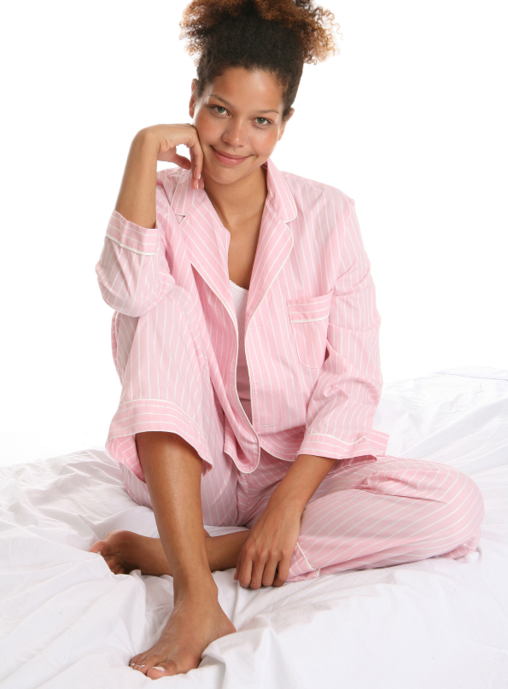 | £11.90  £12.90  £25.80
£179.55
£155.75
£175.95

Tapescript
Prices

1 Excuse me, how much is this skirt?
It’s £29.95.
Thanks.

2 Excuse me, could you tell me the price of this dress?
Certainly, it’s £45.30.
Thank you.

3 How much are these trousers, please?
They’re £32.95.
Cheers.

4 Do you know how much this bag is?
Yeah, it’s £54.59.
Oh, that’s expensive!

5 Have you got these pyjamas in medium?
Yes, here you are.
Thanks, how much are they?
They’re usually £25.80 but they’re half price now, £12.90.
I’ll take them!

6 Is this coat in the sale?
I’m afraid not, it’s £175.95.

7 How much is this jumper?
It’s £27.85.

Tapescript
Prices

8 Could you tell me — how much are these boots?
They’re £49.99.
Thanks. Can I try them on?

9 Excuse me, how much is this blouse?
It’s £9.19.

10 How much are these gloves, please?
They’re £19.50.

11 I like these sunglasses. How much are they?
£20.60.

12 I’m looking for a new suit. How much is this one?
It’s on sale at £128.00.

13 How much are these shoes?
£33.00.
Have you got them in size 5½?

14 Could you tell me how much this jacket is, please?
There’s 10% off so it’s £34.50.

15 How much are these socks?
They’re £2.15.

16 Could you tell me the price of this shirt, please?
Sure. It’s £15.99.

Answer key
Listen and tick the correct prices.

 | £6.20  £12.60  £20.60✓ |  | £28.75  £57.85  £27.85✓ |  | £65.50  £56.60  £45.30✓
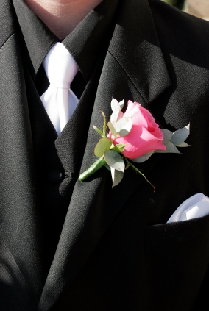 | £100.28  £128.00✓  £108.20 |  | £50.99  £13.99  £15.99✓ |  | £19.99  £9.99  £9.19✓
 | £23.59  £32.95✓  £39.25 |  | £29.95✓  £25.59  £59.25 |  | £44.49  £54.59✓  £54.49
 | £19.50✓  £15.90  £19.05 |  | £34.50✓  £43.15  £34.15 |  | £39.99  £49.99✓  £59.99
 | £2.25  £2.15✓  £2.10 |  | £35.00  £53.00  £33.00✓ |  | £11.90  £12.90✓  £25.80
£179.55
£155.75
£175.95✓

