

ESOL Literacies: National 2

Travel

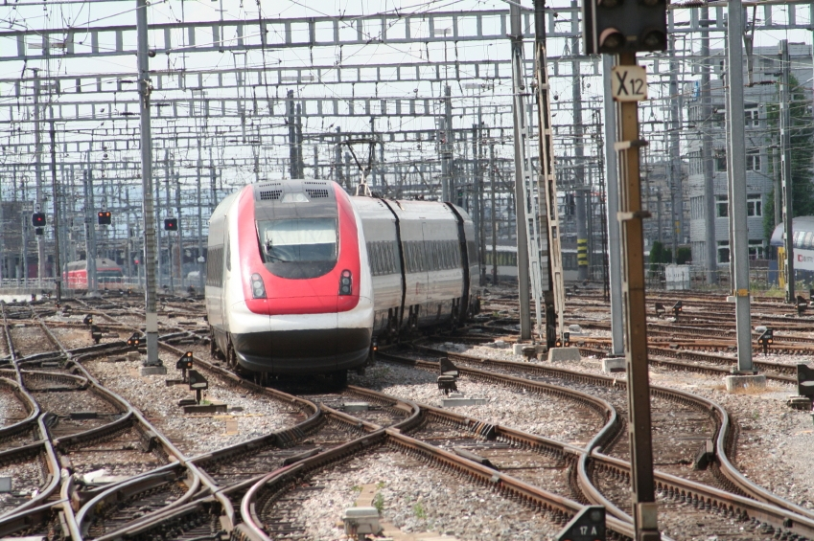






Publishing information
First edition
Published date: March 2008
Publication code: BB4354

First Published 2008

Published by the Scottish Qualifications Authority
The Optima Building, 58 Robertson Street, Glasgow G2 8DQ
Ironmills Road, Dalkeith, Midlothian EH22 1LE

www.sqa.org.uk

The information in this publication may be reproduced in support of SQA qualifications. If it is reproduced, SQA should be clearly acknowledged as the source. If it is to be used for any other purpose, then written permission must be obtained from the Assessment Materials and Publishing Team at SQA. It must not be reproduced for trade or commercial purposes.

© Scottish Qualifications Authority 2008

Please note these materials have been repurposed for the new National Qualifications - August 2015

Contents and notes
Where appropriate, answer keys are included for learners to check their work. You should photocopy certain worksheets.
Page | Activity
1 | Oral activity to introduce the topic.  Language: How do you come to college? I come by … ‘Find someone who …’ table for mingling activity followed by writing task.
3 | Cue cards and worksheet for places — pictures and words for recognition, matching, drilling of language structures.
8 | Listening task — fill in bus numbers and frequency. Language: ‘Which bus goes to the …?’  ‘How often does it run?’  ‘Every … minutes.’  Tapescript included.
12 | Pairwork task. Ask for and give information about buses and complete table.
14 | Picture and word cue cards and worksheet for matching signs and symbols at a bus station.
18 | Large cue cards for eliciting and drilling language for asking about times of buses, trains, flights. Knowledge of 24-hour clock and written times is necessary (see worksheets and cue cards in section on time).  ‘What time is the next bus/train/flight to …?’  ‘What time does it get to …?’  ‘What time does the (10.15) get to …?  ‘How much is a single/return ticket?’  ‘Which platform/gate does it leave from?’
20 | Pre-teach ‘arrive’ and ‘depart’. Small cue cards with destinations for pair or group practice of structures above.
25 | Asking for information about travel times. Teacher can hold up a place name and ask learners in turn to ask the teacher the questions to complete the boxes.
27 | Signs at railway station and picture cue cards for recognition, matching etc. Picture/word match worksheet.
32 | Departures board at railway station with true/false questions.
34 | Arrivals board at railway station with true/false and multiple choice questions.
*36 | Large sign giving directions at a railway station. Matching exercise.  Pre-teach ‘lift’, ‘bridge’ and ‘way out = exit’.
39 | Phonics/spelling: ‘ck’. Picture worksheet for learners to write in the words.
41 | Phonics/spelling: ‘ai’, ‘ay’, ‘a–e’. Reading, matching, copying.
44 | Short story in present tense. Introduce topic with big full page picture, displaying enlarged story on screen. Elicit talk and key words. Class reads chorally and in pairs. Teacher reads story and elicits gist. True/false questions, then underline key phonics, match beginning and ending of sentences cue cards and worksheet, copy sentences.
50 | Notice giving distances of cities and towns from Edinburgh with table for learners to copy information in alphabetical order.
52 | Cue cards — airport signs and symbols for recognition, matching etc. Worksheet of same.
*58 | Identify signs at an airport.
*60 | Identify different types of tickets and get information.
68 | Pairwork exercise on asking for train information.

71 | Mingling task for asking about train information. Each learner has one piece of information and finds the other information from the other learners. This could be done as an alternative to the pairwork exercise or as revision at a later date.
76 | Listening task — airport announcements. Learners fill in flight number, departure time and gate number. Tapescript included.
* assessment practice

Name: | Date:
How do you come to college?

Find someone who: | Name
 walks
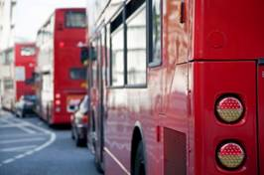 comes by bus
 comes by train
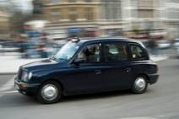 comes by taxi
 comes by car
 comes by bike

Name: | Date:
How do you come to college?

Write some sentences.
eg I come to college by car.
I walk to college.

I come to college __________________________________

My teacher comes to college __________________________

________________________________________________

________________________________________________

________________________________________________

________________________________________________

________________________________________________

________________________________________________

________________________________________________
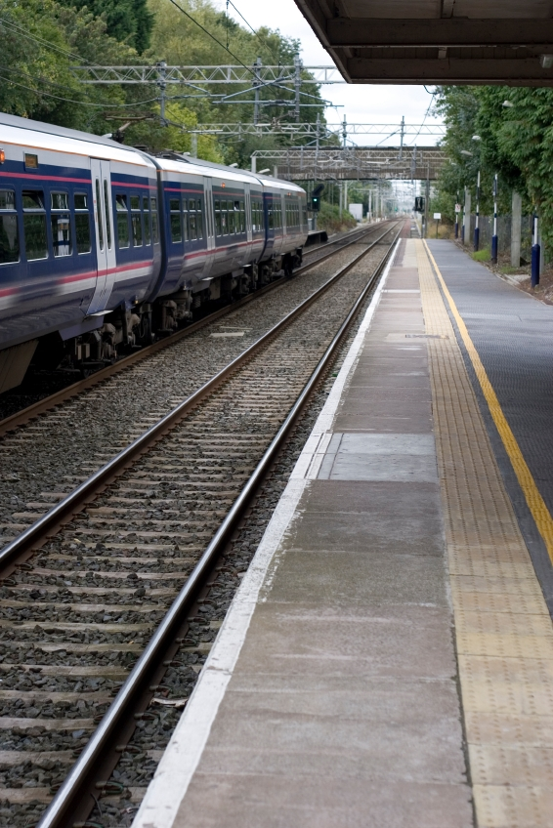 | 
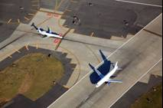 | 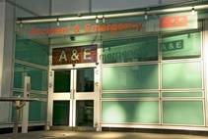
 | 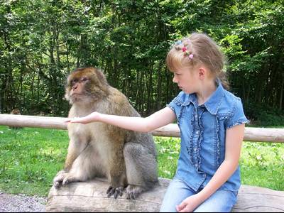
 | 

Railway Station

Park

Airport

Hospital

Library

Zoo

University

Castle

Name: | Date:

Match the words to the places in the pictures.

Hospital Zoo Library Airport
University Park Castle Railway station

_____________ | _____________ |  | _____________
_____________ | _______________ |  | ______________
 | 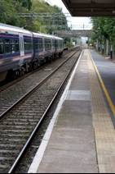
_____________ | ______________

Name: | Date:
Listen and write down the bus numbers and how often they run.

Destination | Bus numbers | How often?
Hospital |  | every ____ minutes
Castle |  | every ____ minutes
Zoo |  | every ____ minutes
Library |  | every ____ minutes
Airport |  | every ____ minutes
University |  | every ____ minutes

Tapescript
1
A: Excuse me, which bus goes to the zoo?
B: The number 26.
A: How often does it run?
B: About every 20 minutes.

2
A: Could you tell me which bus goes to the airport?
B: The number 35.
A: How often does it run?
B: Every 15 minutes.

3
A: Do you know which bus goes to the hospital?
B: The number 19.
A How often does it run?
B: There’s one every half hour.

4
A: You couldn’t tell me which bus goes to the university, could you?
B: I’m not sure, but I think the number 30 does.
A: How often does it run?
B: About every 15 minutes.

5
A: Which bus goes to the library?
B: You can get a number 45 from the stop over there.
A: Thanks. How often does it run?
B: They’re very regular — about every 10 minutes.

Tapescript
6
A: Excuse me, which bus can I get to the castle?
B: You want a number 12.
A: How often does it run?
B: Not very often I’m afraid. About every 30 minutes.

Listen and write down the bus numbers and how often they run.
Answer key

Destination | Bus numbers | How often?
Hospital | 19 | every 30 minutes
Castle | 12 | every 30 minutes
Zoo | 26 | every 20 minutes
Library | 45 | every 10 minutes
Airport | 35 | every 15 minutes
University | 30 | every 15 minutes

Name: | Date:
Partner A
Which bus goes to the bus station?
Number 23

How often does it run?
Every 15 minutes

Ask a partner for the missing information.

Destination | Bus numbers | How often?
Hospital | 12 | 15 minutes
Library
Airport | 100 | 10 minutes
University
Railway station | 82 | 15 minutes
Castle
Zoo | 26 | 20 minutes
Park

Name: | Date:
Partner B
Which bus goes to the bus station?

Number 23

How often does it run?
Every 15 minutes

Ask a partner for the missing information.

Destination | Bus numbers | How often?
Hospital
Library | 15 | 25 minutes
Airport
University | 65 | 20 minutes
Railway station
Castle | 6 | 10 minutes
Zoo
Park | 39 | 15 minutes

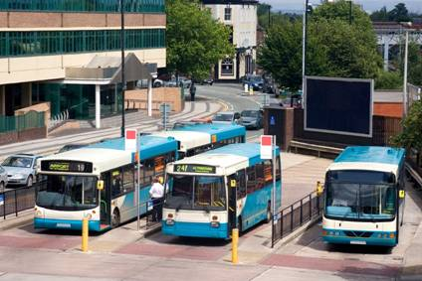 | 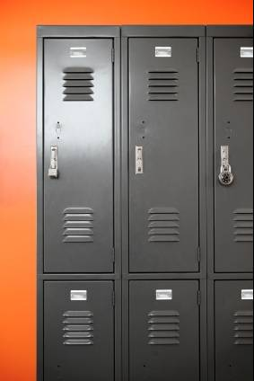
 | 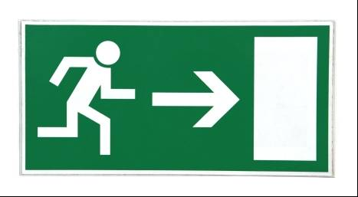
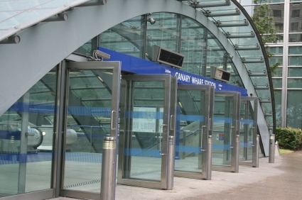 | 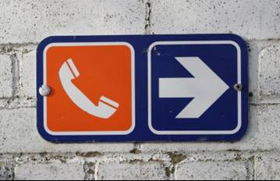

BUS STATION

ENTRANCE

EXIT

LOCKERS

TELEPHONES

NO SMOKING

Name: | Date:

Bus station
Match the words to the pictures.

Lockers

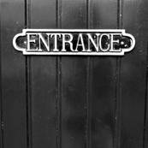 |  | 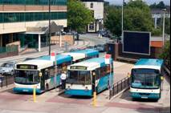




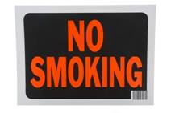



Answer key
Match the words to the pictures.

Lockers

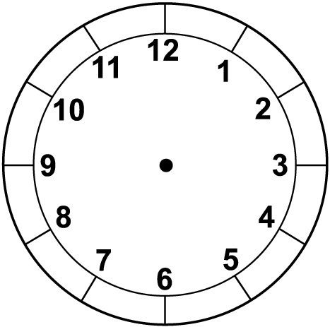

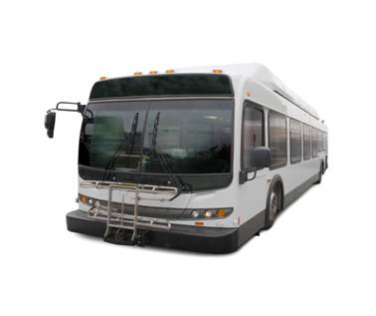

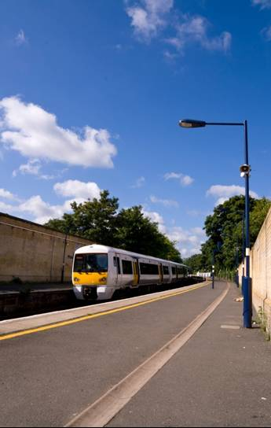

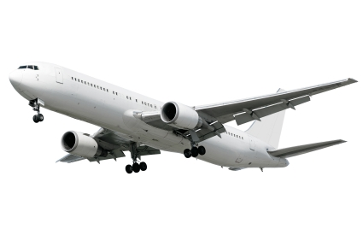

Glasgow
Aberdeen
London
Dundee
York

Newcastle
Inverness
Manchester
Perth
Edinburgh

Paris
Amsterdam
Dublin
New York

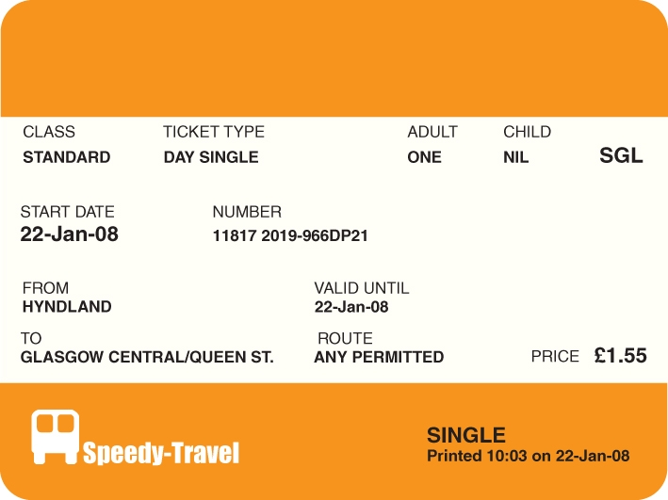
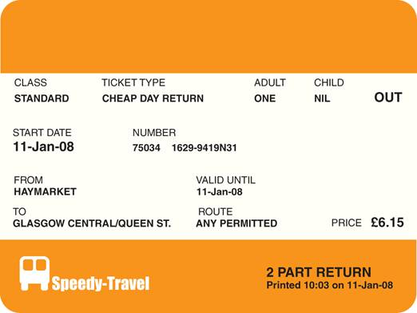

Gates 4 – 8

London? | 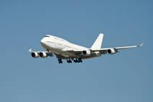 Paris?
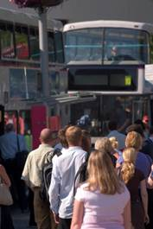 Glasgow? | Newcastle?
Manchester? | London?
Inverness? | Aberdeen?

Glasgow? | Aberdeen?
Perth? | London?
Dundee? | Newcastle?
York? | Aberdeen?

Tickets

Taxis

Platforms

Railway station

Way out

Lost property
Left luggage
Information

Toilets

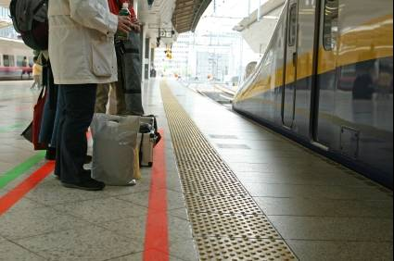
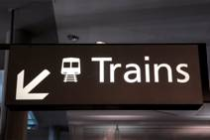



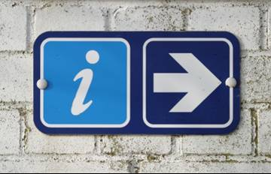

Name: | Date:
Railway station signs
Match the signs to the pictures.
Tickets
1

Taxis
2

Platforms
3

Railway station
4

Way out
5

Lost property Left luggage
6

Information
7

Toilets
8

Answer key
Match the signs to the pictures.
Tickets
1

Taxis
2

Platforms
3

Railway Station

4

Way out
5

Lost property Left luggage
6
Information
7

Toilets
8

Name: | Date:
Departure board
Where would you see this? ______________________
Departures

Time Destination Plat Expt
13:22 Glasgow Central 16 On time

13:25 Kirkcaldy 20 On time

13:30 Glasgow Queen St 8 On time

13:33 Aberdeen 19 On time

13:35 Inverness 15 On time

13:37 North Berwick 4 On time

13:40 Glasgow Central 8 On time

13:42 Glenrothes 16 On time

13:45 Glasgow Queen St 10 On time

14:00 London Kings X 11 On time

14:00 Glasgow Queen St 8 On time

Page 1 of 2 13:18:52

Circle T (true) or F (false).
1 This tells you when trains are leaving. T F
2 There are four trains to Glasgow. T F
3 There’s a train to London at 4 pm. T F
4 The train to Aberdeen is on platform 9. T F
5 There’s a train to Glasgow Queen Street
every 15 minutes. T F
6 There are no late trains. T F
7 The time is nearly 2 pm. T F

Answer key
Departure board
Where would you see this?
At a train station/railway station

Circle T (true) or F (false).
1 This tells you when trains are leaving. T F
2 There are four trains to Glasgow. T F
3 There’s a train to London at 4 pm. T F
4 The train to Aberdeen is on platform 9. T F
5 There’s a train to Glasgow Queen Street
every 15 minutes. T F
6 There are no late trains. T F
7 The time is nearly 2 pm. T F

Name: | Date:
Arrival board
Where would you see this? ______________________
Arrivals

From Time Plat Expt
Inverness 18:11 9 Arrived

London Kings X 18:15 2 18:10

Glasgow Queen St 18:25 8 On time

Aberdeen 18:36 19 18:34

Glasgow Central 18:47 - On time

Glasgow Queen St 18:50 11 18:52

Dundee 18:56 10 19:01

Stirling 19:06 16 19:04

Page 1 of 2 18:10:35

Circle T (true) or F (false).
1 This tells you when trains are arriving. T F
2 The train from London is going to be
5 minutes early. T F
3 The train from Inverness is in the station now. T F
4 The train from Dundee will arrive at platform 11. T F
5 The Stirling train is going to be late. T F
6 The time is about ten past six in the evening. T F

Answer key
Arrival board
Where would you see this?
At a train station/railway station

Circle T (true) or F (false).
1 This tells you when trains are arriving. T F

2 The train from London is going to be
5 minutes early. T F

3 The train from Inverness is in the station now. T F

4 The train from Dundee will arrive at platform 11. T F

5 The Stirling train is going to be late. T F

6 The time is about ten past six in the evening. T F

Name: | Date:
Directions sign
Where would you see this sign? _______________________
1 | 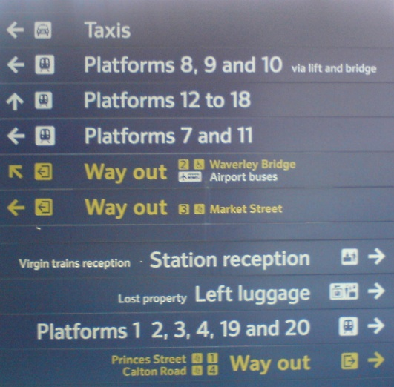
2
3
4
5
6
7
8
9
10

Name: | Date:
Directions sign
Look at the sign on the previous page. Write the numbers in the boxes. The first one has been done for you.
Where can you get a 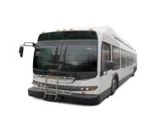to the  ?
5

Where can you leave your ?

Where can you get a 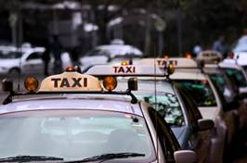 ?

What is the way to number 20?

Which says you need to use the and 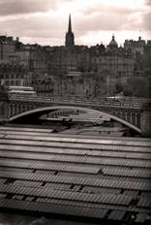 ?

Directions sign
Answer key
Where would you see this sign?
In a train station/railway station
Write the numbers in the boxes. The first one has been done for you.
Where can you get a to the ?
5

Where can you leave your ?
8

Where can you get a ?
1

What is the way to number 20?
9

Which says you need to use the and ?
2
Name: | Date:

Spelling: ‘ck’ words
Look at the pictures. All the words have ‘ck’ in them.
Write the missing letters.
Use the letters at the bottom of the page to help you.
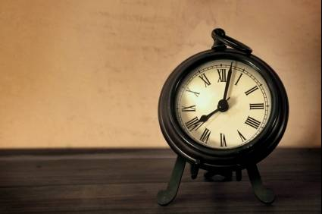
__ __ __ ck | __ __ ck __ __ | __ __ ck __ __
 |  | 
__ __ __ __ | __ __ __ __ | __ __ __ __
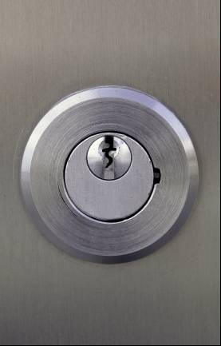 |  | 
__ __ __ __ | __ __ __ __ | __ __ __ __
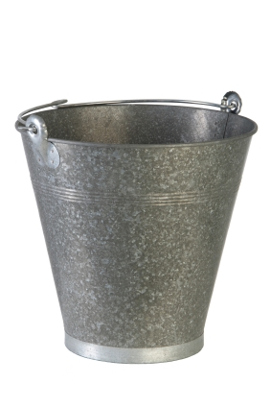 |  | 
__ __ __ __ __ __ |  | __ __ __ __ __ __
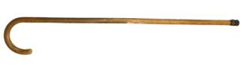 |  | 
__ __ __ __ __ | __ __ __ __ __ __ __
a
e
i
o
u

j
n
b
l
r
d
s
t

cl
st
ch

et
er
ck
en

Answer key

Spelling: ‘ck’ words

clock | ticket | locker
back | neck | sick
lock | duck | sock
bucket |  | jacket
stick | chicken

a
e
i
o
u

j
n
b
l
r
d
s
t

cl
st
ch

et
er
ck
en

Spelling: ‘ai’, ‘ay’ and ‘a_e’
ai ay a_e

Name: | Date:

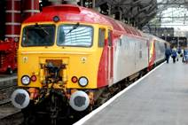
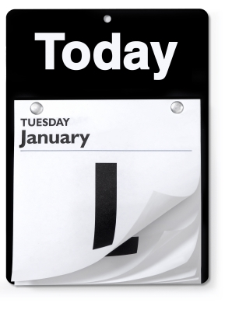

train day plane

Read these words:

rain way date

wait pay late

paid May fare

nail tray gate

stairs stay cake

hair say grapes

Name: | Date:
Spelling: ‘ai’, ‘ay’ and ‘a_e’

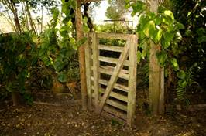
Write the words under the pictures.
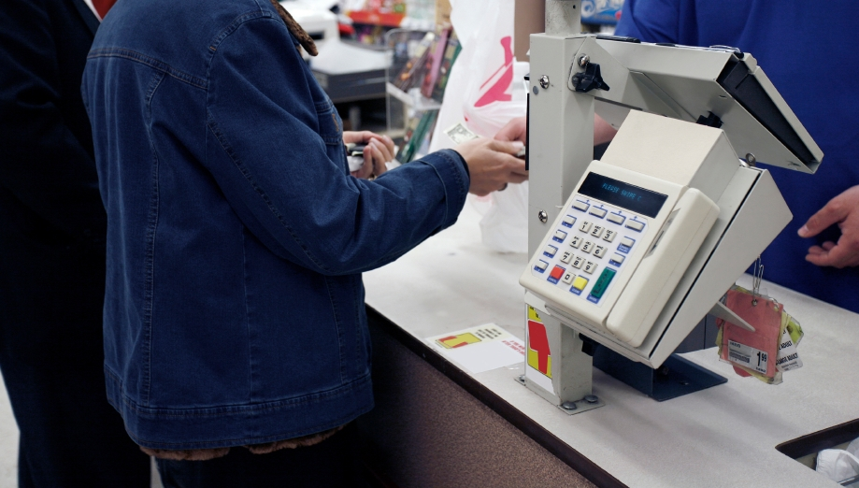

_____________ _____________ ______________
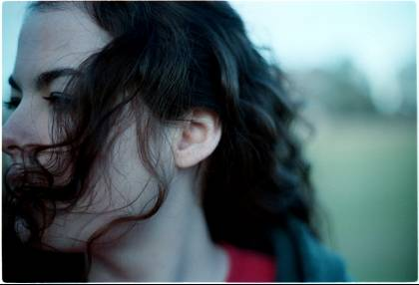
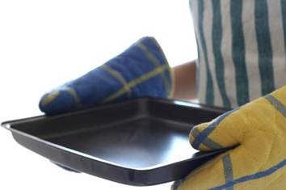


_____________ _____________ ______________
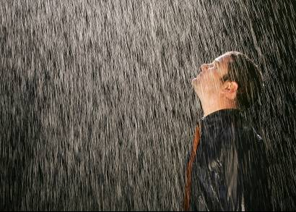



_____________ _____________ ______________

Answer key
Spelling: ‘ai’, ‘ay’ and ‘a_e’
Write the words under the pictures.

stairs pay gate

hair tray date

rain grapes cake

May’s story
Name: | Date:


Name: | Date:
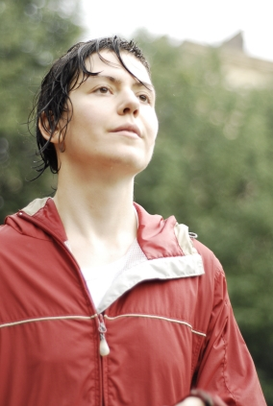
May’s story
Listen to and read the story.

Name: | Date:
May stays in Edinburgh. Today is Saturday. May is waiting at the bus stop. She wants to go to the railway station to get a train to Glasgow. She is going shopping. The bus is late and it starts to rain. May has no umbrella and no hat. Her hair gets wet. She waits and waits. At last the bus comes. She pays the fare but the bus is busy. There are no seats so she stands. She gets off the bus at Haymarket and goes into the railway station. She buys a day return ticket to Glasgow. She runs down the stairs to platform 4 and waits for the train. The train is late. At last the train comes. She gets on the train and sits down. ‘I’ll buy an umbrella in Glasgow!’ she says.

Circle T (True) or F (False).
1 May stays in Glasgow. T F
2 It is Saturday. T F
3 May is at the bus station. T F
4 She is going to Glasgow by train. T F
5 The bus is early. T F
6 It’s a sunny day. T F
7 She takes her umbrella. T F
8 She stands on the bus. T F
9 She buys a single ticket. T F
10 She gets a seat on the train. T F

ai
a_e
ay
Underline all the words in the story with

Answer key
May’s story
Listen to and read the story.

May stays in Edinburgh. Today is Saturday. May is waiting at the bus stop. She wants to go to the railway station to get a train to Glasgow. She is going shopping. The bus is late and it starts to rain. May has no umbrella and no hat. Her hair gets wet. She waits and waits. At last the bus comes. She pays the fare but the bus is busy. There are no seats so she stands. She gets off the bus at Haymarket and goes into the railway station. She buys a day return ticket to Glasgow. She runs down the stairs to platform 4 and waits for the train. The train is late. At last the train comes. She gets on the train and sits down. ‘I’ll buy an umbrella in Glasgow!’ she says.

Circle T (True) or F (False).
1 May stays in Glasgow. T F
2 It is Saturday. T F
3 May is at the bus station. T F
4 She is going to Glasgow by train. T F
5 The bus is early. T F
6 It’s a sunny day. T F
7 She takes her umbrella. T F
8 She stands on the bus. T F
9 She buys a single ticket. T F
10 She gets a seat on the train. T F

ai
ay
a_e
Underline all the words in the story with

May stays | in Edinburgh.
Today is | Saturday.
May is waiting | at the bus stop.
The bus | is late.
It starts | to rain.
May has | no umbrella and no hat.
Her hair | gets wet.
She waits | and waits.
She pays | the fare.
She gets off | the bus.
She buys | a day return ticket.
At last the train | comes.

Name: | Date:

Match the beginning to the end of the sentences.

May stays is late.
Today is a day return ticket.
May is waiting in Edinburgh.
The bus the fare.
It starts Saturday.
May has gets wet.
Her hair comes.
She waits the bus.
She pays no umbrella and no hat.
She gets off and waits.
She buys to rain.
At last the train at the bus stop.

Copy the sentences in your notebook.

Answer key

Match the beginning to the end of the sentences.

May stays is late.
Today is a day return ticket.
May is waiting in Edinburgh.
The bus the fare.
It starts Saturday.
May has gets wet.
Her hair comes.
She waits the bus.
She pays no umbrella and no hat.
She gets off and waits.
She buys to rain.
At last the train at the bus stop.

Copy the sentences in your notebook.

May stays in Edinburgh.
Today is Saturday.
May is waiting at the bus stop.
The bus is late.
It starts to rain.
May has no umbrella and no hat.
Her hair gets wet.
She waits and waits.
She pays the fare.
She gets off the bus.
She buys a day return ticket.
At last the train comes.

Name: | Date:
Travel distances
What is this information about? __________________

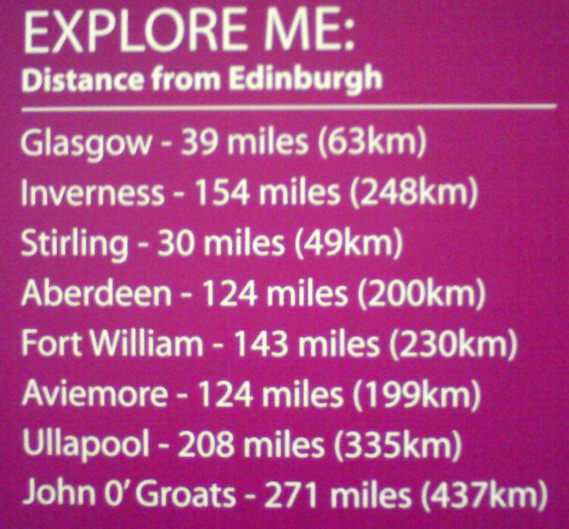

Put the following places in alphabetical order.
Edinburgh to: | Distance in miles
Aberdeen | 124

Answer key
Travel distances
What is this information about?
How far it is from Edinburgh to other towns/cities.

Put the following places in alphabetical order.

Edinburgh to: | Distance in miles
Aberdeen | 124
Aviemore | 124
Fort William | 143
Glasgow | 39
Inverness | 154
John O’ Groats | 271
Stirling | 30
Ullapool | 208

 | 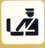
 | 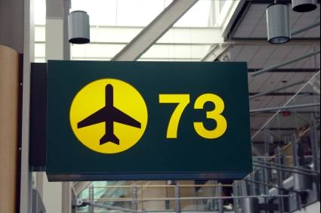
 | 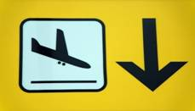
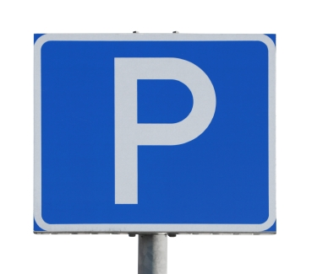 | 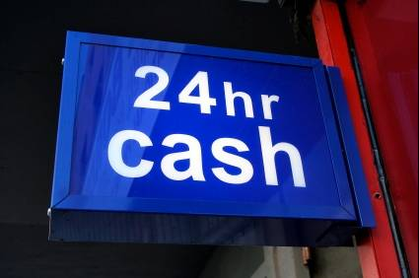

Airport

Arrivals

Departures

Customs

Car park

Lift

Check–in

Cash machine

Name: | Date:

Airport signs
Match the signs to the symbols.
Airport

Arrivals

Cash machine

Check–in

Customs

Car park

Departures
Lifts

Answer key

Match the signs to the symbols.

Airport

Arrivals

Cash machine

Check–in

Customs

Car park

Departures
Lifts

Name: | Date:
Look at the airport signs below.
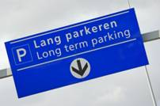  1 |   2
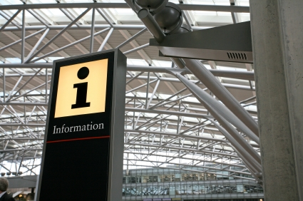  3 |   4
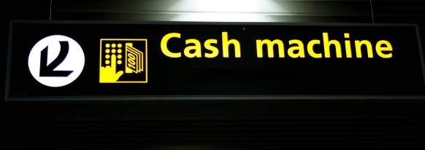  5 | 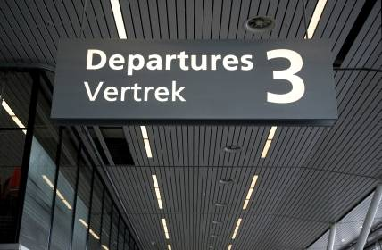  6
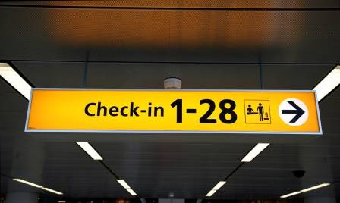  7 |   8
Which sign tells:
a you go here to get on the plane _____
b you can leave your car here _____
c you show your ticket here and get a seat number _____
d you can pay for your parking ticket here _____
e you go here to meet someone arriving _____
f you can get information here _____
g you can get money here _____
h which floor you are on _____
Answer key
Look at the airport signs below.
1 | 2
3 | 4
5 | 6
7 | 8
Which sign tells:
a you go here to get on the plane 6
b you can leave your car here 1
c you show your ticket here and get a seat number 7
d you can pay for your parking ticket here 4
e you go here to meet someone arriving 8
f you can get information here 3
g you can get money here 5
h which floor you are on 2
Name: | Date:

Ticket types

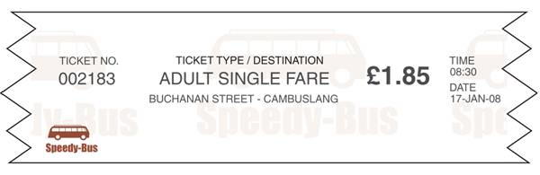

1 What is this? _________________________

2 What is a) the date? _________________________

b) the time? _________________________

c) the price? _________________________

Name: | Date:
Ticket types

1 What is this? _________________________

2 Where is it to? _________________________

3 What is a) the date? ________________

b) the price? ________________

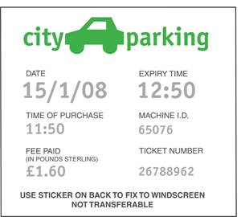
Ticket types
Name: | Date:

1 What is this? _________________________

2 What is a) the date? _____________________

b) the time? from _______ to _______

c) the price? _____________________

Name: | Date:
Ticket types
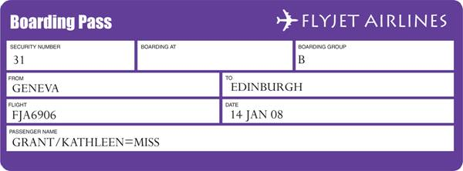

1 What is this? ______________________

2 Which company is it for? ______________________

3 Who is the passenger? ______________________

4 What is the flight number? ______________________

Answer key
Ticket types
date time
bus ticket price

1 What is this? A bus ticket
2 What is a) the date? 17 Jan 08
b) the time? 08:30
c) the price? £1.85

Answer key
Ticket types

date
price
where to

train ticket

1 What is this? A train ticket

2 Where is it to? Glasgow

3 What is a) the date? 11 January 08

b) the price? £6.15

Answer key
Ticket types

date

time time

price

1 What is this? A parking ticket

2 What is a) the date? 15/1/08

b) the time? from 11:50 to 12:50

c) the price? £1.60

Answer key
Ticket types
company

flight
number

passenger’s name

1 What is this? A boarding pass

2 Which company is it for? Flyjet

3 Who is the passenger? Miss Kathleen Grant

4 What is the flight number? FJA6906

Name: | Date:

Ask about train times and fill in the table below.

Destination | Depart | Arrive | Platform no.
Glasgow
Aberdeen
London
Dundee
York
Newcastle
Inverness
Manchester

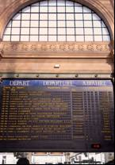 | What time is the next train to _______?  There’s one at ___________.
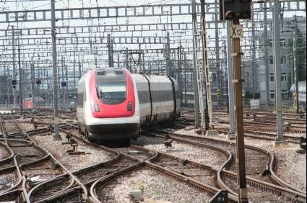 | What time does it get to ___________?  At ___________.
 | Which platform does it leave from?  Platform ___________.

Name: | Date:
Partner A
Ask a partner about train times and fill in the table below.

Destination | Depart | Arrive | Platform no.
Glasgow | 11:35 | 12:20 | 6
Aberdeen
London | 13:15 | 17:35 | 10
Dundee
York | 15:40 | 17:21 | 12
Newcastle
Inverness | 17:20 | 21:10 | 2
Manchester

What time is the next train to _______?

There’s one at ___________.

What time does it get to ___________?

At ___________

Which platform does it leave from?

Platform ___________.

Name: | Date:
Partner B
Ask a partner about train times and fill in the table below.

Destination | Depart | Arrive | Platform no.
Glasgow
Aberdeen | 12:05 | 15:50 | 4
London
Dundee | 13:55 | 15:18 | 8
York
Newcastle | 16:30 | 18:12 | 11
Inverness
Manchester | 18:25 | 22:45 | 1

What time is the next train to _______?

There’s one at ___________.

What time does it get to ___________?

At ___________.

Which platform does it leave from?

Platform ___________.

Destination | Depart | Arrive | Platform no.
Glasgow | 10:15 | 11:05 | 6
Aberdeen
London
Dundee
York
Newcastle
Inverness
Manchester
Perth
Edinburgh

Destination | Depart | Arrive | Platform no.
Glasgow
Aberdeen | 09:40 | 12:55 | 4
London
Dundee
York
Newcastle
Inverness
Manchester
Perth
Edinburgh

Destination | Depart | Arrive | Platform no.
Glasgow
Aberdeen
London | 11:10 | 16:26 | 1
Dundee
York
Newcastle
Inverness
Manchester
Perth
Edinburgh

Destination | Depart | Arrive | Platform no.
Glasgow
Aberdeen
London
Dundee | 13:25 | 14:51 | 2
York
Newcastle
Inverness
Manchester
Perth
Edinburgh

Destination | Depart | Arrive | Platform no.
Glasgow
Aberdeen
London
Dundee
York | 07:05 | 09:44 | 3
Newcastle
Inverness
Manchester
Perth
Edinburgh

Destination | Depart | Arrive | Platform no.
Glasgow
Aberdeen
London
Dundee
York
Newcastle | 15:05 | 16:40 | 11
Inverness
Manchester
Perth
Edinburgh

Destination | Depart | Arrive | Platform no.
Glasgow
Aberdeen
London
Dundee
York
Newcastle
Inverness | 18:50 | 21:25 | 10
Manchester
Perth
Edinburgh

Destination | Depart | Arrive | Platform no.
Glasgow
Aberdeen
London
Dundee
York
Newcastle
Inverness
Manchester | 15:45 | 18:52 | 21
Perth
Edinburgh

Destination | Depart | Arrive | Platform no.
Glasgow
Aberdeen
London
Dundee
York
Newcastle
Inverness
Manchester
Perth | 17:35 | 19:42 | 8
Edinburgh

Destination | Depart | Arrive | Platform no.
Glasgow
Aberdeen
London
Dundee
York
Newcastle
Inverness
Manchester
Perth
Edinburgh | 20:55 | 23:20 | 5

Name: | Date:
Listen to the airport announcements and fill in the missing information below.

 | Flight no. | Destination | Departure time | Gate no.
1 |  | Paris
2 |  | Amsterdam
3 |  | London Gatwick
4 |  | Dublin
5 |  | Glasgow
6 |  | New York

Tapescript
Airport announcements

1 Last call for Air France Flight AF479 to Paris, leaving from gate number 15 at 14:20. Flight AF479, gate number 15 at 14:20.

2 Announcing the departure of Flight KLM876 to Amsterdam at 16:45, gate number 6. KLM flight 876 from gate 6 at 16:45.

3 Announcing the departure of Easyjet flight 232 to London Gatwick from gate number 12 at 19:50. Flight EZY232 leaving from gate 12 at 19:50.

4 Ryanair announce the departure of flight FR2638 to Dublin, leaving at 13:10 from gate number 21. FR2638 to Dublin from gate 21 at 13:10.

5 Would passengers travelling to Glasgow on the 7:40 flight BMi315 please proceed to gate number 11 for immediate boarding. Flight BMi315 leaving at 7:40 from gate 11 boarding now.

6 Announcing the departure of British Airways flight BA628 to New York from gate number 18 at 22:35. Flight BA628 at 22:35 from gate 18.

Answer key
Listen to the airport announcements and fill in the missing information below.

 | Flight no. | Destination | Departure time | Gate no.
1 | AF479 | Paris | 14:20 | 15
2 | KLM876 | Amsterdam | 16:45 | 6
3 | EZY232 | London Gatwick | 19:50 | 12
4 | FR2638 | Dublin | 13:10 | 21
5 | BMi315 | Glasgow | 07:40 | 11
6 | BA628 | New York | 22:35 | 18

Copyright acknowledgements

All images © istockphoto.com (unless otherwise noted)

Cover – Carlos Lozano

p.1
1 Rene Mansi
2 Michele Lugaresi
3 ynamaku
4 Deejpilot
5 jean Schweitzer
6 Maartje van Caspel

p.3
1 adrian beesley
2 harryfn
3 & 8 Jeremy Edwards
4 John Woodworth
5 David H. Lewis
6 Andris Daugovich
7 Chris Schmidt

p.14
1 adrian beesley
2 P_Wei
3 4x6
4 Marcus Lindstrom
5 Ann Steer
6 Joe Gough

pp.25–26
1 ynamaku
2 Scott Stuart
3 Ralph125

p.29
2 Imre Cikajlo
3 Brian Pamphilon
8 Joe Gough
4, 5, 6 & 7 images were downloaded free from
www.online-signs.com

p.37
1 Stephen Rees
2 egdigital
3 Steve Dibblee
4 Yegor Korzh
5 Imre Cikajlo
7 AveryPhotography
6 image downloaded free from
www.online-systems.com

p.39 (left to right)
1 Jeff Ginieqicz
4 Gransovsky Vladislav
5 Igna Ivanova
6 Wolfgang Amri
7 Tom England
8 James Richey
9 Alexandr Stepanov
10 Elias Gomez
11 Stocksnapper
12 Stefan Klein
13 narvikk

p.41
1 ibusca
2 Marie-France Belanger
3 Scott Stuart

p.42
1 Sedar Yagci
2 Tom Hahn
3 & 4 Pamela Moore
5 Leon Chong
6 Meredith Mullins
7 Mark Kolbe

p.44
Alex Cox

p.52
4 Nicola Stratford
6 esemelewe
7 Marcus Lindstrom
8 Lance Bellers
1, 2, 3 and 5 images downloaded free from
www.online-signs.com

p.58
1 Lya Cattel
2 Jaap2
3 arne thaysen
4 Mikal Williams
5 Patricia Hofmeester
6 & 7 Markanja
8 javarman3

p.68
(arrivals board) Dutchy
(train & platform) Carlos Lozano

