Lesson  10 | Local area
Lesson  10 | Local amenities
 |  | Task: Describing the area where you live
Skill: speaking, listening, reading, writing

Activity 1




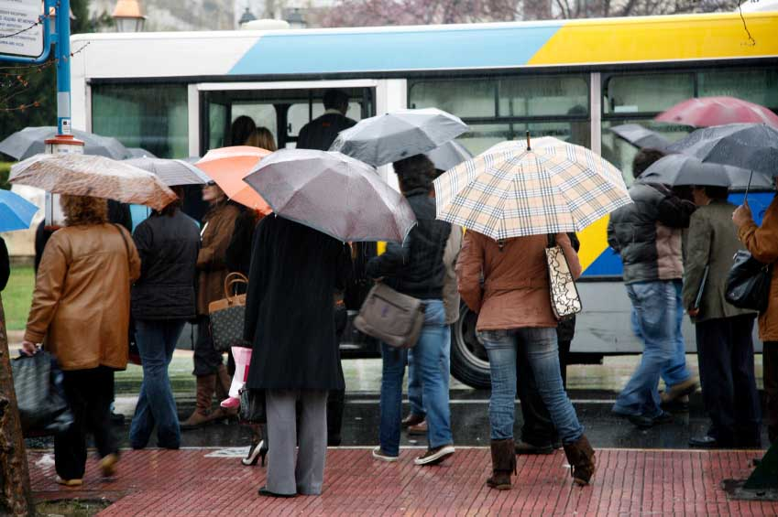

Look at the table below. Think of places in a town which fit under each heading.
1 2 3 4 5

An example for each one has been done for you.

culture | public services | leisure | transport | shops
cinema | library | pub | bus stop | chemist

All photos: (c) istockphoto.com
1 – Hsinli Wang 2 David H. Lewis 3 Nichola Monu 4 Vasiliki Varvaki 5 Sean Locke
Activity 2

Ask your partner about their area using the words in activity 1.

Is there a … in your area?

Activity 3

Read the extract from a local newsletter.

Petersfield is voted the top area to live in the city

__________ who live in the Petersfield area are among the happiest in the city it was discovered this week. Why? Well that is an easy question to answer: Petersfield has everything you need, and all within walking distance.

If we look at education, there is a new ___________ school and a very good secondary school, as well as a community centre and a library.

In terms of culture this area can’t be beaten. There is a theatre and an arts cinema with a photography __________ next door.

Moving on to _________, this area is very well connected to the rest of the city. __________ run regularly into the city centre and the journey time is less than 10 minutes. What’s more the central train station is just a 15-minute walk away if you are wanting to travel out of the city.

If you want to relax there are plenty of things to do nearby. The _________ is a lovely place to walk and has a children’s _________, as well as a football pitch. And if you like other sports there is the leisure centre, which has a large swimming pool, a __________ and tennis courts. After doing all that exercise you can head down to one of the excellent local _________ or pubs.

Finally, Petersfield is a great place to shop. There is a good-sized ___________, plus a chemist, a baker’s, a post office and more.

Now, read it again and fill in the gaps with words from the box below.

gallery playground residents restaurants supermarket
primary buses park gym transport

Activity 4

 Track 11

Listen to Fazilat talk about her local area. Does she like it?

Listen again and circle the places that you can find in Fazilat’s area.

doctor’s surgery supermarket post office

mosque school restaurant

church dentist community centre

chip shop sports centre park

bus stop pub playground

Activity 5

Look at this phrase from the listening.

- There is a bus stop opposite my flat.

Look at the map below and work with a partner to make similar sentences.

park

chemist

supermarket

sports centre

florist

cafe

Activity 6
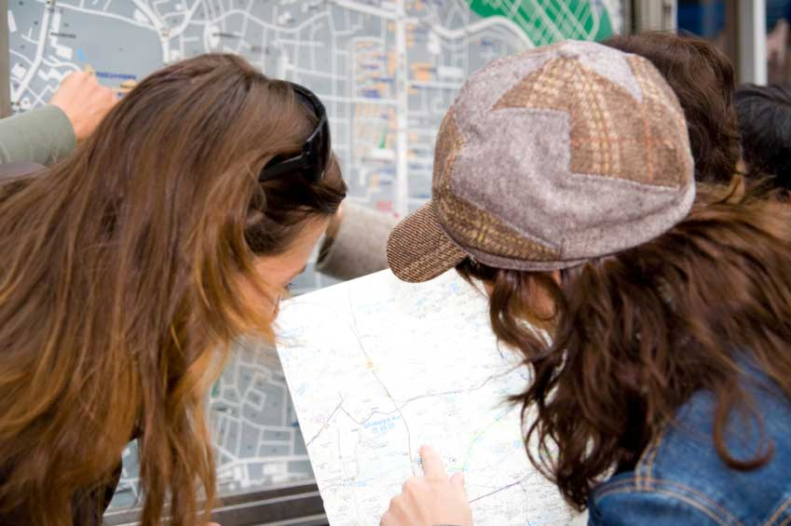

Write a short description of your local area.

Include:

  - public services
  - transport links
  - shops
  - cultural and leisure facilities
  - your opinion of the area
  - what your area needs

Homework task
Finish the description from activity 6.

Photo: (c) istockphoto.com/mihaicalin
Lesson  11 | Social events
Lesson  11 | Celebrations
 |  | Task: Describing social events
Skill: speaking, listening, reading, writing

Activity 1

Look at the different events below. What is happening in each one?

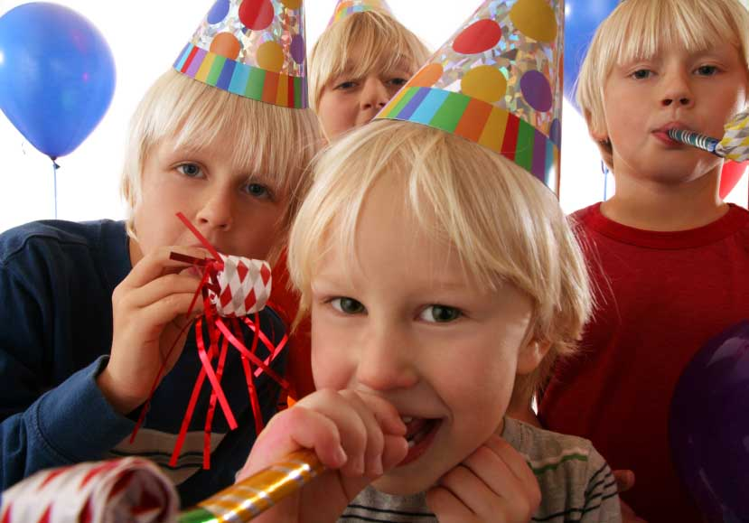  1 |   2 | 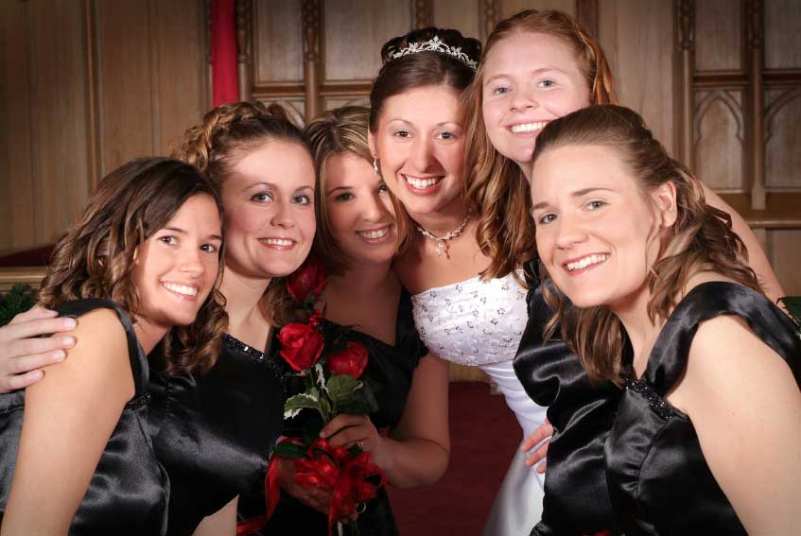  3 | 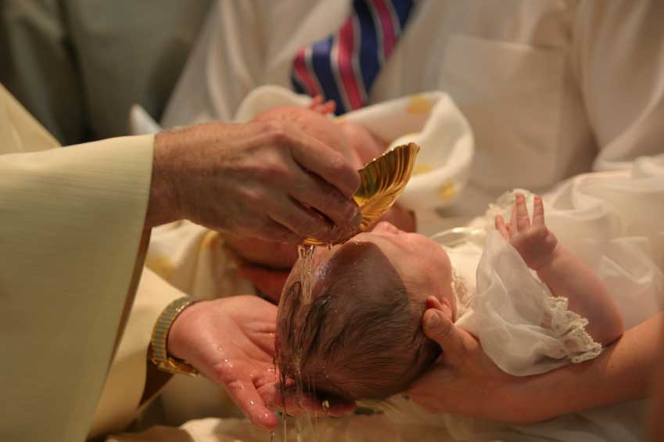  4 | 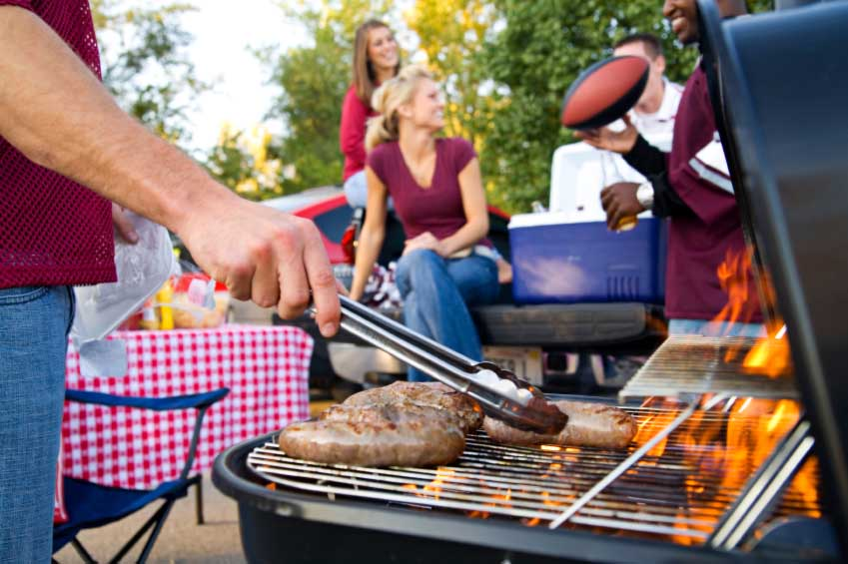  5
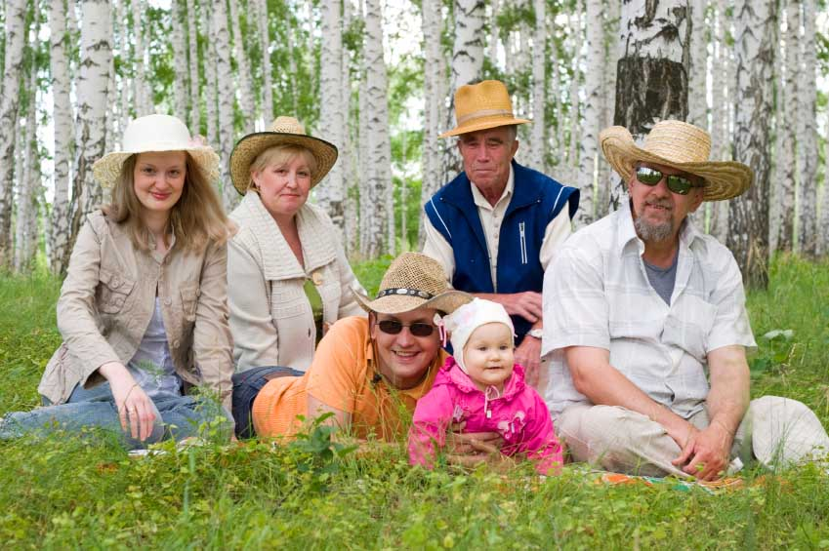  6 |   7 |   8 |   9 |   10

Match the pictures to the types of celebrations below.

- A family get-together.
- A fancy dress party.
- A leaving party.
- A christening.
- A birthday party.
- A wedding reception.
- An office party.
- A house-warming party.
- A barbeque.
- A dinner party.

All photos: (c) istockphoto.com
1 Skip O’Donnell 2 Lovrenc Gasparin 3 Stephanie Phillips 4 Terry Healy 5 Sean Locke 6 Nikolay Suslov 7 Sharon Dominick
8 g_studio 9 Lisa Gagne 10 Tom Young
Activity 2

 Track 12

Listen to Petra’s description of a party she went to. What was the party for?

Listen again and answer the following questions.

1 Where was the party? ______________________________________

2 When was the party? ______________________________________

3 Who did she go with? ________________________________

4 What did she take? _____________________________________

5 What did she eat and drink? _________________________________

6 How long did she stay? _____________________________________

Activity 3

Think about the last party you went to.


Think about:

- where it was
- when it was
- what the party was for
- who was there
- what you took
- what you did/ate/drank
- how long you stayed
- if you enjoyed yourself.

Work in pairs. Take it in turns to ask and answer questions about the last party you went to.

Photo: (c) istockphoto.com/skip o’donnell
Activity 4

Read the letter from Zhu. Why is Zhu writing to Maria?

36 (3F1) Buccleuch Place,
Edinburgh
EH8 7JB

10th April 2007

Dear Maria

I just wanted to say thank you so much for dinner the other day. The food was incredible — it was the first time I had eaten Italian food and I really enjoyed it. You will have to give me the recipe for that pasta dish so I can make it for my family.

It was lovely to meet your family too. It was fascinating to hear stories about Italy — your husband is a very good story-teller, isn’t he?

I’m going to organise a dinner at my house soon. I’ll let you know as soon as I have a date in mind. I’ll cook you some traditional Chinese food and you can meet my wife and kids.

So, see you in class. Enjoy the rest of the holidays.

Best wishes

Zhu

Now, read the letter again and answer the questions. Circle T (True) or F (False)

1 Zhu often eats Italian food. T F

2 Zhu knows Maria’s husband well. T F

3 Zhu wants to invite Maria for dinner. T F

4 Maria has never met Zhu’s family. T F

5 Zhu and Maria are workmates. T F

6 Zhu and Maria are both on holiday. T F

Activity 5

Look how Zhu said thank you in his letter.

Thanks for dinner — the food was incredible.

Match the two parts of these sentences. Each one expresses thanks for something.

1 Thanks for the lovely present — …………………………………………

2 You help was much appreciated — ………………………………………

3 It was very kind of you to send the flowers — ……………………………

4 Thank you for having me —…………………………………………………

5 Thanks so much for inviting me —…………………………………………

6 It was lovely to get your last letter —………………………………………

- I’ll come and stay again soon.

- I really enjoyed hearing your news.

- I had a wonderful time.

- they are beautiful.

- I couldn’t have done it without you.

- it’s just what I wanted.

How can you respond to someone thanking you?

With a partner, practise offering and responding to thanks using the sentences above.

Activity 6

Imagine that you have recently been to a party or other event.

Write a thank you letter to the person who invited you.

…………………………………………………………………………………

…………………………………………………………………………………

…………………………………………………………………………………

…………………………………………………………………………………

…………………………………………………………………………………

…………………………………………………………………………………

…………………………………………………………………………………

…………………………………………………………………………………

…………………………………………………………………………………

…………………………………………………………………………………

…………………………………………………………………………………

…………………………………………………………………………………

…………………………………………………………………………………

…………………………………………………………………………………

…………………………………………………………………………………

Homework task
Finish the letter from activity 6.

Photo: (c) istockphoto.com/Christine Balderas

Lesson  12 | Socialising
Lesson  12 | Making small talk
 |  | Task: Discussing the weather
Skill: speaking, listening, reading, writing

Activity 1

How could you start up a conversation with a stranger in each of these situations?

Match the comments (a–f) with the situations (1–6).

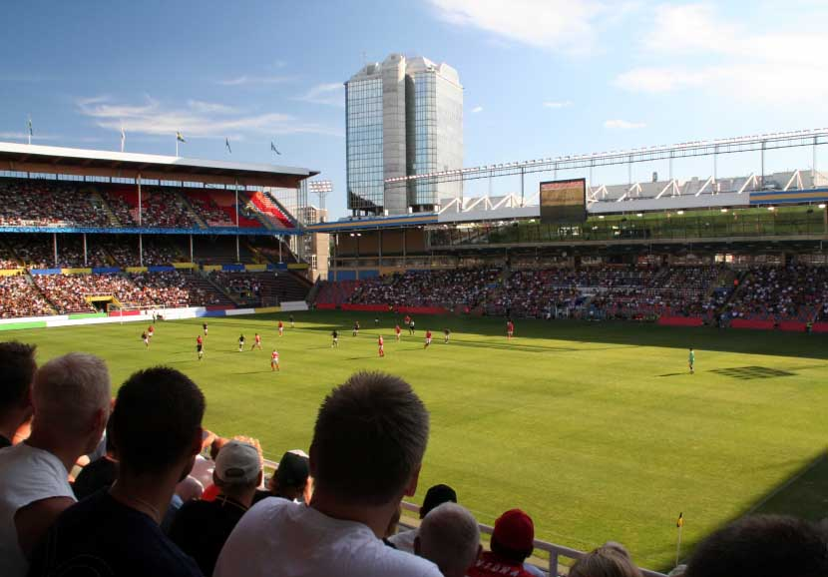
1 Walking in the park.

2 Waiting at a bus stop.

3 Standing in a post office queue.

4 Watching a football match.

5 On your tea-break at work.

6 At a party. 1

a Have you been waiting long?

b So, who do you know here?

c It is always so busy in here, isn’t it?

d Lovely day, isn’t it?

e Would you like a coffee or anything?

f What a goal!
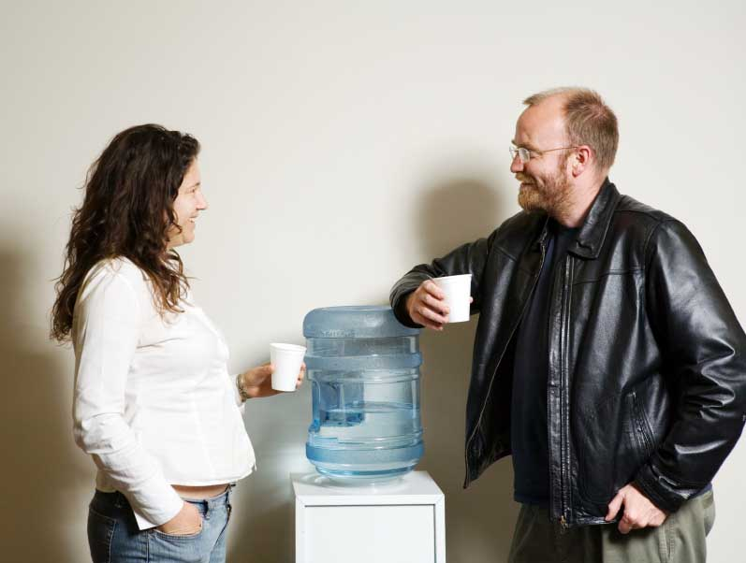
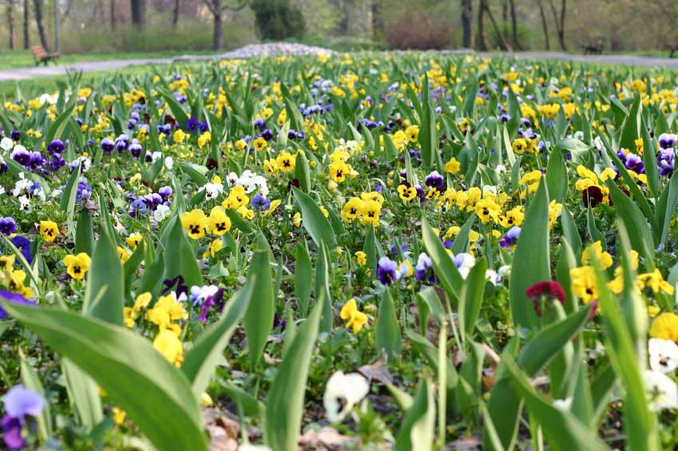
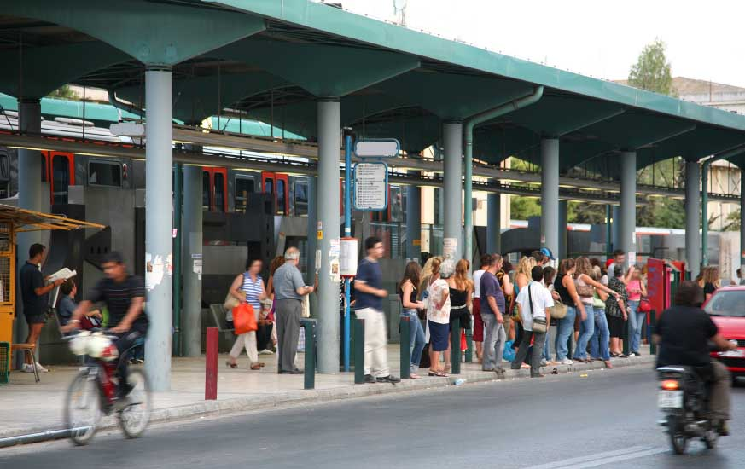

2 3 4 5

All photos: (c) istockphoto.com
1 – Marcus Lindstrom 2 Don Bayley 3 Wojciech Krusinski 4 Vasiliki Varvaki 5 Robert Churchill
Activity 2


British people love to make small talk about the weather.




1 2 3 4 5

Put the weather words in the box below into the correct place in the table. Use a dictionary to help you.

cold | sunny | windy | rainy | cloudy

grey freezing breezy cool stormy

bright icy chilly misty blustery

clear foggy overcast wet frosty

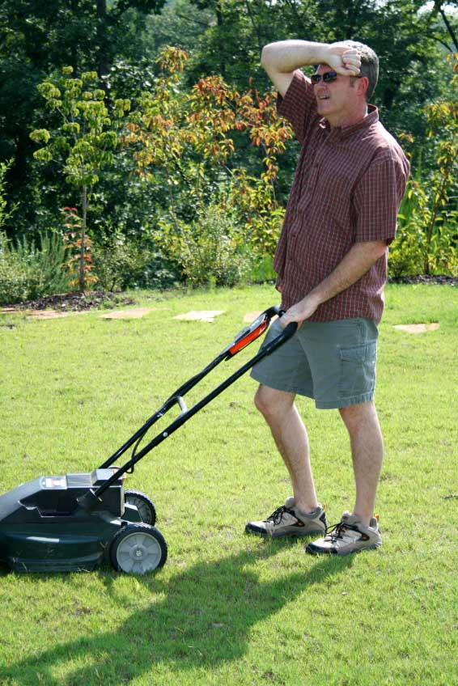
What words do you know that are connected with hot?

What’s the weather like today?

6

All photos: (c) istockphoto.com
1 – Andrei Tchernov
2 – Alberto Pomares
3 – Heiko Grossman
4 – Gremlin
5 – Eray Haciosmanoglu
6 – Brad Killer
Activity 3

 Track 13

Listen to Bill and Lucy talk about the weather. Is the weather good or bad at the moment?

Listen again and answer the following questions. Circle T (True) or F (False).

1 They are outside. T F

2 It is a dry day. T F

3 It is a windy today. T F

4 Yesterday the weather was better. T F

5 There was a bad storm on Tuesday. T F

6 Last week it was warmer. T F

Activity 4

Look at the tapescript from activity 3.

Look at the underlined words. Why do we use them?

Practise the dialogue with a partner.


Photo: (c) istockphoto.com/chris hanke
Activity 5

Read the weather forecast for the next five days. Which is the best day?

The five day forecast for Nairn

Monday Light rain and cloud in the morning with sunshine later in the afternoon.

Tuesday Sunny all day with temperatures a mild 11 degrees centigrade.

Wednesday Heavy rain all day with stormy conditions in the morning.

Thursday Bright and sunny, but chilly with temperatures down to 8 degrees centigrade.

Friday Very cold with temperatures dropping to minus 2 degrees centigrade. Snow in the afternoon.

Now, imagine that you want to make conversation about the weather.

Finish the following stems using information from the forecast.

- I’ve heard that it’s going to be sunny on Monday afternoon.

- I’ve heard that ………………………………………………………

- They say that………………………………………………………..

- Someone told me that……………………………………………..

- I read that……………………………………………………………

- From what I know…………………………………………………..

How can you show interest when someone tells you something?

Practise the above sentences with a partner — make sure you show interest.

Activity 6

Read the postcard below. Where is the person writing from? What’s the weather like?

Hi Katy

Well, as you can see from the postcard I’m in morocco. I’m having a wonderfull time here and I’m doing lots of exciting things. It is so hot here though. It has been around 90 deegres every day this week and I hear that it is going to be even hoter next week. someone told me that it might reach 100.

Anyway I hope you are fine there in Edinburgh. What’s the wether like there. I expect it is gray and rainy as per usual!

So, I’ll give you a ring when I get back and we can catch up

Right, got to go now – our minibus is here. See you soon.

Love from Isobel

There are five spelling and five punctuation errors in the postcard.

Identify the errors and correct them. Write out the postcard again.

Homework task
Write a weather diary for the next five days.

Lesson  13 | Personal opinions
Lesson  13 | Agreeing and disagreeing
 |  | Task: Giving and responding to opinions
Skill: speaking, listening, reading, writing


Activity 1

Read the different opinions on smoking below.

Which ones are for and which ones are against smoking?

I think that smoking is a disgusting habit.

In my opinion, people should be allowed to smoke wherever they like.

To my mind, anyone that smokes is plain stupid.

I feel that everyone should have the choice whether to smoke or not.

I believe that there should be more tax on cigarettes.

Which statements do you agree with?

Photo: (c) istockphoto.com/kutay tanir
Activity 2

Read the following letters about the smoking ban in Scotland.

Which letter is in favour of the ban and which one is against it?
Photo: (c) istockphoto.com/kent rosengaard

Letter A
Letter to the Editor

This week saw the introduction of the smoking ban in Scotland. As from Tuesday it was impossible to light up in any ____________ place, including all restaurants, cafés, bars, pubs and discos. Before this week smoking was already banned in the_____________, but this week’s extension of the ban means that from now on smokers will have just two places left to smoke: their homes or the____________!

In my opinion, this is hugely unfair on smokers. I don’t think that it is right to restrict smoking to such a limited area and I am very disappointed that the Scottish Executive has made this decision. As I see it, everybody should be able to enjoy a ______________in their leisure time, if not at work. When I go to a pub or restaurant I am there to relax, and I enjoy having a cigarette after my ___________or with a drink. I don’t see how this can bother other people so much.

What’s next? A ban on breathing?

Mr R Jessops, Edinburgh

Letter B
Letter to the Editor

This week I am celebrating. Why? Because I can now go out in the evening, go to a pub or disco, enjoy a drink with friends and not come home smelling of cigarette______________. Wonderful!

As far as I’m concerned, the smoking ban should have been implemented a long time ago. I’m convinced that _______________ smoking has some very serious health risks for non-smokers and I personally believe that cigarettes should be made even more ______________ to try and stop more people taking up this disgusting ____________.

I feel sure that the smoking ban in Scotland is a ______________ thing and that in the end even the smokers will recognise this fact.

Mrs Madeleine Lowe, Peebles

Now, fill in the gaps in the two letters using the words in the box below.

expensive street cigarette habit

smoke public positive

workplace passive meal

Activity 3

Look at the language the two people used to introduce their opinions. Underline the different phrases you find.

How can you respond to opinions? Look at the different responses below and put them into the correct box – agree or disagree.

That’s true. I don’t believe that. You have a point there.

I disagree I don’t agree with you there. You’re right.

I know what you mean Exactly! I wouldn’t say that.

There’s no evidence for that. You could be right.

agree | disagree

Activity 4


What are your opinions on the following topics?



1 2 3

- football
- fast food
- alcohol
- television
- the internet
- Scotland

Discuss your opinions with a partner. Introduce your opinions with the phrases you underlined in the activity 2 reading. Respond with the language in the box from activity 3.

Activity 5

 Track 14

Listen to Yasmin and Diego’s conversation. What topic are they discussing?

Read the statements below. Listen again and fill in the name of the person who says each thing. Write Yasmin or Diego in the gap.

1 _______________ thinks that bull-fighting is cruel.

2 _______________ believes that bull-fighting is an art.

3 _______________ says that bull-fighting is very violent.

4 _______________ doesn’t feel that the bull suffers.

5 _______________ thinks that being a matador is a dangerous job.

6 _______________ doesn’t believe that animals are very important.

All photos (c) istockphoto.com
1 Andrew Manley 2 Matjaz Boncina 3 Dan Thornberg
Activity 6

Look at the tapescript from activity 4.

How do Yasmin and Diego ask for repetition and clarification? Underline the examples you find.

Now, match the two parts of these mini dialogues. Draw lines to join them.

- I think Bob is right. Sorry, how many did you say?

- The ban started on Tuesday. Sorry, what time did you say?

- You can’t smoke in pubs. Sorry, who did you say?

- 8 pm is good for me. Sorry, how much did you say?

- I smoke 20 a day. Sorry, when did you say?

- A packet costs £5.50. Sorry, where did you say?

Practise asking for repetition and clarification.

Try to talk for one minute about your experience at this college or school and your opinion of it — your partner should interrupt as many times as possible to ask for repetition or clarification.

Activity 7

You have seen a very negative letter about your college or school in the newspaper. Write a letter to the editor expressing your opinion.

Homework task
Finish your letter from activity 6.

Lesson  14 | Review
Lesson  14 | Social and physical environment
 |  | Task: Revision: lessons 8–13
Skill: speaking, listening, reading, writing

Activity 1

Find out what your partner has to do after today’s class and for the rest of the day.

When you tell your partner about your obligations you should use some of the following linking words.

First of all …
Then …
Next …
Later on …
After that …
After …ing …
Last of all …

Activity 2

Look at the following sentences. Find the errors and correct the sentences.

1 What time do you normally has dinner?

…………………………………………………………………………………

2 My husband always finishs work at 5 pm.

…………………………………………………………………………………

3 How often they watch TV?

…………………………………………………………………………………

4 Never I eat breakfast on weekday mornings.

…………………………………………………………………………………

Photo: (c) istockphoto.com/ever
Activity 3

Look at the survey below. What is the survey about?

Survey

Please answer as many of the questions as you can about your home and local area.

Please mark the boxes where applicable.

Name: _Natalie Singh_

- Area you live in - ___Denniston____

- Detached house Semi-detached house Terraced house Flat

- Own garden Shared garden

- Owned Rented

- Time in property - ____5 years______

- Total number of rooms - ____5____

- Number of bedrooms - ____2____

- Size of property - ______90 m²______

- Would you like to move to a different property? Yes No

If the answer to the above answer was ‘yes’, please state why below.

Would like another bedroom so that children don’t have to share

- Transport links in your local area - Good Reasonable Poor

- Public services in your local area - Good Reasonable Poor

- Shops in your local area - Good Reasonable
Poor

- Sports facilities - Good Reasonable Poor

- Would you like to move to a different area? Yes No

If the answer to the above question was ‘yes’, please state why.

There is no primary school in the area – children have to get bus

Read the survey carefully.

Write a description of Natalie’s home and local area using the information given.

Include all the information given in the survey.
Use your imagination to expand the information given
about the local area.
Write the description in the third person.

1
Activity 4

 Track 15

Listen to Margaret talking to Yan on the phone. Why is she calling?

Listen again and answer the following questions.

1 What kind of party was it? ___________________________________

2 What did they eat? _________________________________________

3 What did Margaret like best about the party? ____________________

4 What does Yan thank Margaret for? ___________________________

5 What does Yan say to change the subject? _____________________

6 What’s the weather like where Margaret lives today? ______________

Activity 5

Look at the weather words below. Fill in the gaps to complete the words.


- m_s_y
- b_i_ _ng
- fr_s_y
- o_er_as_
- b_ee_ _
- c_il_y
- b_us_e_y
- f_e_z_ _ _
2
- h_mi_
- i_ _
- w_ _

All photos (c) istockphoto.com
1 – Christine Balderas 2 - Blindelinse
Activity 6

Look at the six boxes below. Each box contains three statements.

Work in small groups or pairs — your teacher will give you a die. Take it in turns to roll the die and to pick a statement to talk about from the appropriate box.

Say if you agree or disagree with the statement and give your reasons.

1

Smoking should be made illegal.

Men are better drivers than women.

Scotland is a great place to live.
2

Planes are the best way to travel.

Spring is the nicest season.

Learning English is easy.
3

Television is bad for children.

Nuclear power is a good idea.

People in this city are friendly.
4

Television is too violent.

Red is the best colour.

Wearing a school uniform is a good idea.
5

Film stars earn too much money.

The most important thing about a job is the money.

Cats are better pets than dogs.
6

Acting is the hardest job in the world.

Moving to a new country is difficult.

Everybody should get married.

Homework task
Revise the vocabulary and language in lessons 8–13.

Lesson  15 | Free time
Lesson  15 | Hobbies and free-time activities
 |  | Task: Describing current and past hobbies and free-time activities
Skill: speaking, listening, reading, writing

Activity 1

Look at the pictures. What activities are the different people doing?

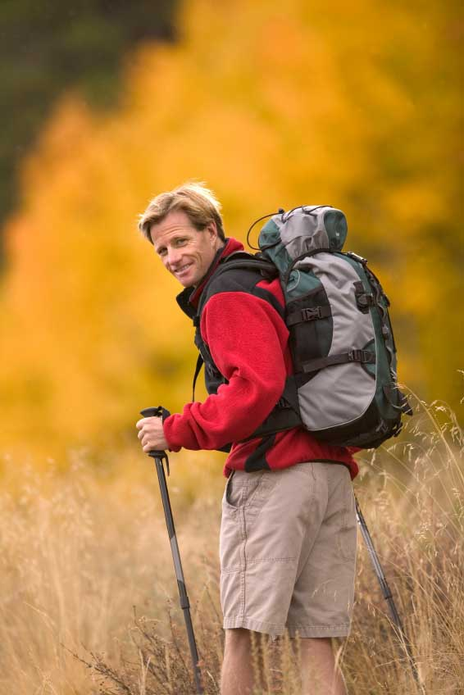
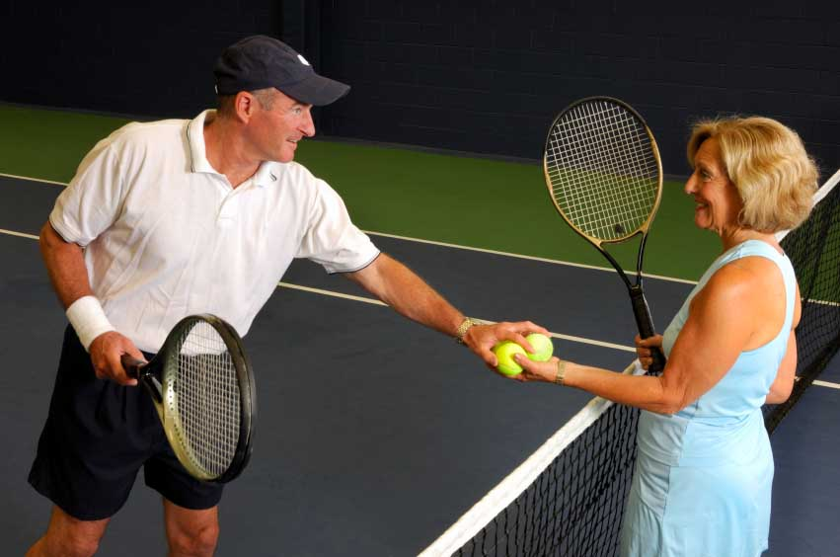

1 2 …..3

With a partner, think of at least 10 more typical hobbies or free-time activities.

- ………………………………………………..

- ……………………………………………….

- ……………………………………………….

- ……………………………………………….

- ………………………………………………..

- ……………………………………………….

- ………………………………………………..

- ………………………………………………..

- ………………………………………………..

- ……………………………………………….

Think about what equipment or clothing you need to do these activities and where you can do them.

All photos (c) istockphoto.com
1 Quavondo Nguyen 2 Ben Blankenburg 3 al wekelo
Activity 2

Find out if anybody in the class does any of the activities in your list.

What question can you ask them?

If the answer is ‘yes’, find out how often your partner does that activity.

  - every day
  - daily
  - five days a week
  - twice a week
  - a couple of times a week
  - every week
  - weekly
  - once a week
  - fortnightly
  - monthly
  - now and again
  - every so often
  - once in a blue moon.

Activity 3

 Track 16

Listen to Safinaz talking about what she does in her free time. What is her main hobby?

Listen again and answer the questions. Circle T (True) or F (False).

1 She doesn’t do gardening every day. T F

2 She works in the garden every morning. T F

3 She goes to the gym three times a week. T F

4 She normally goes jogging on a Saturday or Sunday. T F

5 She regularly goes hill-walking. T F

6 She hardly ever goes to the cinema. T F

Activity 4

Read Antonio’s description of what he does in his free time. What is his hobby?

At the moment, I’m really busy at work so I don’t have that much time for my passion in life, which is fishing. I absolutely love the peace and quiet that you get when you go down to the river to fish; it’s just you and the water. There’s no chatting, or noise or interruptions, which is so different to my job, where I’m always surrounded by people.

I would like to go fishing every day but of course that is impossible. I try to go quite regularly though, so I go at least once a week, usually on a Saturday. I live quite close to a nice place where I can fish so it is not a problem for me to get there; it’s just a 20-minute walk.

The only problem is that you do need to get up early as the best fishing is in the morning. Also, there is quite a lot to carry: rod, bait, net, stool, plus lunch and an umbrella in case it rains. You do have to be prepared for bad weather when you go fishing. The weather can change very quickly, so I always take a waterproof jacket and trousers with me. The only other thing that you need is patience.

When I was younger I didn’t use to like the idea of fishing because I thought it looked boring. I used to prefer much more intense and dangerous sports like mountain-biking. I used to go cycling every weekend until I hit 50, but now my body prefers the calm of the river.

Now, answer the following questions:

1 Does Antonio go fishing with other people? ______________________

2 How often does he go fishing? ________________________________

3 Is the river handy for him? ___________________________________

4 What equipment do you need to go fishing? _____________________

5 Was he interested in fishing when he was younger? _______________

6 When did he stop cycling? ___________________________________

Activity 5

Look at the extracts from the text in activity 5:

- I used to go cycling every weekend.

- I didn’t use to like the idea of fishing.

Think of three free-time activities that you used to do but that you don’t do now.

- I used to …………………………………………………………………..

- ………………………………………………………………………………

- ………………………………………………………………………………

Now, think of three activities that you do now but that you didn’t use to do.

- I didn’t use to …………………………………………………………….

- ………………………………………………………………………………

- ………………………………………………………………………………

Work with a partner. Ask questions about your partner’s childhood.

What questions can you ask?


Photo (c) istockphoto.com/Andrzey Burak
Activity 6

Think about your favourite free-time activity. Write a description of it.

Include:
  - how often you do it
  - where you do it
  - what equipment you need
  - what clothes you need
  - when the best time to do it is
  - why you like it.

Homework task
Finish the writing task from activity 6.

Photo (c) istockphoto.com/Christine Balderas
Lesson  16 | Going out
Lesson  16 | Suggestions, invitations and apologies
 |  | Task: Deciding what to do
Skill: speaking, listening, reading, writing

Activity 1

Look at the pictures below. What activities can you see?

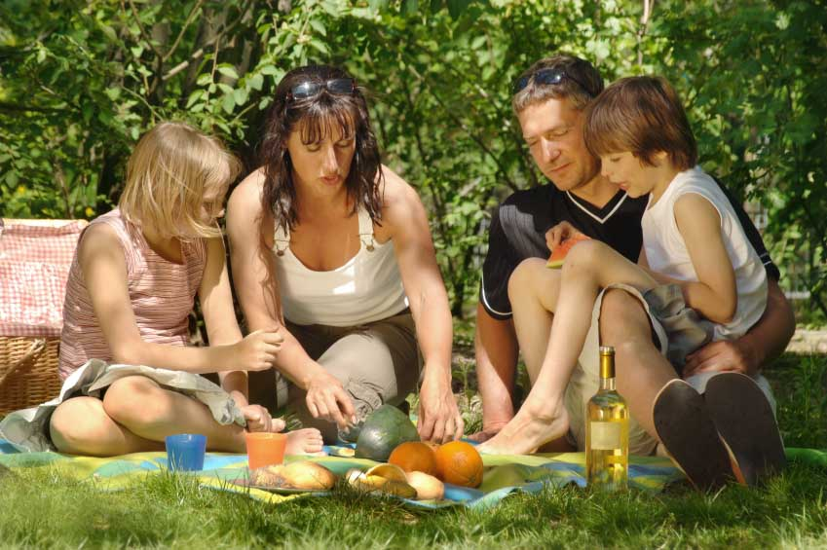


1 2 3

Activity 2

 Task 17

Listen to Emma talking to Gara on the phone. When are they making plans for?

Listen again and tick the activities that they suggest doing from the list below.

- Going to the cinema ____
- Having a drink at the pub ____
- Having a coffee ____
- Going for a walk ____
- Going to the theatre ____
- Playing tennis ____
- Meeting up with other friends ____
- Going swimming ____
- Having a picnic ____
- Going hiking ____
- Watching a dvd ____
- Going to a concert ____
- Having a pizza ____

What do they finally decide to do?

All photos (c) istockphoto.com
1 Maartje van Caspel 2 Baldur Tryggvason 3 Diego Cerva
Activity 3

Look at the tapescript from activity 2. What language do Emma and Gara use to make suggestions? Put the examples you find into the table below.

How do they respond to the different suggestions? Find examples in the tapescript and put them in the table.

Suggestions | Positive responses | Negative responses

Imagine that you and your partner are both free after the class. Together make a plan for after the class. Make suggestions for things to do — you can respond either positively or negatively.

Activity 4

 Track 18

Listen to the message left on Jack’s phone. Why is Sabey leaving a message?

Listen again and fill in the gaps in the sentences below:

- Sorry, but I can’t meet up on Friday because I’m …………………….

- Saturday is no go too because I’m ………………………………………

- Sunday morning is impossible because I’m …………………………..

Think about any fixed plans that you have for the coming week.

Write them in your notebook — for example:

- On Thursday I’m seeing the doctor.
- On Saturday I’m having lunch at my mother’s.
Activity 5

Read the following letter of invitation. What is it for?

We are getting married !

Mr and Mrs John Spencer
have the joy of inviting you to be present at the marriage of their daughter
Miss Elizabeth Spencer
to
Mr David James
which will take place on Saturday, the eleventh of May 2008 at 3 o’clock in the afternoon at St Andrew’s Church, Linlithgow.

Following the marriage ceremony we have the pleasure of inviting you to a reception at The George Hotel, Edinburgh.

R.S.V.P.
39 Hill Place
Linlithgow
Scotland
LN8 6TD
01867 354 6234

Now, read the invitation again and answer the following questions.

1 What is the name of the bride’s father? ________________________

2 What is the name of the groom? ______________________________

3 When is the wedding going to take place? ______________________

4 Is it a civil ceremony? ______________________________________

5 Is the party in the same place as the marriage ceremony? _________

6 How can you respond to the invitation? ________________________

Activity 6

Write a short letter in response to the wedding invitation from activity 5.

Include:

- thanks for the invitation
- apologies — you can’t go
- reason for not being able to go.

…………………………………………………………………………………

…………………………………………………………………………………

…………………………………………………………………………………

…………………………………………………………………………………

…………………………………………………………………………………

…………………………………………………………………………………

…………………………………………………………………………………

…………………………………………………………………………………

…………………………………………………………………………………

…………………………………………………………………………………

…………………………………………………………………………………

…………………………………………………………………………………

…………………………………………………………………………………

Homework task
Finish the letter from activity 6.

Lesson  17 | Television
Lesson  17 | Programmes and viewing habits
 |  | Task: Describing programmes you watch
Skill: speaking, listening, reading, writing

Activity 1

Match the television vocabulary (1–10) to the definitions below (a–j).

1 remote control _____
2 terrestrial television _____
3 satellite television _____
4 screen _____
5 volume _____
6 TV licence _____
7 aerial _____
8 adverts _____
9 viewer _____
10 presenter _____

- the person who watches TV.
- the front of the TV.
- the thing you use to change channels.
- the thing you have on the top of your house to receive the signal.
- what you must have if you own and watch a TV.
- the things that are on between the programmes.
- the person who presents a TV programme.
- BBC1, BBC2, ITV, Channel 4, Channel 5.
- the level of the sound.
- TV programmes that you need a special dish to watch.

Photo (c) istockphoto.com/Matjaz Boncina
Activity 2
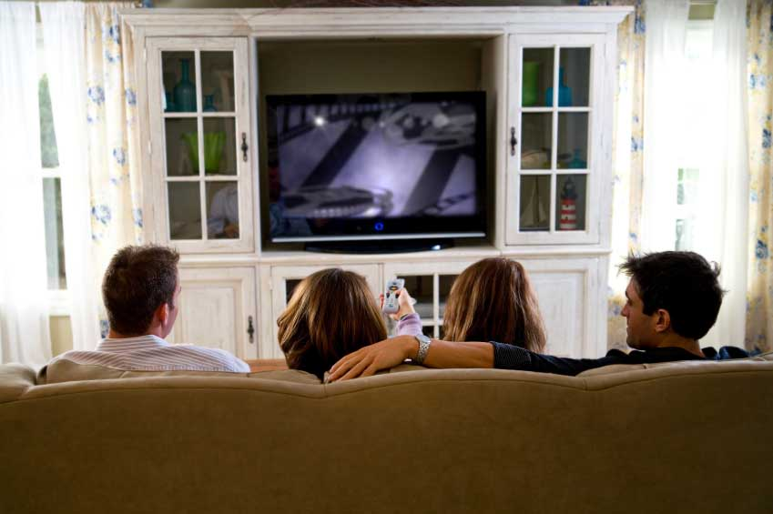
What kind of programmes can you watch on TV?

With a partner make a list of different programme types —
for example: cookery programmes.

Find out which types of TV programmes are most popular in the class.

Activity 3

 Track 19

Listen to the man describing television preferences. Which country is he talking about?

Listen again and choose the correct answer. Circle a) or b).

1 The percentage of Scots with a satellite dish is: a) 24 per cent
b) 25 per cent

2 The average Scot watches: a) over three hours of TV a day
b) over four hours of TV a day

3 The people who watch more TV are: a) men
b) women

4 The age group that watches the most TV is: a) pensioners
b) teenagers

5 The most watched channel is: a) BBC1
b) ITV

6 The most popular type of TV programmes are: a) soap operas
b) reality TV shows

Photo (c) istockphoto.com/Sean Locke
Activity 4

Read this extract from a TV magazine. What is it describing?

New on Channel 4

This month you can tune into a new series of Lost, the television series that nobody can live without! If you like adventure, mystery and action then this is the drama for you.

From this Tuesday you will be able to tune in twice a week to your favourite show. Episodes will be shown on Tuesdays and Fridays from 9.30pm to 10.30pm. And on the first Tuesday you will get the first two episodes back to back — that’s two solid hours of Lost!

If you have missed the first series of Lost, don’t panic as you can download all the episodes from the Channel 4 website. And if you miss an episode of the new series, you can always catch up with events by watching the omnibus edition on Sundays from 3 pm to 5 pm.

You can also get background information on the characters and the story, plus read interviews with members of the cast, the writers and the director by going to: www.lost.com

Read the extract again and answer the following questions:

1 When does the new series start? _____________________________

2 Is it a comedy? ___________________________________________

3 Will the same episode be shown on Tuesdays and Fridays? ________

4 What time will Lost finish on the first Tuesday? __________________

5 Is Lost repeated on Sundays? ________________________________

6 Can you download episodes of Lost from www.lost.com? __________

Activity 5

Look at the sentences below. What kinds of words are missing?

1 The news is on ____ 9 pm.

2 A new series starts ____ the spring.

3 My favourite programme is ____ Sundays.

4 I never watch television ________ the day.

5 The programme will be broadcast again ____ 5th March.

6 I love watching TV ____ the evenings.

7 There are loads of good films on TV____ Christmas.

8 The soap opera I like is ____ Thursday afternoons.

9 I sometimes get up and watch television ____ the middle of the night.

10 I always unplug the television ____ night.

Fill the gaps with the appropriate words.

Activity 6

Tell your partner about a programme that you really like.


Think about:

  - type of programme
  - channel
  - time
  - frequency on
  - frequency you watch it
  - actors/presenters
  - why you like it.

Photo (c) istockphoto.com/Sharon Dominick
Activity 7
Write a review of your favourite television programme.

It can be a television programme that you watch in Scotland
or a television programme that you have watched in another
country.

Homework task
Keep a television diary for five days.

Photo (c) istockphoto.com/Christine Balderas
Lesson  18 | Media
Lesson  18 | Newspapers and magazines
 |  | Task: Understanding and talking about the news
Skill: speaking, listening, reading, writing

Activity 1

Look at the newspaper headlines below. Match each headline (1–8) to the section of the newspaper you would find it in (a–h).

1 2
Djara wins gold for Mali
Fly to Italy for a weekend break

3 4
Warning of severe snow storms in the north
FILM DIRECTOR, FRED WALTERS DIES

5 6
Fighting continues in Afghanistan
Gun crime explodes in Glasgow

7 8

House prices rise by 30% in 6 months
The return of the boy wizard: Harry Potter 7 out in July

a international news _____
b sport _____
c travel _____
d business _____
e national news _____
f weather _____
g obituaries _____
h culture _____

Which parts of the newspaper do you like reading?

Activity 2

Look at the pictures below.

What can you see happening in each photo?
How do you think the people are feeling?
What do you think happened before each photo was taken?
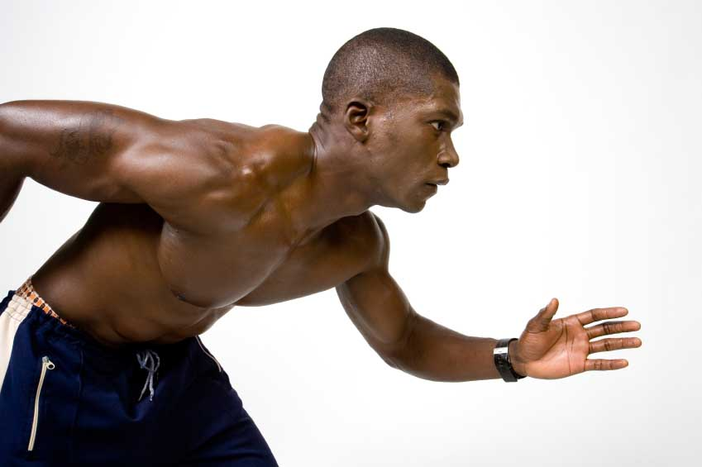
A B C
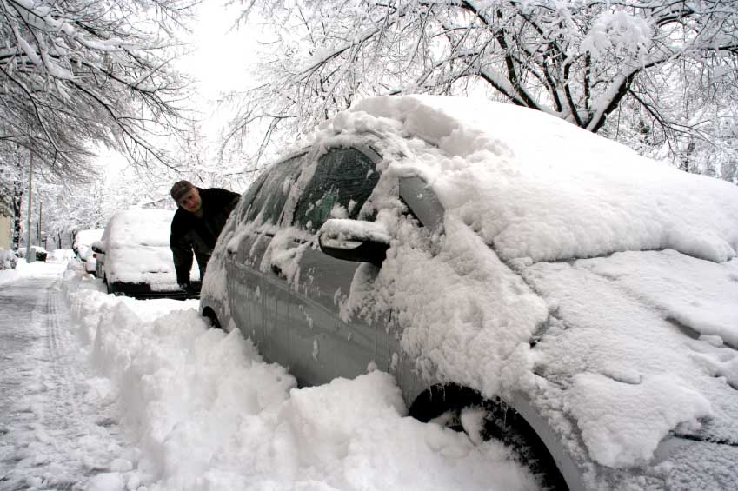


Now, skim read the extracts from the newspaper stories below. Match each story to the appropriate picture above.

1. Motorists all over the country have been affected by severe weather conditions, but it is the north that has had the worst of it.
Yesterday, in the Highlands, roads were closed, schools were shut, and normal life was put on hold.
Three people have died due to the bad conditions and many more accidents have been reported.
One eye-witness told us about her experience of driving through the storms, ‘I was travelling to work along the A82 when a lorry turned over in front of me because of the icy conditions — it was so frightening’.
2. Several arrests were made yesterday in connection with the murder of a Glasgow school boy, which took place yesterday morning in the north of the city.
The 14 year-old boy was cycling to school when a group of teenage boys pushed him off his bike and shot him.
The family of the boy who was killed say they can’t understand why their son was a target and are deeply distressed by his death. Local people are shocked and the
police say they are worried about the increasing number of guns in the city, especially among young people.
3. In an incredible finish, Salif Djara ran the race of his life to win the 800 metres at the World Youth Games in Stockholm last night.
After a poor start the 19 year-old athlete form Mali, recovered to win the race in a record time, beating the existing world record by a whole second.
It is the first time that Mali has won a gold medal in the Youth Games and Salif is now a national hero in his country. His mother told us, ‘I wasn’t watching the race when he won — I was too nervous.’

Scan the stories above to find the information needed to complete the sentences on the next page.

All photos (c) istockphoto.com
A Csaba Fikker B Olga Mirenska C Branden Laufenberg

1 Salif Djara is from ___________________________________________

2 Schools were shut in _________________________________________

3 The boy who was killed was from _______________________________

4 The World Youth Games took place in ___________________________

5 ____________________________ people have died in the storms.

6 The murdered boy was _______________________________ years old.

Activity 3

Look at these sentences from the newspaper articles in activity 2. In each sentence, which event is long and which is short?

- I was travelling to work when a lorry turned over in front of me.

  - The boy was cycling to work when a group of teenagers pushed him off his bike.

- I wasn’t watching the race when he won.

Make similar sentences from the prompts below.

1 Travel to college/school — bus break down

…………………………………………………………………………………

2 Walk to college/school — see an accident

…………………………………………………………………………………

3 Drive to college/school — my mobile phone ring

…………………………………………………………………………………

4 No rain — leave the house

…………………………………………………………………………………

Activity 4

 Track 20

Listen to Megan talk about a news story she has heard about. Is it a happy story or a sad story?

Listen again and answer the following questions. Answer T (True) or F (False).

1 The man in the story is a postman. T F

2 He won six million pounds. T F

3 He didn’t stop work when he won the money. T F

4 He gave his friends money. T F

5 He is not a father. T F

6 He works in a rich area of the city. T F

Activity 5

Look at these sentences from the listening in activity 4. What do the underlined words mean in each sentence?

  - He gave away the money.
  - He didn’t give up his job.
  - He carried on working.
  - Most people take up an expensive hobby when they win the lottery.
  - He got on well with everybody who worked there.
  - They decided to give him back his job.
  - I don’t have anyone to look after.

Finish the following sentences from your own point of view:

1 I get on well with …………………………………………

2 I’d like to take up …………………………………………

3 I have to look after ………………………………………

4 I want to give up …………………………………………

5 Last year I gave away …………………………………..

Activity 6


Your teacher will dictate a news story to you. Listen carefully and write down what you hear.

When the teacher has finished speaking, read your story again to check it makes sense and that the grammar, spelling and punctuation are ok.

Homework task
Cut out a story from a newspaper or magazine that you think is interesting. Bring it in to show the class — be prepared to talk about it.

Photo (c) istockphoto.com/Dean Sanderson

Lesson  19 | Holidays and festivals
Lesson  19 | Trips and days off
 |  | Task: Describing holidays and festivals
Skill: speaking, listening, reading, writing


Activity 1

What different ways can you travel when you go on holiday?

What do you think is:

  - the cheapest way to travel?

  - the greenest way to travel?

  - the slowest way to travel?

  - the safest way to travel?

  - the quickest way to travel?

  - the most comfortable way to travel?

  - the most uncomfortable way to travel?

  - the most expensive way to travel?

Find out what your partner’s favourite way to travel is.

Photo: (c) istockphoto.com/blindelinse
Activity 2

Read the e-mail below. Where has Francesca been on holiday?

To: anasanchez@yahoo.com
From: francesca@gmail.com
Subject: hello
Thanks for your last message. Lovely to hear all your news! Sorry I didn’t get back to you sooner but I was away. I managed to get Friday and Monday off work and I went to Skye for a long weekend with my Italian friend Fabio, who was visiting for a few days. Have you met Fabio?

Anyway, we had a lovely time, although the journey was a nightmare. We took the train to Glasgow, changed there and went on to Mallaig. From there, we caught a ferry over to Skye. It took over seven hours in total! We were so tired when we got there. We stayed in Ardvasar the first night in a pretty B & B, which was above a pub. Then, the next day we travelled up to Portree. I think you’d like the town — it’s a pretty port full of lovely coloured houses. On the way to Portree we could see the Cuillin Hills in the distance — they were spectacular. We didn’t go hiking there, but we did do a bit of walking along the coast near Portree. And the weather was great! We had clear skies and sunshine the whole time. I had expected rain so I was so happy! In fact the weather was so good that we had a few picnics while we were there. The rest of the time we ate in pubs but I can’t say that we tried any typical island food. We did try a local whisky and Fabio liked it so much that he bought a bottle to take home to Italy. Anyway, I’ll show you all the pictures when I next see you. By the way, I think meeting up in June is a great idea.

Speak to you soon. Fran x

Now, read the e-mail again and answer the following questions:

1 How many days was she away for? ___________________________

2 Did she go away with a friend of Ana’s? ________________________

3 How did she get to her holiday destination? _____________________

4 Did it take seven hours to get to Mallaig? _______________________

5 Where did they go walking? _________________________________

6 Did she buy herself any souvenirs? ___________________________
Activity 3

Find out about your partner’s last holiday.

Make questions from the following prompts:

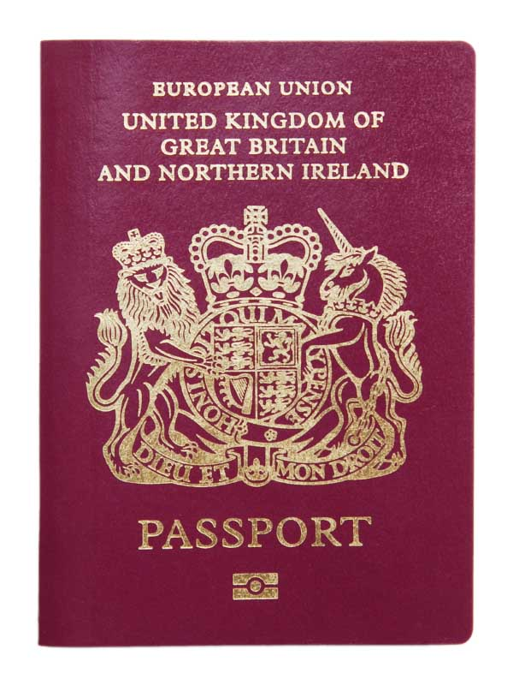
  - where
  - when
  - who with
  - how long for
  - transport
  - journey time
  - activities
  - food and drink
  - souvenirs.

Activity 4

 Track 21

Listen to Kate and Alex’s conversation. Are they talking about past or future events?

Listen again and complete the sentences below:

1 If I feel better, I’ll ……………………………………………………………

2 If the weather is good, I’ll …………………………………………………

3 If it rains, I won’t ……………………………………………………………

4 If I decide to stay in, I’ll ……………………………………………………

5 If my mum says it’s ok, I’ll ………………………………………………..

Photo: (c) istockphoto.com/Brian Pamphilom
Activity 5

Imagine that tomorrow is a bank holiday in the town where you live and that you have no obligations for the day.

Complete the following sentences:

  - If it rains I’ll …………………………………………………………………..

  - If it’s sunny I’ll ……………………………………………………………….

  - If I feel energetic I’ll …………………………………………………………

  - If I’m tired I won’t ……………………………………………………………

Activity 6

In Scotland what days of the year are bank holidays?

Match the following dates to the bank holidays or festival/celebration days below:


31st December St Andrews Day

1st January Burn’s Night

25th December New Year’s Day

26th December Good Friday 1

Late March or early April Boxing Day

30th November New Year’s Eve

25th January Christmas Day 2

Find out from your partner what days are bank holidays or festival/celebration days in another country he/she knows well.

All photos (c) istockphoto.com
1 Grafissimo 2 Jim Jurnica
Activity 7

Imagine that you went away for a long weekend because there was a bank holiday.

Write a postcard to a friend telling them where you are and describing what you have done there.

Homework task
Bring photos of a holiday you have had or a festival you have celebrated into the class. Be prepared to talk about the pictures and the events.

Lesson  20 | Review
Lesson  20 | Free time and leisure
 |  | Task: Revision: lessons 15–19
Skill: speaking, listening, reading, writing

Activity 1

Find free-time activities in the anagrams below.

1 ndggieanr ______________________

2 ighkni ______________________

3 mmnisgwi ______________________

4 ihngfsi ______________________

5 ognjgig ______________________

6 ylcngic ______________________

Now, put the above activities into the correct part of the table below:

have | go | watch | play | do

With a partner, think of other free-time activities to put into each part of the table.

Activity 2

You have a day off tomorrow and you want to do something fun.

You decide to ring a friend to ask her if she is free and to suggest doing something. When you ring your friend is not there.

Think about the message you can leave on the answering machine.


You must say:

  - who you are
  - why you are calling
  - what you want her to do.
1

Work in pairs. One student pretends to ‘be’ the answering machine; the other student leaves their message on the answering machine. You can then swap roles.

Your teacher will give you a cassette recorder. Record both parts onto a cassette.

Activity 3

 Track 22

Listen to Pablo talking about the kind of television programmes he watches in his free time. What are his favourite kinds of programmes?


Listen again and answer the following questions: 2

1 What kinds of programmes does he never watch? ________________

2 How often does he watch the news? __________________________

3 How many channels does he have? ___________________________

4 Does he like adverts? ______________________________________

5 Does he prefer watching documentaries or sports events? _________

6 How many hours of TV does he watch a week? __________________

All photos (c) istockphoto.com
1 Choicegraphx 2 Ian McDonnell
Activity 4

Read the following sentences from a news story about a fire. Where was the fire?

  - When asked how the fire had started he said that it looked like faulty electrics were to blame. _____

  - Amazingly, there were no other serious injuries and everybody else was evacuated safely from the building, before the fire-brigade arrived. _____

  - There were scenes of chaos as people tried to escape the smoke and several people were crushed as they ran for the door. _____

  - Fire destroys city nightclub. ______

  - One of the people crushed was taken to hospital with serious chest injuries and remains in a critical condition. ______

  - In the early hours of yesterday morning a fire broke out at a nightclub in the old town. ______

  - It was about 2 am when guests at the nightclub noticed smoke on the dancefloor. _____

  - In fact, the fire was so intense that one fire officer said that the building would have to be pulled down due to the amount of damage caused. _____

  - Despite the fire brigade being on the scene very quickly, it took them over an hour and a half to put out the fire. ______

The story is in the wrong order. Put events into the correct order by numbering the sentences 1–9. Number 1 is the headline.



Photo: (c) istockphoto/Angel Herrero de Frutos
Activity 5

Look at the following sentences. Identify the error in each sentence and correct it.

1 I go jogging every mornings.

…………………………………………………………………………………..

2 When I was a child I’m used to play football.

…………………………………………………………………………………..

3 How about go to the cinema tomorrow?

…………………………………………………………………………………..

4 I can’t come to the party because I will have dinner with a friend.

…………………………………………………………………………………

5 I always watch too much TV in Christmas.

…………………………………………………………………………………

6 That TV show starts on the summer.

…………………………………………………………………………………

7 I was doing my homework when the telephone was ringing.

…………………………………………………………………………………

8 He was ill and had to give in his job.

…………………………………………………………………………………

9 Travelling by train is more greener than travelling by car.

…………………………………………………………………………………

10 If it will be sunny I’ll go to the beach.

…………………………………………………………………………………

Activity 6

Look at the note below. Why did Jules have to write a note?

There are 12 errors in the text. Identify them and correct them.

Look for errors in:

- punctuation
- spelling

Hi Gulistan

I came round to see if you wanted to go to the cinima this afternoon, but youre not in!

I’m going into town now to meet Juan for lunch and then the plan is to go to the odeon on Lothian road to see the new james bond film. It starts at 315pm so if you want to come you could meet us at the cinema at about 3pm. Ive heard it’s a rilly good film so come along if you can. we can go for a drink afterwords.

Anyway, hope you can make it. It would be absolutely lovelly to see you, and you can meet Juan at last!

Love Jules x

Homework task
Review the language and vocabulary from lessons 15–19.

