Lesson  10 | Review of lessons 6–9
 |  | Task:
Skill: Speaking, Listening, Writing

Activity 1 Speaking

health questionnaire

How healthy are you? Tick one box for each sentence.

true false
1 I don’t get much exercise. □ □
2 I eat too much chocolate. □ □
3 I smoke. □ □
4 I spend a long time on my computer. □ □
5 I’m overweight. □ □
6 I don’t play any sports. □ □
7 I watch a lot of television. □ □
8 I often go to bed late. □ □
9 I drink a lot of coffee. □ □
10 I often eat big meals. □ □
11 I feel ill a lot of the time. □ □
12 I love fast food and eat lots of it. □ □

Now give yourself 1 point for each true sentence and write your score here —

____
12

Work with a partner. Look at each other’s scores. Give each other advice …

You should ….
You ought to …
You must …

Activity 2 Listening

Track 6

Food and exercise quiz

Work with a partner. Discuss the questions below and try to agree on an answer to each. Then listen to CD track 6 and check your answers.

1 Which is healthier — brown bread □ or white bread □?

2 Which are better for you — thin french fries □ or thick chips □?

3 Which is healthiest — corn oil □, olive oil □ or vegetable oil □?

4 Which has more vitamins — green pepper □ or red pepper □?

5 Which contains most vitamin C — milk □, oranges □ or brussels sprouts □?

6 Which is better for you — dark chocolate □ or milk chocolate □?

7 How often should you eat fish — every day □, once a week □
or twice a week □?

8 Which is the healthier way to cook fish — bake it □ or fry it □?

9 Which nuts contain the fewest calories —
Brazil nuts □, hazelnuts □ or salted peanuts □?

10 How many tins of diet coke give you the same number of calories as a tin of normal coke — 3 □, 48 □ or 93 □?

11 Which fruit contains most fat — an apple □, an avocado □ or a banana □?

12 How much aerobic exercise should teenagers do — two hours every day □, an hour once a week □ or 30 minutes at least three times a week □?

13 How long must you walk to burn the calories in a 250g pizza —
less than an hour □, more than an hour □ or more than two hours?

14 How long must you play tennis to burn the calories in a Big Mac —
half an hour □, an hour □ or more than an hour □?

15 Which is better for you —
dark chicken meat (leg) □ or white chicken meat (breast) □?

16 Which are best for your health —
boiled vegetables □, fried vegetables □ or steamed vegetables □?

17 How many grams of popcorn have the same number of calories as 100 g of chocolate — 60 □, 100 □ or 130 □?

18 It’s an hour before you play a big game or run a race and you feel hungry. What is best to eat —
a hamburger and french fries □
an apple and a biscuit □
or spaghetti and meat sauce □?

Activity 3 Language focus

Work with a partner. All of the sentences below are wrong, or they sound silly. Try to make them better. Change one verb to the past simple, the past continuous, or add will or (be) going to. Sometimes more than one form is possible.

1 I watched the news on TV when it broke down.
2 Is the roast chicken nice? OK, I have that.
3 She’s wearing a suit because she meet the new boss today.
4 I think I go and have some lunch.
5 Mike was catching a small fish and had it for breakfast.
6 Arnie played football when he broke his leg.
7 He’s almost at the finishing line! He win the London Marathon!
8 Shamira hung the washing out when the rain started.
9 She was getting into her car and drove away.
10 Can somebody close this window? ‘OK, I do it.’
11 Alan was hitting his thumb accidentally with a hammer.
12 I see the doctor after work today. The appointment’s at 5.30.

Activity 4 Vocabulary

1 Write one word on each line from the box below.
chemistry
extraction
filling
general practitioner
operating theatre
patients
pharmacist
surgery (x 2)

chemist
dentist
doctor
nurse
surgeon

__________ There are two types. One works in a hospital. The other, a GP (_____________), works in a _____________ in the town.

__________ They can fill your teeth (a_____________) or pull them out (an _____________). They work in a _____________. You don’t call them Doctor, but Mr/Mrs/Ms. – or just their first name.

__________ They work with doctors, surgeons and dentists, and look after the _____________.

__________ This is the normal word for a _____________. They work either in a hospital or in a chemist’s shop – or just a chemist’s. We also use this word for scientists who work in _____________.

__________ They do operations in an _____________ in a hospital. Like dentists, you don’t call them Doctor.

2 What’s wrong with Laura? Match the medical problems 1–6 with the treatment a–f.

1 She’s got flu.
a She has to stay warm and drink lots of fluids.

2 She cut her hand.
b It’s in plaster and she’s walking on crutches.
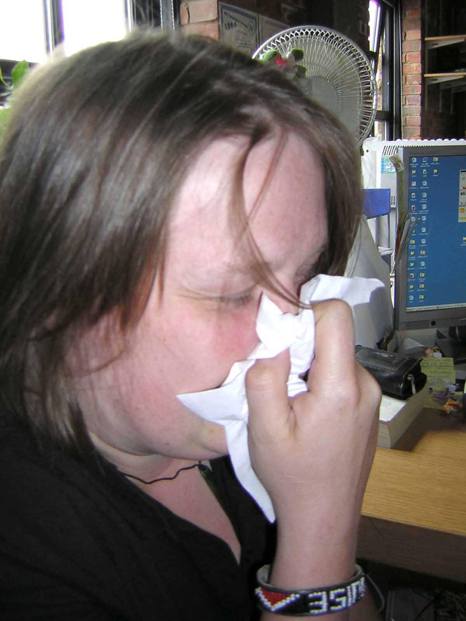
3 She’s got a stiff neck.
c She’s using drops and taking antibiotics.

4 She’s got a broken leg.
d She’s seeing the physiotherapist.
courtesy BTL

5 She’s got a broken arm.
e She’s wearing a bandage.

6 She’s got an infected eye.
f She’s wearing a sling.
Activity 5 Writing

This map shows the percentage of people who are very overweight in western European countries. Work with a partner. What percentage do you think are overweight in Britain? Discuss your ideas with a partner.

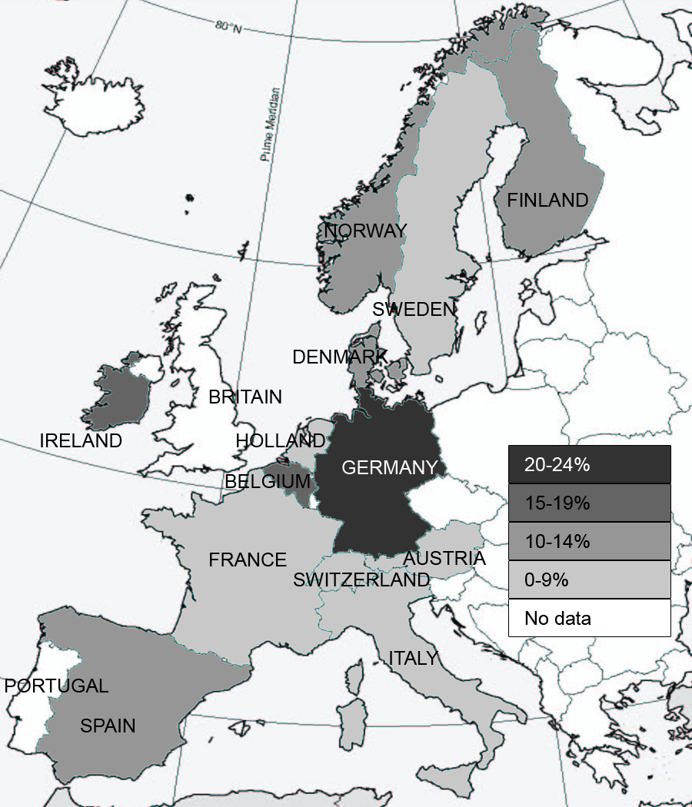

Your teacher will tell you the percentage for Britain.

Now write a report. Describe the information in the table. Why do you think there are different percentages in different countries? Think of possible reasons like diet, lifestyle, government campaigns etc.

Homework task

In Britain, the government has regular campaigns on issues such as smoking, drinking, healthy eating, etc. Adverts appear on TV and in newspapers and magazines. Use the internet or a library. Find some brochures or adverts and write a report on the campaign.

Lesson  11 | Travel
Lesson  11 | Enquiries and bookings
Task: Make enquiries
Make bookings and arrangements for transport and accommodation
Skill: Speaking, Reading, Writing

Activity 1 Speaking

Work with a partner. You want to have the full details of this tour of the Highlands. Your partner works for Staga Tours and will answer your questions. Ask a question about each item in bold. When you finish the questions, book a place on the tour.

Example:
Where does the bus leave from in Glasgow?
From George Square.

Staga Tours
When ….

Weekend tour of the Highlands

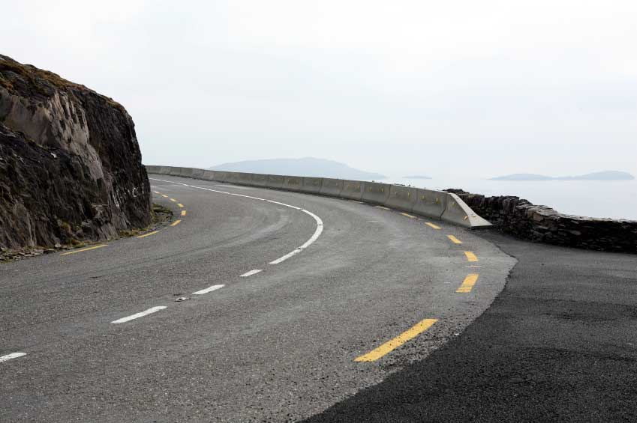
We set off from George Square, Glasgow at 10.00. We drive up the beautiful side of Loch Lomond before stopping for a three-course lunch in Crianlarich. After lunch we drive north through Bridge of Orchy and Rannoch Moor, arriving at the three-star Highlander Hotel near Fort William in the late afternoon. This allows time to freshen up before a dinner of traditional local food in our award-winning Rob Roy Restaurant. In the evening there is music and dancing in the Ben Nevis Bar. © iStockphoto.com/Ngirish

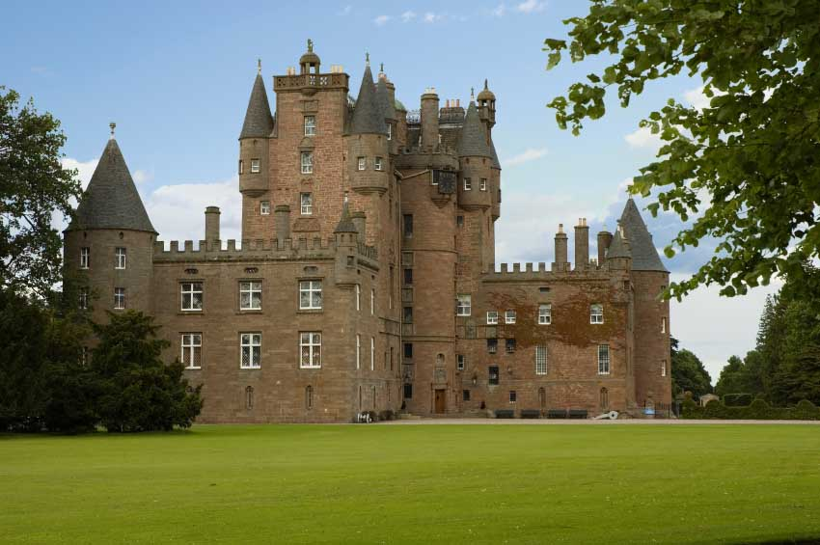
(C) iStockphoto.com/ Orellana
Saturday begins with a choice of cooked or Continental breakfasts between 8.00 and 9.00. Then we set off up the Great Glen to Inverness, stopping for coffee in the attractive village of Fort Augustus. We have lunch in the Red Deer restaurant near Inverness, looking over the Caledonian Canal. After lunch we drive down the A9 to Blair Atholl, where we have a tour of the historic Castle. We stop for dinner in the famous Tayside Restaurant near Perth before returning to Glasgow, George Square, at 8.30.
© iStockphoto.com/Francisco Orellana

The cost of the tour is an amazing £143.00.

