Activity 2 Reading

Regional Britain

1 Look at the map below. It shows some of the regions of Britain. Read the texts a–h and decide which region 1–8 each one is about. Write the numbers on the lines below. Then compare your results with a partner’s.

a b c d e f g h
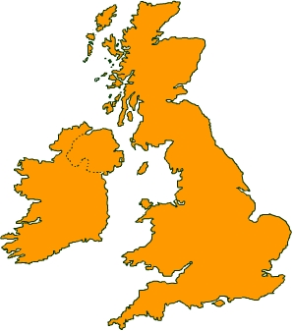
___ ___ ___ ___ ___ ___ ___ ___
1 The West Country
2 The Valleys
6 The Lake District
5 Yorkshire
7 The Borders
8 The Highlands
3 East Anglia
4 Snowdonia

3 East Anglia
4 Snowdonia
a This is the most mountainous part of England. It also has many lakes. Because it is quite near the big cities of Newcastle, Liverpool and Manchester, it gets large numbers of visitors.
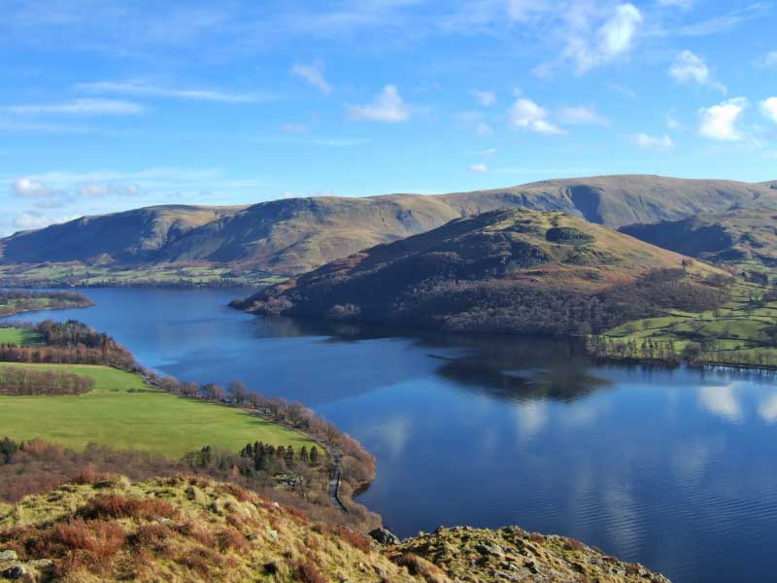
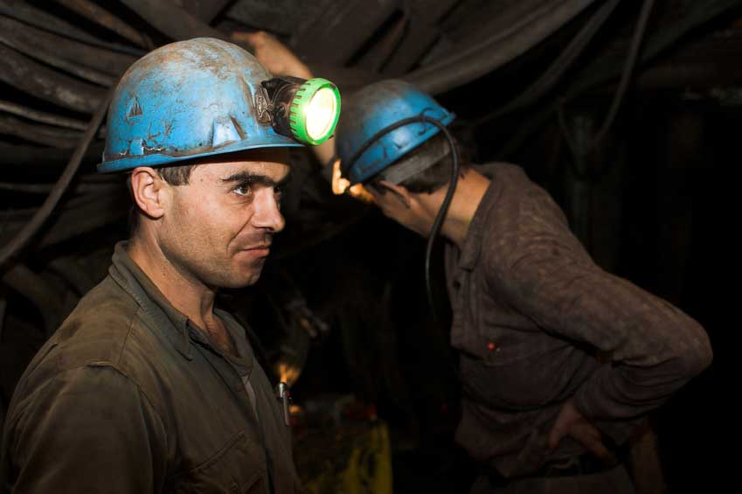
b Until quite recently, people in this part of south Wales worked in coal mining and steel making. Most of this has gone now but it is still the most populated part of the country. People here are fond of rugby and singing.
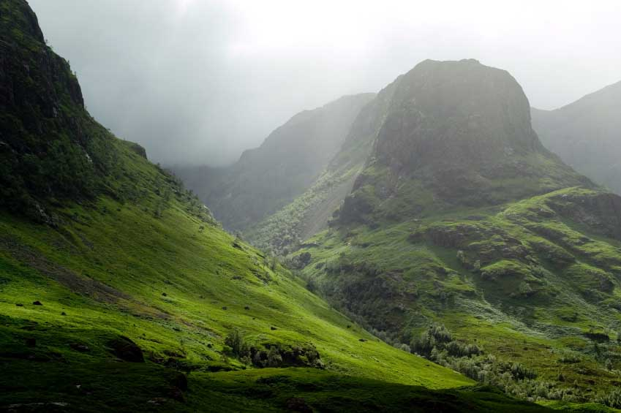
c In the past, rich people came to this part of Scotland for shooting and fishing. Tourism is now more important. A large number of people are university graduates and many work on software design, using internet connections to their homes.
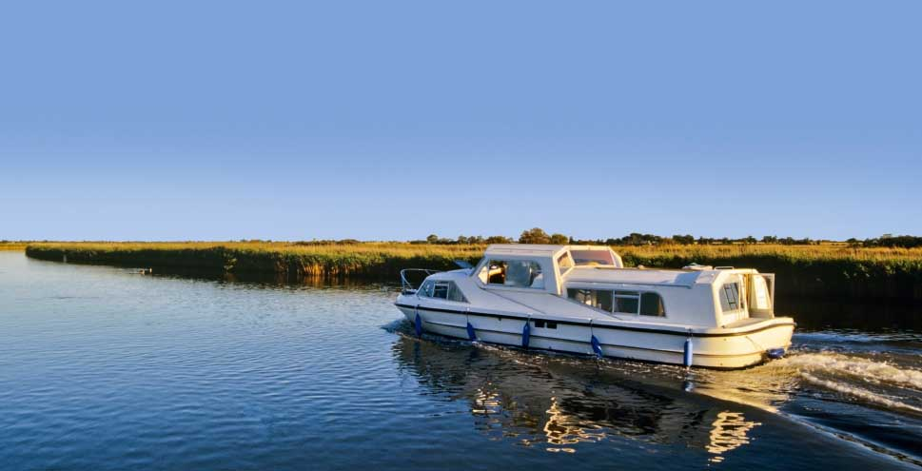
d This is the furthest east part of England. It is very low and flat, and has many rivers and small lakes. People come here to spend their holidays on boats. Cambridge, with its famous university, is in this part of the country.
e The scenery is not as interesting as in the Highlands, but this part of Scotland gets many visitors. There are old ruined abbeys and castles. Every town has a festival in the summer where people ride horses.
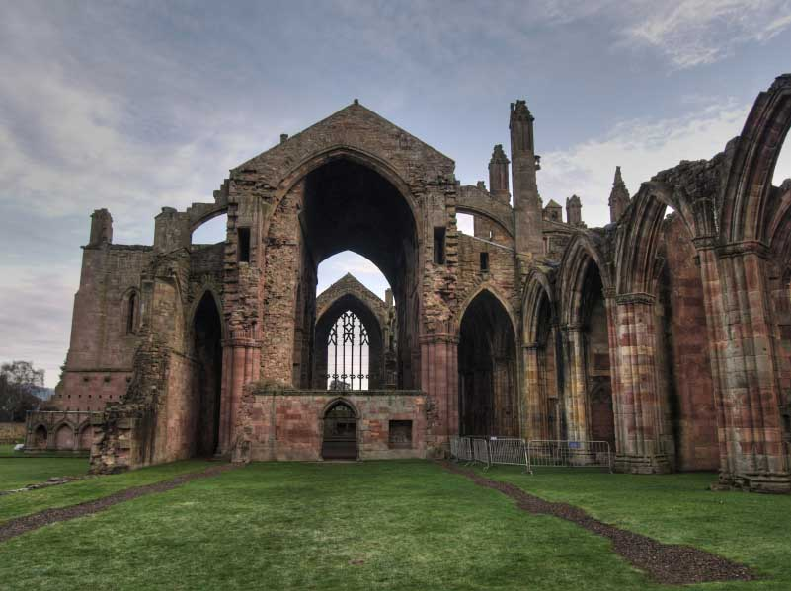
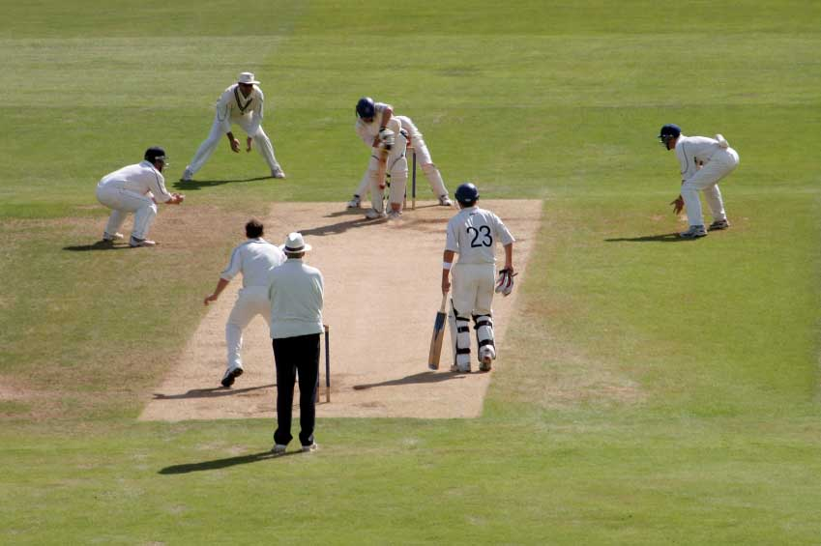
f This English county has a very strong identity. Its symbol is the white rose. The oldest city is York and it attracts many visitors. Many people in this county are passionate about cricket.
g This area traded with the Romans for many years before they conquered Britain. It contains Land’s End, the furthest west part of England. The biggest open-air music festival in the world happens in Glastonbury every year.
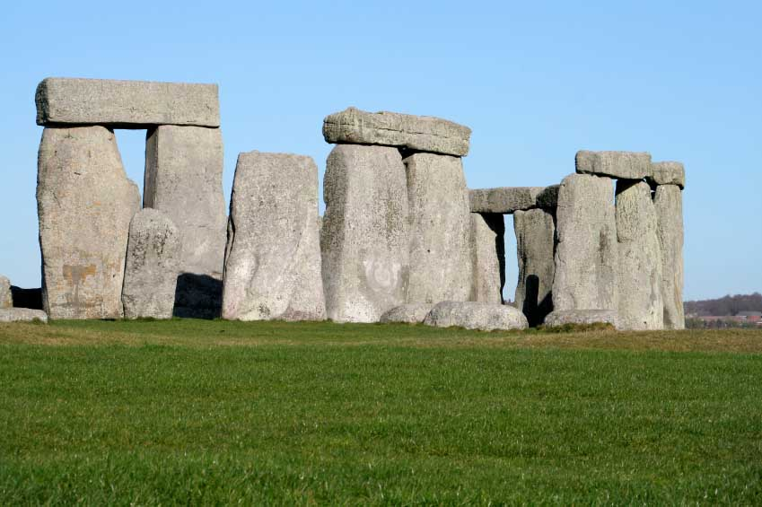
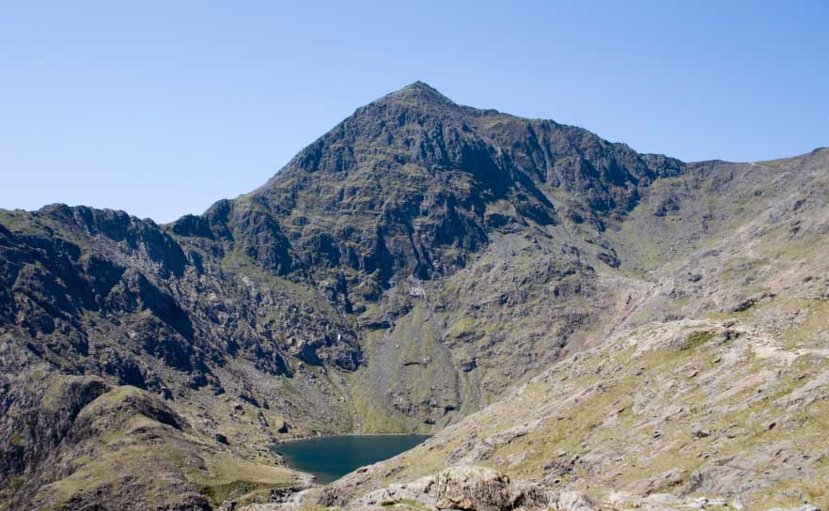
h This is the area around Snowdon, the highest mountain in Wales. This part of the country is a national park. Many people come here as visitors. Some of them climb Snowdon – but you don’t have to because a train will take you to the top.

Photos: A: (c) istockphoto/Kevin fawes B – (c) istockphoto/tomas bercic C - (c) istockphoto/Mike Bentley D - (c) istockphoto/David Hughes E - (c) istockphoto/Chad Bontrager F - (c) istockphoto/Lance Bellers G - (c) istockphoto/Lance Bellers H - (c) istockphoto/Jonathan Maddock

2 Many British cities have nicknames for their people. Here is a list. Write one nickname under the name of each city.

Aberdonians
Brummies
Cockneys
Dundonians
Geordies
Glaswegians
Liverpudlians or Scousers
Mancunians

Glasgow
_______________
Liverpool
_______________
Manchester
_______________
London (East End)
_______________
Newcastle
_______________
Dundee
_______________
Aberdeen
_______________
Birmingham
_______________

Activity 3 Language focus

Work with a partner. Look at the phrasal verbs in the box. Write one on each line in the conversation below.

check in get away get on go through set off stop off take off

1 ‘It’s going to be great to _________ for a few days.’
2 ‘What time does the plane _________?’
3 ‘At 2 o’clock, but we have to _________ two hours before the flight.’
4 ‘So we’d better _________ about ten o’clock.’
5 ‘Make that a bit earlier – we can _________ for coffee on the way.’
6 ‘Do you know a good route? I don’t want to _________ the city.’
7 ‘Sure – we can _________ the motorway. It’ll take us to near the airport.’

Activity 4 Vocabulary

Work with a partner. You are taking a flight. Decide on the correct order of these sentences. Write the letters on the lines below.

___ ___ ___ ___ ___ ___ ___ ___ ___ ___ ___

a Go through customs.
b Wait till the plane takes off.
c Go to the baggage hall and collect your luggage*.
d After the plane lands, go through passport control.
e When your flight is called, go to the departure gate.
f Go there, show them your ticket and give them your luggage.
g Join the queue, give them your boarding pass and board the plane.
h Put your flight bag in the locker, sit down and fasten your seat belt.
i For flights outside the European Union, you can now buy duty-free goods.
j Look at the departures board, find your flight and the correct check-in desk.
k Take your boarding pass, go through security and then to the departures lounge.

* Airlines use the US form baggage for luggage.

Activity 5 Writing

Your teacher will dictate a story to you. Write it down, using capital letters, full stops, commas, quotation marks and question marks in the correct places. Then compare your results with a partner’s.

Homework task

Use the internet or visit a travel agent. Find information about different types of holidays. Write a description of a holiday you would like to take.

Lesson  12 | Travel
Lesson  12 | Getting there
 |  | Task: Provide and follow directions
Skill: Speaking, Listening, Writing

Activity 1 Speaking

getting there

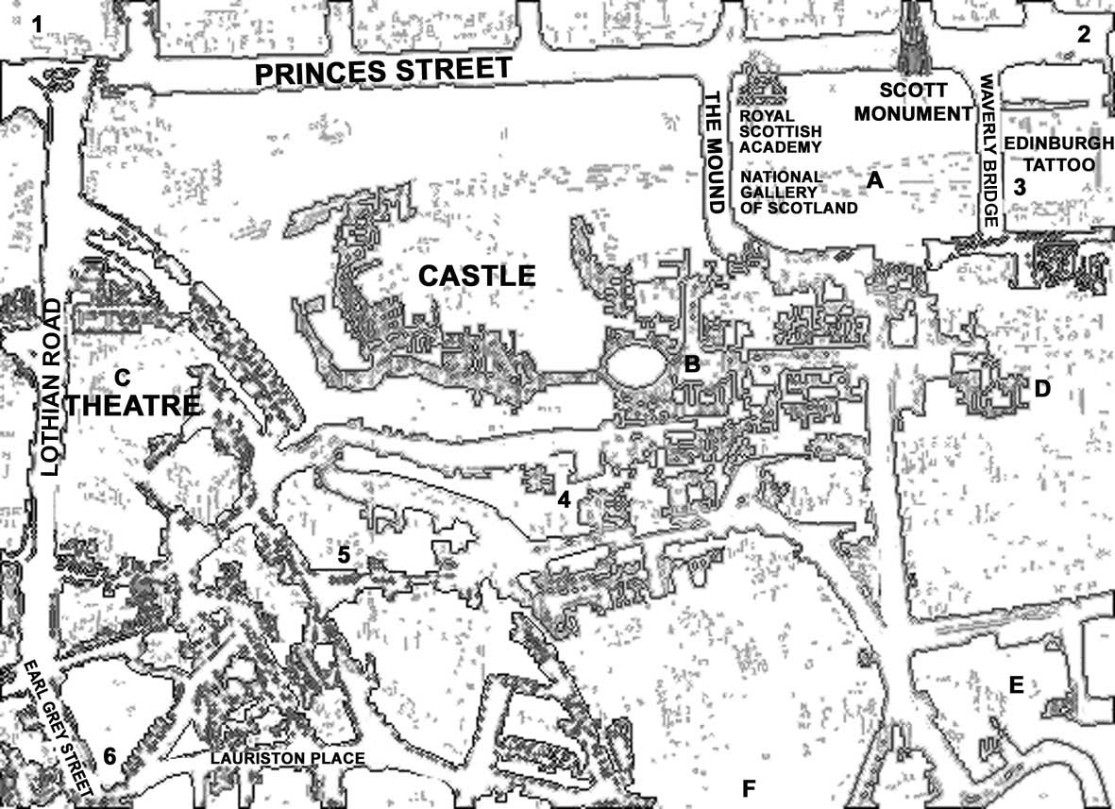

Work with a partner and look at the map above.

There are six starting points:

1 The West End
2 Princes Street
3 Waverley Bridge
4 The Grassmarket
5 The West Port
6 Earl Grey Street
There are six destinations:

A The National Gallery of Scotland
B The Scotch Whisky Heritage Centre
C The Royal Lyceum Theatre
D St Giles Cathedral
E The Museum of Scotland
F George Heriot’s School

- Agree with your partner on a starting point and a destination.
- Ask your partner for directions.
- Then choose another starting point and destination and change roles.

Example:

Starting point: Princes Street

A Excuse me, can you tell me the way to St Giles Cathedral?

B Yes —– go along there and turn right into Waverley Bridge. Cross the bridge and turn right again into Market Street. Go along Market Street and take the first left into Bank Street then left again into the High Street and it’s ahead of you. You can’t miss it.

Activity 2 Listening

Track 7

Journey to Edinburgh

Mike and Antonia are students in London. Mike is Scottish, and they have decided to spend a long weekend in Edinburgh. It is now 1.45 and they are at King’s Cross Station in London. Before you listen to the CD track, look at the route of their journey from London to Edinburgh. Then look at the map of Edinburgh.

You will now hear the CD track twice. Listen and decide on the correct answers, then compare your answers with a partner’s.

1 Where does the train leave from and when?

a Platform 14 at 14.15
b Platform 14 at 15.15
c Platform 15 at 14.15

2 Why is it leaving late?

a It has been delayed.
b It has been derailed.

3 Which of these places does the train not stop at?

a Peterborough
b Doncaster
c York
d Darlington
e Newcastle-upon-Tyne
f Berwick-upon-Tweed
g Dunbar
h Edinburgh Haymarket
i Edinburgh Waverley

4 How late will the train be in Edinburgh?

a 5 minutes
b 10 minutes
c 15 minutes

5 Which coach is the buffet in?

a C
b D
e E

6 Where did Antonia fall asleep?

a before York
b in York
c after York

7 Berwick-upon-Tweed is in:

a England
b Scotland

8 The hostel is in:

a the High Street
b Blackfriars Street
c Bank Street
Activity 3 Language focus

Work with a partner. Write one preposition on each line.

along at beside by in on over through

Last week, we had a few days ______ the seaside. We went to a little village ______ the south-west of England. It’s one of the nicest places ______ the coast. Our campsite was ______ the sea. After lunch, we walked ______ the beach for miles, crossed ______ the river ______ an old bridge, then walked back ______ a beautiful valley.

Activity 4 Vocabulary

Work with a partner. Look at the words in the box. All of them are connected with travel. Match each word in the box to its correct definition. Use your dictionary if you need some help.

cabin carriage compartment deck gangway harbour platform terminal

1 The floor on a ship.
2 A room on a ship. You sleep there.
3 Water inside walls. A ship stays there before it sails.
4 A large building in an airport. Big airports have more than one.
5 A ‘coach’ on a train.
6 A room inside a carriage.
7 You walk up this to get onto a ship.
8 You stand there and wait for a train.

Activity 5 Writing

People often tell this story about a Rolls Royce car. Maybe it’s true, maybe it isn’t. Nobody knows. To complete it, choose one verb from the box for each space and change it to its past form. Then compare your answers with a partner’s.
©istockphoto.com/Maciej Noskowski
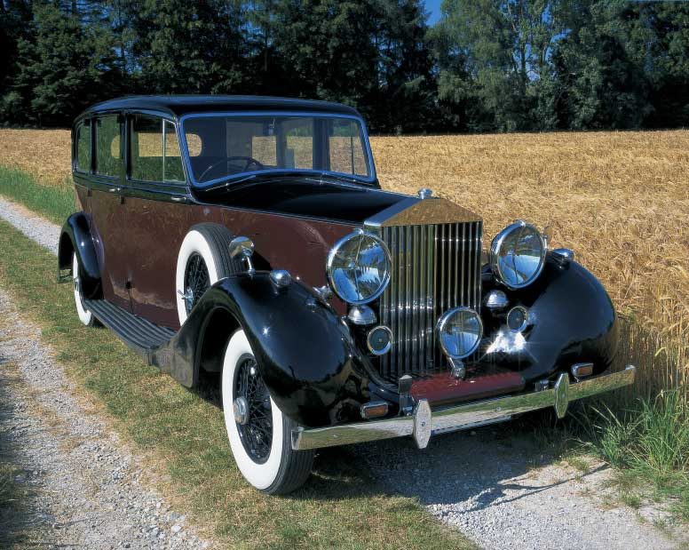
buy come fix get out go happen hear land
leave phone (x2) return speak stop tell

A man 1_____ a Rolls Royce car and 2_____ on holiday to France. One day he 3_____ a loud bang and the engine 4_____. He 5_____ Rolls Royce in London and 6_____ them the problem. Later that day, a helicopter 7_____ and three mechanics 8_____. They 9_____ his car and 10_____. Later, he 11_____ to London. No bill 12_____ for the repair. After three months he 13_____ Rolls Royce again and 14_____ to the manager about it. The manager said, ‘Sir, I’d rather not talk about this. It never 15_____. Rolls Royce cars don’t break down.’

Homework task

Write directions from your home to your class. How do you get there? Which streets do you walk along and which way do you turn.

