Lesson  16 | Free time and leisure
Lesson  16 | Enquiries
 |  | Task: Make and respond to enquiries
Skill: Speaking, Listening, Writing

Activity 1 Speaking

Garvie Health & Fitness Club

Special offer: Join this week and get three months free membership!

Student A

While out walking one day you see this notice:

You decide to go inside and find out some more.

Talk to the receptionist. You must ask for the following information and also respond to any questions you are asked.

- How much it will cost you.
- The opening hours.
- The facilities they have.
- The different classes they have.

You should talk to your partner for around 3–4 minutes.
___________________________________________________________

Student B

You are the receptionist at Garvie Health & Fitness club.

Student A is interested in joining the club and is asking you some questions.

Respond to any questions you are asked and ask your own questions using the following information:

Membership is an initial payment of £80 and then £25 a month – but if anyone joins this week they get three months free – though they still have to pay the initial £80.

Opening hours are Monday–Thursday, 6.30am–10.00pm
Friday, 6.30am–9.00pm
Saturday/Sunday, 8am–7pm

The centre has

- a fitness room with exercise machines and weights
- a small swimming pool
- 4 squash courts
- trampolines

There is also a café.

There are two types of fitness training:

- aerobics classes
- instruction in the use of the exercise machines and weights.

Ask how fit Student A is at the moment.

Ask Student A which type of training they prefer and if they would like to try a free introductory class.
________________________________________________________

Activity 2 Listening

Track 9

Now listen to this conversation between four overseas students. Alina is Polish, Sandila is South African, Sue Yen is Chinese and Temel is Turkish. They are all studying at a college in London. It is Sunday lunchtime and they are in the college refectory.

Decide, in the opinion of the speakers, if these statements are true or false. Put a tick (✓) on one line.
true false

1 The British make good coffee. ___ ___
2 The British make good tea. ___ ___
3 The British make good food. ___ ___
4 The fish in Britain is good. ___ ___
5 The weather in Britain is good. ___ ___
6 British people don’t care much about clothes. ___ ___
7 The football in Britain is good. ___ ___

Listen to the CD track again. Decide if these statements are true or false. Put a tick (✓) on one line.
true false

8 Alina is drinking coffee. ___ ___
9 Sue Yen is drinking coffee. ___ ___
10 One person is eating Shepherd’s Pie. ___ ___
11 One person is eating fish. ___ ___
12 Sandila lives near the sea. ___ ___
13 Temel lives near the sea. ___ ___
14 One person is eating pasta. ___ ___
15 The weather is good. ___ ___
16 Temel is going to a football match after lunch. ___ ___

Now compare your answers with a partner’s.

Activity 3 Language focus

Work with a partner. Look at the sentences below. Tick the ones where the present continuous is possible.

1 You watch / You’re watching too much football these days. ___
2 I don’t understand this. What does it mean? / What is it meaning? ___
3 Is this a good idea or not? How do you feel? / How are you feeling? ___
4 ‘Where do you go / Where are you going?’ ‘Oh, shopping, as usual.’ ___
5 I really love / I’m really loving chocolate biscuits. ___
6 ‘Where’s the boss?’ ‘She has / She’s having lunch.’ ___
7 ‘Do you like Johnny Depp?’ ‘I don’t know / I’m not knowing – who is he?’ ___
8 ‘Is your dad there?’ ‘He’s outside — he works / he’s working on the car.’ ___
9 Don’t tell me any more. I’m not believing / I don’t believe you. ___
10 ‘That wasn’t very clever, was it?’ ‘No, I don’t suppose / I’m not supposing so.’ ___
Activity 4 Vocabulary

1 Besides football, other team sports are popular in Britain and Ireland. Match each picture to its description.
cricket
There are 11 players on each team. They use a bat and a ball. Games sometimes last for five days. It is popular in England, Australia, New Zealand, India, Pakistan, Bangladesh, South Africa and the West Indies.

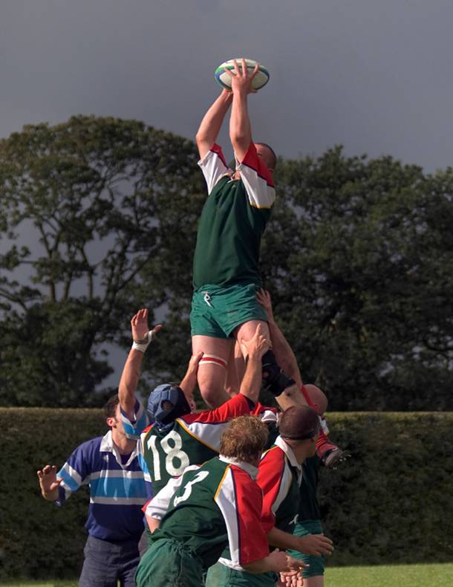
shinty
There are 12 players on each side. The goals are similar to football goals, but narrower and higher. Players use a stick called a caman. Shinty is popular in the Scottish Highlands.
shinty
There are 12 players on each side. The goals are similar to football goals, but narrower and higher. Players use a stick called a caman. Shinty is popular in the Scottish Highlands.
b
a
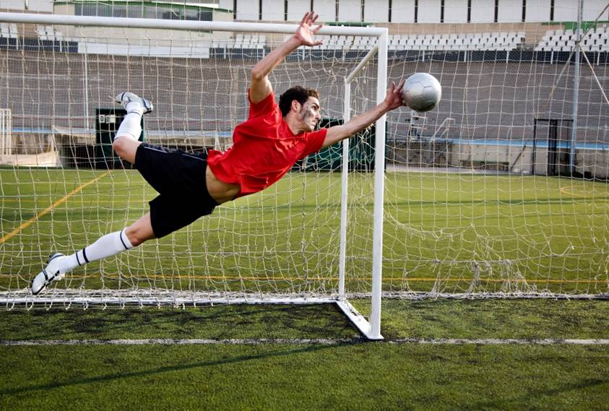

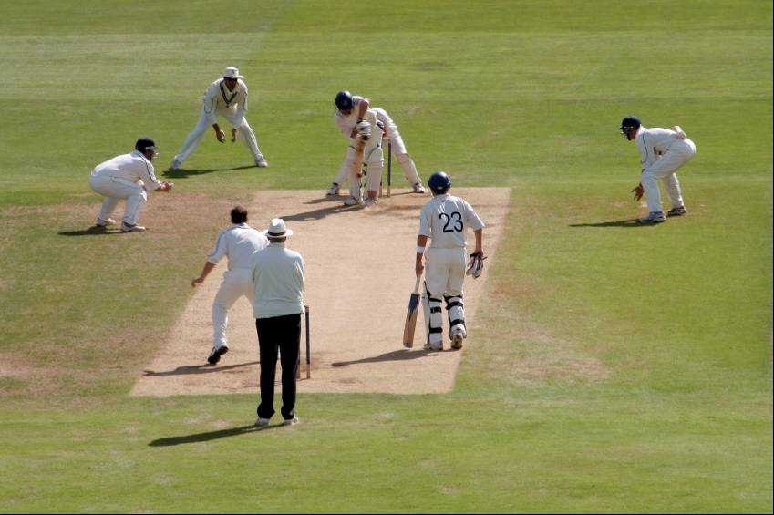

c
d
c
Gaelic football
There are 15 players on each side. One is a goalkeeper. The ball is round but the players can bounce it with their hands. The goals are also H-shaped and have a net across the bottom. It is played in Ireland.
football
There are 11 players on each side. One is a goalkeeper. The ball is round and the goals are square. It is popular in Britain, Ireland, South America and many European countries.

rugby union
There are 15 players in each team. The ball is oval and the goals are H-shaped. It is most popular in Britain, Ireland, France, parts of Italy, New Zealand, Australia, South Africa and some Pacific islands.

Photos: A (c)– i-stockphoto/han3617 B (c)– i-stockphoto/Elena Korenbaum C (c)– i-stockphoto/Donald Linscott D (c)– i-stockphoto/Lance Bellers

2 There are many other sports, apart from team sports. Work with your partner, and use your dictionaries if you need them. Match one name from the box with each one.

abseiling base jumping bungee jumping
free fall parachuting/skydiving kayaking paragliding
rafting rollerblading sailboarding/windsurfing
skateboarding snowboarding surfing

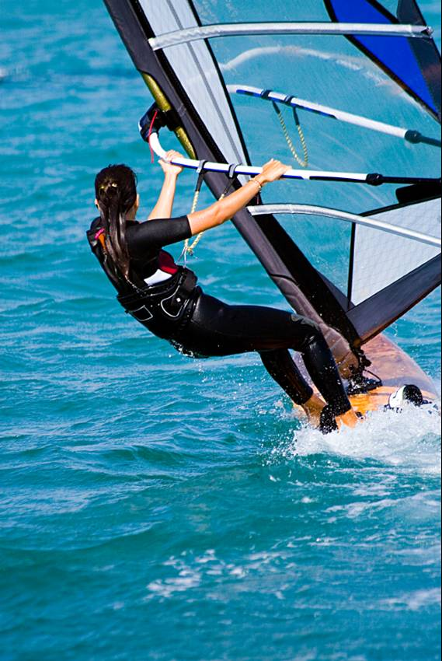1 ______________
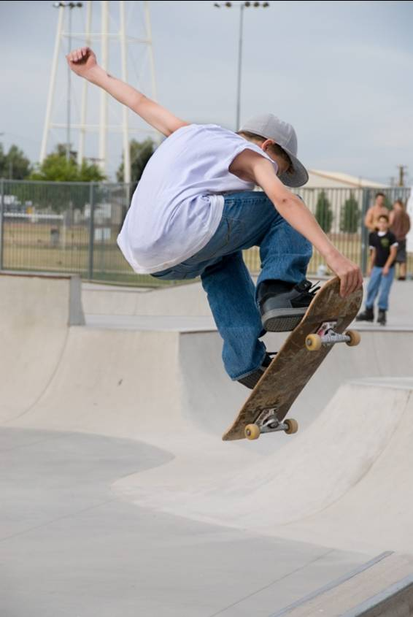
3 ______________

2 ________________

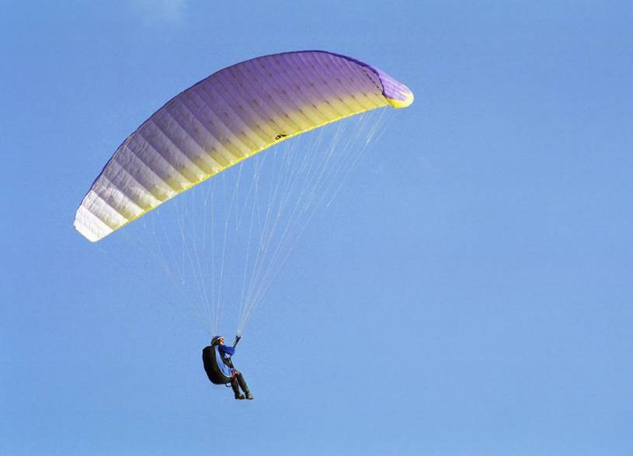
5 _____________
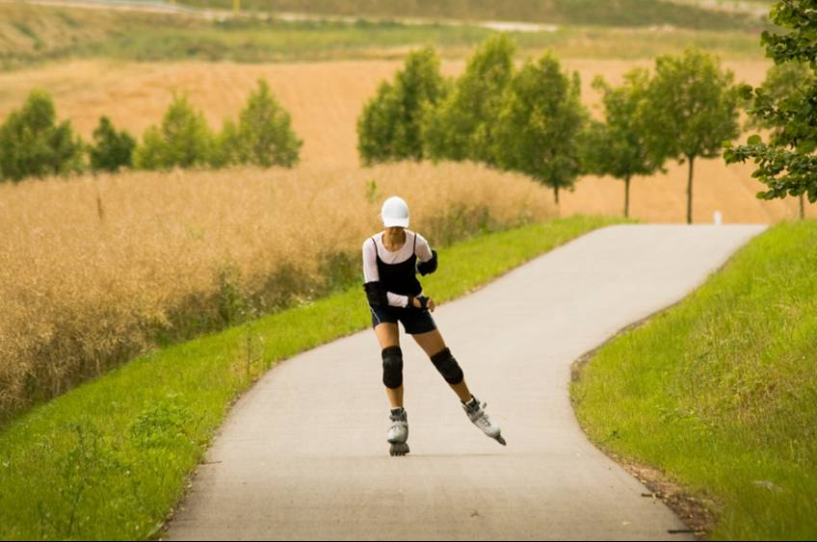
4 __________________

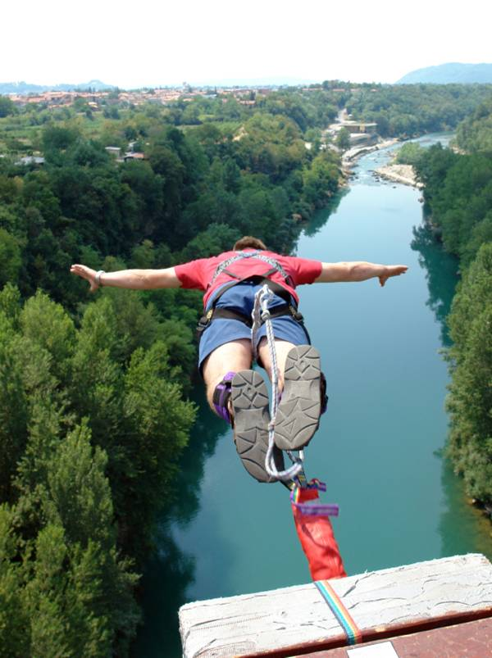
6 ______________


7 ________________

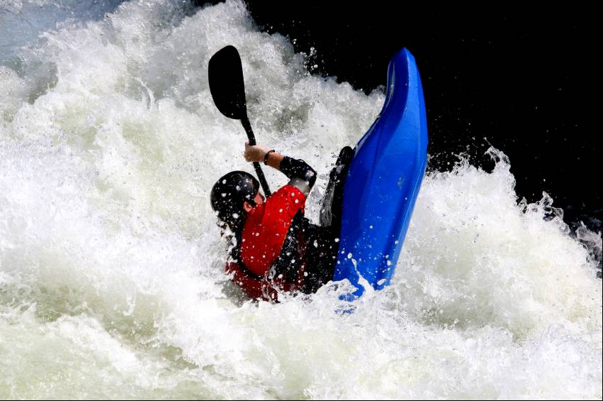
8 _____________

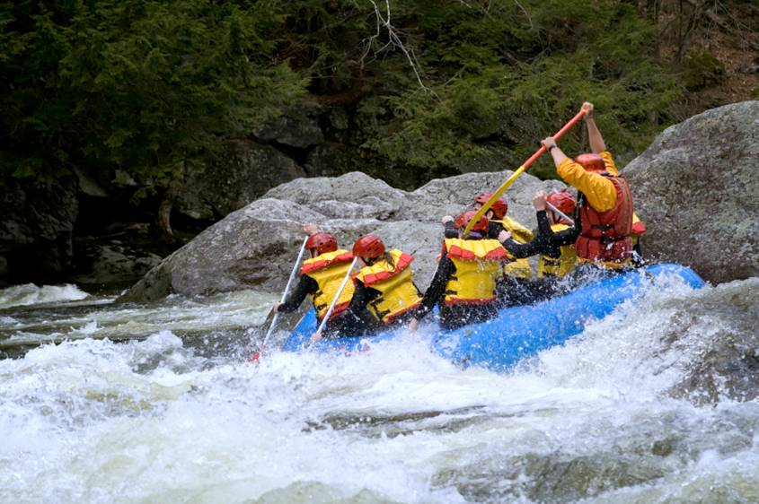
11 _________________
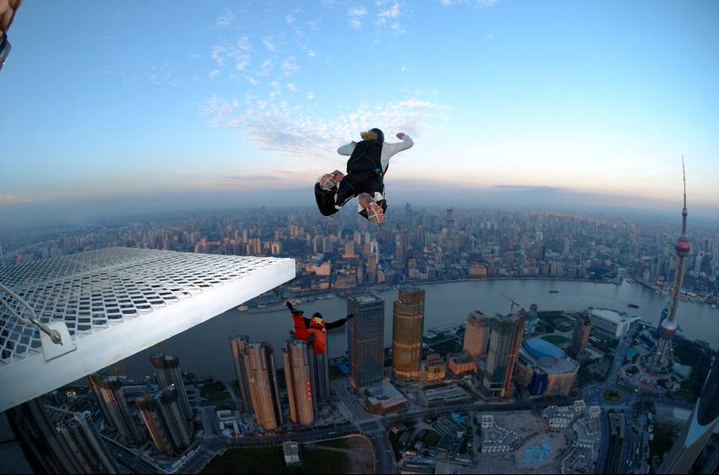
9 ______________

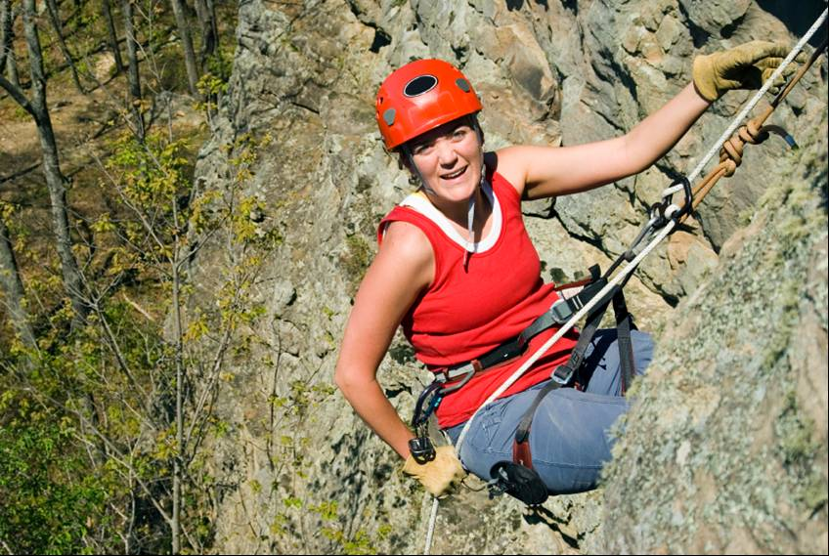
12 __________


10 _____________

© istockphoto.com. 1. Bulent Ince; 2 drazen Vukelic; 3 James Ferrie; 4 Val Th; 5 Mikhail Tolstoy; 6 Matej Michelizza; 7 Linc Lippincott; 8 Phil Berry; 9 Christophe Michot; 10 Michael Braun; 11 Christine Glade; 12 Mark Rose
Activity 5 Writing

You have applied for a job with a sports and leisure company. They want to know about your personal level of fitness and interest in sport. Fill in the form below, giving all the information requested.

The length of your writing should be approximately 150 words.

Sholto Sports & Leisure

Employee sport and fitness survey

Name: __________________________________

Date: ____________________

Give details of the sports you are interested in, and whether as a spectator or a participant.

Give information about the amount of time you spend taking exercise every week, and the form of exercise this is.

Tell us how you think your experience of sport and fitness might be useful to Sholto Sports & Leisure.

Homework task

Use the internet or a library and find out more about the sports and leisure facilities in your area. Think about sports centres, swimming pools, gyms, etc. Write a report.
Lesson  17 | Free time and leisure
Lesson  17 | Bookings
 |  | Task: Make, change and confirm bookings
Skill: Speaking, Listening, Reading, Writing

Activity 1 Speaking

Work with another student. Decide if you are Student A or Student B. Read the instructions on one of the sheets below.

Student A
You work for a company called Conference Solutions. They organise conferences. Your boss has asked you to phone a restaurant and book some tables for tonight. Read the e-mail below and follow the instructions.

Student B will take the phone call. Sit with your back to Student B so that you can’t see each other.

When you make the booking, give only the surname of the first person or couple.

Not all the bookings will be possible. Tick (✓) the groups that you manage to book.
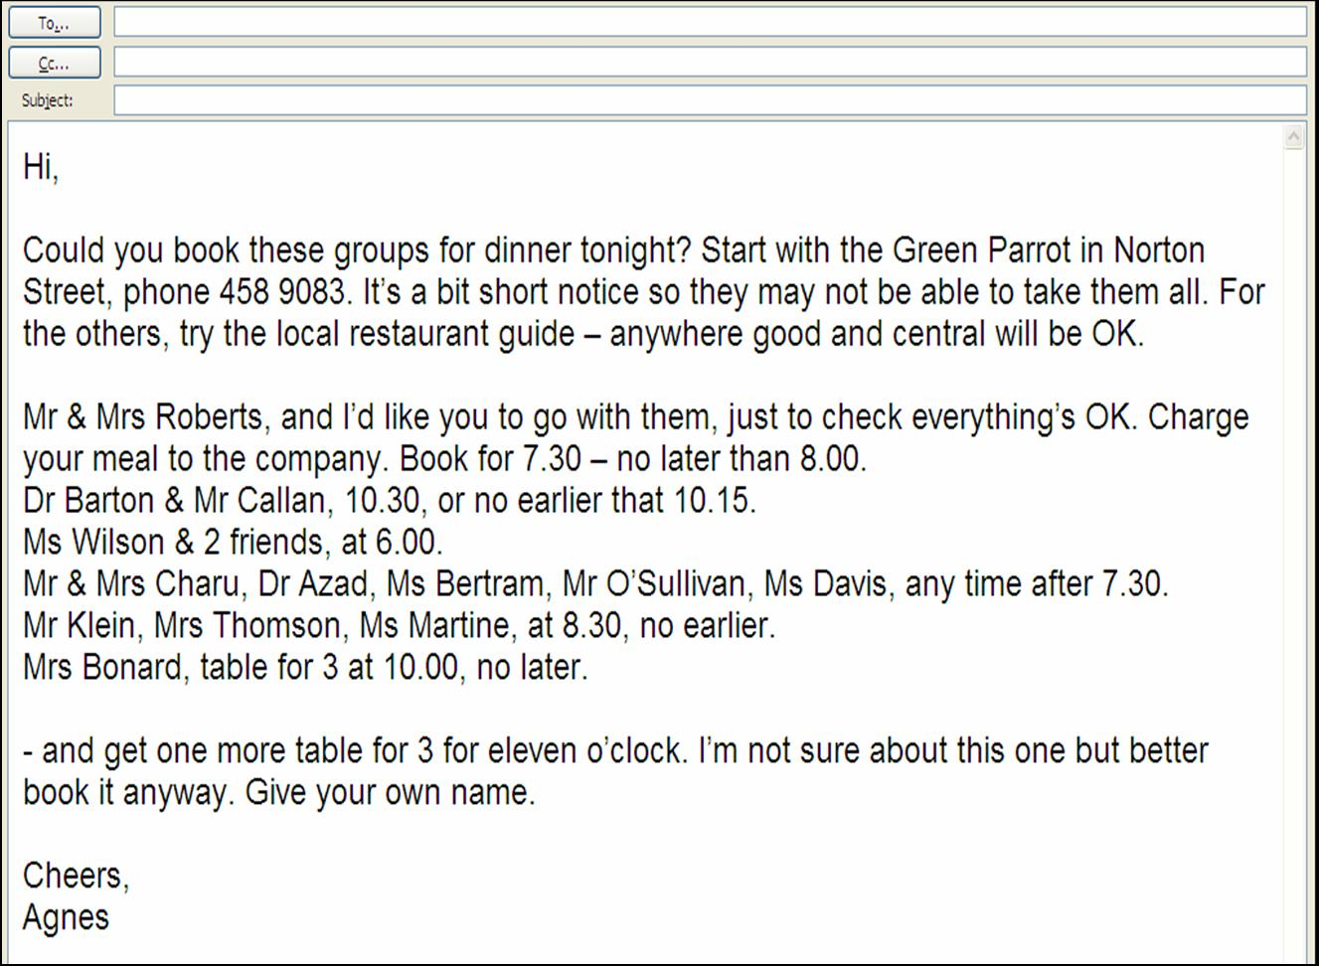
Student B
You work in the Green Parrot restaurant. Student A will phone you and try to book some tables for tonight. Sit with your back to Student A so that you can’t see each other.

Not all the bookings will be possible. If they are, write the surname of one person from each group in the correct place below.
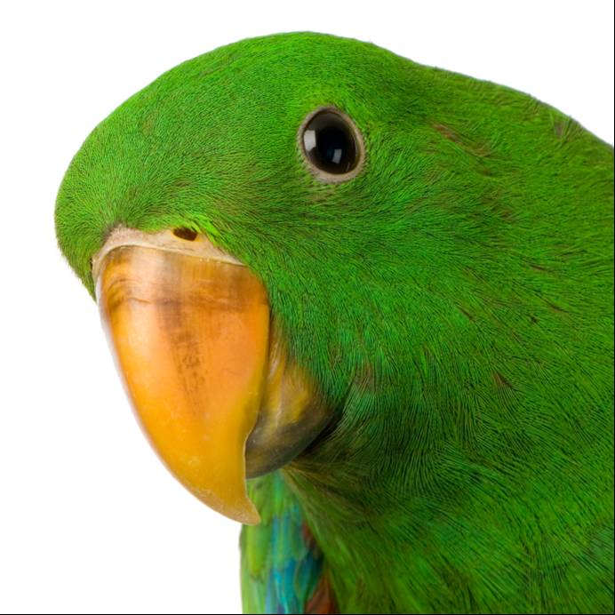
Green Parrot Restaurant

tel. 01892 458 9083
Photo: (c) i-stockphoto.com/Eric Isselee

Table booking sheet

- Tables 4 and 6 can take an extra chair.
- Accept bookings even if all chairs are not filled.
- Do not accept bookings for after 10.30.
- Allow 2 hours for each meal.

table no. |  | 1 | 2 | 3 | 4 | 5 | 6
seats: |  | 4 | 3 | 6 | 2 | 3 | 5
6.00 |  | Paterson |  |  | Franzoni | Campbell
6.15 |  |  | Sobieski |  |  |  | O'Hare
6.30
6.45 |  |  |  | Sinclair
7.00
7.15
7.30
7.45
8.00 |  |  |  |  | Muir
8.15 |  |  | Marston
8.30
8.45 |  |  |  | Kiernan
9.00
9.15 |  | Chan
9.30
9.45
10.00 |  |  |  |  |  | Bergman
10.15 |  |  |  |  |  |  | Singh
10.30
10.45
11.00
11.15
11.30
11.45
12.00
Activity 2 Reading

tea, coffee, Pepsi, Coke and water

Work with a partner. Look at the ends of sentences a–l below. Then read the texts in the boxes and add the correct one to each text.

a invented instant coffee.
b quietly disappeared.
c he simply called it ‘Brad’s Drink’.
d and that Christians should drink it.
e he rested his troops and elephants there.
f heavier than water.
g the first in Central Europe.
h 3.2 kg a year.
i 85% of tea comes from tea bags.
j most of the ships in the world.
k salt and butter to their tea.
l in Istanbul in 1475.

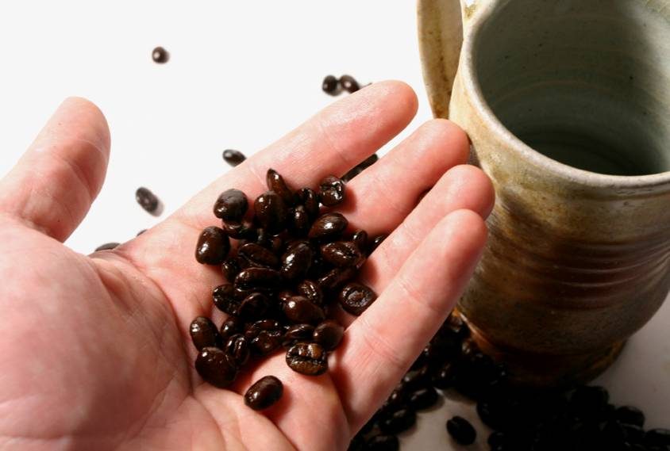

2 The world’s first coffee
house, Kiva Han, opened
___________________
1 Perrier water comes from
Les Bouillens in France.
After Hannibal crossed the
Pyrenees in 218 BC, ______
_____________________

3 The first coffee house in Italy opened in 1645.
The drink became popular and the wine makers
grew jealous. They asked Pope Clement VIII
to say that it was un-Christian. However,
when Clement tasted it he said that it was
delicious ______________________________
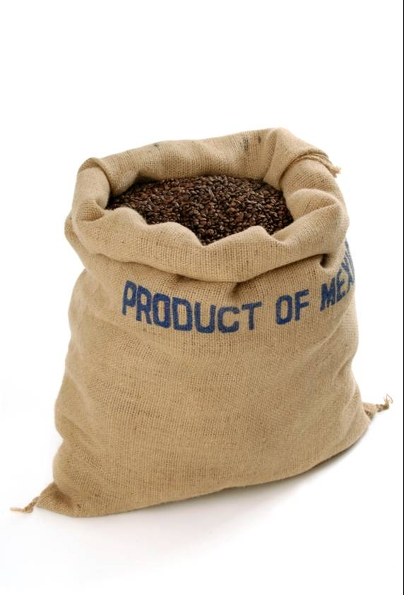

4 When the Turkish army moved away from
Vienna in 1675, they left behind sacks of
coffee. Nobody knew what it was except
Franz Georg Kolschitzky, because he had
lived in Turkey. He took the coffee and
opened a coffee house, _______________
5 In 1668 Edward Lloyd opened his coffee house in London. It became popular with merchants and men who insured ships. It grew into Lloyds insurance company. Today Lloyds insures ___________________________



9 Many people in Tibet and nearby countries add ________________
________

11 People in Ireland drink more more tea than any others — six cups a day or ___________
8 Thomas Sullivan, an American, invented the tea bag in 1908 – accidentally. He sent out samples of his tea in silk bags. Customers thought they should put the whole bag in the pot. Today, in the UK, ________________________
______________________
6 Caleb Bradham, a North Carolina chemist, invented Pepsi Cola in 1893. For the first five years _________________________
7 In 1901 an American chemist, Satori Kato, ______
______________________
Copyright iStockphoto.com. 1. Lise Gagne; 2 Rob Friedman; 4 Maartje van Caspel; 5 Fabio Bianchini; 6 Jon Helgason; 9 Pam Jeffries; 10 Sandramo; 11 Emilia Stasiak;
12 A tin of diet coke will float in water but a tin of normal coke will sink. Normal coke has more sugar and less water. Sugar is ____________
10 In 1985, Coca Cola decided to change its formula. However, Americans didn’t like the new drink so Coke started to sell the old one again as Classic Coke. After some time, New Coke ______________

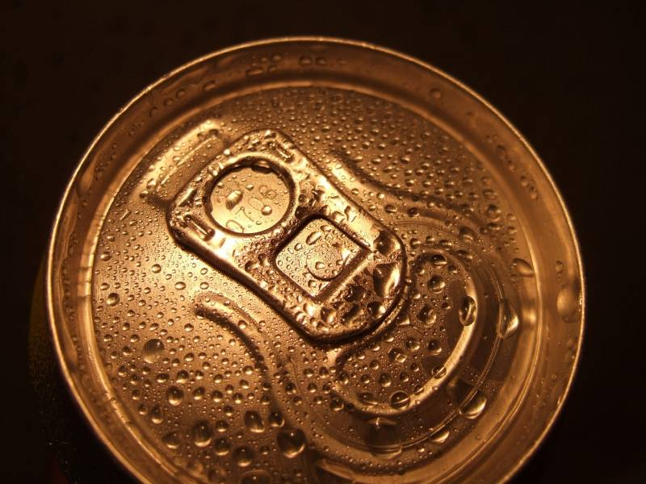
Activity 3 Language focus

Work with a partner. Look at these sentences. All of them are about events in the future. Write the verbs in either the present simple or the present continuous. Remember to pay attention to questions and negatives.

1 Hurry up – the film (start) in ten minutes.

2 Eric (have) a coffee with Jenny after school today.

3 I’m tired – I (not go) out tonight.

4 You (have) another class at 3 o’clock?

5 I’m a bit overweight – I (start) a diet soon.

6 I’m going to the airport now – her plane (arrive) in an hour.

7 What time your train (leave)?

8 I have to hurry – I (meet) Maria in town.

9 Zoe (see) the dentist at four.

10 Martha (come) to the wedding?

11 The term (not end) for another three weeks.

12 Where she (have) her birthday party?

Activity 4 Vocabulary

British and American food words

Work with a partner. Match the American words for food, in the box, with the British words below. Use a dictionary if necessary. Write one on each line.



alligator pear Chinese gooseberry corn cracker/cookie
eggplant fish sticks french fries granola ground meat jello
jelly chips oatmeal salt beef sweetcorn zucchini

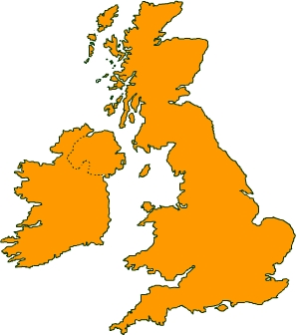
aubergine __________________

avocado __________________

biscuit __________________

chips __________________

corned beef __________________

courgettes __________________

crisps __________________

fish fingers __________________

jam __________________

jelly __________________

kiwi fruit __________________

maize __________________

mince __________________

muesli __________________

porridge __________________
Activity 5 Writing

The meal in the Green Parrot Restaurant was not very successful. You felt that the tablecloths were not very clean, the service was slow, the waiters weren’t very cheerful, some of the dishes were cold and others didn’t taste as they should. Altogether, it seemed that the restaurant couldn’t handle the number of customers, and didn’t try very hard. Some of the Conference Solutions guests didn’t mind but others noticed. Mr & Mrs Roberts, in particular, were not pleased, and made a number of critical remarks.

Write a report for Conference Solutions on the form on the next page, in response to the following e-mail. Write around 150 words, covering all the points mentioned above.

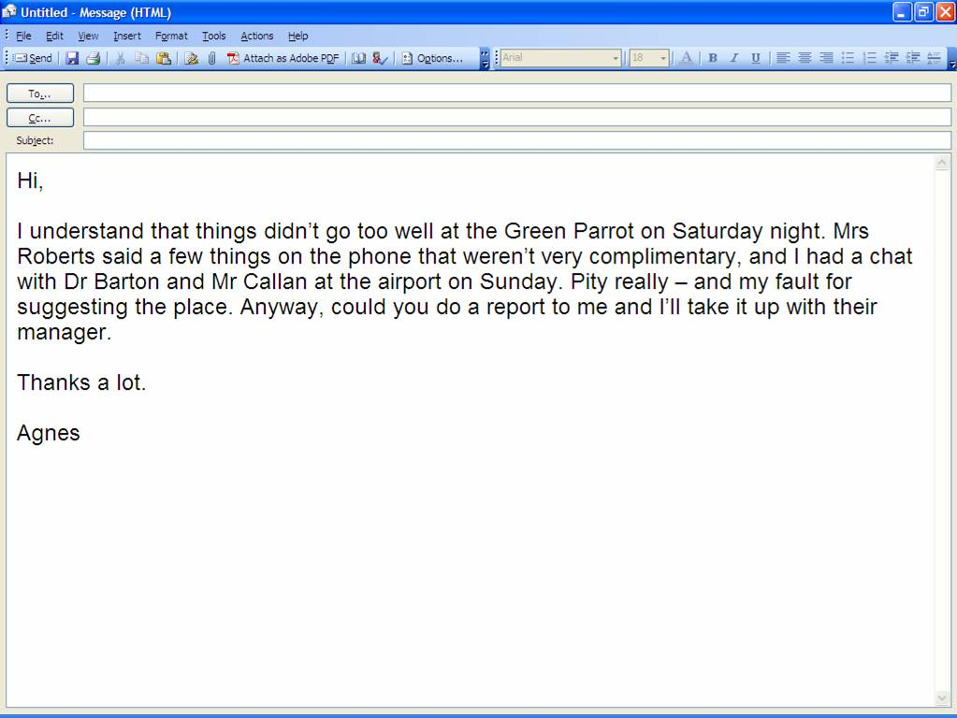

Conference Solutions

Confidential report

from: _________________________________

to: __Agnes Patullo, Hospitality Manager___

subject: __Green Parrot Restaurant___________

date: _________________________________

Homework task

Imagine you are writing a restaurant review for a newspaper. Think of a restaurant — either a real of fictitious one. Write a review of a meal there. Describe the location, the décor, the service, the food and any other things you feel are worth mentioning.

Lesson  18 | Free time and leisure
Lesson  18 | Complaints
 |  | Task: Make a complaint
Skill: Speaking, Listening, Writing

Activity 1 Speaking


Work with a partner and read the menu below. Use your dictionary to check any new words.
The International Restaurant
Menu
Starters

JapanSushi
Pieces of raw fish with vegetables.

TurkeyLamb’s Brain Salad
A slice of lamb’s brain with lemon juice and parsley.

ChinaPrawn and Noodle Soup
A delicious soup made with prawns, vegetables, herbs and spices.

SpainMussels on a bed of vegetables.
Mussel shells filled with vegetables with a cooked mussel on top.

Main courses

GreeceStewed Octopus with Macaroni
Octopus cooked with wine, garlic, onion and macaroni.

IndiaBeef Vindaloo
Very hot curry! Not for beginners.

BritainSteak and Kidney Pudding
Steak and kidney cooked with gravy in a soft pastry case, served with carrots and roast potatoes.

FranceGarlic Frog’s Legs
Frog’s legs fried in butter and baked in garlic sauce.

Now work with a partner. Choose to be either Student A or Student B. Read one of the cards below.

Student A

You are a customer in the International Restaurant. You have ordered either a starter or a main course. Write its name here:

___________________________

You are not happy with it. Think of a reason — eg it was too hot, too cold, it didn’t taste right, it had too much salt / garlic / chilli, etc. in it:

______________________________________________________

Decide what you want: the same dish again, another dish, your money back, etc:

______________________________________________________

Now call the waiter and complain.

___________________________________________________________

Student B

You are a waiter in the International Restaurant. A customer calls you with a complaint. Listen to the complaint and decide what you are going to do.

___________________________________________________________

Activity 2 Listening

Track 10

Look at the questions for this part. You will hear a radio presenter talking about tonight’s television programmes. Put a tick in the correct box for each question. You will hear the CD track twice.

1 At 6.30 you can hear

A □ national news.
B □ international news.
C □ local news.
D □ national weather.

2 Top Sounds is on television from

A □ 7.00 to 7.30.
B □ 7.00 to 8.00.
C □ 7.30 to 8.00.
D □ 7.30 to 8.30.

3 Jenny McCabe is

A □ a police officer.
B □ a drug dealer.
C □ a murderer.
D □ a comedian.

4 The Laura Pinkerton Show is

A □ a documentary.
B □ a comedy show.
C □ a police drama.
D □ a review.

5 You can see part of a football match between

A □ Italy and Wales.
B □ Scotland and Italy.
C □ Denmark and Italy.
D □ England and Denmark.

6 At 11.30 there is

A □ a food programme.
B □ an old film.
C □ a Greek film.
D □ a British film.
Activity 3 Language focus

Work with a partner. For each question, match a clause on the left with one on the right.

1 If he arrives after 8.00 a if Arnie’s going to the party.
2 He’ll have problems b vote for them.
3 If she’s broken my CD player c if you can’t be more cheerful.
4 She must be mad d I’ll just call the boss.
5 I can get you a sandwich e if he takes that job.
6 If I’ve told you once f if you lend me some money.
7 I’m staying at home g she’ll have to pay for it.
8 Go away h I’ve told you a hundred times.
9 If you’ll take a seat i if she thinks I’ll go out with her.
10 If you like them, j it’ll be too late to go out.

Activity 4 Vocabulary

Music words

Work with a partner. Write one of the music words from the box in each space.

bass electronic live (adj) lyrics melody

percussion recorded rhythm synthetic

types of sound _________ using electric guitars and other instruments
_________ using computers

parts of music _________ the ‘beat’
_________ the main tune
_________ the lower tune, often played by a bass guitar
_________ the words of a song
_________ the sound of drums

types of performance _________ performed in front of the audience
_________ played from a CD, etc.
Activity 5 Writing

You have been asked to organise a visit to the theatre for your class at school or college. Write an email to a local theatre to obtain information about group bookings. Make sure you write about all the points below:

- First of all, decide on a date in the near future for your visit. Tell the theatre when you want to come.

- Ask for the prices of tickets for different parts of the theatre.

- There are 15 in your group. Ask if there is a discount for group bookings.

- All of you are students. Ask if they have lower prices for students.

- You would like to eat before the show. The theatre has a small restaurant. Ask them to send you a copy of the menu, and ask if they can take a group booking for 15 before the show.

Homework task

Write a description of a film you have seen and enjoyed, either at the cinema, on TV or DVD. It can be in English or your own language. Tell the story, give the names of the leading actors and say why you like it.

Lesson  19 | Free time and leisure
Lesson  19 | Opinions
 |  | Task: Express an opinion
Skill: Speaking, Reading, Writing

Activity 1 Speaking

- Work with a partner.
- Decide if you are Student A or Student B.
- Read the notes in your box, but don’t read your partner’s.
- Act out the conversation
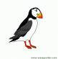
ClubPuffin

This is a telephone conversation, so sit back-to-back with your partner.

Student A

You enjoy playing the computer games at an internet site called ClubPuffin. You pay £3.50 a month by direct debit to do so.

Recently, you have had problems logging on to the site and are thinking of cancelling your subscription. You have sent two e-mails but have had no response. You are now calling their number.

When you get through, explain your problem. The assistant, Student B, will try to keep you as a customer by making you a special offer. You still like the games so consider the offer and make a decision.

Useful language: I’ve had problems logging in. I want to cancel my subscription. Yes, I do enjoy the games. How about two months free? Well, let me think about that.
This is a telephone conversation, so sit back-to-back with your partner.

Student B

You answer telephone enquiries for an internet site called ClubPuffin. This site allows customers to play games in return for a direct debit of £3.50 a month.

A customer, Student A, calls you with a problem. He/she is thinking of cancelling their subscription. Because of the problem, you can offer them a month’s free subscription. Try to keep them as a customer.

Useful language: Oh, I’m sorry you’ve been having problems. I’m sure we can fix that. I can offer you a month’s free subscription.

Activity 2 Reading

Read the text below and answer the questions. Then compare your answers with a partner’s.

What the British do

They’re eating fish and chips. There are many other takeaway foods in Britain today – pizzas, hamburgers, kebabs, etc, but people still like fish and chips. There are over 8000 fish and chip shops in Britain. Besides fish, people eat other things with chips in different parts of the country – like chicken, pies, hamburgers, black pudding, 1 or even pizza.
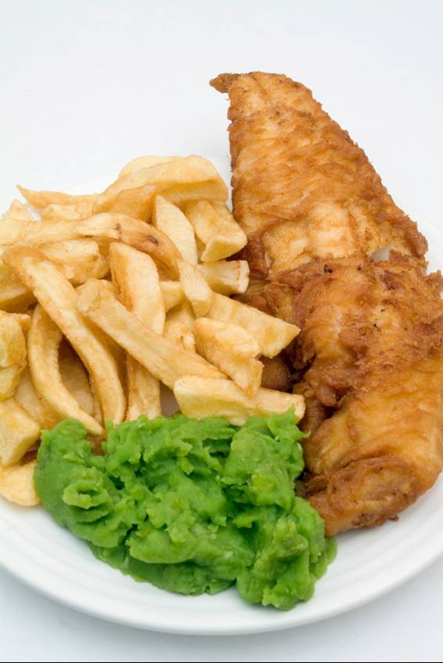

She’s reading the Sunday papers. On Sunday, newspapers are very large and they have many different sections – for sport, entertainment, books, travel, etc. The newspaper shops deliver the papers to houses. People like to get up late and read the papers – or they might stay in bed and read them. 2


They’re dancing in a disco in Ibiza. Every summer young people in Britain go for a holiday in a warm country. Spain and Greece are very popular. They usually go with friends. They swim in the sea. They sunbathe – usually too much. In the evenings they go to clubs and discos. Often they drink too much and get into fights. 3
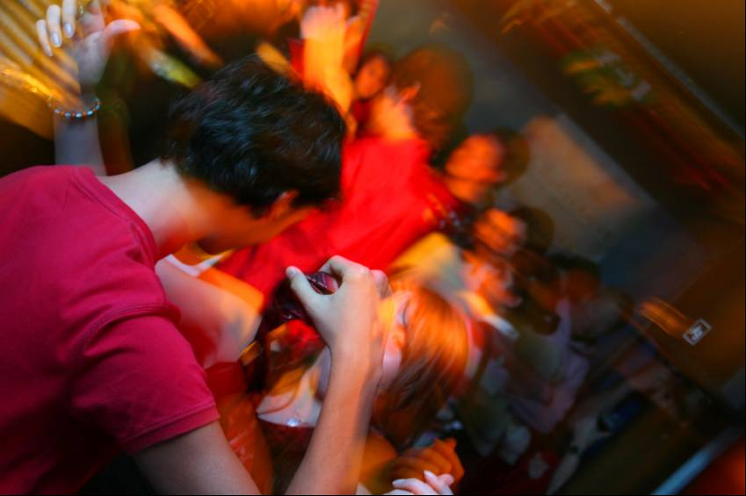

They’re eating Sunday lunch. This is an important meal, in England, but not in every part of Britain. Sometimes people invite other members of their families – grandparents, brothers, sisters, etc. Very often the food is roast meat or lamb. After lunch some people go for a walk. Others watch TV or read the Sunday papers. 4
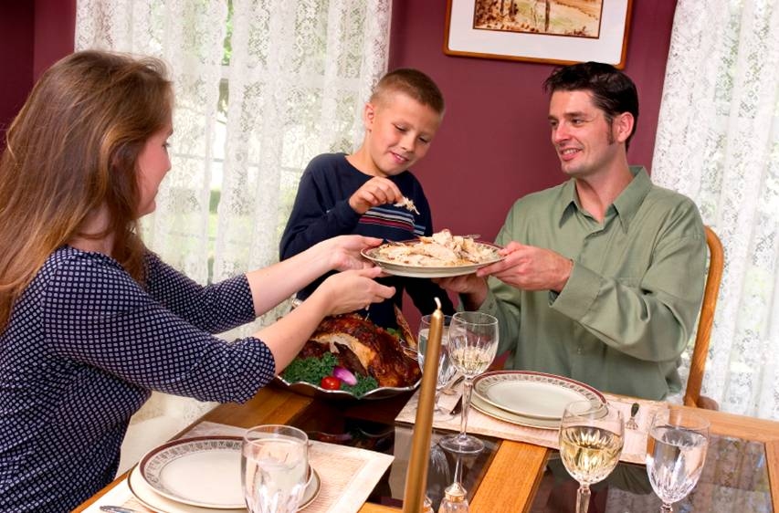

They’re working in their garden. People in Britain love gardening. They spend a lot of time there. People in flats sometimes have a piece of land in another part of the town. This is called an allotment. Also, the British like to talk about gardening. There are gardening programmes on television and young people enjoy it as well. 5
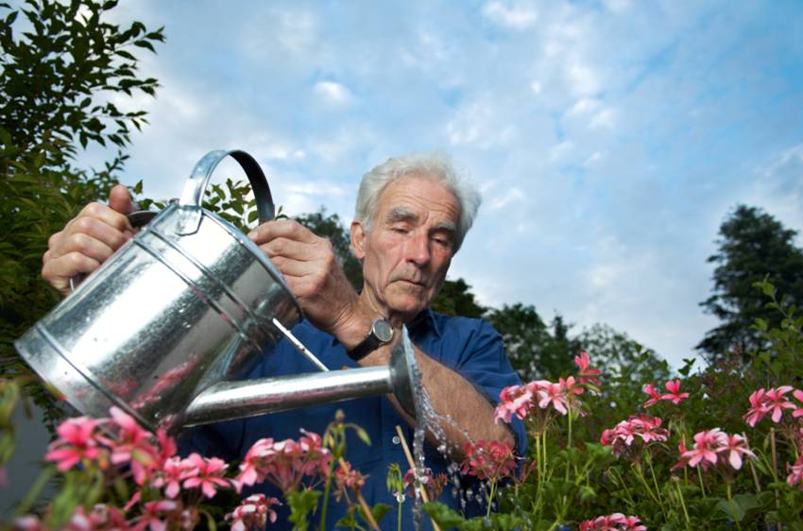

Photos: 1 - (c) i-stockphoto.com/Mike Bentley 2 - (c) i-stockphoto.com/Michal Koziarski 3 - (c) i-stockphoto.com/Simon Podgorsek 4 - (c) i-stockphoto.com/Sean Locke 5 - (c) i-stockphoto.com/Thomas Voss
He’s painting his house. This is called DIY – Do It Yourself, and the British love to work in their houses. They paint windows and doors, and put up wallpaper and shelves. Sometimes they even move walls. In the larger towns there are DIY superstores. In them you can buy almost anything to improve your house. 1
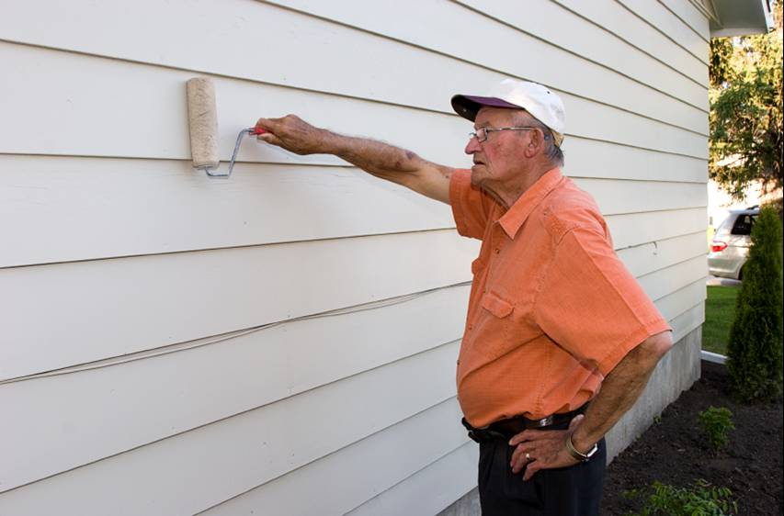
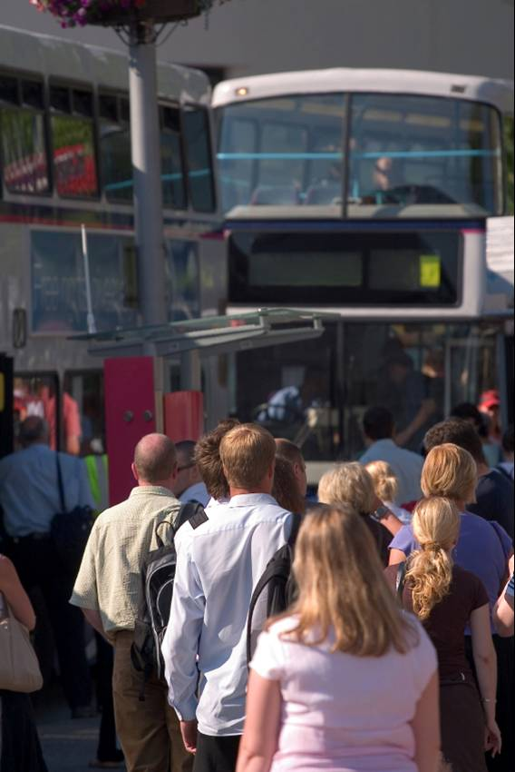
They’re standing in a queue. British people like to queue for most things — but not everything. There are no queues for the Tube in London, for example. There, everybody moves forward at the same time. And not everybody queues for buses — but the people in the queue get on the bus first. 2

Read these statements and write T (true) or F (false) on each line.

1 Fish and chips is very popular in Britain. ___
2 People always eat fish with their chips. ___
3 Sunday newspapers have many different parts. ___
4 Young British people usually go on holiday with their parents. ___
5 People don’t always sunbathe sensibly. ___
6 Young people on holiday are sometimes violent. ___
7 Sunday lunch is important in all parts of Britain. ___
8 People sometimes invite their relatives for Sunday lunch. ___
9 Everybody in a flat has some land for gardening. ___
10 Gardening is a popular subject for conversation in Britain. ___
11 There are special DIY shops. ___
12 Everybody queues for buses. ___

Photos: 1 - (c) i-stockphoto.com/Reuben Schulz 2 - (c) i-stockphoto.com/Rob Hill

Activity 3 Language focus

All of these sentences use present tenses. Some also use will/’ll. Change present tenses to past and will/’d to would/’d where this is necessary.

1 I wish they are here now.
2 I hope you know the answer.
3 If I know I’ll tell you.
4 If it rains, I’m staying at home.
5 If I am you, I’ll do it.
6 He died five years ago. Suppose he’s alive today, how old will he be?

7 I’m sorry you’re not here.
8 If you need some help, just give me a ring.
9 I’ll be happy if I’m taller.
10 We’ll win if we play like this in the second half.

Activity 4 Vocabulary

Work with a partner. Match each adjective with the correct noun.

brussels chocolate
diet juice
fast con carne
french bolognaise
milk sugar
olive pepper
red sprouts
doner coke
spaghetti food
chilli kebab
brown oil
orange fries

Activity 5 Writing

Farclay’s National Bank is opening a call-centre in another country. The staff will respond to calls from customers in the UK. The bank has to train its overseas staff. Part of this is to let them know about everyday life in the UK, so they can understand their customers. Use the material in the reading text, What the British do, above. Write a report for the bank of around 150 words about everyday life in the UK.

Homework task

How do you feel about the activities you have read about in What the British do? How many of them are you involved in? Are there any you really dislike or disapprove of? Write about this.

Lesson  20 | Review of lessons 16–19
 |  | Task:
Skill: Speaking, Listening, Writing

Activity 1 Speaking

Work with a partner and try the activity. Talk to your partner as you work out the answer. All the information below can’t be used in the order it is given. Be prepared to move up and down the list.

There are four students – Alina, Sandila, Sue Yen and Temel.

Each likes a different drink, does a different sport and likes a different type of music.

- Alina likes rock music and Temel likes blues.
- Sandila goes running.
- Sue Yen likes tea.
- The tennis-player likes coffee.
- The runner likes jazz.
- The cyclist likes classical music.
- The swimmer likes cola.
- The cola-drinker likes blues.
- Which student likes orange juice?


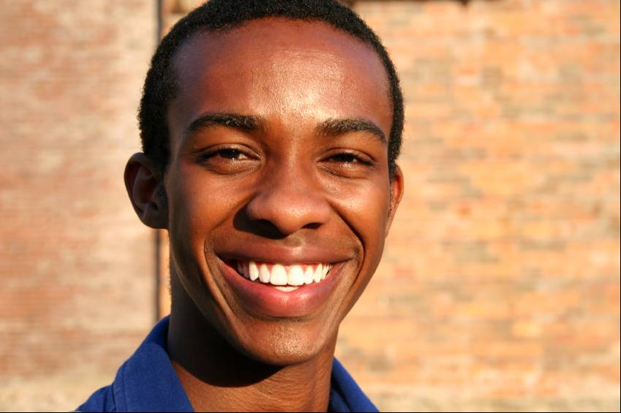



Alina1 Sandila2 Sue Yen3 Temel4
music

sport

drink

Photos: 1 - (c) i-stockphoto.com/Alexander Hafemann 2 - (c) i-stockphoto.com/Dan Brandenburg 3 - (c) i-stockphoto.com/Jaymast 4 - (c) i-stockphoto.com/Soubrette
Activity 2 Listening

Track 11

Listen to this joke and decide on the best answer to each question that follows. You will hear the CD track twice. When you finish, check your answers with a partner.
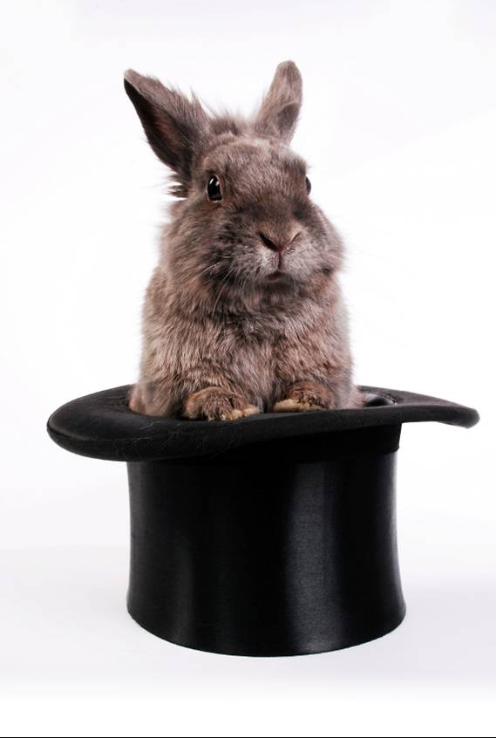



1 2 3

1 The magician worked A on a ship.
B on the Titanic.
C in a theatre.
D on television.

2 The story happened A before the Second World War.
B during the Second World War.
C in the 1940s.
D in the 1840s.

3 After some time the parrot A walked around.
B sat on his shoulder.
C got tired.
D caused problems.

4 He did nothing to the parrot because: A he liked it.
B people liked it.
C it did good tricks.
D the ship blew up.

5 After the ship blew up, he saw A people in the water.
B dangerous things in the water.
C a life-raft.
D a lifeboat.

6 When the parrot arrived, it A spoke to him.
B looked at him.
C went to sleep.
D gave up.

Photos: 1 - (c) i-stockphoto.com/Mirela Schenk 2 - (c) i-stockphoto.com/Dave Huss 3 - (c) i-stockphoto.com/Eric Isselee
Activity 3 Language focus

Work with a partner. Decide on the better form, of the two in bold, for each sentence.

1 If you go / ’ll go out, get some milk at the corner shop.
2 If I have / had time, I’ll come and see you.
3 I have / ’m having dinner at my sister’s house on Friday.
4 What time does the film start / is the film starting?
5 I wish I am / was a millionaire.
6 If it will rain / rains, we’ll cancel the picnic.
7 If you come along tonight I give / ’ll give you the CD.
8 If I have / had the money I’d help you.
9 I study / ’m studying for my exam this week.
10 If he’s gone home, I speak / ’ll speak to him tomorrow.
11 He’s gone into town because he wants / ’s wanting a new jacket.
12 Nargis says that she loves / ’s loving chocolate.

Activity 4 Vocabulary

Work with a partner. Rearrange the letters on the right to make the correct words.

1 a type of spaghetti a l o g e s o b n I __________________
2 American courgettes c h u z i c n I __________________
3 going up or down with a rope s l a i b n i g e __________________
4 music played from a CD, etc d e c r e d o r __________________
5 on the waves with a board g r u f n i s __________________
6 US aubergine g a n g p e l t __________________
7 using a small narrow boat k n i g a y a k __________________
8 where sprouts come from s l u r b e s s __________________
9 white, milk or dark t a l c o h o c e __________________
10 words of a song s l i c r y __________________

Activity 5 Writing

Keeping in touch

1 When people use text, text messaging, internet chat rooms or e-mails they often use abbreviations. Look at the abbreviations below. Work with a partner and match each of 1–10 with its normal English form a–j.

1 BCNU a Bye for now
2 COS b Thank you
3 N1 c Anyone
4 MUSM d Talk to you later
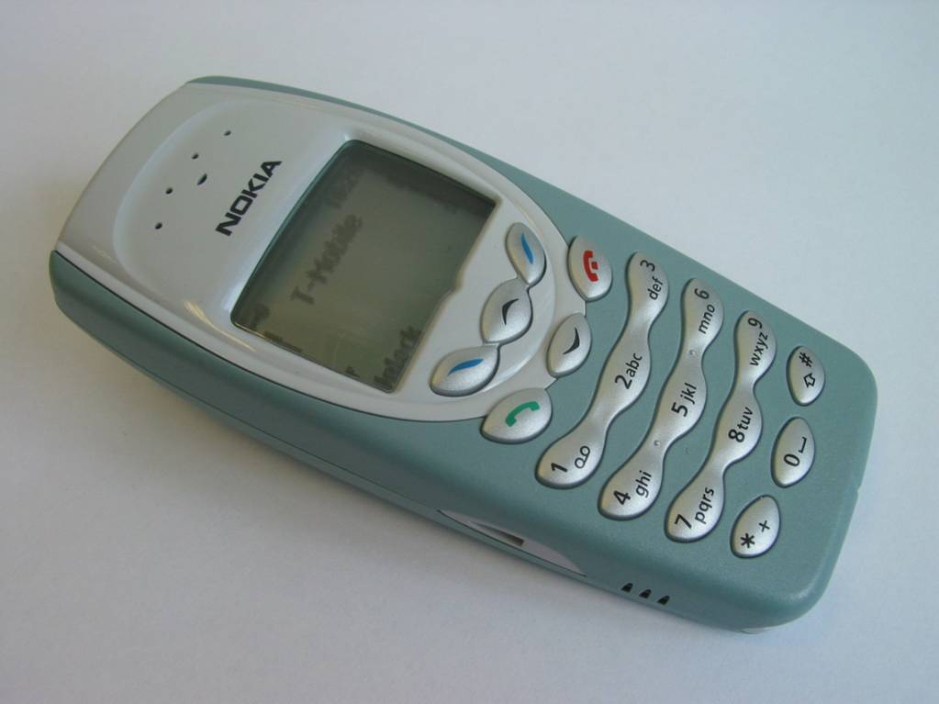
5 CUL8R e Mind your own business
courtesy BTL
6 NE1 f Because
7 MYOB g Miss you so much
8 BFN h Nice one
9 TLK2UL8R i Be seeing you
10 THNQ j See you later
2 Look at this text conversation between Max and his friend Sally. Use the text glossary below and the examples above and translate it into normal English – with some punctuation.

Max Hi Sal – HRU? ____________________________
Sally Hi Max – G2CU ____________________________
Max WRUD? ____________________________
Sally Busy – TGIF ____________________________
Max Oh – PMFI ____________________________
Sally NP ____________________________
Max Anyway, LTNS ____________________________
Sally Yes – IMS ____________________________
Max Can I CUS? ____________________________
Sally When? ____________________________
Max WKD? ____________________________
Sally SLAP – Sat at 7? ____________________________
Max Maybe L8R ____________________________
Sally OK – 8? ____________________________
Max FBM, will call 4U ____________________________
Sally GR8 – GTG BFN ____________________________
Max HF – XX ____________________________
Sally XX ____________________________
glossary
4U For you
ASAP As soon as possible
ATM At the moment
B/F Boyfriend
B4 Before
BC Because
BFN Bye for now
BOL Best of luck
BRB Be right back
CUS See you soon
DTS Don't think so
FBM Fine by me
G2CU Good to see you
GTG Got to go
GL Good luck
GR8 Great
H&K Hugs & kisses
H2CUS Hope to see you soon
H8 Hate
HAND Have a nice day
HF Have fun
HRU How are you?
IDUNNO I don't know
ILBL8 I'll be late
ILU I love you
IMS I am sorry
KNIM Know what I mean?
L8R Later
LOL Laughing out loud
LTNS Long time no see
M8 Mate
MSG Message
NLT No later than
NO1 No one
NP No problem
OIC Oh, I see
PLS Please
PMFI Pardon me for interrupting
RUOK Are you okay?
SLAP Sounds like a plan
SOL Sooner or later
SRY Sorry
SUITM See you in the morning
SUL See you later
TGIF Thank goodness it's Friday
THNX Thanks
WB Welcome back
WKD Weekend
WRUD What are you doing?
X Kiss

Homework task

Write a text message to a friend using abbreviations taken from the list above, and real words where you need them. Ask how they are, what they are doing and suggest meeting on Friday night.
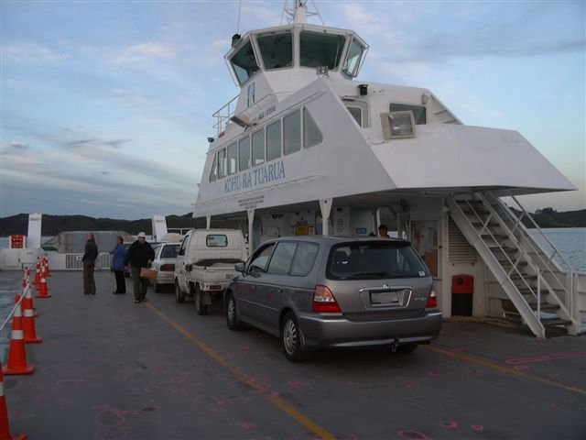

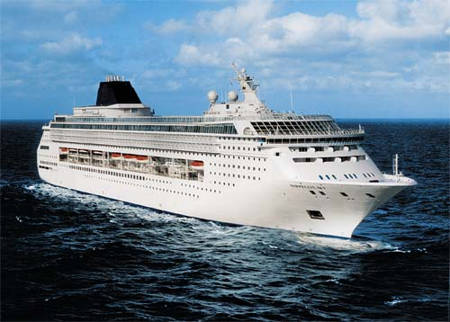

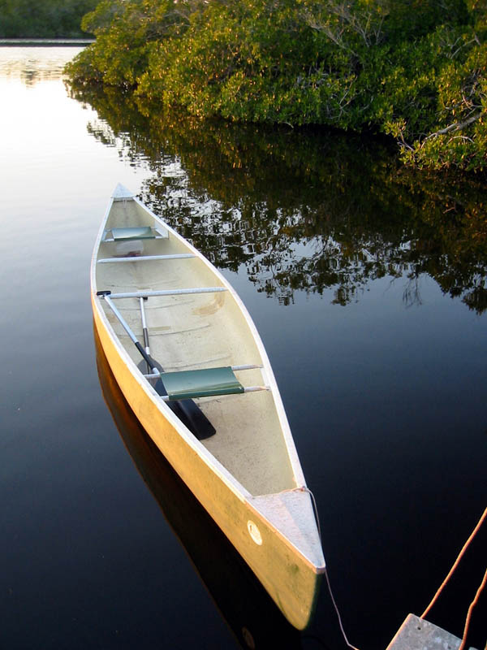

r

d

