Lesson  15 | Work
Lesson  15 | Review of lessons 11–14
 |  | Task: Discussing different jobs
Skill: Speaking, Reading, Writing

Activity 1 Speaking

Look at these aspects of a job:

salary: high or low ____
extras: company car, free private health care, etc ____
location 1: new purpose-built premises or old/not too suitable ____
location 2: inside an office or outdoors ____
location 3: in one place or with travelling ____
dress: formal or casual ____
hours of work: 9 to 5 / shift work / having to finish work at home ____
contacts 1: working from home, with colleagues or with the public ____
contacts 2: working with adults, children, animals or computers ____
employer: private company / local authority / the government ____

Think of jobs you have done, are doing or hope to do in the future. Why did you choose these jobs, or why are you interested in these jobs? Now rank the aspects above in your order of priority. For example:

I don’t care much about money, or having a company car and so on. I don’t want to work inside though, and I’d like to travel, so location’s important. Put that at number 1. I don’t like wearing a suit. I don’t mind what hours I work, but I don’t want to work alone. Colleagues maybe, not the public, and definitely not children or animals. I don’t mind who I work for — private or public, as long as I enjoy the work.

Write 1 after the most important aspect, 2 after the next, and so on down to 10 against the one you care least about.
Now work with a partner. Discuss your different preferences, the jobs you would like to do and why.
Activity 2 Reading

© iStockphoto.com/Mark Goddard
The text below compares life in prison and at work. Some of the endings are not there. You’ll find them below.

Work with a partner. Write one letter a–i on each line.

IN PRISON you spend most of your time in a small cell.
AT WORK you spend most of your time in a smaller cubicle.

1 IN PRISON ___
AT WORK you only get a break for one meal and you have to pay for it.

2 IN PRISON you get time off for good behaviour.
AT WORK ___

3 IN PRISON a guard locks and unlocks all the doors for you.
AT WORK ___

4 IN PRISON ___
AT WORK you get fired for watching TV and playing games.

5 IN PRISON ___
AT WORK you have to share.

6 IN PRISON they allow your family and friends to visit.
AT WORK ___

7 IN PRISON ___
AT WORK you pay all the expenses to go to work and then they deduct taxes from your salary to pay for prisoners.

8 IN PRISON ___
AT WORK you spend most of your time wanting to get out and go inside bars.

9 IN PRISON there are wardens who are negative.
AT WORK ___
a all expenses are paid by taxpayers and you don’t have to work.
b they are called managers.
c you can’t even speak to your family and friends.
d you get rewarded for good behaviour with more work.
e you get three meals a day.
f you get your own toilet.
g you have to carry a security card and unlock and open all the doors yourself.
h you spend most of your life looking through bars from the inside wanting to get out.
i you can watch TV and play games.
Activity 3 Language focus

Work with a partner. The sentences below use the grammar in the language focus sections of lessons 11–14. Choose the better form in each one.


1 ‘What do you do / What are you doing?’ ‘Just having some lunch.’

2 How do you feel / How are you feeling about the new boss?

3 You work / You’re working too hard this week. 1

4 The dayshift finishes / is finishing at six o’clock.

5 I give / I’m giving a presentation to the sales team tomorrow.

6 She takes / She’s taking some time off next week. 2

7 When I see / I’ll see George I tell / I’ll tell him about this.

8 If you want / you’ll want the job, apply for it.

9 I quit / I’ll quit if I have another day like this.

3

Activity 4 Vocabulary
Work with a partner to solve the crossword puzzle on the next page. The answers to the crossword are in the vocabulary sections of lessons 11–14. See if you can work them out.

Photos © iStockphoto.com
1 – Matt Jeacock 2 – VisualField 3 – absolut_100

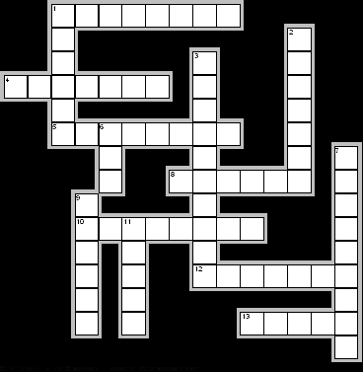

down

1 Artists work here. (6)
2 You turn nuts with it. (7)
3 They don’t make books to read. (10)
© iStockphoto.com/Edward Todd
6 For cutting wood. (3)
7 A kind of leave to have a baby. (9)
9 Makes doors and windows. (6)
11 Told to leave your job. (5)

across

1 Makes statues. (8)
4 Delivers babies. (7)
5 You stop work to get more money. (2, 6)
8 You hit nails with it. (6)
10 They are not people who work in offices. (8)
12 Works in a theatre, but isn’t an actor. (7)
13 There are three of these — day, night or back. (5)
© iStockphoto.com/atbaei

Activity 5 Writing

Choose a piece of technology that you use. This might be your mobile phone, MP3 player, camera, CD/DVD player, etc.

A friend has just bought the same item but can’t understand the instructions. Write an e-mail and tell them how to use it.


© iStockphoto.com/Fuat Kose
If you want to make a call, just type in the number. Then press the button on the top left, where it says ‘call’. When you finish, press the button on the top left that says ‘end call’. If you want to store a number…



Homework task

Find a set of instructions for a piece of technology. If you haven’t got these at home, use the internet. Compare the language with what you wrote yourself. In what ways are they similar or different? Which do you think is most helpful? Bring your instructions into class and show them to other students in a group.

Lesson  16 | Work
Lesson  16 | Messages; demonstrations/presentations
Task: Understand/pass on/leave straightforward messages.
Follow a straightforward demonstration/presentation
Skill: Speaking, Listening, Writing

Activity 1 Speaking

Work with a partner. Choose to be Student A or Student B. Your teacher will give each of you a tasksheet. Read yours and follow the instructions.

Activity 2 Listening

Track 9

Listen to this talk by a college principal to some members of staff. As she talks, she shows some PowerPoint slides. For slides 2, 3 and 4, decide if she shows slide a, b, c or d. Tick (✓) one slide.

Slide 1



Slide 2

a b

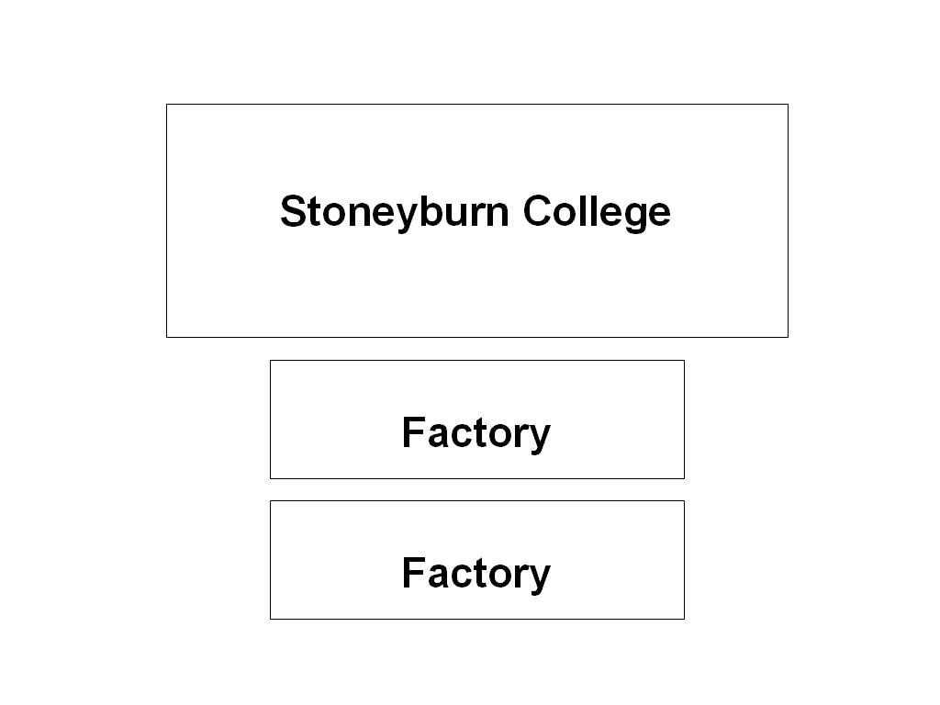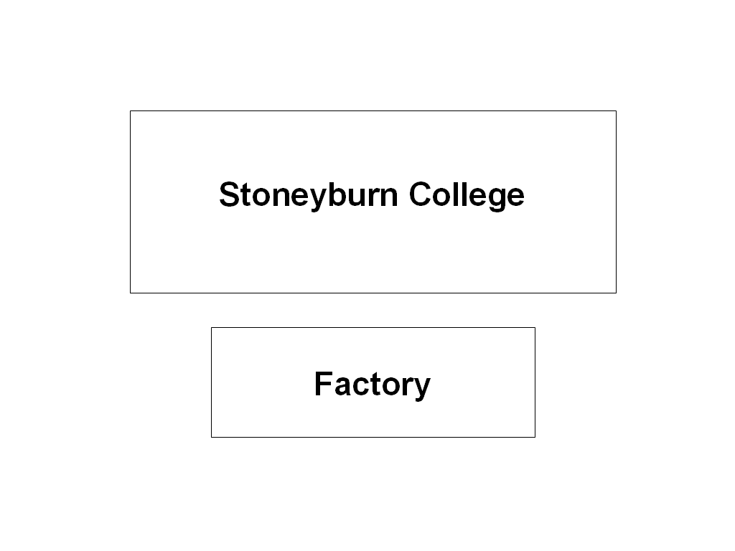
north
south
west
east

c d
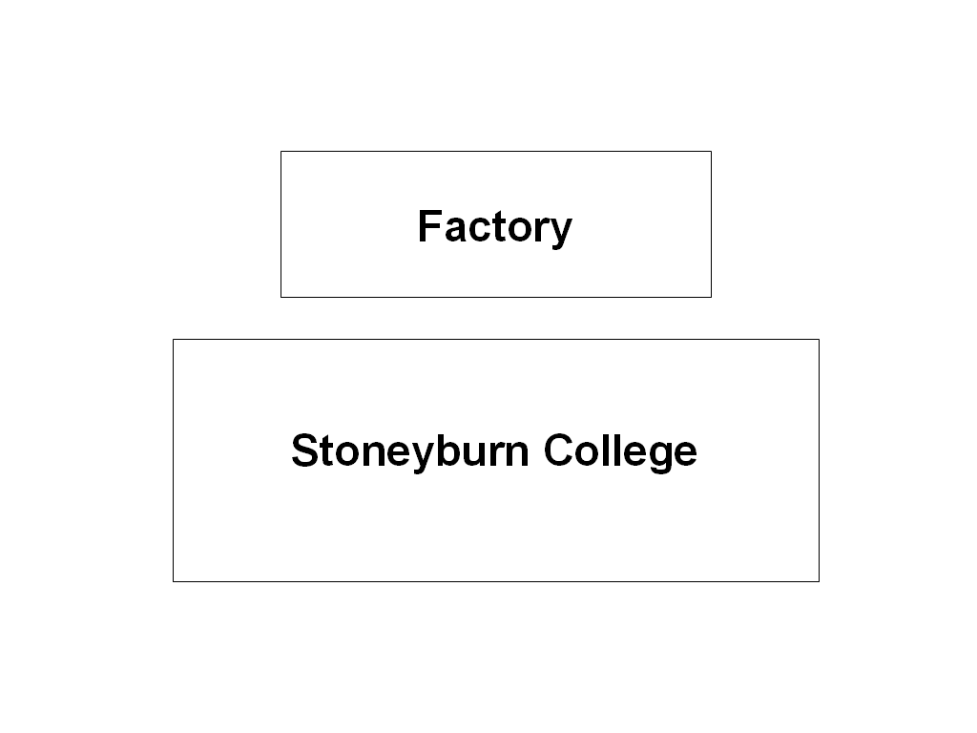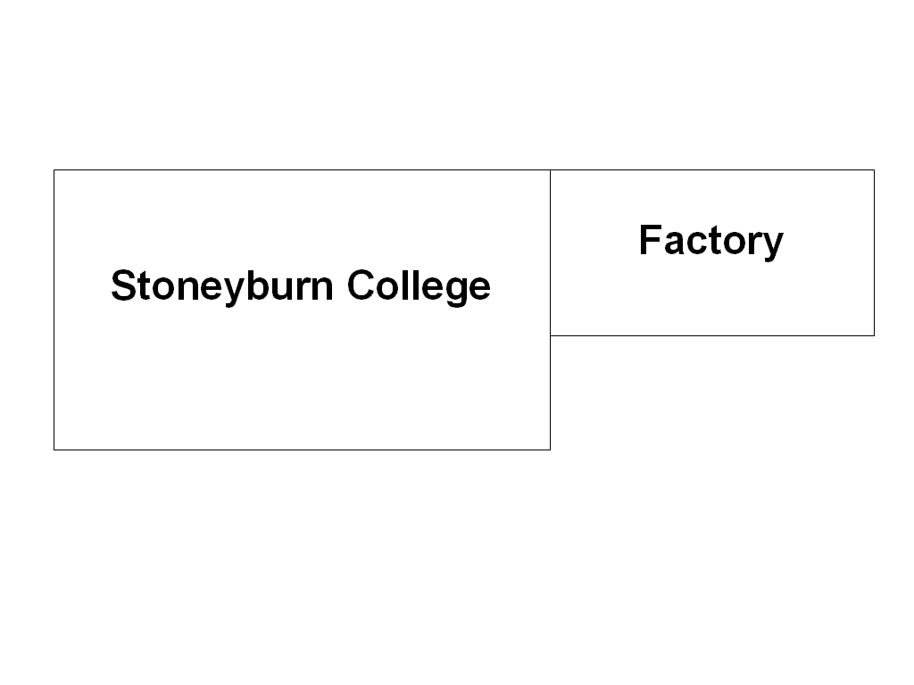

Slide 3

a b

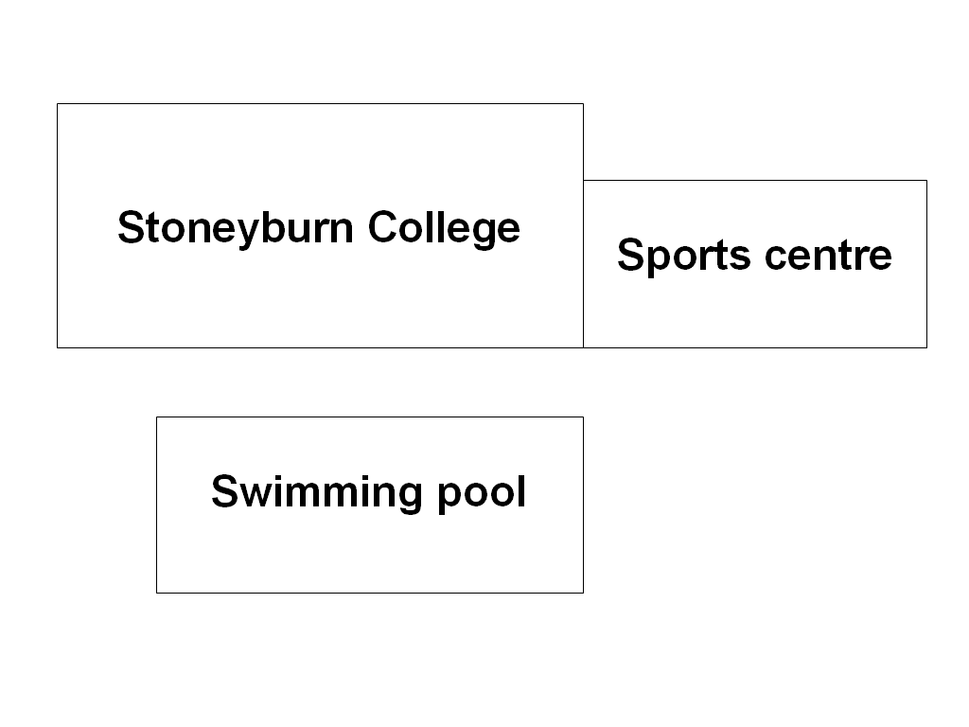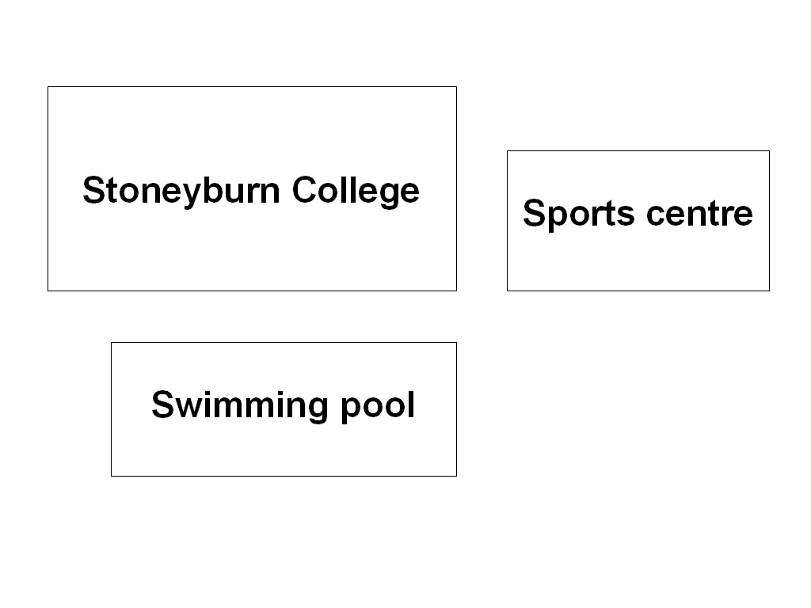
north
south
west
east

c d

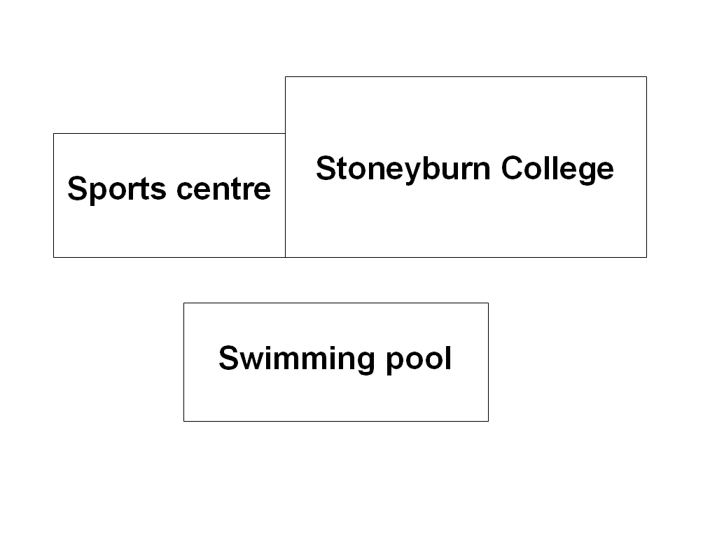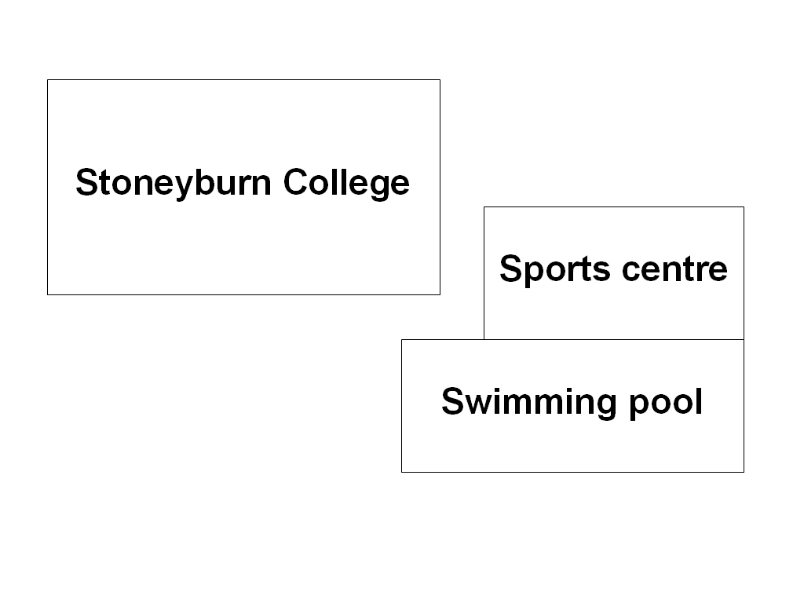

Slide 4

a b
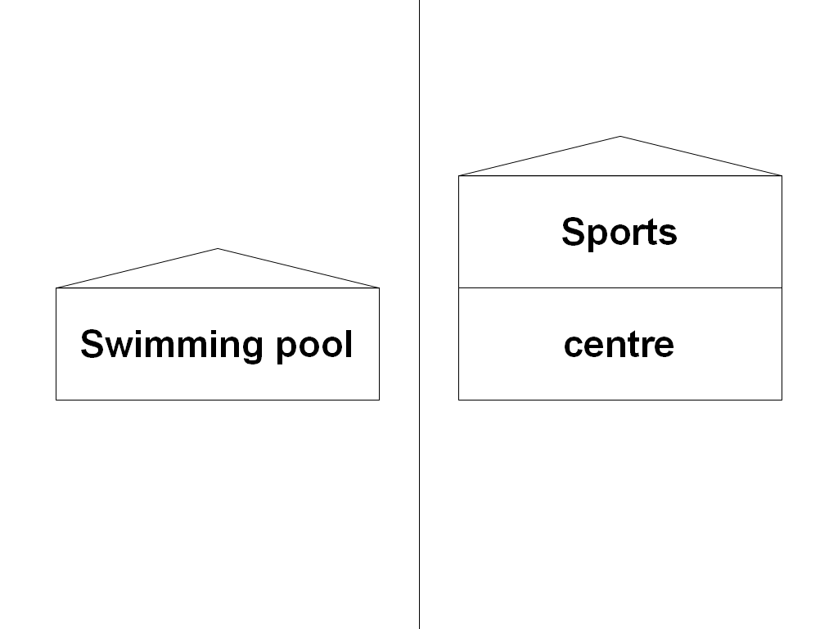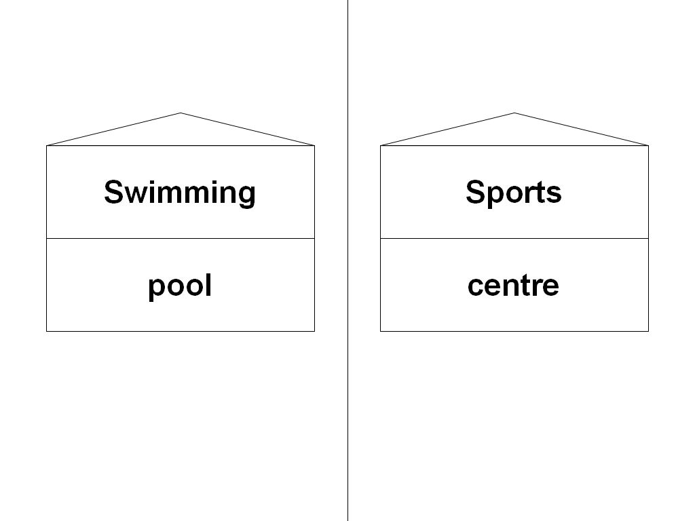

c d
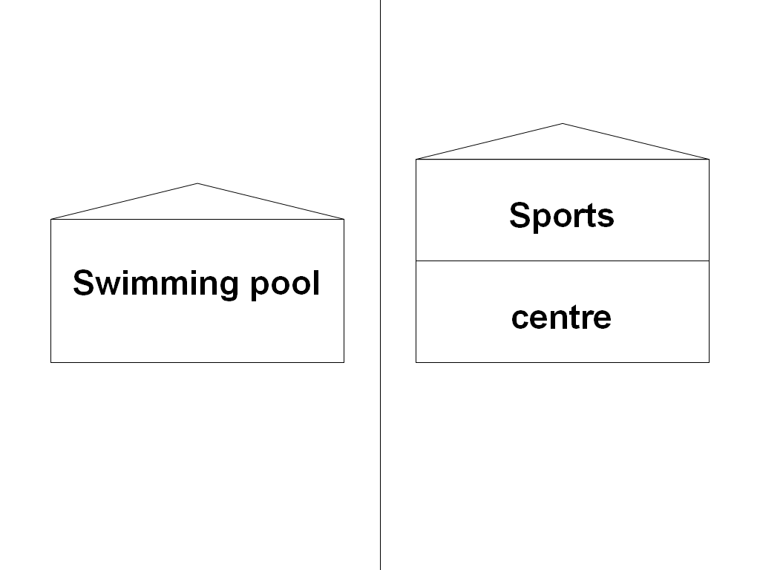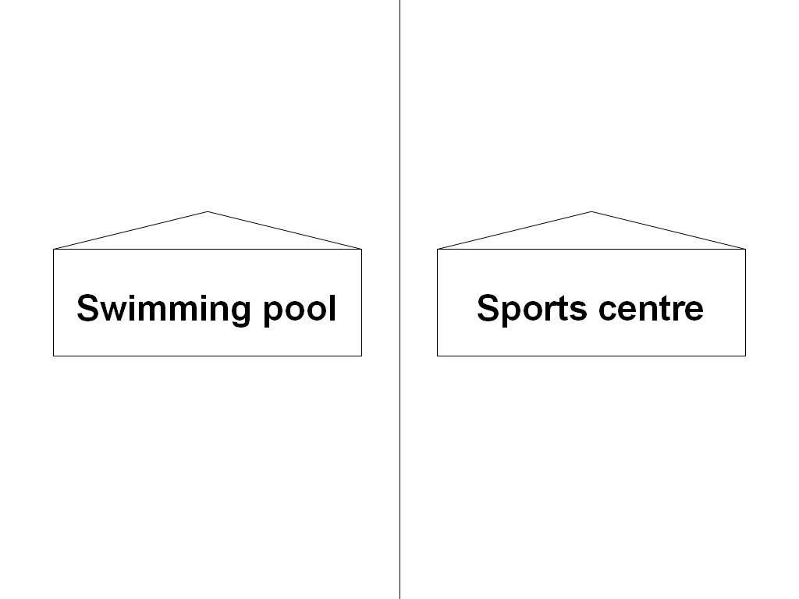

Activity 3 Language focus

past simple vs past continuous

Look at this sentence:

I drove home when my scooter ran out of petrol.
This doesn’t work. You can’t drive a scooter without petrol. You want to say you ran out of petrol on the way home. You need to make drove longer so that ran out of petrol happens in the middle. You can do this with the past continuous, which makes shorter-time verbs longer:

I was driving home when my scooter ran out of petrol.

If the verb can’t get longer, it repeats:

He banged his head on the door. → He was banging his head on the door.

This changes the meaning from a possible accident to a probably deliberate activity.

1 Work with a partner. Look at the sentences below. Some of the tenses are wrong. Change the wrong ones to the correct tense — either past simple or past continuous.

1 I drove to Glasgow when I crashed my car.
2 I was calling Jim Mitchell when I dropped the phone.
3 When I came into the room she was dropping the report.
4 When I was finishing the report I photocopied it.
5 When I was talking to the manager, the fire alarm went off.
6 A box was falling on my head so they sent me to hospital.
7 He got into his car and drove away.
8 When Sheila was losing her job she went to the Job Centre.
9 I woke up with a sore stomach so I stayed at home.

2 Now write answers to these questions:

What were you doing:

at eight o’clock this morning ___________________________________________________________

at ten o’clock last night? ___________________________________________________________

at one o’clock yesterday? ___________________________________________________________

at nine o’clock on Sunday evening? ___________________________________________________________

at this time last week? ___________________________________________________________

on the 1st of January this year? ___________________________________________________________

on the afternoon of your last birthday? ___________________________________________________________
Work with a partner. Ask and answer the questions. Do you have the same answers?
Activity 4 Vocabulary

Work with a partner. Draw a line from each job in the box to an associated word outside it. The first one has been done for you.




A
B
C
D
E

Students paint and wallpaper
old things shares
rubbish drinks

academic accountant advocate antique dealer
chiropodist decorator estate agent janitor paediatrician
publican refuse collector stockbroker welder

metal court cases
numbers houses
feet children doors





G
H
I
J
F
All photos © i-stockphoto.com

A Andrew Manley
B Maciej Korzekwa
C Mike Clarke
D Rebecca Ellis
E Aupo Kikkas
F Andy Nowack
G Angel Herrero de Frutos
H VisualField
I Jan Tyler
J Edyta Pawowska

Activity 5 Writing


Imagine you are the boss of a company. At the moment, you have your offices in an old building in the city centre. The company wants to move to new offices in a new building on the edge of the city. These offices will be bigger, will have better computer connections and will include sports facilities. However, most of the staff would prefer to stay in the city centre.
© iStockphoto.com/Tony Tremblay

You have called your staff together to talk about the proposed move. You need to describe the new offices, from the outside and what they will be like to work in. You need to make your staff want to move there. Write your presentation.

Homework task

You have heard the boss give a presentation about the move to new offices. You and some of your colleagues are still not happy about it. Write an email to the boss. Give your reasons why you think the present offices are better.

Lesson  17 | Work
Lesson  17 | Advertisements and job descriptions; instructions
Task: Read simple texts relating to employment opportunities, eg advertisements, job descriptions.
Understand instructions in the form of a continuous text in own job area
Skill: Speaking, Reading, Writing

Activity 1 Speaking

1 Read the sentences below. Tick (✓) if they are true or false for you.
Use your dictionary if you need help.
true false no.
I can work under pressure. ___ ___ ___
I have a good sense of humour. ___ ___ ___
I am very energetic. ___ ___ ___
I can talk to a room full of people without being shy. ___ ___ ___
I am good at negotiating and making agreements. ___ ___ ___
I can take control of a situation and tell people what to do. ___ ___ ___
I can keep on working on something until I finish it. ___ ___ ___
I am very patient and don’t lose my temper often. ___ ___ ___

2 Now think of a job you would like to do. Write its name here: _________________
3 Which qualities are most important for this job? Which ones are least important? Number them. Write 1 beside the most important. Continue with 2, 3, 4 Now look at your true ticks ✓✓✓.

4 Work with a partner. Compare your profiles. Ask and answer these questions:
- Has your partner ticked the correct qualities as true or false or is he/she telling lies?

Do you agree with your partner’s numbers 1, 2, 3, etc for the job they want to do?

5 Discuss your qualities.
Activity 2 Reading

Scotjobs

Work with a partner. Read these job adverts from an internet site. For questions 1–9, put ticks (✓) on the correct lines for jobs 1–4. You may tick more than one job for each question.

KEYWORDS
Full/Part time

Found 34 jobs

1
Edinburgh
CHEF
The Marloch Centre

As one of Scotland's leading Conference Venues, we want to recruit highly customer-focused staff, who share our passion for hospitality.

To lead a small team servicing our busy cafe and banqueting operation. Full details of post and how to apply are available on our website at www.marlochcentre.co.uk, or call Cheri McKeever, Office Manager on 0131 551 3008.

2
Perth
SENIOR SECRETARY
£18,157 to £21,050
The University of Perth

You will provide administrative service. You must show personal responsibility, judgement and initiative. You will have experience of administrative management, and of dealing with IT software and hardware problems.

Benefits include generous holidays plus 9 public holidays, pension and staff discounts including gym membership. Apply online at our website or telephone the recruitment line on 01738 651 3097.

3
Glasgow
RECEPTIONIST ADMINISTRATORS
Govan Thistle Football Club
We require two receptionists. You will be presentable and have an excellent telephone manner. The work involves administration, so a good knowledge of modern systems is important.
The two positions will be interchangeable. One person will work mornings 8 am to 1 pm with the other working 1 pm to 6 pm. Some match day work is also required.
To apply please send your CV to Jadranka Sulic, Govan Thistle FC, Parkfoot Stadium, McLean Street, Glasgow, GL19 2QL.

4
Elgin
NHS SPEYSIDE, Cabrach Hospital
Level 1 Nurse — Band 5
£18,039-£24,803 pa — day and night rotation.

You will demonstrate strong leadership qualities and excellent interpersonal skills. You must have experience of managing a ward in the absence of a Charge Nurse.

Personal and professional development opportunities will be provided. Hours are 37.5 per week.

For an application pack please call 0845 240 34735 (24 hours) or email recruitment.speyside@nhs.net quoting reference N/MN/24

1 2 3 4

1 You work part-time. ___ ___ ___ ___
2 You work on some Saturdays. ___ ___ ___ ___
3 You work shifts. ___ ___ ___ ___
4 You must sound pleasant on the phone. ___ ___ ___ ___
5 You have the chance to get more training. ___ ___ ___ ___
6 You can get more information from a website. ___ ___ ___ ___
7 You are in charge of other workers. ___ ___ ___ ___
8 You need to know about computers. ___ ___ ___ ___
9 You can get some things at a lower cost. ___ ___ ___ ___
Activity 3 Language focus

the present perfect
We use the present perfect

1 for events which started in the past and have continued up to now.

‘She’s worked there for years.’

2 for events in the past where we don’t know the exact time, or the time is not important:
‘I’ve seen that film lots of times.’
We use the past simple when we say the time the event happened, or when this time is important … or both.
‘I saw Charlie yesterday.’
‘Did you have a nice holiday?’

We use the past simple for events in the past which we see as distant or remote, as not connected to the present.

We use the present perfect when the event is still happening, or when its result is important now. Both uses are connected to the present — that’s why we call it the present perfect.

Work with a partner. Look at these sentences. Decide if they should be in the present perfect or the past simple and rewrite the verbs.

1 He (sit) __________ at that desk for years — I think he’ll be there forever.
2 Joe’s coming here tomorrow. I (not see) __________ him for years.
3 It’s a good company — I (buy) __________ a few things from them.
4 It was a terrible company. I only (buy) __________ from them once.
5 When I started here I (work) __________ very hard. Now I don’t do so much.
6 I (have) __________ this computer for too long. I need a new one.
7 Artemis (start) __________ with the firm in 1986.
8 She (work) __________ for them since then.
9 You (do) __________ anything interesting in Glasgow last week?
Activity 4 Vocabulary

Look at the words in each box. These show different levels in various jobs. Write a number 1–4 against each job, starting at the top.

school
deputy head teacher ___
head teacher ___
principal teacher ___
teacher ___
nursing
matron ___
nurse ___
sister ___
staff nurse ___
university
head of department ___
lecturer ___
professor ___
senior lecturer ___


SHAPE \* MERGEFORMAT
© iStockphoto.com/Rudi Tapper
© iStockphoto.com/Bob Thomas
commerce
chair/chief executive officer (CEO) ___
director ___
executive ___
personal assistant (PA) ___
police
constable ___
inspector ___
sergeant ___
superintendent ___
Roman Catholic Church
bishop ___
cardinal ___
pope ___
priest ___
politics
member of parliament (MP) ___
minister ___
prime minister ___
secretary of state ___

© iStockphoto.com/Brett Charlton
air force
air marshal ___
flight lieutenant ___
group captain ___
squadron leader ___
army
captain ___
colonel ___
private ___
sergeant ___
navy
admiral ___
captain ___
lieutenant ___
seaman ___


© iStockphoto.com/ Kelly Cline
kitchen
chef ___
commis chef ___
kitchen porter ___
sous chef ___

Activity 5 Writing
Think of a job you do, have done or know something about. A new employee is going to start this job on Monday. Your boss wants you to explain the job to this person, but you won’t be at work on Monday — you have an appointment elsewhere. Write an e-mail to the boss. Give instructions about how to do the job for the boss to pass on to the new employee.

Homework task
Look at one of the boxes in the vocabulary above — choose one that interests you. Do some research, in the library or on the internet, about the different work that people do at the various levels of this job. Find out if there are other levels in this job. If there are, what are their names?

Lesson  18 | Work
Lesson  18 | Requests; letters, e-mails, memos, etc
Task: Write requests on a range of routine matters
Write straightforward letters,
e-mails, memos, etc
Skill: Speaking, Listening, Writing

Activity 1 Speaking

Jobs alphabet

Work in a group of three. Choose one student to write. Think of a job that begins with each letter of the alphabet below. Write one on each line. Use the pictures to help you.

A ____________________________________

B ____________________________________

C ____________________________________
© iStockphoto.com/James Margolis

D ____________________________________

E ____________________________________

F ____________________________________
© iStockphoto.com/Michelle Malven

G ____________________________________

H ____________________________________

I ____________________________________
© iStockphoto.com/Oscar Durand

J ____________________________________

K ____________________________________

L ____________________________________

M ____________________________________
© iStockphoto.com/Chris Schmidt

N ____________________________________

O ____________________________________

P ____________________________________

Q ____________________________________
© iStockphoto.com/Sean Locke

R ____________________________________

S ____________________________________

T ____________________________________

U ____________________________________

V ____________________________________

W ____________________________________

X ____________________________________

Y ____________________________________

Z ____________________________________

Activity 2 Listening

Track 10

You will hear six messages left on answer phones. For each one, tick (✓) the best answer a–d.

1 Audrey wants:

a the income figures for April. ___
b the income figures for May. ___
c the expenditure figures for April. ___
d the expenditure figures for May. ___
© iStockphoto.com/RainforestAustralia


2 The train will arrive:

a at 7 o’clock at Platform 11. ___
b at 7.30 at a platform to be announced. ___
c at around 8 o’clock at a platform to be announced. ___
d at around 8 o’clock at platform 11. ___
© iStockphoto.com/hfng

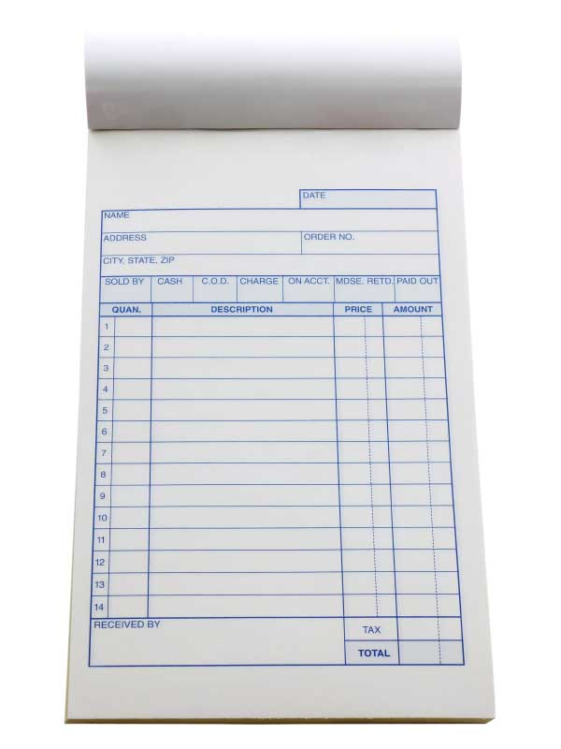
3 Conway Electrical want payment for:

a their August invoice for £450. ___
b their August invoice for £295. ___
c their September invoice for £450. ___
d their September invoice for £295. ___

© iStockphoto.com/brentmelissa
4 Farzana has to:

a take a package to RS Morrison’s. ___
b pick up a package from RS Morrison’s and pay for it. ___
c pick up a package from RS Morrison’s and sign for it. ___
d take a package from RS Morrison’s to Andrew Street. ___


5 Mehmet will:

a phone Joe from his car. ___
b phone Joe from the office before 9.30. ___
c phone Joe from the office after 9.30. ___
d go and see Joe after 9.30. ___

© iStockphoto.com/Dave Herriman
6 Charles should:

a buy 500 shares in Marcel Insurance. ___
b sell shares in Marcel Insurance and buy shares in Cambus Computers. ___
c buy 500 shares in Canterbury Computers. ___
d sell some shares and put the money into the bank. ___
Activity 3 Language focus

Work with a partner. Look at the sentences below. All of them use the past simple, but only half of them use it for past time. The others use it for present time. Divide them into two groups. Write five numbers in each of the boxes below.

1 I left work late on Monday night.
2 It’s time we sorted out these files.
3 I thought about taking the job but decided against it.
4 If I knew the answer I’d tell you.
5 She went to London two years ago.
6 Martha got a new job last week.
7 I wish I had a fast car.
8 She worked in the Perth office when she first started.
9 Imagine if you got the job.
10 I thought we were having a meeting — where is everyone?
past time
___ ___ ___ ___ ___
present time
___ ___ ___ ___ ___

Why do we use the past simple in some sentences about present time? What kind of sentences are these? Discuss this with your partner.

Activity 4 Vocabulary
Work with a partner. Connect the first parts 1–9 of the phrases on the left with their second parts a–i on the right. Use your dictionaries if you need help.

1 compensation for a representative
2 end of year b rights
3 industrial c dispute
4 minutes of a d price
5 retail e injury
6 time f lieu
7 time off in g meeting
8 trade union h bonus
9 workers’ i management
Activity 5 Writing

Look at this e-mail from your boss:
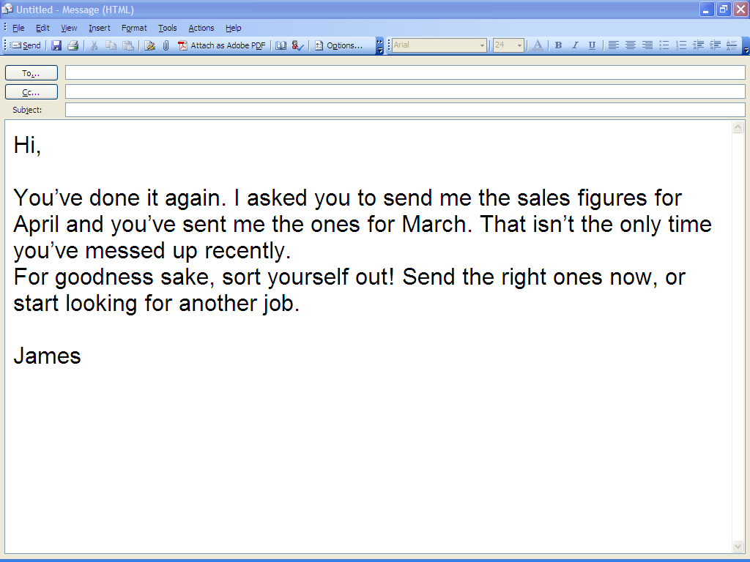

You are not happy about this, for these reasons:

- You are quite sure James asked you for the March figures. You even took a note of this. He was talking on the phone at the time and may have given you the wrong month.

- You are new to the job. You have made a couple of mistakes, but neither was very serious. You are trying to do your best.

- James doesn’t have the authority to sack you. His boss is Alison, the Managing Director. She can sack you but she seems quite happy with your work.

- You feel that if James wants to criticise your work, he should speak to you personally rather than putting his thoughts into e-mails.

Write an e-mail to James. Say that you have attached the April sales figures. Write about the points above. Ask for a meeting with James, with Alison present.

Homework task

What can you do if you are being bullied or harassed in your school/college or workplace? Find out about the procedures in place in your work or study situation. Also, use the internet or a library to find out about national organisations that could help you.

Lesson  19 | Work
Lesson  19 | Letters; application forms
Task: Understand and act on a standard letter,
Complete application forms with some assistance.
Skill: Speaking, Reading, Writing


Activity 1 Reading
Work with a partner. You live in the UK but have family connections with a country that manufactures cloth. You have a small business that imports and sells cloth. You have just made an agreement with a tailor, Paul Scott Suits (see page 98). They send you a contract. Read it and for each question 1–7 below, tick (✓) one line.
© iStockphoto.com/
Aleksandr Lobanov

1 On the 14th of April, Paul Scott Suits phones you and says they need some woollen cloth. You don’t have any in stock and so refuse. They say they will cancel the whole contract. Can they do this?
Yes ___ No ___

2 You deliver a batch of cloth on the 1st of May. When are you paid?
31st May ___ 30th June ___ 31st June ___

3 Paul Scott Suits sends you a cheque for this batch. You say that you wanted to be paid into your bank account. You want them to make future payments in this way. They refuse. Can they do this?
Yes ___ No ___

4 You deliver most of a batch of cloth to Paul Scott Suits by the agreed date. But some of it is delayed in Customs. You say you will deliver this within a few days. They say they will only pay a reduced price for it. Are they allowed to say this?
Yes ___ No ___

5 A week later you still can’t get the rest of the batch from Customs. Paul Scott Suits cancels the whole order. You ask them to send the first part back to you. Do they have to do this?
Yes ___ No ___

6 They refuse to return the cloth. You refuse to go and pick it up. Two months pass. Who now owns the cloth?
Paul Scott Suits ___ You ___

7 You deliver a batch of cloth to Paul Scott Suits. They say that the quality is below standard. You say that it is good cloth but they refuse to accept it. Can they do this?
Yes ___ No ___
Paul Scott Suits
© iStockphoto.com/Jurga Rubinovaite

25 Airthrey Street, Glasgow
tel. 0141 589 4832

Contract For Supply

Dear
I am pleased to confirm that Paul Scott Suits is able to ask you to supply textiles for the period as detailed below and this letter records the agreement between you and Paul Scott Suits.
The period of this contract is from 1st April to 31st October of this year. During the contract you are not obliged to respond to requests for textiles from Paul Scott Suits if this is not convenient to you.
Textiles supplied will be paid for at a price arrived at by agreement. This price will apply only to that delivery and payment will be made at the end of the calendar month, the month after delivery of the complete batch. Payment will be in full and each payment will either be made into your bank account or by cheque, according to your preference.
When the price of a batch of textiles is agreed, a delivery date will also be agreed. If the complete batch is not delivered by that date, Paul Scott Suits have the right to cancel delivery and payment or to renegotiate the price of all or part of the batch. If receipt is cancelled and part of the batch has been delivered, it is for you to uplift that part from our premises at your own expense. This must be done within 30 days or ownership of that part will revert to Paul Scott Suits.
If Paul Scott Suits feels that the quality of a delivery is not up to standard, we reserve the right to cancel receipt and payment.
Please confirm that this arrangement is acceptable to you by signing and dating one copy below and returning it to me in the enclosed SAE.

Yours sincerely

Aysegul Douglas

Aysegul Douglas
Head of Supply
___________________________________________________________
I confirm acceptance of the terms of the contract for supply set out above.

Signed ………………………………………

Dated ………………………………………
_________________________________________________________________
Activity 2 Speaking

Work with a partner. Choose one of the situations 1, 4 or 5 above. Now choose to be Student A or Student B. Read the briefing notes below.
___________________________________________________________

Student A
You are the supplier. You have gone to the Paul Scott Suits office. Talk to a representative from the company. Try to make them change their mind. Be prepared to offer a better deal on future contracts.
___________________________________________________________

Student B
You work for Paul Scott Suits. You are talking to a supplier who is unhappy with a decision the company made. You want to keep this supplier so be prepared to negotiate.
___________________________________________________________

Activity 3 Language focus
Work with a partner. Discuss whether the sentences below are about real or unreal situations in present time. Then write the verbs in brackets to the appropriate form to make 1st or 2nd conditional sentences. Use will/’ll or would/’d where necessary.

1 We’re making lots of money. If this (go on) _______ we (be) _______ able to expand.
2 If my father (be) _______ alive today, he (agree) _______ . But he’s dead.
3 The manager (help) _______ if he (be) _______ here, but he’s in New York.
4 Of course I (give) _______ you the data — if I (have) _______ it. Let me check.
5 If that (be) _______ the best you can do I (ask) _______ somebody else next time!
6 Look — I don’t know what to do here. If I (do) _______ I (tell) _______ you.
7 We (expand) _______ the company if we (have) _______ the money — but we can’t.
8 I’ll just see if he’s free. If he _______ (be), he (see) _______ you.
Activity 4 Vocabulary

Work with a partner. Finish each of the sentences 1–7 with one of the work idioms below them. Write one letter a–g on each line. Pay attention to the grammar, because this may help you. Use your dictionaries if you need them.

1 You’re taking on a difficult job. I don’t know if you’ll succeed. You’ll certainly ___

2 The boss told me to work closely with Peter on this project. I don’t know what she means — I already ___

3 OK, do a good job for them, but don’t overdo it. Don’t ___

4 Keith really knows what he’s doing. We couldn’t sort out the computer but he just sat down and ___

5 He may be a genius but I made the company successful. I did ___

6 He keeps trying to stop new ideas. Every time we think of something interesting he ___

7 Burning buildings, pet rescue, car crashes, false alarms — for the fire service it’s ___

a all in a day’s work
b have your work cut out for you
c made short work of it.
d puts a spanner in the works
e the donkey work
f work hand in glove with him
g work yourself into the ground

Activity 5 Writing
Think of a job you would like to apply for.

Write its name here: ________________________________
Write a short description of this job: ________________________________
________________________________
________________________________

You have just completed an application form for this job. You have filled in sections on your name, address, education, qualifications, experience, etc. You now turn to the last page and find this:

---------------------------------------------------------------------------------------------------
page 4

Use this space to supply any further information in support of your application.
This allows you to interest the company in you. Write around 150 words. Tell the company why they should give the job to you, and not to someone else.

___________________________________________________________

___________________________________________________________

___________________________________________________________

___________________________________________________________

___________________________________________________________

Homework task

Use the internet or a library to find out more information about a job you would like. Write a short essay giving your plans for more language learning, education and training to get from where you are now to the job.

Lesson  20 | Work
Lesson  20 | Review of lessons 16–19
 |  | Task:
Skill: Speaking, Listening, Writing

Activity 1 Listening
Track 11
Jessica Boyd is going for an interview with a company, Philby Information Systems. Listen to the interview and complete the form below. Put a tick (✓) on the correct line for each area.
___________________________________________________________
Philby Information Systems

Interview checklist

Name of interviewee: Jessica Boyd Date: 1st October

Panel: Kenneth Philby, MD
Laura Fitzroy, Head of Finance
Sadia Kaur, Assistant Head, Human Resources

Post: Clerical assistant, Finance

Strength of application form: strong ___ average _✓_ weak ___

Initial greeting and introduction: good ___ poor ___

Reason for application for work: good ___ poor ___

Reason for choosing Philby Information Systems:
good ___ poor ___

Positive qualities: ________________________
________________________
Attitude to overtime: good ___ poor ___

Attitude to emergency extra work: good ___ poor ___

Software skills: Microsoft Word: good ___ poor ___
Microsoft Excel: good ___ poor ___

Attitude to travel: good ___ poor ___
___________________________________________________________
Now talk with your partner. Decide if you would give Jessica the job. Tick one of these lines: yes ___ no ___
Activity 2 Speaking

Work in a group of four. Your teacher will give three of you copies of the interview checklist above. You work for Philby Information Systems. You are going to interview the fourth member of the group for a job as Clerical Assistant in the Finance section.
© iStockphoto.com/Jacob Wackerhausen

Sit behind a desk. The interviewee should come in. Exchange greetings and invite them to sit down. Ask questions to cover the points on the checklist. Mark the interviewee’s answers as good or poor. Afterwards, discuss your answers with the others on the panel and decide if you will offer a job.

Activity 3 Language focus

Work with a partner. The sentences below use the grammar in the language focus sections of lessons 16–19. Choose the better form in each one.

1 I ran/was running down the stairs when I fell and twisted/was twisting my ankle.

2 I wish I have/had your confidence.

3 I’ll ask Joan to help — I knew/’ve known her for years.

4 You’d be mad if you sign/signed this contract.

5 I left/was leaving the office when he arrived/was arriving so we had a quick chat.

6 It’s time you look/looked for a new job.

7 He drove/has driven a company car so he bought a new one when he left.

8 If you know/knew how to do this, why not help me?

Activity 4 Vocabulary

Work with a partner. Write the names of jobs in the grid below. If you are correct, another job will appear in one of the vertical columns. Tell your teacher when you see it.


1 works with numbers
2 in school
3 Army or Navy
4 hospital worker
5 churchman
6 police officer
7 university teacher
8 lawyer
9 kitchen worker
© iStockphoto.com/egdigital
10 politician
11 in charge of security

1
2
3
4
5
6
7
8
9
10
11

Activity 5 Writing

In five years’ time

Think about your future. If you are at school will you still be there? Or will you have moved from school to college, university or work? If you are at college, will you be in work? If you are working now, what job do you hope to have in the future. If you haven’t made up your mind about the future, think of the different possibilities. Where will you live — in the same place or somewhere else? How will your life have changed? Write around 150 words about your future.

Homework task
Use this to encourage the students to collect some information about their future career or course of study. This should take the form of leaflets or downloads from websites. When they return with their material, put them into groups according to future interest and ask them to show what they have found to the others in the group, then to the class.

