

Learning Support Materials

English for Speakers of Other Languages:
ESOL in Context - Work (National 5)
Teacher’s Notes




Introduction

These materials are designed to support learning and teaching for the National 5 Unit English for Speakers of Other Languages: In Context - Work. They form part of a series of materials for the three National 5 Units.

The materials are not designed to be a stand-alone teaching pack but to supplement the materials which lecturers, teachers and tutors already use to deliver courses and to support ESOL and EAL learners.

The teacher’s notes are arranged in 4 sections as follows:

- Teacher’s notes
- Answer Key
- Listening CD track index and Tapescripts
- Supplementary materials

Table of Contents

Page

Teacher’s Notes 4

Answer Key 36

Listening CD track index 46

Tapescript 47

Supplementary Materials 54

01 | Describing jobs  Types of jobs
Task: |  | Talking about jobs
Skill: |  | Speaking, Listening
System: |  | Vocabulary, Pronunciation
Materials: |  | Tape recorder, cassette, tape script  OHP, acetates and pens may be required; video or audio recorder for recording presentations (if this is desirable)
Notes: |  | Activity 1  The purpose of this warmer is to get students tuned into the subject of jobs, a dominant feature of this Unit, by focusing on their own background. For this reason, there is an alternative version for school pupils. Of course some students may not wish to talk about their background even in this fairly light-hearted manner (refugees, for example) so, as ever when eliciting personal information from students, use tact.  Activity 2  There is no one correct answer to this; instead, what the teacher should be listening out for is the students engaging with the process of prioritising and explaining decisions. It may be worthwhile prefacing the activity with a run-through of the language used in this type of discussion. (See the ‘Useful language’ list)  Activity 3  Students listen and find the correct answer to the question. The task is quite simple here but the actual listening is deliberately pitched at quite a high level. Students should bear in mind that they are only being asked one simple question per extract so they do not worry while they are listening.  Activity 4  Presentations are a keystone of this Unit and it is vital that students are given plenty of practice from an early stage. There may well be students in the class who have never spoken in public before and so you may have to deal with considerable stage fright. For this reason, allow students the option of making their presentation to a small group rather than the whole class. This presentation has been kept deliberately short and the students have been given the choice to deliver a humorous presentation precisely in the hope of alleviating such fears.  At this early stage it may be counterproductive to load students with too much information about how to give a good talk. However, a few basic rules must be understood from the outset:  - Always speak in a clear, strong voice.  - Do not forget about the audience – involve them.  - Structure your talk – divide it up into manageable chunks.  This final point may not be relevant to such a short talk (2-3 minutes) but it will become a crucial factor in later, more ambitious efforts.  It is essential that every student has the chance to speak, even if this means further planned activities have to be abandoned.  Extension  Bringing in some job adverts and have students come up with appropriate jobs for each other.  Possible sources are:  The Scotsman (Friday)  The Herald (Friday)  The Sunday Herald  Scotland on Sunday  The Big Issue (good for community/charity jobs)  www.s1jobs.com (if you have internet access)

Useful language for this lesson:
(get/keep) a job  lose your job  job – career –work  at work/in the workplace  Giving a presentation  I’d like to talk to you today about …  I wish to focus on …  As you may know …  Do you have any questions? | Opinions, agreement, disagreement  I think x is more important/more dangerous/nicer than y  Why do you think that x is …?  What do you mean?  I think/I feel …  In my opinion …  I don’t agree.  I agree completely.  Well, I’m not sure I agree with you there …

02 | Describing jobs  Volunteers
Task: |  | Examining volunteer work
Skill: |  | Speaking, Reading
System: |  | Grammar, Vocabulary
Materials: |  | None
Notes: |  | Activity 1  It is hoped that the wording ‘work for no money’ should be striking enough to provoke interest in the topic. Students should do this warmer in pairs or small groups, reporting back to the class when they have come up with five reasons. (Needless to say, the reasons given do not all need to be serious.) Each pair or group should have a ‘secretary’ to write the ideas down.  Activity 2  The agencies listed are either local (CLAN) or UK-wide, with a presence in Scotland.  It is not the point of this exercise to see how well-versed students are in the Scottish voluntary sector. A close look at the names should give students a rough clue as to what these organisations do  Some practice in the language of speculation (‘I think …’, ‘could this maybe be …?’) might be helpful here.  Activity 3  This is a fairly long text, so it will be useful for students to know something about skimming and scan-reading techniques, to avoid trawling through the text for a long time looking for answers. Scanning skills would prove particularly effective in answering question 1. Students should do this exercise on their own, with a feedback session to follow.  Activity 4  A short writing exercise. Students should be able to take the information from the first half of the text and put it in their own words.  Activity 5  After completing the sentences, students talk to each other in pairs and give their thoughts on the subject of volunteer work. It might be useful to have each student take notes on what their partner is saying. These notes could then form the basis of a feedback session, time permitting.  Activity 6  A short vocabulary exercise, this aims to increase students’ awareness of word forms. It should also help them to become more efficient users of dictionaries.  Homework  Linked to Activity 2, this is a useful chance for students to find out more about the voluntary sector. If your establishment has a Self-Access Centre then it may be worth exploring internet sites.  Extension  If students are interested in volunteering, there are plenty of opportunities for taking the subject further. The larger organisations have websites and they also distribute leaflets, which can be found in local libraries, among other places. In addition some have their own network of charity shops, a further source of information.  There are also a few umbrella organisations, with their own websites. The following could be fruitfully explored in a CALL session:  www.jobsincharities.co.uk  www.scvo.org.uk  www.workwithus.org  The Big Issue is also a very good source of information on volunteering opportunities (see the advert section at the back).  It may be possible to use an authentic advert for practice – have students respond to an advertisement and ask for further information.
  Useful language for this lesson:
  I’m very much interested in (working with young people)  I don’t think I’m any good at / I think you would be good at (fundraising, teaching) | I would like to try … It would be fun to try (teaching/cooking)  I would/wouldn’t like to work (in a shop/outdoors/with animals)  I would/wouldn’t be able to work (outdoors/with young people)

03 | Describing jobs  Personal skills and qualities
Task: |  | Talk about job skills
Skill: |  | Listening, Speaking
System: |  | Grammar

Materials: | Tape recorder, cassette, tape script
Notes: | Activity 1  The purpose of this warmer is to get students thinking about the idea of personal skills and aptitudes for different jobs. If some of the students’ choices surprised the others, this leads neatly into discussion of the topic (‘I didn’t see you as a …’, ‘I didn’t know you were interested in …’). Of course the success of this warmer depends greatly on how well the students know each other.  Activity 2  Again, students should be given the chance to express their own opinions and canvas those of others. This is not an exercise with clear right/wrong answers.  Activity 3  Introduce the activity by asking the students if they know the expression ‘Careers Guidance’. If they do not, explain that this is a department of many secondary schools in the UK which has the job of helping students to work toward their post-school career. One of the many things that a Career Guidance department does is to invite representatives from local employers to talk to students and that is what is happening in the recording.  The recording should be played twice for the purposes of answering the questions and can be played again to clear up any further comprehension issues.  Activity 4  Most students should already have encountered the present perfect but the topic of CV preparation and application forms is an ideal place to consolidate it.

Useful language for this lesson:
I’m quite good/not very good at (maths, languages)  I’m quite good/not very good with (children, computers)  I have some experience/no experience of (computers, children, working outdoors) | Present Perfect v Past Simple  I’ve never worked with (children, money, computers)  NOT:  I never worked with …

04 | Describing jobs  Review and remember 1
Materials: |  | None
Notes: |  | Activity 1  Introduce this with some examples about yourself and clarify that the students understand how to use gerunds. School pupils can write about their studies or sport. Follow up with a discussion in pairs.  Activity 2  Students unscramble the six words. All of these have been used in lessons 1–3.  Activity 3  Students have to identify and correct mistakes in the 5 short sentences. This is a test of how well students have absorbed information about dependant prepositions and vocabulary.  Activity 4  This is an elimination activity. Students only keep those jobs on the list that another student has also listed. Eventually there should only be a few job titles left.  This is a test of students’ ability to talk with some discernment and intelligence about the topic they have been studying. Circulate around the groups and listen to what is being said. Credit should be given for cogent expression and explanation of choices.  Activity 5  This is, largely, a test of how well students have learned to use a dictionary for information about word-forms (unless they happen to know the different forms of the given words already).

05 | Applying for a job  Making enquires
Task: |  | Enquire about a job
Skill: |  | Listening, Writing
System: |  | Pronunciation, Grammar
Materials: |  | Tape recorder, cassette, tape script
Notes: |  | Activity 1  There will almost certainly be a few words here that students do not know, e.g. ‘temp’.  Activity 2  Students listen only to one side of the recording and attempt to fill in the gaps using their judgment and imagination. The recording should be played at least twice as there may be some initial confusion as to what is going on. It may be helpful to work in pairs so that versions can be compared.  Activity 3  A short phrasal verb exercise. While it is recommended that students learn these, do not allow this activity to drag on.  Activity 4  Do this as a whole-class activity. Write the boxed words on the board. Play the tape twice, allowing students to make a count. Then play the tape again, pausing and marking numbers on the board. It is not necessary to reach agreed totals. The object is to focus students’ minds on the use of these words.  Activity 5  Give students plenty of time to look over the task and prepare a first draft. You can hover and suggest corrections after seeing the first draft.

Useful language for this lesson:
Spoken  Could you please tell me something about this job? | Written  I am writing to enquire as to the availability of employment in your organisation.  Could you please give me some further information regarding salaries and conditions?

06 | Applying for a job  Adverts
Task: |  | Understanding job adverts
Skill: |  | Listening, Speaking
System: |  | Vocabulary
Materials: |  | Tape recorder, cassette, tape script  Some job adverts for Activity 5
Notes: |  | Activity 1  Students may need some help with the vocabulary here. Either encourage them to use dictionaries or elicit on a whole-class basis.  Activity 2  Students listen to the presentation twice and fill in the answers.  Point out to students that answers do not necessarily fall in the same order as questions, i.e. as a matter of instinct, students should not be searching for the answers to the last few questions at the end of the recording. The answers could well be at the beginning. (In this case they actually are.)  Activity 3  Students listen again to the recording but this time for the benefit of their presentation skills. Some discussion could come out of this if students remain uncertain about good talking technique.  Activity 4  A vocabulary/idiom activity. Students match the correct idiom to the sentence.  Activity 5  Adverts should be copied and distributed fairly randomly (you will need to collect these). Students should build up a profile of the ideal candidate for the job. Alternatively they could decide which of their groups would be best suited to the job and why. Any vocabulary/language difficulties can be dealt with while the teacher monitors the groups.

Useful language for this lesson:
Common constructions in adverts  We are seeking …  A great opportunity for a/an (see opposite) person to join our expanding/ ambitious/high-achieving (sales team)  We can offer:  - competitive salary  - opportunity to develop and grow professionally  - benefits  Degree in social work essential./You will have a degree in social work.  for immediate start  subject to disclosure (police check) | Common language used to describe the person an employer wants  ambitious  highly motivated  self–starter  team player  dynamic  committed  excellent communication skills  (oral and written)  able to work on own initiative

07 | Applying for a job  Job descriptions
Task: |  | Understanding job descriptions
Skill: |  | Reading, Writing
System: |  | Grammar, Vocabulary
Materials: |  | Optional: Job description forms (perhaps taken from the Internet) to post up around the wall or circulate
Notes: |  | Activity 1  Students work in pairs to come up with a job description for a job. Students should be encouraged to use their imagination here.  Activity 2  This text contains the core of the lesson, with material for Activities 3, 4 and 5. So students should read it repeatedly until they are comfortable with it. Question 4 of this Activity revisits the recently-studied area of phrasal verbs and could well serve as a prompt for students to revise these.  Activity 3  Students fill the blanks using the information from the email but in a formal register. Some students may well find this difficult and it is important for the teacher to reassure them that formal English represents a serious challenge even to many native speakers.  Activity 4  Continuing the theme of formal English. Students have to match formal and less formal equivalents. It may be a good idea to have dictionaries to hand as these are a good source of information on this.  Activity 5  It is possible that some students will already have encountered the difference between the Present Perfect Simple and Continuous. However it is unlikely that this structure will have been mastered by many as it is fairly subtle and complex.

Useful language for this lesson:
A written job description should always mention the following:  responsibilities  qualifications/experience  salary (salary scale)  hours  shifts  Location |  |  | holidays  pension scheme  other benefits  starting date  Qualifications and experience are usually described as either ‘essential’ or ‘desirable’
08 | Applying for a job  Review and remember 2
Materials: |  | None
Notes: |  | Activity 1  Students unscramble words which they then use to complete a job advert. The second part of the exercise may help students with the first, depending on how well they have remembered the formulaic language of adverts.  Activity 2  Allow students time to compare their results. There may be some confusion between the first two answers, ambition and motivated. If so, ask the students which collocation, ‘highly ambitious’ or ‘highly motivated’ is more likely in this context.  Activity 3  Six sentences, all with mistakes. The areas tested here are phrasal verbs and present perfect versus present perfect continuous.

09 | Applying for a job  Formal letter of request
Task: |  | Responding to a job advert
Skill: |  | Reading, Writing
System: |  | Discourse
Materials: |  | Tape recorder, cassette, tape script
Notes: |  | Activity 1  Try to encourage discussion of their ideas, at first in pairs and then with the whole class.  Activity 2  Check that the language of the advertisement is understood. Working in groups the students have the chance to decide if they think such things as living away from home might be an advantage or not. Remind them that it is not a matter of being right or wrong, more to check that they understand and have opinions. Give time for some discussion where there are different views.  Activity 3  Allow some time for discussion before checking that students understand the concept of CSV. For some this may be novel.  Activity 4  Ask students to read the questions before listening to the tape script. Make sure they understand these before playing the tape. After students have listened and answered, ask students to check their answers with a partner before going through the answers. Then students have to think about what sort of message was being responded to, so a variety of simple messages asking the caller to leave name and number should be modelled on the board.  Activity 5  With a different partner, students work in pairs, asking for the information suggested. This is a revision of straightforward language, but should develop confidence in asking for and provision of simple information. Monitor the pair-work, and finish with a review of strengths and weaknesses in the work you have heard. If you have time, and it seems appropriate, one pair could act out their dialogue.  Activity 6  Revise how to set out a letter, and possibly give students this task to complete as homework, if there is not enough time in class. Check that openings and closings of letters are understood and stress that the letter does not have to be long. It is more important that it is clear.
10 | Applying for a job  Application forms
Task: |  | Completing application forms
Skill: |  | Speaking, Writing
System: |  | Vocabulary
Materials: |  | None
Notes: |  | Activity 1  Collect the adjectives each pair produce and write them on the board, checking for general understanding.  Activity 2  This is an opportunity to check understanding of the layout and language of application forms. Make sure students have a clear idea of advantages and drawbacks of different types of work: for example better pay for night shifts, fewer qualifications needed for manual jobs. Students may work in groups of two or three or it may be more useful to have a whole class discussion if few have work experience.  Activity 3  A matching exercise which can be done in pairs or alone. This is intended to help students prepare for the language of application forms. Explain that not all forms ask for all the information but it is important to be prepared. Check answers before moving to next activity.  Activity 4  Some points may need to be explained, but encourage students to work independently on this as this will develop their confidence if they later have to complete one on their own. Monitor to see which areas are giving problems and be prepared to discuss these points after students have had time to work alone.  Before giving the remainder of the application form for homework, go through each section with the students to help them to understand what is required and why it is on the form.

11 | Applying for a job  CVs
Task: |  | Preparing CVs
Skill: |  | Speaking, Listening, Reading
System: |  | Discourse
Materials: |  | Tape recorder, cassette, tape script  CV from Supplementary Materials  ‘CV Writing Tips’, an alternative text giving advice on CVs, in Supplementary Materials
Notes: |  | Activity 1  Check that the students know the meaning of curriculum vitae.  Activity 2  There is a copy of a CV in Supplementary Materials. This may be given to the students as an example.  Before asking students to read ‘Tips for preparing a CV’, explain that it is some guidance written for those preparing their CVs. Allow students enough time to read and absorb the text before asking them to work on the questions. After reading it they may need a general discussion before attempting to answer the questions. It may be worthwhile to ask students to answer in pairs, so they can identify what areas are giving most problems.  At some point, either before or after they write their CV, students can be given a copy of ‘CV Writing Tips’, an alternative guide, in Supplementary Materials.  Activity 3  This enables students to consolidate what they have read, and also helps them with setting out their own CV. Make sure everyone makes an effort and check as a whole class where there are differences and make it clear that while some areas can be put in a different order, it is important to have all the personal details at the start. Also there might be some disagreement about where each item fits (sports played might go into experience if the job was relevant to sport, for example), but the important thing is for students to get used to the contents of a CV.  Activity 4  This is an exercise in note-taking and summarising. The important facts are not so much what is decided (to return with a CV and to go in and ask about jobs) as to ensure that students follow people deliberating about different options. After students have made a brief summary ask a few to read out what they have written. Model a few on the board, but stress that their own work is not incorrect. There are different correct ways of completing the task. Students can either write their answers or do it by discussion in class.  Activity 5  This is a fluency exercise, but before asking students to role-play, give them or elicit a few suggestions of how to ask the relevant questions.  If it is appropriate, students could start to prepare their CVs, but they may not yet feel ready.

Useful language for this lesson:
CV (curriculum vitae)  job hunting  comprehensive  format | to have an impact  to attain  to elaborate  to back up with examples  to blow your own trumpet

12 | Applying for a job  Covering letter
Task: |  | Writing covering letters
Skill: |  | Reading, Writing
System: |  | Discourse
Materials: |  | None
Notes: |  | Activity 1  Ask the students to read the instructions to get the general idea of the game. Then ask them to write the questions. Check grammar by going round the groups and perhaps by constructing some sentences on the board. Use this to deal with any obvious areas of grammatical misunderstanding. Then ask one group to play the game while the others watch. Clarify that everyone knows the procedure before letting all the groups play.  Activity 2  The purpose of this gap-fill is to focus the students’ minds on the idea of a covering letter. When they finish, discuss the various possibilities with the whole class. Check that they all understand the basic purpose of a covering letter before moving on.  Activity 3  Make sure students understand the advert and know what they would put into a letter. Then draw their attention to the business letter format on the next page. There are possible variations in business letter formats but the purpose here is to make students familiar with a workable example. Discuss the difference between this and the format of a personal letter.  Ask the students to write their covering letter. If they can work independently this is best, but if you think they need support, pair them in a way they will learn from each other.  If students haven’t finished their letters by the end of the lesson, finish by giving a summary of what they have learned and encourage them to work at home on finishing the piece. Remind them this is the type of task they might meet in the assessment.

Useful language for this lesson:
prospective employer  relevant  fall into the trap | sigh of relief  show your personality

13 | Applying for a job  Job interviews
Task: |  | Preparing for a job interview
Skill: |  | Speaking, Listening
System: |  | Discourse
Materials: |  | Tape recorder, cassette, tape script
Notes: |  | Activity 1  This is to introduce the topic. Remind students that even if they have little experience of job interviews they may have had others, for example to attend courses, to join clubs at school, etc. Explore differences there may be in other countries about how interviews are conducted.  Activity 2  Even if students have no experience of interviews, they should be able to bring something to this discussion: ideas on dress, punctuality, basic courtesy, etc.  Activity 3  Encourage students not only to obtain the facts to complete the chart but also to appreciate the style both of the questions and answers.  Activity 4  This is another chance for students to hear how to answer questions at an interview, especially if they are not very keen on giving a straight answer. Students should work individually initially then check answers with others or as a whole class.  Activity 5  Ask the students to work alone here. As they prepare answers, go round the class and ask questions to individual students. Then check over various options with the whole class. Elicit useful vocabulary and check grammar.  Activity 6  Choose two confident students to demonstrate an interview. Stress that the interviewer should try to ask a follow-up question after each answer.

Useful language for this lesson:
entering data  major achievements  dealing with the public | efficient(ly)  creatively  positively  productively  resourcefully  successfully  flexibly

14 | Applying for a job  Review and remember 3
Materials: |  | Tape recorder, cassette, tape script
Notes: |  | Activity 1  This activity may take some time and not all pairs may manage a full list. Be prepared to collect individual examples and build up a list on the board for the class.  Activity 2  This should not cause problems for most students. Allow time for pairs to check their answers before going over them with the class.  Remind students that they may have to change the verb from that in the word list.  Activity 3  This is a revision exercise and students can refer to the suggested ideas for volunteers in the previous CSV advert if they need help. They should be more accurate than when they met the advert in Lesson 9 but it is still important that fluency is encouraged.  Activity 4  The last two questions can be discussed as a class. In addition it may be useful to discuss the text and how students have responded to the advice in the text. Take the opportunity to go through the main ideas of the reading material and ask students questions in addition to those they have already completed.  Activity 5  This is a task which requires listening for specific information. Accuracy should be checked.  By the end of this unit students should have a record of work which includes their writing tasks. Try and encourage them to finish off anything they have not had time to complete in class. Remind them not only will this work be useful for the assessment, they may well need to use what they have learned if they are going to look for a job in the UK.

15 | The World of Work  Agendas for meetings
Task: |  | Learning about agendas
Skill: |  | Speaking, listening
System: |  | Pronunciation, Vocabulary
Materials: |  | CD recorder, CD, tape script
Notes: |  | Activity 1  This is setting the scene and trying to use the experience of the students even if they have not attended many formal, work-related meetings.  Activity 2  This matching exercise is to introduce the vocabulary and students should use dictionaries if they find it difficult. Students can work alone and then check their answers in pairs.  Activity 3  Explain that each of the items will use one of the headings from Activity 2. If students try to understand the meaning the first time they hear the item, then on second listening, they should decide where in the meeting it might be said.  Round up the lesson by encouraging students to appreciate the reason for having a structure for meetings.

Useful language for this lesson:
agenda  minutes  matters arising (from the minutes) | any other business (AOB)  apologies

16 | The World of Work  Minutes for meetings
Task: |  | Taking minutes
Skill: |  | Listening, Reading, Writing
System: |  | Discourse
Materials: |  | Tape recorder, cassette, tape script
Notes: |  | Activity 1  Introduce the reading text by explaining it is the record of a meeting. It may be useful to discuss the text after students have skimmed it quickly before setting the activity. Note the way the each part of the meeting has been highlighted, and refer back to the previous lesson’s work.  Activity 2  At this stage it is enough for students to make notes on what they understand. If they have problems with this section then some notes on the board as feedback from this activity will allow students to perform the next activity.  Activity 3  With or without the help of some notes on the board, students should try to set out their notes as minutes. Make sure they use the headings from the previous lesson and they model their minutes on the text they have. The task of taking minutes is difficult, so the standard of work expected should allow for this.  Activity 4  The purpose of this is to draw together the work and to remind student of the function of minute-taking.

Useful language for this lesson:
to report  to propose  to contact  to attach | to discuss  to circulate  to agree  appendix/appendices

17 | The World of Work  Instructions and regulations
Task: |  | Giving a talk
Skill: |  | Speaking, Reading
System: |  | Discourse
Materials: |  | Health and Safety Law leaflet, in Supplementary Materials.
Notes: |  | Activity 1  This is setting the scene, and if students come up with ideas for laws which already exist that is fine. This task assumes the students are in UK, and if they are studying this before coming then it may be necessary to indicate that different countries have different attitudes to Health and Safety legislation. However, there will always be a desire to minimise accidents at work and health dangers for workers.  Activity 2  As an introduction to this, ask students to read through the passage and then make sure they have an idea what the text refers to. Only then should they start to think of gap-filling. They should work in pairs discussing alternative possible words.  The full leaflet is in Supplementary Materials.  Activity 3  Draw students’ attention to the style of these sentences. They are written in a formal, quasi-official style which is distant and typical of language used in regulations. By deciding who has the different duties, students will indicate if they understand this language.  Activity 4  This task could be done as a whole-class activity if short of time. However, as a homework task students should try to manipulate the language and prepare a talk about something connected with this topic.

Useful language for this lesson:
workplace  duty/legal duty  responsibility  representative  in confidence | legislation  welfare  precaution  exposure  enforce/enforcing

18 | The World of Work  Written communication
Task: |  | Writing a memo
Skill: |  | Speaking, Writing
System: |  | Discourse
Materials: |  | None
Notes: |  | Activity 1  This could be done as a whole class activity to introduce all the different methods of written communication to the class: i.e. notes, emails, forms, faxes letters etc. For each item accept all suggestions but point out some might be more likely than others.  Activity 2  There are different possible answers to most of these. Encourage students to think of alternatives rather than focusing on one ‘correct’ answer.  Activity 3  To introduce this task it might be useful for students to say what they mean by memo and if they have different dictionaries how the word is translated and explained. After the activity they should feel they have at least their own definition in a particular context.  Activity 4  If students would find this task very difficult, then prior to writing you may want to discuss how the memo should be tackled and even outline what should be said paragraph by paragraph. However, it is important that students practise doing some independent writing, so make sure there is time for this in class.  Activity 5  This is a discussion task, and either groups could discuss it and share their ideas or the whole class could decide what options are possible. Draw attention to the importance of having a record of the communication. This is what makes written communication so important.

Useful language for this lesson:
memo (memorandum)  wire | hazard

19 | The World of Work  Verbal communication
Task: |  | Role-playing a meeting
Skill: |  | Speaking, Listening
System: |  | Discourse
Materials: |  | Tape script  Phrases in Supplementary Materials
Notes: |  | Activity 1  Please note that there is no recording for this activity. Either, a recording can be made by the teacher or the extracts can be given to pairs of students to be read/acted out and the other students can say where the extracts come from. The extracts can be found in the Tapescript Section.  Prior to this activity explain to students these are short overheard extracts from longer conversations. The purpose is to guess from the content and style of language where such an extract might come from. It might be a good idea to do at least the first one as a whole class activity so students grasp the idea.  Activity 2  The conversation only has to involve setting up a time and place for the meeting, so students do not need long to prepare their dialogues. As they work in pairs, monitor how they are performing. Ask a good pair to demonstrate for the others.  Activity 3  You may want to give the students the phrases they are to use at this point (in Supplementary Materials). Once the phrase has been used the student can put the phrase on the table, and the meeting has to continue until everyone has used their phrases. Check that everyone has one interruption phrase and one disagreeing phrase to use.  Once students have these and their roles, they will be able to start on Activity 3. It is up to the teacher whether to suggest the students keep their phrases a secret from the others. It is also a matter of choice whether students play a game with this activity to see which group can use all the phrases first.  Activity 4  Go over any major problems students encountered with the previous task. Emphasise that expression conveys meaning and something can sound rude or polite depending on how it is said. Try to show the difference by repeating some of the phrases with different stresses. Before ending the task try to ensure students have understood the purpose of the lesson.

Useful language for this lesson:
colleague  face to face | prospect  trailing

20 | The World of Work  Review and remember 4
Materials: |  | None
Notes: |  | Activity 1  This is just a quick revision of minutes and agendas and should not cause any difficulties.  Activity 2  As it is a long text, before students look at the questions it might be worth asking them a few pre-task questions, such as what they think it is about, who it is for and why there are instructions like these. A discussion of what other countries do about reporting accidents and ill-health at work could fit in here too. After completion go quickly through the answers to the multiple choice questions.  Activity 3  If students want to practise memo-writing the report could be in the form of a memo. As this is revision it is best if students work independently on this activity, but monitor how students cope as it is the type of exercise they might encounter in their assessment. If appropriate you may ask them to do it as a timed activity and collect in their work after 30 minutes, whether or not it is finished.  Activity 4  This is a chance for students to express any concerns and to ask for further practice or advice. Encourage comments.

21 | Transferable skills  Preparing a presentation 1
Task: |  | Designing a presentation
Skill: |  | Speaking
System: |  | Discourse
Materials: |  | None
Notes: |  | Students may not have any experience of speaking in front of people or may have had difficult experiences of trying to speak in this situation. The most important aspect of the next few lessons is to try to encourage students to be confident and to see how preparing a presentation can help them with many other situations.  Encourage students to share experiences.  Activity 1  This is a very gentle introduction. Students may not be aware of how long a minute can be when it comes to filling it with speech. Their first attempt may cause them to reflect on the need for preparation. As you listen to the pairs, encourage the students to try again, with the same or a different topic.  Activity 2  Organisation and structure is critical to students’ presentations and can help them in other areas of writing and reading. Make the point that structure helps the audience or reader to follow the presentation or argument.  You can give a short presentation here and use all the phrases to enable students to pick out the correct position.  Monitor students as they try to incorporate signpost words and ensure that they are using them in context. Give examples if appropriate.

Useful language for this lesson:
structure  signpost words  audience | introduction  development  conclusion

22 | Transferable skills  Preparing a presentation 2
Task: |  | Using voice and body language
Skill: |  | Speaking
System: |  | Discourse
Materials: |  | None
Notes: |  | Activity 1  Discuss the question of volume, and demonstrate that you can project your voice without resorting to megaphones.  Activity 2  Check students understand all the key words in the evaluation sentences. Introduce students to the value of being able to evaluate presentations as well as presenting as a way of developing skills.  Take feedback with the whole class.  Activity 3  Give examples of appropriate and inappropriate body language, e.g. jangling keys in your pocket, looking above the audience.  Monitor students as they evaluate each other and take feedback with the whole class.

Useful language for this lesson:
gestures  eye contact | to project your voice  to distract the audience

23 | Transferable skills  Preparing a presentation 3
Task: |  | Preparing visual aids
Skill: |  | Speaking
System: |  | Discourse
Materials: |  | OHP, whiteboard, flip chart, examples of charts/diagrams. If available, projector and computer for PowerPoint demonstration.  Flip chart/whiteboard pens, acetates and non-permanent pens.
Notes: |  | Activity 1  Ask students to think about the words ‘visual’ and ‘aids’ – what do they mean? How are they useful in a presentation? Elicit that by seeing something as well as hearing something it is easier to follow.  Elicit as many visual aids as possible - if students are not sure of words, get them to draw the visual aids.  Activity 2  Check answers and provide new vocabulary as required.  Activity 3  Demonstrate use of the OHP, flip chart, whiteboard and how to incorporate the charts etc. If you have a PowerPoint presentation you can demonstrate here.  Provide materials for students to use and monitor as they incorporate these into their presentations.

Useful language for this lesson:
overhead projector (OHP)  flip chart  power point  white board | handout  graphs  charts  pie chart

24 | Transferable skills  Presentation practice: Work
Task: |  | Making a presentation
Skill: |  | Speaking
System: |  | Discourse
Materials: |  | Selection of visual aids and equipment.  Presentation evaluation sheets, in Supplementary Materials
Notes: |  | Activity 1  Brainstorm topics. Then give out the notes for Activity 1. Compare their ideas with the suggested ones. Go through each part of the instructions so students can use these guidelines to prepare this presentation. Refer to the part about asking questions and tell the students they will practise this at the end of the lesson. Highlight rules on use of notes. Choose a topic that the whole class can work on and brainstorm for more detailed ideas.  Activity 2  Put students into pairs and get them to work on a structure using the ideas from Activity 1. Refer students back to lesson 21 to help them if necessary.  Stress importance of notes and visual aids. If not already mentioned, introduce prompt cards and how to use them – check students are using appropriately. Monitor and give individual feedback as required.  Give students an evaluation form so they can watch each other’s presentation (in Supplementary Materials). Stress that timing is also important – get students to time each other. Give general feedback when all the students have presented.  Activity 3  Ask students to write down 3 questions they could be asked – give an example. Write possible questions on the board and then get students to practise in their pairs. Stress that this is an important part of the Outcome.  Note: depending on the size of the class it is likely that you will need extra time to allow all students to practise – divide the activities appropriately as required over 2 or 3 lessons.

Useful language for this lesson:
check list | prompt cards

25 | Transferable skills  Discussions and debates
Task: |  | Developing an argument
Skill: |  | Speaking
System: |  | Discourse, Grammar
Materials: |  | None
Notes: |  | Activity 2  Discuss how people formally debate serious issues as well as informally talk about personal things. The statements a, b, and c could be quite controversial (depending on the nationalities of the students) and could produce some lively discussions. However, if something is becoming too personal, move students onto another statement.  Activity 2  As students discuss, monitor for use of the target language. Introduce other language if appropriate but try not to give too many options – introduce the idea of strongly agreeing or disagreeing with something or being indifferent. If there is time, ask students if they think people still have strong opinions in their own country about important issues.

Useful language for this lesson:
to debate  a debate  to discuss  a discussion  a statement | to argue  an argument  to develop an argument  to win/lose and argument  to make a point

26 | Transferable skills  Debate practice
Task: |  | Debating an issue
Skill: |  | Speaking
System: |  | Discourse
Materials: |  | Tape recorder and blank tape
Notes: |  | Activity 1  Give students time to think about the vocabulary they need to describe their work and get them to use the Useful language vocabulary. Check comprehension of 9-5 and flexible hours as this is the key to the debate. Students discuss in small groups.  Activity 2  Take time to go through the question and give some examples if necessary. Make sure that the teams are evenly divided between strong and weak speakers. Stress that all students are expected to take part and monitor as they compile lists of points.  Activity 3  Make your own notes as the debate develops about common errors and good points for feedback later. Play the tape to the students and get them to give you a list of good/bad points related to grammar, vocabulary, pronunciation and the development of their points, then give them your feedback. If you want to you can declare a winner. If there is time, re-run the debate swapping the team’s roles.

Useful language for this lesson:
a nine-to-five job  flexible hours  restrictive | part-time  full-time

For Teaching Notes on the following lessons please refer to the Citizenship materials for ESOL Learners pack at:

www.niace.org.uk/projects/esolcitizenship

- select the Scottish Pack

- download Section 7: Working in the UK

27 | Citizenship  Reading and questioning a pay slip
Materials:
Notes:

28 | Citizenship  Contract of employment
Materials:
Notes:

29 | Citizenship  Understanding minimum wage law
Materials:
Notes:

30 | Citizenship  Discrimination at work
Materials:
Notes:

31 | Citizenship  Comparing salaries
Materials:
Notes:

Answer Key

01 | Describing jobs  Types of jobs

Activity 3

1 postman(-woman) 2 IT worker 3 coal miner

02 | Describing jobs  Volunteers

Activity 2

Enable works with children and adults with learning difficulties and mental health problems.

CLAN provides literacy and numeracy tuition to adults.

Children 1st works with children and their carers (see Activity 2).

Shelter works with homeless and badly-housed people.

Friends of the Earth an environmental charity.

Age Concern works on behalf of at-risk elderly people..

Activity 3

1 a 40 b 50 c 75 d £290,000 e £120,000
2 F 3 T 4 DS

Activity 4

There is no one correct answer here; credit should be given for any answer that is reasonably well written and includes at least two of the following points:

A free telephone hotline staffed by supervised volunteers takes calls from parents and carers all over Scotland can offer advice on any issue

Activity 5

1 voluntary 2 charitable 3 assistants 4 commitment

03 | Describing jobs  Personal skills and qualities

Activity 3

1 insurance 2 employers 3 essential 4 F 5 T 6 DS

Activity 4

1 b 2 a 3 a 4 b

04 | Describing jobs  Review and remember 1

Activity 2

1 communication 2 volunteer 3 flexible 4 recruit 5 experience
6 career

Activity 3

1 at maths. 2 I worked 3 into three parts. 4 experience 5 three jobs

Activity 4

1 voluntary 2 skilful 3 insurance 4 employment 5 committed
6 enthusiasm

05 | Applying for a job  Making enquires

Activity 3

1 shut up 2 put out 3 go on 4 break down 5 give in

06 | Applying for a job  Adverts

Activity 2

1 F 2 T 3 DS 4 Scotsman (or Herald) 5 Herald (or Scotsman) 6 Friday
7–10 Choose any four from: business sector, local government, science and research, education, community work, office work, temporary work, volunteer work, training opportunities 11 ‘How to understand employers’ 12 a question and answer session

Activity 3

1 A projector 2 in two parts 3 He talks to the audience throughout the talk. Examples: ‘I’m sure a few of you have had that problem’, ‘how many of you knew’, ‘hands up’

Activity 4

1 six and half a dozen 2 at sixes and sevens 3 second nature 4 in two minds
5 fifty-fifty

07 | Applying for a job  Job descriptions

Activity 2

1 DS 2 F 3 T 4 b

Activity 3

1 Title 2 Throughout 3 Salary 4 year 5 desirable 6 essential / required
7 Experience 8 essential/required 9 co-operation/collaboration

Activity 4

1 obtain 2 comprehend 3 terminate 4 advised 5 purchase 6 declined

Activity 5

1 been working 2 written 3 been doing 4 lived 5 been going out
6 been doing

08 | Applying for a job  Review and remember 2

Activity 1

ambitious, motivated, initiative, communication

Activity 2

1 ambitious 2 motivated 3 communication 4 initiative

Activity 3

There is no single correct answer here. Give credit for sentences that are fairly well written, in an acceptably colloquial style, and make the necessary points.

The following are suggested as model answers:

After our solicitor (or lawyer) told us about the situation we had to end Mr Smith’s employment with us / we had to sack Mr Smith.

I am writing to ask if you have any jobs available.

We understand how serious the situation is.

Mr. Jones refused Mr. Black’s offer/Mr. Jones said no to Mr. Black

Activity 4

1 been reading 2 broke down 3 give in/up 4 read 5 find out 6 experience

09 | Applying for a job  Formal letter of request

Activity 3

1 F 2 T 3 F 4 F 5 T 6 T

Activity 4

1 Karen 2 Cathy 3 Phone back with details 4 Lisa
5 Name, address, times available, etc.

10 | Applying for a job  Application forms

Activity 1

1 apprenticeship 2 reference 3 shifts

Activity 3

1 D 2 A 3 E 4 B 5 C

11 | Applying for a job  CVs

Activity 2

1 name, address and contact telephone number, career aim, skills, employment history, education, personal interests

2 less than 2 pages

3 yes

4 the last

5 achievements/accomplishments

6 to impress your prospective employer

7 after name and contact details

8 wait until offered the job to select appropriate referees

12 | Applying for a job  Covering letter

Activity 2

1 covering letter 2 have to/need to/must 3 work/effort/time 4 place/chance
5 want

13 | Applying for a job  Job interviews
Activity 3

Erica hasn’t worked in a call centre before.

a 2001
b 2003
c In a call centre.
d Telephone and computer/data entry skills.
e 15 hours (but flexible)

Activity 4

1 F 2 F 3 T 4 F 5 T 6 F

14 | Applying for a job  Review and remember 3

Activity 2

1 references 2 dealing with the public 3 sigh of belief 4 needs a break
5 shifts 6 major achievements

Activity 4

1 c 2 a 3 b 4 b 5 d 6 c

Activity 5

 | job 1 | job 2
Telephone number | 333 1414 | 525 7759
Company name | Capital Van Company | Scottish TV
Person to contact | Jim Smith | Mary West
Job | Driver | TV star
Skills needed | Safe, good driver | Sing, dance or play music

15 | The World of Work  Agendas for meetings

Activity 2

1 i 2 f 3 a 4 c 5 g 6 d 7 h 8 b 9 e

Activity 3

1 | Date of next meeting
2 | Minutes
3 | Apologies
4 | Reports
5 | Matters Arising
6 | Any Other Business

16 | The World of Work  Minutes for meetings

Activity 1

1 b 2 c 3 b 4 a 5 c 6 d 7 a 8 a

17 | The World of Work  Instructions and regulations

Activity 2

1 health 2 you 3 employer/boss 4 with 5 one 6 discuss
7 telephoning/calling 8 employer 9 not 10 discussed 11 answer 12 safety
13 advice 14 law 15 names

Activity 3

Employers Duties: 1 4 6 7 9 10 11 12
Employees Duties: 2 3 5 8 9 12

18 | The World of Work  Written communication

Activity 1

(suggested answers)

1 Application form/letter 2 Chart/form/memo 3 Message pad/email/note
4 Email/sending agenda/memo 5 Email 6 Memo/form

Activity 3

1 T 2 F 3 F 4 T 5 F 6 T 7 T 8 F

19 | The World of Work  Verbal communication

Activity 1
Situation | relationship
1 Maybe on the phone. Trying to sell something. Work. | Talking to customer.
2 At work. | Talking to boss/superior.
3 Having a chat, maybe at work. | Friends or maybe work equals.
4 In a Post Office. | Customer to assistant.
5 Chatting, storytelling. | Friends.
6 At work, in a meeting. | Work colleagues.

20 | The World of Work  Review and remember 4

Activity 2

1 b 2 c 3 c 4 d 5 a 6 c
7 death, major injury, over-three-day injury, disease, dangerous occurrence
8 Ring HSE InfoLine on 0541 545500

21 | Transferable skills  Preparing a presentation 1

Activity 2

c a b

Introduction c e f Development b Conclusion a d

23 | Transferable skills  Preparing a presentation 3

Activity 2

a flipchart b overhead projector (OHP) c whiteboard d pie chart
e bar chart

27 | Citizenship 1  Reading and questioning a pay slip

Activity 1

1 d 2 j 3 b 4 h 5 e
6 i 7 f 8 g
9 a 10 c

Activity 2

1 461L 2 £4.50 3 Part time (20 hours) 4 £90 5 For a week (20 x £4.50)
6 £15.65 7 It is correct.

Activity 3

1 multiply 2 subtract 3 divide 4 add

Activity 4

In the first wage slip, the amount before deductions is wrong. It should be £113.00.

In the second wage slip, the tax must be wrong.

28 | Citizenship 2  Contract of employment

Activity 1

1 assistant 2 service 3 10 August 2004 4 45 hours 5 £164 6 bank account
7 20 days 8 paid holiday 9 sick pay 10 doctor’s certificate 11 one week

Activity 2

Basic pay Monthly hours Amount
a £164 per week b 160 c £656

Overtime rate
d £6.10 per hour d 2 e £12.20
Gross pay f £668.20
Income tax £69.32
NI £34.46
Net pay g £564.42

29 | Citizenship 3  Understanding minimum wage law

Activity 1

1 a 2 e 3 b 4f 5a 6g 7d

Activity 3

a e f c b d

Activity 5

1 29p an hour.
2 He had just come from Africa.
3 67p: from 29p to 96p.
4 By £3.54.
5 He complained to an organisation.

30 | Citizenship 4  Discrimination at work

Activity 1

1 c 2 f 3 b 4 a 5 d 6 e

Activity 2

1 yes 2 no 3 no 4 no 5 yes

Listening CD track index

Lesson Number | Track Number
Introduction to unit | Track 1
Lesson 1  Activity 3 | Track 2
Lesson 1  Activity 3 | Track 3
Lesson 1  Activity 3 | Track 4
Lesson 3  Activity 3 | Track 5
Lesson 5  Activity 2 | Track 6
Lesson 6  Activity 2 | Track 7
Lesson 9  Activity 4 | Track 8
Lesson 11  Activity 4 | Track 9
Lesson 13  Activity 3 | Track 10
Lesson 14  Activity 5 | Track 11
Lesson 15  Activity 3 | Track 12
Lesson 16  Activity 2 | Track 13

Tapescripts

01 | Describing jobs  Types of jobs

Activity 3

(Speakers 2 and 3 have a Scottish accent)

Speaker 1
Well, of course, traditionally it’s always meant getting up very early in the morning, although that’s changing now, deliveries are getting later in the morning. But the bag is as heavy as ever, even despite all the email that gets sent nowadays. I thought email would mean the end of this job but no, we seem to be busier than ever.

Speaker 2
My job’s a very recent one. Until ten or fifteen years ago there were very few people employed in this sector in Scotland, everything was in America. Of course America’s still the main place but there are a lot of companies over here now too. I like being able to work with the latest technology and to develop new software – that’s a really interesting challenge for me.

Speaker 3
Well, when I was younger there were thousands of people all over Scotland in this job but there aren’t many left now. A lot of the mines were closed down in the eighties and people went off to do different jobs and never came back. And of course these days people say they want cleaner and safer energy and less pollution and so on. And I suppose they’re right enough. I mean this really is a dirty and dangerous job when you think about it.

03 | Describing jobs  Personal skills and qualities

Activity 3

Female speaker

Good morning everyone and thank you for inviting me to your school. My name is Marjorie Brightman and I work for the Forth & Clyde insurance company. Forth & Clyde is one of the largest employers in this area. And this morning I want to talk to you about the possibility of working with us.

Now you might not think that you want to work in an insurance company … but believe me there are so many different jobs involved in a big company like ours that you would almost certainly find something to keep you interested. For example, insurance would obviously be a good place for someone good at maths, statistics … and someone who understands money.

But insurance isn’t all about money – there are other crucial factors involved, like customer relations, for example. Now if you wanted to work in customer relations you might not need the numbers skills so much – but it would be absolutely crucial for you to be able to deal with the public, to work well with people and to have a polite, friendly manner.

Like any big company, we also have a large Human Resources department and this is a very important part of what we do. Now, Human Resources is a very big category and it includes things like recruitment and training. Here again I would say that what really matters is an ability to work with people and to be supportive of them and to help them do their best.

So you see, insurance can be quite an interesting area to work in – there are lots of different areas and they all require their own skills. But I’d like to finish by saying this – no matter what area you want to work in, there are some qualities that are absolutely essential. They are good communication skills, flexibility and some basic IT skills. Without these you won’t get very far.

OK, if you have any questions I’d be happy to answer them …

05 | Applying for a job  Making enquiries

Activity 2

tapescript 1

(J = Jane)

J: Good morning, Smith and Co.

J: Speaking. How can I help you?

J: Certainly – could I just have your name please?

J: Right, Mr Wilson, what exactly is it you’d like to know?

J: Well, experience is always an advantage but we do offer training to all our new starts anyway so you would be trained.

J: Starting salary is around £15,000 before tax.

J: That’s alright. We could get paperwork sorted out after you started if you come to work with us … I mean I can send you an application pack if you like, that would obviously have more information than I can really give you off the top of my head.

tapescript 2

(B = Bob; J = Jane)

J: Good morning, Smith and Co.
B: Ah yes good morning … er … could I speak to Jane Summers please?
J: Speaking. How can I help you?
B: Oh right … I’m phoning about the job advertised in today’s paper. I was wondering if you could give me some more information about it.
J: Certainly – could I just have your name please?
B: Yes, it’s Bob Wilson.
J: Right, Mr Wilson, what exactly is it you’d like to know?
B: Well …er … just find out a few general things really – I mean … er … to start with, do I need to have experience of this kind of work?
J: Well, experience is always an advantage but we do offer training to all our new starts anyway so you would be trained.
B: Right that’s good. And … um … what about the salary?
J: Starting salary is around £15,000 before tax.
B: OK. Right. Now … um ... I’ve been a student for a while so obviously I don’t have a P45 or anything like that … that I …
J: That’s alright. We could get paperwork sorted out after you started if you come to work with us … I mean I can send you an application pack if you like, that would obviously have more information than I can really give you off the top of my head.
B: That would be nice, yeah. Definitely. I’ll just give you my address then – um … have you got a pen and paper there?
06 | Applying for a job  Adverts

Activity 2

Male speaker

Good morning ladies and gentlemen; thank you very much for inviting me to speak to you today. As you know, I am here today to talk to you … excuse me while I just turn the projector on – sorry … to talk to you about how to look for jobs. I’ll be speaking to you for about ten minutes or so, and then I thought we might have a sort of open floor question and answer session, where if you have any questions or queries just feel free to ask me and I’ll do my best to answer them. Does that sound alright? (murmured ‘yes’ from the audience)

OK, then we’ll begin. I want to divide my talk into two parts, both equally important. Part 1 is called ‘How to find employers’ and Part 2 ‘How to understand employers’. In the first part I hope to tell you where the best places to look for jobs are and part 2 will deal with how to understand job adverts once you find them.

So let’s look at Part 1 – ‘How to find employers’. Now, I’ve often heard people say that they would love to find a new job but they just don’t know how to look for one. I’m sure a few of you here have had that problem. And yet really it is such a simple thing. If you look at the projector screen behind me you will see I’ve written down three headings – newspapers, community newsletters and the Internet. All of these regularly carry news of job opportunities, training opportunities and adverts from employers … I mean, for example, how many of you knew that both of Scotland’s national quality newspapers carry half a dozen pages of job adverts every Friday – hands up – did anyone here know that? (murmurs) At least six pages of job adverts, every Friday in both the Scotsman and the Herald. And it isn’t just a few small jobs that are advertised there – it’s the whole range: business sector, local government, science and research, education, community work, office work, temporary work, volunteer work, training opportunities … you name it, it’s there. So there’s a place to start.

Now, moving on to community newsletters …

09 | Applying for a job  Formal letter of request

Activity 4

(K = Karen)

K: Hi, this is a message for Cathy. Hi, Cathy, this is Karen calling from CSV. I received your message off our answering machine. If you want to give us a call back today, it’s 0800 374 991. It will be Lisa that you’ll talk to and if you’re interested in full-time volunteering then give us a call and Lisa will take down all your details. All right, Cathy, hope to hear from you. Bye.

11 | Applying for a job  CVs

Activity 4

(H = Helen; A = Anna)

H: Do you see that shop, Next? I’d really like to work there. I love the clothes they sell.
A: Yeah.
H: Do you think they have any jobs?
A: I don’t know. Some shops have signs in the window when they have jobs. Do you see anything?
H: Mm, no, I don’t see any signs. Maybe I could just go in and ask. Or do you think I should write to them?
A: Well, you could take them your CV. Or you could send it to them.
H: Do you think I should send a CV before I ask if there are any jobs?
A: Mm, if you really want to work there, it would be a way of letting them know you’re interested. Then if a job came up, they might think of you.
H: So, do you think I should just send in my CV?
A: I suppose you could go in and ask if there are any jobs, and check if there is an application form. And they might not know if another branch has jobs. So to go in and ask is a good start.
H: I think I will go in. Will you come with me?
A: Hey, I know – why don’t we go home, put on our good clothes and come back with your CV? Then we could go in, and ask about work and if there’s a place to send CVs or application forms.
H: That’s a great idea!

13 | Applying for a job  Job interviews

Activity 3

(I= Interviewer, E = Erica)

I: Good morning, Erica, Thank you for coming today. Please take a seat.
E: Thank you.
I: Now, I’d just like to go through some of the information on your CV. You say you’re studying in this country.
E: Yes, I came here in 2001, and took an English course. Um, then I applied to Napier University.
I: I see … er … now that was in ...
E: 2003. I’m still studying there.
I: And you’re looking for a part-time job in our call centre?
E: Yes, my lectures are all in the morning, so I’m free in the afternoon and at weekends. And of course, in the holidays I’m free all the time.
I: So, how many hours would you like to work?
E: I was hoping to work about 15 hours a week, but I’m very flexible.
I: Have you any experience of call centre work?
E: Well, I use the telephone myself a lot, and I have helped my father in his business. I’ve taken messages for him as he works from home. Also, I’ve had a job in a supermarket, so I’m used to dealing with the public. So I feel I have the necessary skills.
I: Right, now, do you have any experience of entering data into a computer?
E: I have to use a computer all the time at college and I have a computer at home, so I feel quite comfortable with computers.
I: Good, now … how about references? Do you have any from your last employer?
E: My last employer was in France, but I can give you two references from people in this country, including my tutor at university. Would that be satisfactory?
I: Yes, I think so.

14 | Applying for a job  Review and remember 3

Activity 5

Job 1
Earn extra cash in your spare time. Can you drive? Capital Van Company are looking for good drivers who are willing to work in the evenings. You must be a safe driver and ready to work hard. If you think this describes you, then telephone Capital Van Company on 333 1414 and ask to speak to Jim Smith.

Job 2
Have you got what it takes to be a famous TV star? Scottish TV is looking for people who have talents worth showing the world and who really want to be famous. If you can sing, dance or play music then you may soon be on your way to fame and riches. For anyone serious about wanting to show their skills on TV, telephone Mary West on 525 7759 and give her your details. You may be a phone call away from becoming a star! Let the viewers of Scottish TV see what you can do.

15 | The World of Work  Agendas for meetings

Activity 3

Extract 1
Can I suggest that we hold the next meeting at 2 p.m. on Wednesday 14 September? I hope everyone can get along for that.

Extract 2
Has everyone had a chance to read the minutes? Do all of you who were here agree that they are an accurate record of the last meeting?

Extract 3
Peter Johnson asked me to say that he couldn’t make it today because he’s attending another meeting.

Extract 4
As the Treasurer I’d just like to explain that we have £320.15 at present, and I’ve started to do the accounts for the year and I’ll have them ready for the next meeting.

Extract 5
I notice that last month we said we would try to find out if we could meet the Head of Department. Did anyone find out if there was a time we could do that?

Extract 6
Is there anything else anyone wants to talk about today?
16 | The World of Work  Minutes for meetings

S: OK, is this everyone? Do you know if there is anyone else to come?
M: Oh, sorry, Peter asked me to mention that he couldn’t make it today. He has another meeting, which was organised at the last minute. He’s very sorry, but he’s been told he has to go to the other meeting.
J: I don’t know of anyone else who said they’d come.
S: Right then, so it’s just the three of us. Do we all know each other? I should introduce myself, I’m Susan and I have just been made the Safety Officer.
M: Hi, I’m Mike and I’m the Union Rep. I’m pleased someone has been appointed at last.
J: And my name’s Jenny, and I work in Human Relations so of course I’m very concerned about safety in the building.
S: Good. Well, um, .. I’m sure we all have the same idea, to make our workplace as safe as possible and to reduce the danger to a minimum. And that’s why I called this meeting. I know it’s the first time I have been to the Safety Committee. I have the minutes here from the last meeting, and I hope that you two can agree that they are accurate.
M&J: Yes, … the minutes seem fine.
M: It was a very short meeting last time, so there isn’t very much in the minutes, and I don’t see any matters arising.
S: So, we’re all able to decide what we want to do.
M: That sounds good. I know I have been really worried about a lot of things.
J: Yes, I think it will be useful to have a time and a place to talk about the things that are a problem.
S: Now, I don’t want to sound as if I’m criticising anyone, but I’ve had a look around and I’ve written a report of some of the areas that I think we should investigate. Here’s a copy of it. I realise you won’t have time to look at it properly now, but I wanted to give the report to you rather than send it before the meeting. I was worried that you might get so concerned that you would be afraid to come into the building. Although the report is about the state of the building, I should say that we aren’t in any danger, but I know that people can get frightened. So, can I ask you to look through it and I hope we can have a really good discussion about it at the next meeting. There’s too much for you to read now.
J: Mmm. I think it would be good to meet again quite soon, don’t you?
M: Yeah, I want to have a good look at this report. Er … I don’t think I can really raise any other business until I’ve had a read of what you have written.
S: That suits me. So why don’t we finish now, and meet again next Friday at 2 pm? Do you think Peter can make it then too?
M: I’ll ask him.

19 | The World of Work  Verbal communication

Activity 1

1 Hello, am I speaking to Mrs Jones? I wonder if you could spare a few moments to answer some questions concerning your fuel bills? It won’t take long and I hope I’ll be able to offer you a very attractive prospect.

2 Excuse me interrupting, but there’s someone here to see you.

3 Oh you poor thing! (laughter) Why do things like that always happen to you? You must have felt such an idiot.

4 I’d like a book of first class stamps and … um … 20 second class stamps please. Oh, and do you have a form to apply for a passport?

5 So, I went up to him and said, ‘Do you know you’ve left your lights on?’ and he turned round and would you believe it? It was my brother who I hadn’t seen for three years.

6 There’s just one point I’d like to add, and that is about the suggestion that we may have a downturn in sales next year. It seems to me that we’re being too pessimistic.

English for Speakers of Other Languages
In Context –Work (National 5)
Supplementary Materials

11 | Applying for a job  CVs

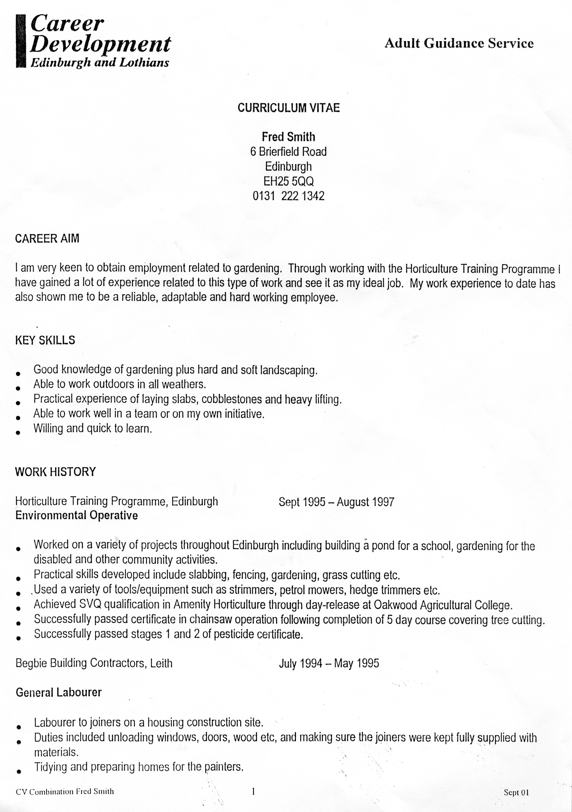

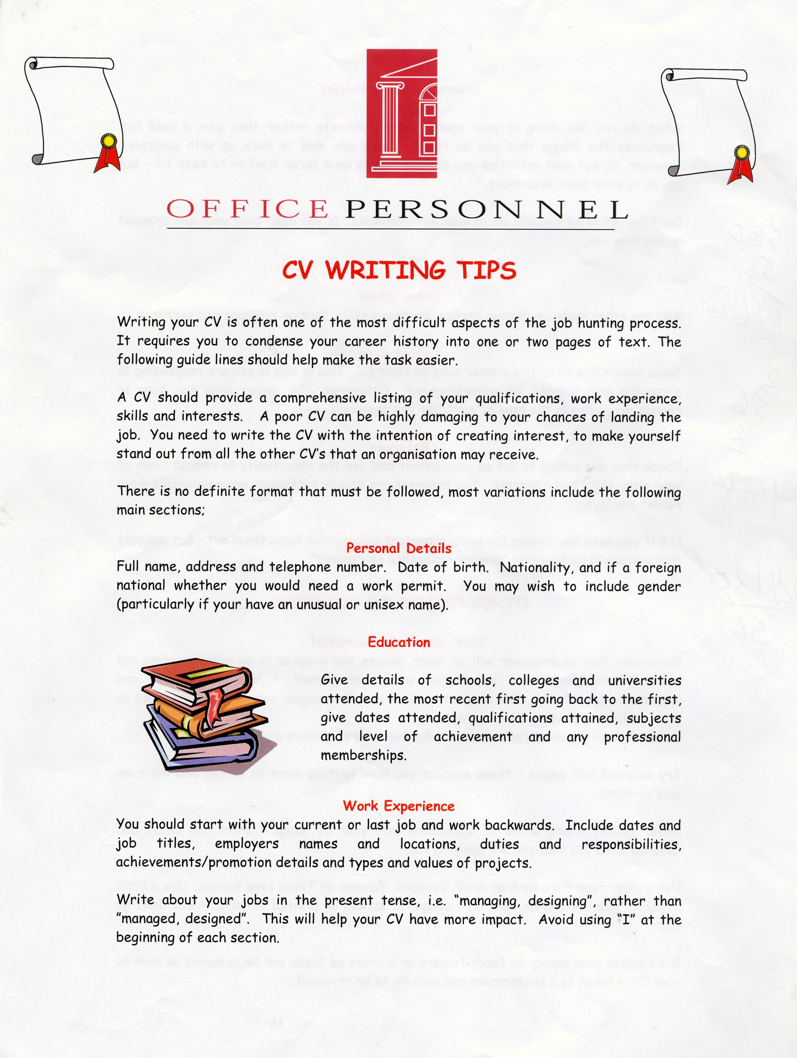

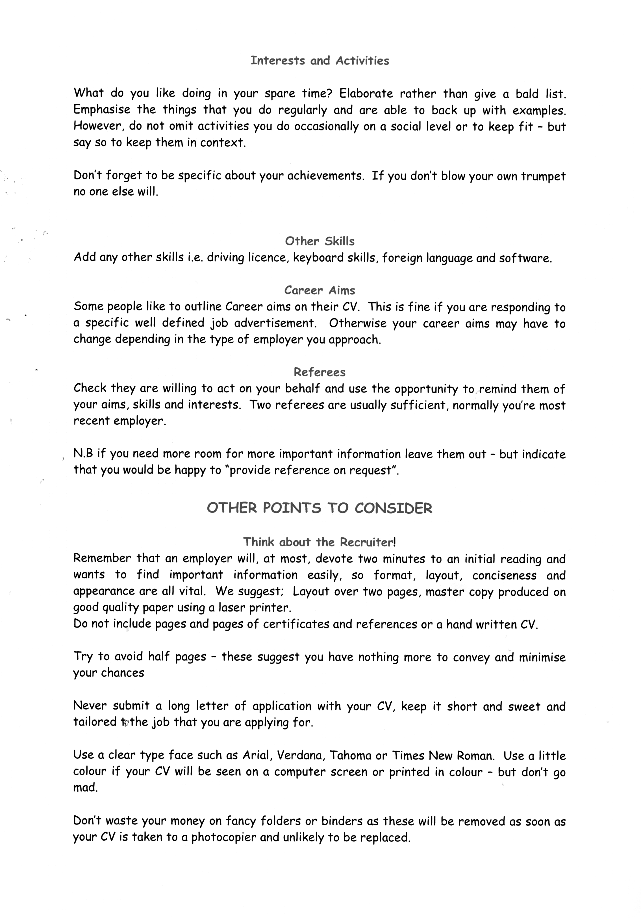

Source: www.officepersonnel.com
17 | The World of Work  Instructions and regulations

Source: Scottish Executive, Health and Safety Law (Crown Copyright)

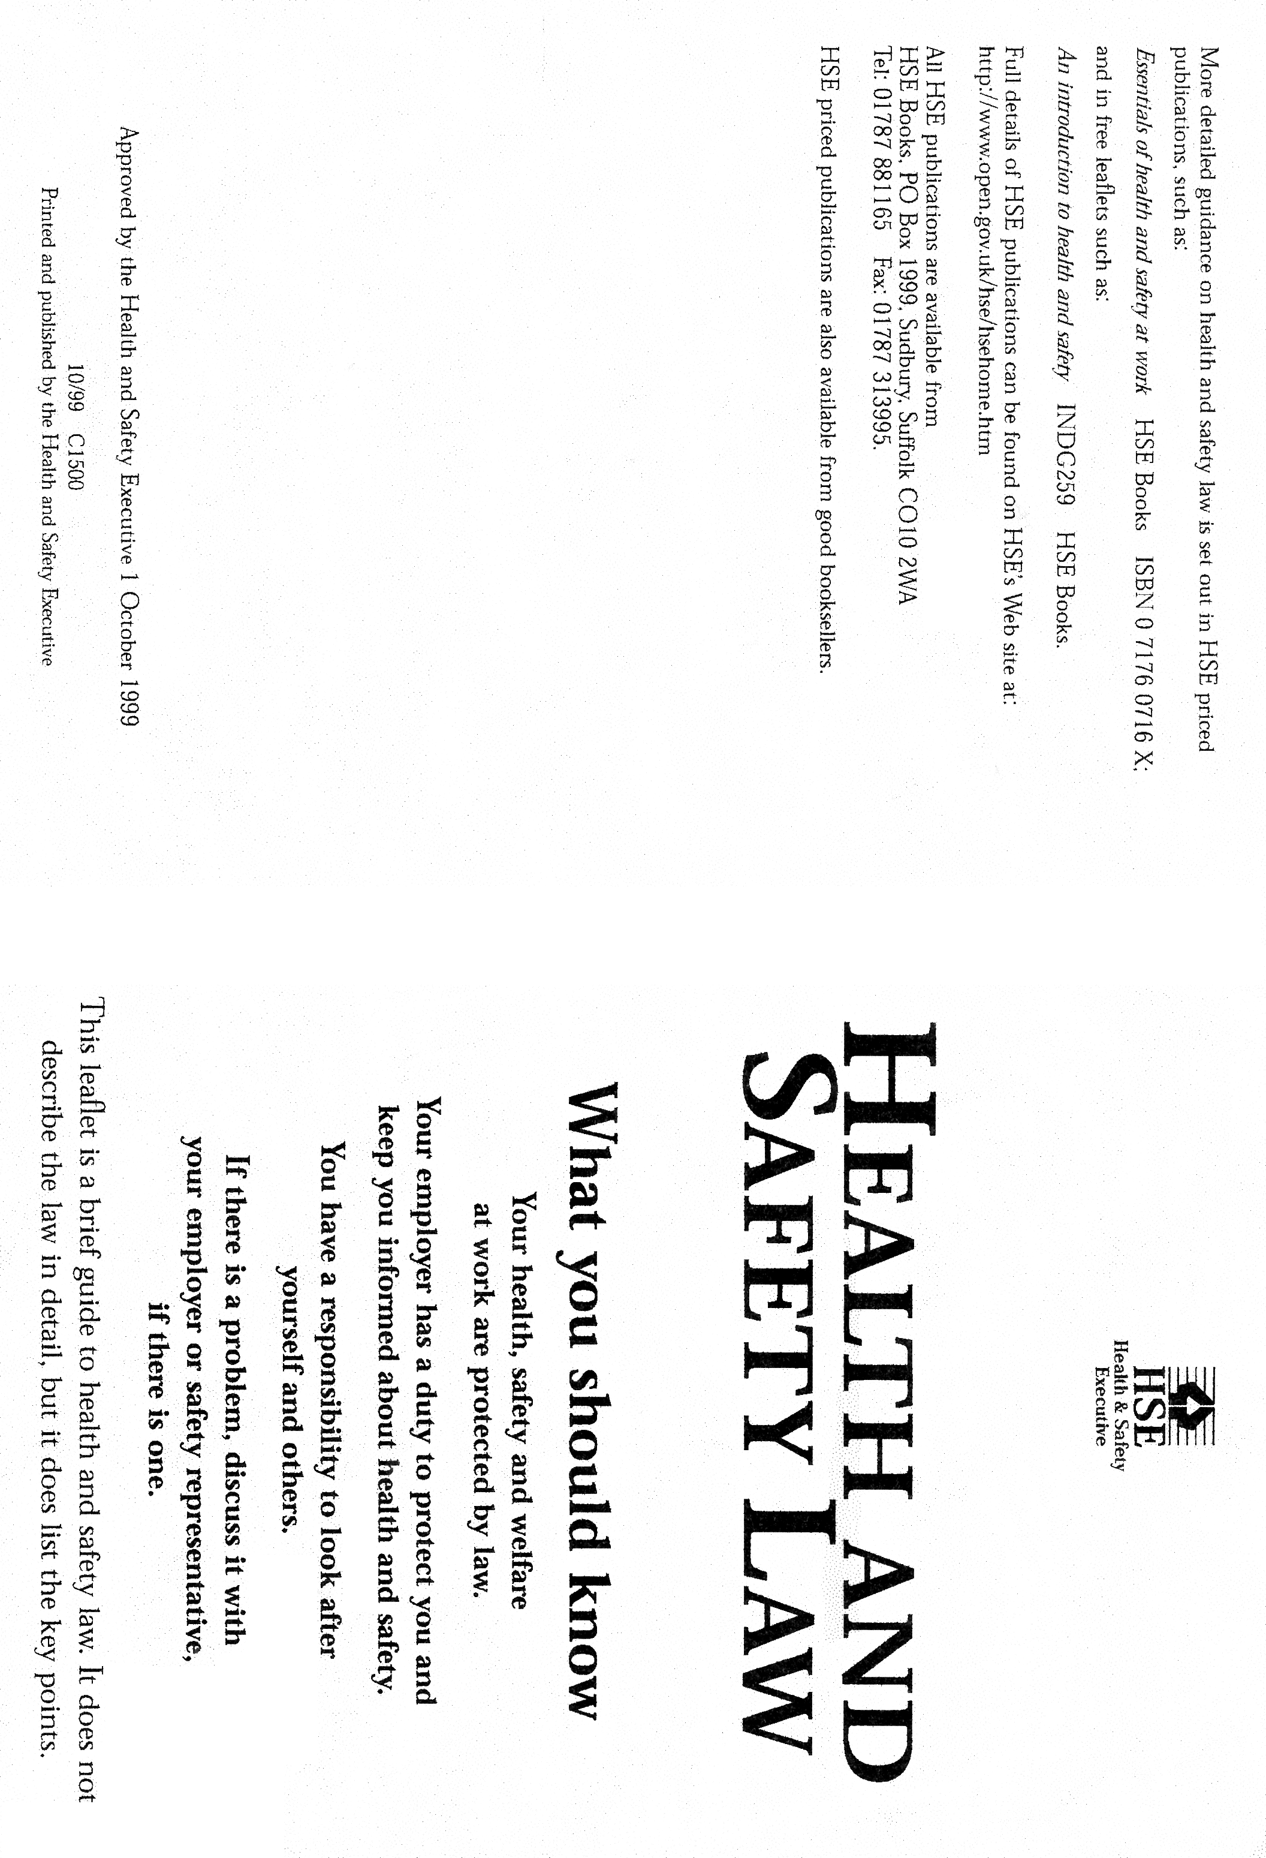

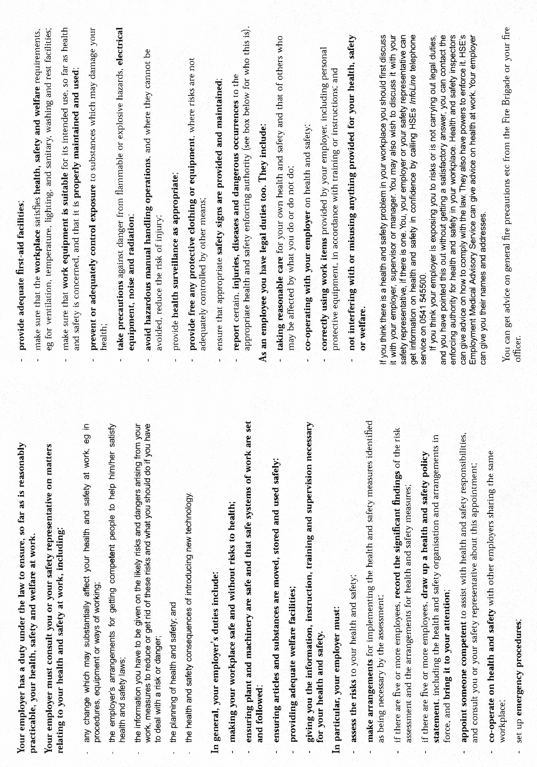

19 | The World of Work  Written communication

If I could just make a point here

I’d just like to say
May I interrupt
Excuse me, I’d just like to add
I’m not sure I agree with
I feel rather unhappy about
I can’t say I feel the same about
I disagree entirely

24 | Transferable skills  Presentation practice: Work

Activity 3

PRESENTATION EVALUATION FORM

1 What were the strong points of the talk?

2 Was the content well organised and well presented?

3 Was the speed of speaking satisfactory?

4 Was the voice loud and clear enough?

5 Did the speaker make eye contact with you? Was there any body language that distracted you?

6 If you had any problems following the talk, were they caused by:

Accent Grammar Topic Other aspects?

7 How did the speaker deal with questions?

8 What advice would you give the speaker for future presentations?

