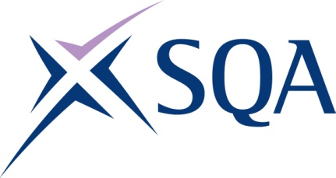

GH74 23 SVQ 3 Emergency Fire Services: Control Operations at SCQF Level 7 – Structure
To attain the qualification candidates must complete 8 Units in total. This comprises:
- 6 Mandatory Units
- 2 Optional Units

Please note the table below shows the SSC identification codes listed alongside the corresponding SQA Unit codes. It is important that the SQA Unit codes are used in all your recording documentation and when your results are communicated to SQA.

Mandatory Units: Candidates must complete 6 Units from this group
SQA code | SSC code | Title | SCQF level | SCQF credits
H55P 04 | SFJC01 | Maintain Information on Fire and Rescue Operational Resources | 7 | 10
H55R 04 | SFJC02 | Take Responsibility for Effective Performance in Fire and Rescue | 7 | 10
H55S 04 | SFJC03 | Gather Information to Co-ordinate a Fire and Rescue Response | 8 | 15
H55T 04 | SFJC04 | Co-ordinate a Fire and Rescue Response | 7 | 14
H55V 04 | SFJC06 | Manage Fire and Rescue Information to Support the Needs of Your Community | 7 | 12
H55W 04 | SFJC05 | Maintain the Reliability and Readiness of Fire and Rescue Control Operations and Equipment | 6 | 10

Optional Units: Candidates must complete 2 Units from this group
SQA code | SSC code | Title | SCQF level | SCQF credits
H55X 04 | SFJC07 | Specialist or Bespoke Software | 6 | 14
H55Y 04 | SFJC08 | Support the Development of Colleagues in Fire and Rescue | 7 | 10
H562 04 | SFJC09 | Drive, Manoeuvre and Redeploy Fire and Rescue Vehicles | 7 | 13
H563 04 | SFJFRSFF1 | Inform and Educate Your Community to Improve Awareness of Fire and Rescue Safety Matters | 6 | 7

