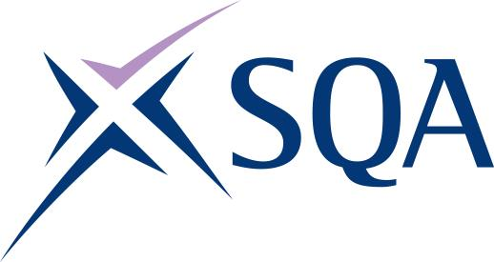

Scottish Vocational Qualifications

Food and Drink Qualifications Update

Autumn 2020

The Qualifications Team
Graeme Findlay
Qualifications Manager graeme.findlay@sqa.org.uk
Suzanne Train
Qualifications Officer suzanne.train@sqa.org.uk

We were unable to hold a provider network this year, so we’ve brought together the information in this update.

Contents
- Session 2019–20
- Session 2020–21
- The SVQs currently available
- Changes that have been applied to the Foundation Apprenticeship
- Our first successful Brewing candidates
- The latest from the National Skills Academy for Food and Drink
- Overviews from Skills Development Scotland and Food and Drink Federation Scotland

We hope that you find this useful, and would welcome your feedback.

Session 2019–20
Due to the pandemic, last session ended in a flurry of activity that was aimed at ensuring learners would be able to complete their courses to the best of their abilities, given the restrictions that were imposed on them.

We were able to hold verification visits before lockdown but, thereafter, verification was done virtually. All qualification types were covered. Feedback from Iain Percival, Senior External Verifier was that:

- ‘There were many instances of good practice, especially with the use of technology to capture observations.
- Centres are adhering to the requirements of the qualifications.
- Staff must be suitably qualified and have occupational competence to deliver and assess.
- It’s important to standardise and share best practice.’

Session 2020–21
An Update on qualifications regulated by SQA Accreditation was issued in September 2020.

Plans are in place for alternative methods of verification to take place, with the emphasis on capturing evidence virtually or by means of proctoring. More information can be found in
Supporting the delivery, assessment and verification of SQA units, session 202–21.

SVQs in Food and Drink Operations
The SVQs that are currently available are listed below. More detailed information on each framework can be found on the SVQs in Food and Drink subject page.

Course | Code | Focus
SVQ in Food and Drink Operations (Brewing Skills) level 5 | GP6P 22 | Aimed at staff in the sector, this qualification covers areas such as food safety standards in manufacture, malt handling, milling, brewing, mashing and conversion, wort boiling, cooling, fermentation, maturation and conditioning.
SVQ in Food and Drink Operations (Craft Bakery Skills) level 5 | GP23 22 | Aimed at staff in the sector, this qualification covers areas such as food safety standards in manufacture, working safely, and producing and finishing bakery products using machinery.
SVQ in Food and Drink Operations (Dairy Skills) level 5 | GP22 22 | Aimed at staff in the sector, this qualification covers areas such as food safety standards in manufacture, working safely, producing and finishing dairy products, weighing, measuring, mixing dairy products, planning, and food hygiene.
SVQ in Food and Drink Operations (Distribution Skills) level 5 | GP21 22 | Aimed at staff across the food and drink sector, this qualification covers areas such as food safety standards in manufacture, working safely, storing and organising goods and materials, stock control, transporting goods, packing orders, and the security of goods and materials.
SVQ in Food and Drink Operations (Fish and Shellfish Processing Skills) level 5 | GR5T 22 | Aimed at staff in the onshore fish and shellfish sector, this qualification covers areas such as filleting, processing, grading, packing, retail display of fish and shellfish, counter/take-away food service and sales.
SVQ in Food and Drink Operations: Food Manufacturing Excellence level 5 | GP20 22 | Aimed at staff across the food and drink sector, this qualification covers areas such as developing productive working relationships, maintaining product quality in food, workplace food safety standards in manufacturing, working safely, environmental safety, sustainability, and developing product specifications.
SVQ in Food and Drink Operations (Meat and Poultry Skills) level 5 | GR63 22 | Aimed at staff in the sector, this qualification covers areas from handling of livestock to primary meat processing, secondary processing/butchery and butchery sales.
SVQ in Food and Drink Operations (Production and Processing Skills) level 5 | GP1V 22 | Aimed at staff across the food and drink sector, this qualification covers areas such as food safety standards in manufacture, working safely, plant and equipment operation, batching, depositing, forming, conditioning, bottling, pelletising, and slicing.
SVQ in Food and Drink Operations (Food Sales and Service Skills) level 5 | GP1W 22 | Aimed at staff across the food and drink sector, this qualification covers areas such as food safety standards in manufacture, working safely in food manufacture, selling food and drinks products, table/tray service, assembling and processing products, storing and organising.
SVQ in Food Technology at SCQF level 6 | GP0D 23 | Aimed at staff across the food and drink sector, this qualification covers areas such as food business, food manufacture, working relationships with colleagues, health, safety and environmental management, food safety hazards and team work.
SVQ in Food and Drink Operations at SCQF level 6 | GP1X 23 | Aimed at staff across the food and drink sector, this qualification covers areas such as food safety at critical points, health, safety and environmental systems, maintaining product quality, energy efficiency, waste minimisation, water usage, process control of production, and leadership.
SVQ in Food and Drink Operations (Engineering Maintenance) level 6 | GL46 23 | Aimed at staff across the food and drink sector, this qualification covers areas such as complying with statutory regulations and organisational safety requirements, using engineering drawings and documents in maintenance activities, working efficiently and effectively, and completing handovers and confirming completion of maintenance activities.
SVQ in Food and Drink Operations (Fish and Shellfish Industry Skills) level 6 | GR5R 23 | Aimed at staff in the onshore fish and shellfish sector, this qualification covers areas such as monitoring and managing fish and shellfish processing operations, leadership, developing skills in a range of fish and shellfish processes including procedures and recording production operations, product knowledge, frying fish and chips, smoking, quality assessment and seafood sales.
SVQ in Food and Drink Operations: Food Manufacturing Excellence level 6 | GP1Y 23 | Aimed at staff across the food and drink sector, this qualification covers areas such as developing productive working relationships, maintaining product quality in food, workplace food safety standards in manufacturing, working safely, environmental safety, sustainability, and developing product specifications.
SVQ in Food and Drink Operations (Supply Chain Skills) level 6 | GP1T 23 | Aimed at staff across the food and drink sector, this qualification covers areas such as monitoring food safety at critical control points, health, safety and environmental systems, maintaining product quality, organising storage of goods, picking and packing orders, wrapping and labelling, and managing plant and equipment.
SVQ Spirits Operations SCQF level 6 | GR4A 23 | Aimed at staff in the sector, this qualification covers areas such as food safety, health, safety and environmental systems, product quality, operation control systems; site security; malting; milling, mashing, fermentation, distilling, flavouring and cask filling.

Foundation Apprenticeship in Food and Drink Technologies
Skills Development Scotland has created customised units that sit alongside the existing SVQ units. This will allow centres to continue delivering the course in the current situation, which is restricting movement/access to the workplace, and enable learners to generate evidence accordingly.

More on the customised units from Skills Development Scotland

SDS guidance on placement options for Foundation Apprenticeships

Dumfries and Galloway is continuing to develop its Foundation Apprenticeship in Food and Drink Delivery. Using virtual modes of learning, course leader Isla Porteous is encouraged by the work that her learners are submitting. Next up is a virtual placement with Dawnfresh, who will mentor the group as they work on the development of a food product.

SVQ in Food and Drink Operations (Brewing Skills) level 5
The first two successful candidates to complete the SVQ in Food and Drink Operations (Brewing Skills) level 5 qualification, Stuart Byars and Matthew Bennet, were presented with their certificates.

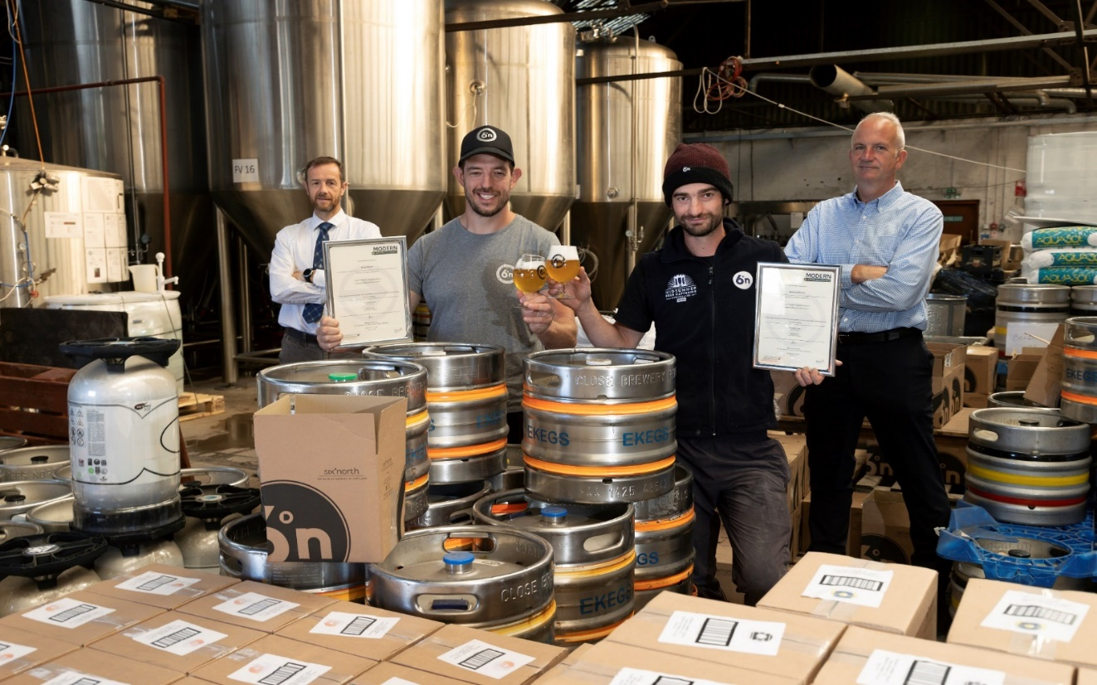

John Farquharson, Craft Skills Scotland assessor and SQA External Verifier, Stuart, Matthew and Graeme Findlay.

Stuart and Matthew both work at Six Degrees North in Laurencekirk, and were supported through their training by our partners Craft Skills Scotland, who said they were just the first in a pipeline of apprentices from Orkney to the Borders being trained as brewing craftsmen in consultation with the brewing industry.
​​​​​​​Scotland’s food and drink sector has come a long way over the last 10 years and is now one of the best performing sectors of the economy. With over 160 brewers in Scotland, sustaining more than 8,500 jobs, the SVQ in Food and Drink Operations (Brewing Skills) level 2 was developed to support this growing industry, which has annual sales in excess of £380 million.

It's encouraging to see the first two graduates complete the SVQ. The brewing sector in Scotland, particularly craft brewers such as Six Degrees North, has seen huge growth in recent years. The qualification gives employers an opportunity to develop their staff, which is proving to be particularly important as they look at ways in which to grow whilst navigating the challenges of COVID-19 and looking to the future. But, more importantly, the course also gives employees the chance to demonstrate their skills and knowledge, to become qualified and to develop their careers in Scotland’s vibrant food and drink industry.

The National Skills Academy for Food and Drink

Matt Hardy, Qualifications and Assessment Manager

GR4A 23 — SVQ in Spirits Operations at SCQF level 6
A brand new SVQ and Modern Apprenticeship is now available for delivery in Scotland.

The SVQ in Spirits Operations at SCQF level 6 and new Modern Apprenticeship will meet the needs of employers and stakeholders across the range of spirit distillers — including those making whisky, gin, Bacardi, tequila, vodka, brandy, rum and liqueurs.

This SVQ has been developed for those involved in operations including processing, bottling, packing, labelling, casking, warehouse and despatch.

Reviews of SVQs
Existing SVQs have been reviewed with employers in the Fish and Shellfish, and Meat and Poultry sectors. Minor changes have been made to these qualifications to incorporate updates to National Occupational Standards.

The updated SVQs are now available for delivery. The new codes are:

- GR5T 22 — SVQ in Food and Drink Operations (Fish and Shellfish Processing Skills) at SCQF Level 5
- GR54 23 — SVQ in Food and Drink Operations (Fish and Shellfish Industry Skills) at SCQF Level 6
- GR63 22 — SVQ in Food and Drink Operations (Meat and Poultry) at SCQF Level 5

The updated SVQ in Food and Drink Operations Meat and Poultry at SCQF Level 6 will be available soon.

National Occupational Standards review
During 2020–21, the existing National Occupational Standards for Engineering Maintenance in the food and drink sector will be reviewed with employers and stakeholders across the four UK nations. Once updated, employers and stakeholders will be engaged to review SVQs and Modern Apprenticeships for Engineering Maintenance, with this work planned for 2021–22.

More information on the National Skills Academy for Food and Drink can be found at: www.nsafd.co.uk and www.tastycareers.org.uk.

Skills Development Scotland update

Gerry McBride, Strategic Relations Manager, Food and Drink

Skills Development Scotland has produced two pieces of work to highlight the impact of COVID-19.

Food and Drink COVID-19 LMI:

Partnership presentation on SDS Programme of Work, pathways to apprenticeships:

If you have any questions on the content, please contact gerry.mcbride@sds.co.uk.

Food and Drink Federation Scotland update

Moira Stalker, Skills Manager
As part of the Scotland Food and Drink Skills Partnership, we are working with industry to develop 12 new case studies that reflect good practice in the food and drink industry. These resources will form part of the overall Scotland Food and Drink Skills collateral materials. Following the impact of COVID-19, we are repurposing these case studies to reflect how industry has reacted to adversity, and how developing the workforce resulted in innovation, staff loyalty and retention.

Podcasts
A number of skills podcasts have been recorded and published: there’s a Skills Update, a review of the Lockdown Lunch Challenge, and a Graduate Apprenticeship podcast with four universities from across Scotland and SDS to raise awareness of how Graduate Apprenticeships can benefit the food and drink industry.

Future planned podcasts include: a promotion of Modern Apprenticeships and a launch of Teacher CPD. The Food and Drink Federation Scotland suite of podcasts also includes a ‘behind the scenes with MacSweens’ and a number of reformulation broadcasts.

Career long profession learning (CLPL) for educators
A number of CLPL programmes are underway.

In partnership with RHET, QMS and The Rowett Institute, collectively we run CLPL under the heading 'Good Food Champions'. We received funding from Education Scotland to deliver STEM CLPL for teachers to promote links between STEM and Learning for Sustainability, using food and drink as the context for learning.

We are working with partners from University of Edinburgh to inform the development and delivery of a Learning for Sustainability MOOC (massive open online course), using food and drink as the context for learning.

There are regular update meetings with DYW and SDS scheduled to ensure we are working collaboratively with DYW teams across Scotland, providing updates and input to inform industry and education links to promote careers in the food and drink industry. Several joint promotional initiatives have taken place and are planned with DYW Scotland, notably with DYW D&G with whom we are filming inside industry, interviewing members of industry, providing interview tips and techniques, and filming food-related STEM experiments with teachers. This collateral will be available across all DYW teams.

If you have any questions for Moira, she can be contacted at moira.stalker@fdfscotland.org.uk.

Follow us online
Twitter: @sqanews

Facebook: Scottish Qualifications Authority

LinkedIn: Scottish Qualifications Authority

YouTube: SQAonline

Sign up to MyAlerts
To receive email alerts when content you are interested in has been added to, or updated, on our website, subscribe to MyAlerts at www.sqa.org.uk/myalerts.

Contact us

Please contact our Customer Support Team:

Tel: 0303 333 0330
Fax: 0345 213 5000
Email: mycentre@sqa.org.uk

