SQA/REHIS Information for Centres 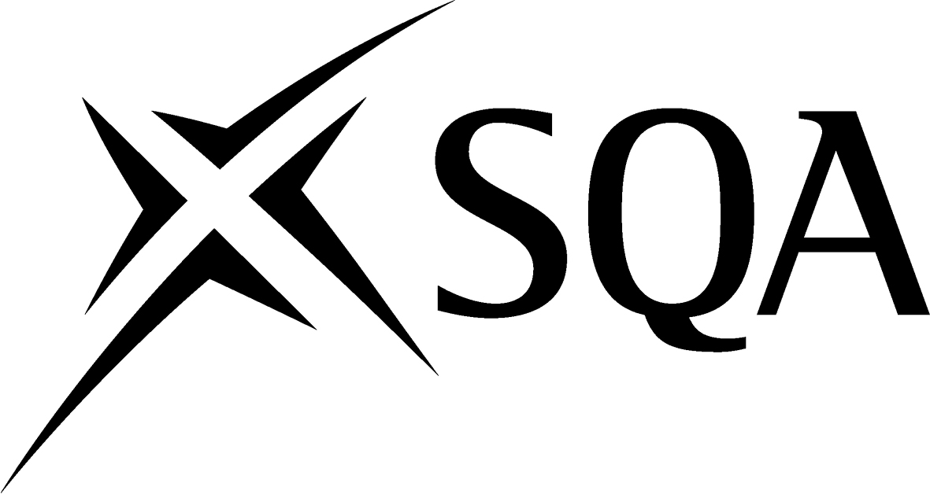

Candidates who have successfully achieved the HN Food Hygiene Intermediate Unit (F4TL 34) are eligible to claim certification with The Royal Environmental Health Institute of Scotland (REHIS) for their Food Hygiene Practices: Intermediate Food Hygiene Certificate. In order to obtain certification, there is an additional charge payable directly to REHIS, per person, for the REHIS Certificate.

Candidates who wish to claim certification must complete an application form, which can be found at www.sqa/org.uk or by contacting REHIS directly at contact@rehis.com

SQA Unit code | HN Unit title | REHIS equivalence | Dual certification cost
F4TL 34 | Food Hygiene Intermediate | REHIS Intermediate Food Hygiene Certificate | £16

