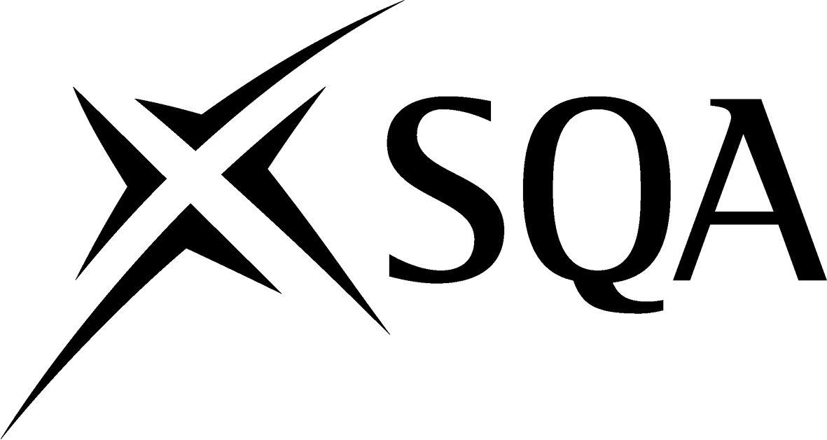

Arrangements for:
National Progression Award (NPA) in
Administration: Medical
(Administrative Secretary)
at SCQF level 5

Group Award Code: G9WV 45

Validation date: 4 June 2010

Date of original publication: June 2010

Version: 01

Acknowledgement
SQA acknowledges the valuable contribution that Scotland’s colleges have made to the development of National Qualification Group Awards.

History of changes

It is anticipated that changes will take place during the life of the qualification, and this section will record these changes. This document is the latest version and incorporates the changes summarised below.

Version  number | Description | Date | Authorised by

Contents

1 Introduction 1
2 Rationale for the development of the Group Award 1
2.1 Nature and purpose of the award 1
2.2 Establishing the need for the qualification 2
2.3 Establishing the level of the award 2
2.4 Target Client Group 2
3 Aims of the Group Award 3
3.1 Principal aims of the Group Award 3
3.2 General aims of the Group Award 4
3.3 Target groups 4
3.4 Employment opportunities 4
4 Access to Group Award 4
5 Group Award structure 5
5.1 Framework 5
5.2 Mapping information 5
5.3 Articulation, professional recognition and credit transfer 6
6 Approaches to delivery and assessment 6
6.1 Sequence of delivery 6
6.2 Core Skills 7
7 General information for centres 7
8 General information for candidates 7
9 Glossary of terms 8

1 Introduction

This is the Arrangements Document for the new National Progression Award in Administration: Medical (Administrative Secretary) at level 5, which was validated on 4 June 2010. This document includes: background information on the development of the Group Award, its aims, guidance on access, details of the Group Award structure, and guidance on delivery.

The NPA in Administration: Medical (Administrative Secretary) has been designed to equip candidates with the skills required for success in current and future employment within the Health Sector or for progression to further academic qualifications.

The NPA has been developed along with the National Certificate development in Administration and the Units are available as optional Units within the new National Certificate in Administration at SCQF level 5
(G99P 45).

2 Rationale for the development of the Group Award

The National Progression Award in Administration: Medical (Administrative Secretary) at SCQF level 5 consists of three mandatory 40 hour Units.

The NPA has been developed by SQA with the purpose of improving learners’ skills in medical terminology and ICT skills. It meets the needs of colleges which require a greater degree of flexibility in the delivery of their programmes.

National Progression Awards are designed to:

- mainly be used in post-compulsory education
- be followed part-time for those already in work; or for those who have a desire to enter employment in the business and commercial sector
- assess and certificate a defined set of skills and knowledge.
- Give credit to full-time candidates who may not be able to complete their full course

The NPA is designed for individuals who are currently working in or desire to work in the Health Sector. Completion of the NPA may also provide candidates with opportunities for progression either within the sector or to other advanced level academic qualifications.

2.1 Nature and purpose of the award

The National Progression Award in Administration: Medical (Administrative Secretary) at SCQF level 5 is designed to meet the Terminology, Word Processing and Audio skills required in the health sector. The award structure and Unit content provides a coherent and progressive curriculum which creates and promotes effective articulation and transition into further and higher education, whilst simultaneously recognising and supporting skills for the sector and future employment.

2.2 Establishing the need for the qualification

Consultation was undertaken with sector practitioners and schools and it was agreed that the NPA would be beneficial.

The NPA in Administration: Medical (Administrative Secretary) at SCQF level 5 award, would allow candidates who wish to develop their IT skills and Medical Terminology knowledge an opportunity to gain a recognised qualification.

In recent years candidates have also looked for more flexibility in delivery and have been less prepared to commit to a full year’s programme of study. Overall the QDT felt that there was a requirement for an award which would:

- be recognised by schools, employers and other educational institutions
- award a group of units signifying achievement
- retain flexibility in delivery
- provide a progression route from level 4 courses
- prove an exit route
- match the capabilities, expectations and interests of candidates enrolling for the award

2.3 Establishing the level of the award

The level of the NPA in Administration: Medical (Administrative Secretary) was influenced by the fact that the new NC in Administration is leveled at SCQF level 5, and therefore, the NPA was designed around this. SQA design principles allow a minimum credit value of 12 SCQF credit points (at least two Units) and at least half of the credit points have to be at the level of the Group Award. As the suggested new NPA in Administration: Medical (Administrative Secretary) is designed for candidates who wish to apply for employment or higher education it was felt that the Units should all be at level 5.

2.4 Target Client Group

The NPA in Administration: Medical (Administrative Secretary) is intended for candidates who want to develop their Terminology, Word Processing and Audio skills. It is considered that this NPA would be suitable for:

- young people who may still be at or who have left school recently
- mature ‘adult returners’ who have decided to re-enter education
- employees wishing to enhance their qualifications
- potential candidates looking for access to HN
- employers wishing short CPD courses for their employees

These groups have quite different characteristics. Many recent school leavers have limited formal school attainment. Adult returners may also possess few formal qualifications and while they frequently have valuable experience, they may lack confidence in their ability to learn. As more emphasis is put on Lifelong Learning and Continuing Professional Development, employers are keen to offer certificated courses to employees.
It is envisaged that this award could be offered in one of the following modes:

- full- time
- part- time
- infill into existing classes
- evening classes

The NPA will provide formal recognition of existing skills and provide new skills.

3 Aims of the Group Award

The National Progression Award in Administration: Medical (Administrative Secretary), (level 5) has been designed as a flexible programme which aims to provide candidates with a range skills to suit a medical environment. It recognises that learners will be at a stage where they are making choices about their future. As a result, it offers multiple exit routes, either towards employment or further study, depending on the wishes of the candidate. Completing the award will put candidates in a stronger position to move to the next stage of their career and should increase their chances of doing this successfully.

3.1 Principal aims of the Group Award

1 Give candidates a strong foundation in medical terminology which will enable them to progress within a medical environment.

2 Enable candidates to consider the various options open to them and to make informed career choices for their future.

3 Prepare candidates for entry into further qualifications such as Higher National awards in Administration and Information Technology and other related areas.

4 Provide candidates with relevant skills in medical related occupations, Core Skills for ICT, administrative and medical related occupations and for further study in administration.
5 Provide candidates with an introduction to medical terminology.

The table below references the above aims into the individual three mandatory Units:

Unit code | Unit title | Reference to aims of the award
F5AK 11 | Medical Terminology: An Introduction (level 5) | 1, 3, 4, 5
F7KV 11 | Word Processing: Medical (level 5) | 3, 4
F7KS 11 | Audio: Medical (level 5) | 4

3.2 General aims of the Group Award

The general aim of the National Progression Award in Administration: Medical (Administrative Secretary), (level 5) is to provide candidates with the necessary skills in Medical Terminology, Word Processing and Audio and to certificate same. As a result it is hoped that candidates would then be able to either progress in education, find suitable employment or progress within current employment.

3.3 Target groups

It is envisaged that the following groups would be targeted:

- School leavers
- Adult returners
- Employees wishing to enhance their qualifications
- Potential candidates looking for access to HN
- As ‘added value’ to full-time candidates

3.4 Employment opportunities

On successful completion of the NPA in Administration: Medical (Administrative Secretary), (level 5) it is envisaged that employment could be gained in the health sector in one of the following areas:

- Medical Secretary (hospital and GP)
- Receptionist/Secretary (hospital and GP)

For candidates who are looking to progress into employment in the NHS, the NPA in Administration: Medical (Administrative Secretary) is aimed at Band 2 staff who wish to progress into Band 3 Administrator/Support Secretary roles, particularly the Audio Typing and Word Processing Units.

4 Access to Group Award

There are no specific recommended entry requirements for this award. Entry will be at the discretion of the centre.

We would recommend that candidates should have previous experience in Communication, Audio and Word Processing at level 4 or related work based experience.

5 Group Award structure

The National Progression Award in Administration: Medical (Administrative Secretary) consists of three mandatory Units taken from the validated NC in Administration (SCQF level 5) All three of the Units are taken from the optional Units in the new NC Administration (level 5). In accordance with the design principles with all of the Units being at SCQF level 5, the National Progression Award will be leveled at 5.

5.1 Framework

Unit title | Code | SCQF  credit  points | SCQF  level | SQA credit value
Medical Terminology | F5AK11 | 6 | 5 | 1
Word Processing: Medical | F7KV11 | 6 | 5 | 1
Audio: Medical | F7KS11 | 6 | 5 | 1

5.2 Mapping information

The structure of the NPA in Administration: Medical (Administrative Secretary) meets the aims and the requirements of the award in a number of ways which can be summarised as follows:

- it provides skills, knowledge and capabilities needed for employment
- it provides the credibility of a nationally accredited award
- it consists of Units which are practical and will engage the interests of learners
- it is compatible with existing arrangements currently adopted by centres
- it provides the flexibility which learners and centres value
- it provides an opportunity for learners to develop Core Skills in Information and Communication Technology and Communication

A small grouping of relevant Units nationally accredited into a named award is attractive to many learners who don’t want or have the time for a long period of study. It will provide learners with the options to move into employment or take further study at the same level allowing them to broaden their skills, or progress to SCQF level 6, for example Word Processing. Because the award is made up of Units from the NC in Administration, it is likely that many candidate will also have the necessary skills to progress to relevant HN awards.

The flexibility of the award is further enhanced as the structure takes into account that centres are likely to offer the NC in Administration as the central part of programmes of 17–20 modules. The new award is, therefore, compatible with existing arrangements.

Links to occupational standards are shown in the table below. The Council for Administration publishes the standards for SVQs in Business and Administration. The table below shows where the Units for this award have specific links to the National Occupational Standards.

Mandatory Units | Level | Links to NOS
Word Processing (Medical) | Level 5 | 214, 224
Audio (Medical) | Level 5 | 213, 223
Medical Terminology | Level 5 | *

*No specific suite of NOS for Medical Secretaries

5.3 Articulation, professional recognition and credit transfer

The National Progression Award in Administration: Medical (Administrative Secretary) SCQF level 5 will give a platform which will allow development of appropriate skills in medical terminology, word processing and audio to progress into higher education or employment.

6 Approaches to delivery and assessment

The delivery of the award is at the discretion of individual centres. They may choose to deliver over a 120 hour period, during the day, evening or by infilling into existing classes, or as a mixture of all of these.

Timetabling of the three Units would be at the discretion of individual centres. It is important that centres offer the Medical Terminology Unit prior to the Word Processing and Audio Units as candidates will require this knowledge.

Assessment Support Packs have a critical role in ensuring that delivery of Units is linked to Medical administration and admin-related situations allowing for integration of delivery and assessment where possible.

E-assessment may be appropriate for some assessments in this Unit. By
e-assessment we mean assessment which is supported by information and communications technology (ICT), such as e-testing or the use of
e-portfolios or e-checklists. Centres which wish to use e-assessment must ensure that the national standard is applied to all candidate evidence and that conditions of assessment as specified in the Evidence Requirements are met, regardless of the mode of gathering evidence. Further advice is available in SQA Guidelines on Online Assessment for Further Education (AA1641, March 2003), SQA Guidelines on e-assessment for Schools (BD2625, June 2005).

6.1 Sequence of delivery

Centres can choose the order to teach and assess the Units, according to their local market needs and resources. It may be beneficial to have two or three Units taught at the same time to allow integration of teaching and assessments.

6.2 Core Skills

Candidates have the opportunity to develop the Core Skills Communications (SCQF level 3) through the Unit Medical Terminology: An Introduction and Information and Communication Technology (SCQF level 4) through the Unit Word Processing: Medical.

Candidates will achieve the Core Skills component providing/creating information @ SCQF 4 through the Unit Audio (Medical).

7 General information for centres

Disabled candidates and/or those with additional support needs

The additional support needs of individual candidates should be taken into account when planning learning experiences, selecting assessment instruments, or considering whether any reasonable adjustments may be required. Further advice can be found on our website www.sqa.org.uk/assessmentarrangements.

Internal and external verification

All instruments of assessment used within this/these Group Award(s) should be internally verified, using the appropriate policy within the centre and the guidelines set by SQA.

External verification will be carried out by SQA to ensure that internal assessment is within the national guidelines for these qualifications.

Further information on internal and external verification can be found in SQA’s Guide to Assessment (www.sqa.org.uk).

8 General information for candidates

The National Progression Award in Administration: Medical (Administrative Secretary) SCQF level 5 will give you a platform which will allow you to develop appropriate skills in medical terminology, word processing and audio to help you to progress into higher education or employment.

The National Progression Award in Administration: Medical (Administrative Secretary) contains three mandatory Units which you need to successfully complete in order to gain the award.

There are no specific entry requirements for the National Progression Award in Administration: Medical (Administrative Secretary). However, we would recommend that you have a basic understanding of word processing.

9 Glossary of terms

SCQF: This stands for the Scottish Credit and Qualification Framework, which is a new way of speaking about qualifications and how they inter-relate. We use SCQF terminology throughout this guide to refer to credits and levels. For further information on the SCQF visit the SCQF website at www.scqf.org.uk

SCQF credit points: One SCQF credit point equates to 10 hours of learning. NQ Units at SCQF levels 2–6 are worth 6 SCQF credit points, NQ Units at level 7 are worth 8 SCQF points.

SCQF levels: The SCQF covers 12 levels of learning. National Qualification Group Awards are available at SCQF levels 2-6 and will normally be made up of National Units which are available from SCQF levels 2–7.

Dedicated Unit to cover Core Skills: This is a non-subject Unit that is written to cover one or more particular Core Skills.

Embedded Core Skills: This is where the development of a Core Skill is incorporated into the Unit and where the Unit assessment also covers the requirements of Core Skill assessment at a particular level.

Signposted Core Skills: This refers to the opportunities to develop a particular Core Skill at a specified level that lie outwith automatic certification.

Qualification Design Team: The QDT works in conjunction with a Qualification Manager/Development Manager to steer the development of the National Certificate/National Progression Award from its inception/revision through to validation. The group is made up of key stakeholders representing the interests of centres, employers, universities and other relevant organisations.

Consortium-devised National Certificates/National Progression Awards are those developments or revisions undertaken by a group of centres in partnership with SQA.

